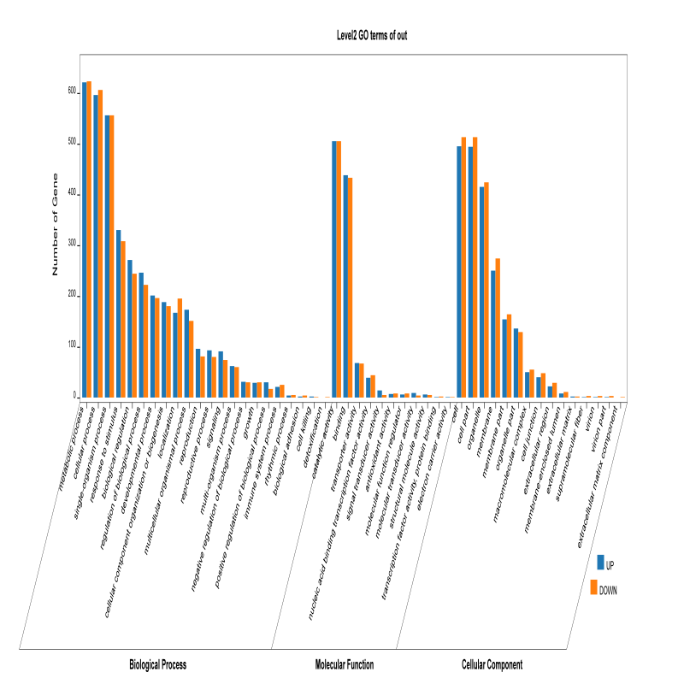

Figure S6. GO enrichment functional annotation and classification of DEGs