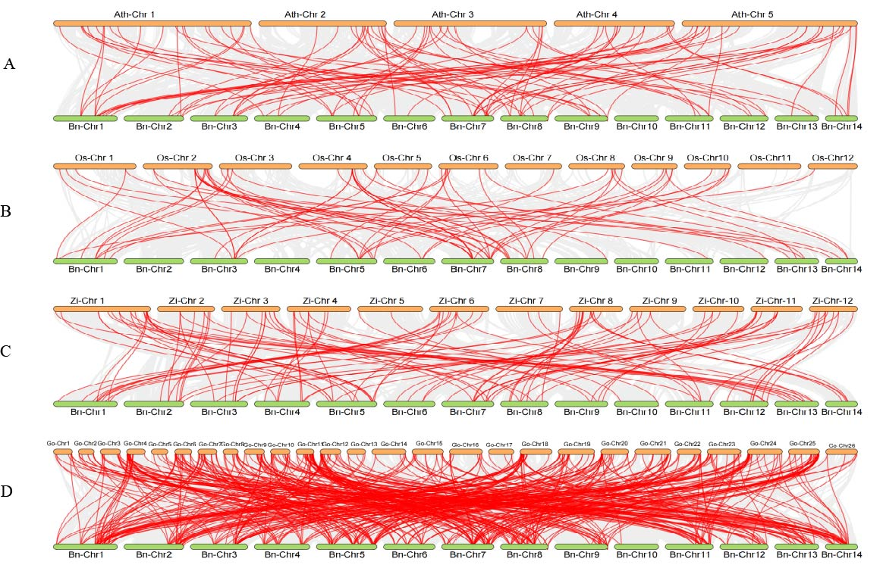

**Figure S5. Collinearity and synteny relationship of *BnAP2/ERF* genes between ramie and Arabidopsis, rice, jujube, and cotton.** Collinear gene pairs are developed between ramie and Arabidopsis (A), rice (B), jujube (C), and cotton (D). The gray line in the background shows the collinear area and the red line area highlights the collinear gene pair.