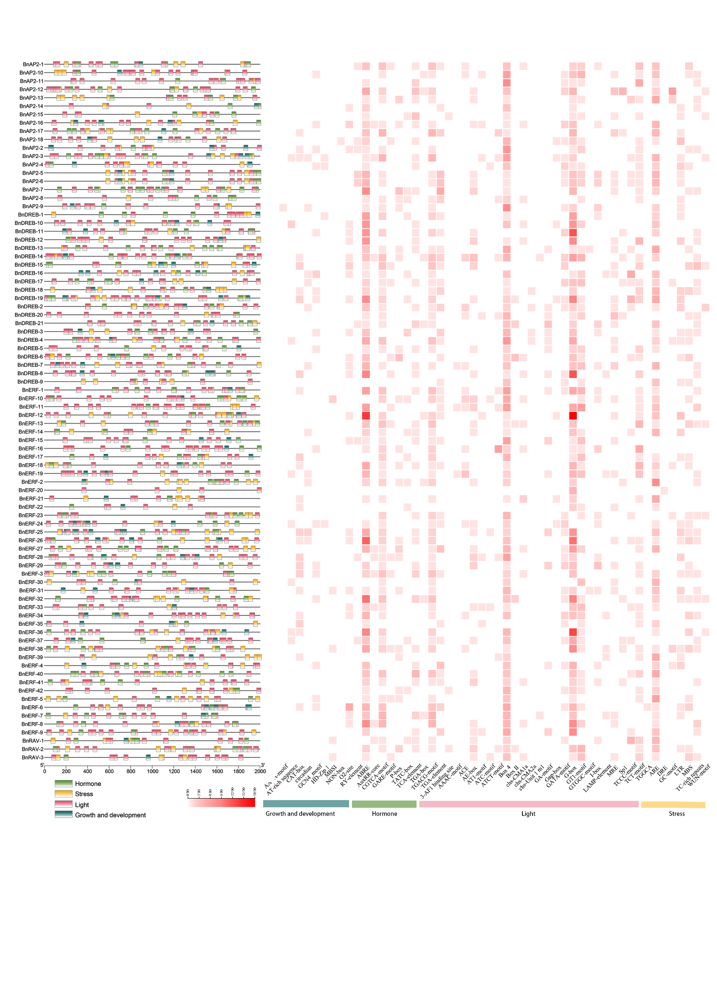
Figure S4. Analysis of cis-acting elements in the promoter region of BnAP2/ERFs. The left panel shows the distribution of cis-acting elements in the promoter region. The heat maps of cis-acting elements for the light-responsive, hormone-responsive, stress-responsive, growth and development-responsive, and the color concentration of the squares indicates the number of cis-acting elements.

