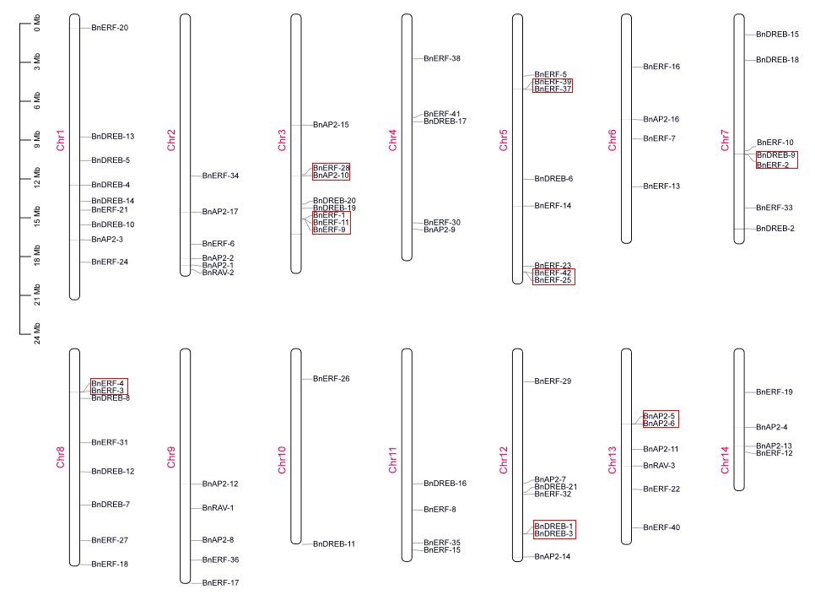

Figure S3. Chromosomal locations of BnAP2/ERFs. The gene name is presented to the right of each bar, while the chromosome name is to the left. To the left of chr1 is a 3-Mb bar. The clusters are shown with a red frame.