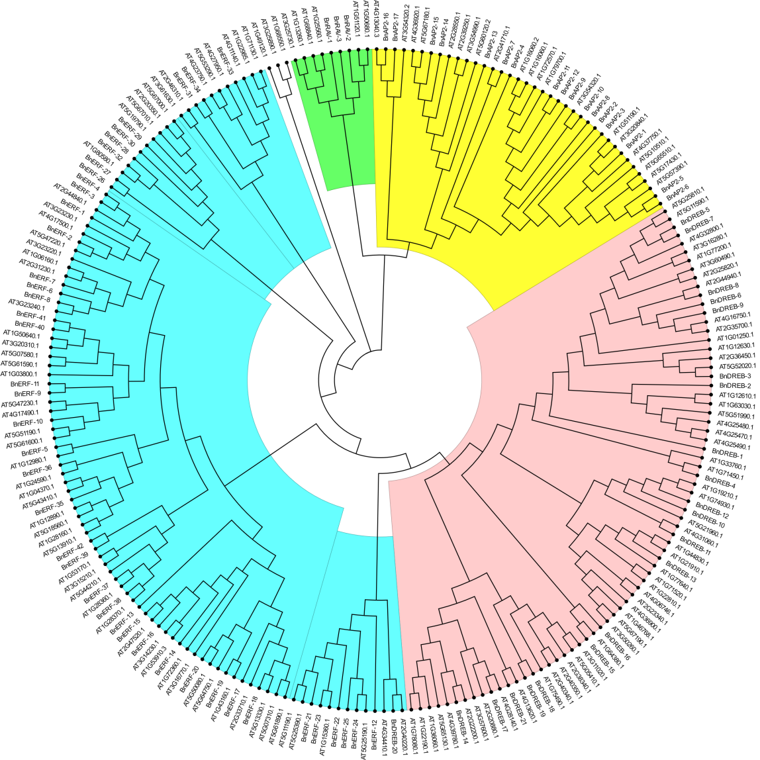

Figure S1. Phylogenetic analysis of 84 ramie AP2/ERF proteins. A phylogenetic tree by the maximum likelihood (ML tree) method was constructed using muscle software for the multiple sequence alignment of 84 AP2/ERF proteins sequences of ramie and 147 AP2 / ERF proteins sequences in Arabidopsis (yellow: AP2-type; blue: ERF-type; pink: DREB-type; green: RAV-type;). The bootstrap consensus tree inferred from 1000 replicates is taken to represent the evolutionary history of the taxa analyzed. Branches corresponding to partitions reproduced in less than 50% bootstrap replicates are collapsed.