Supplemental Material
- Detailed Methods
Search strategy
1 | primary hyperaldosteronism/ | 7,666
2 | (aldosteronism or hyperaldosteronism).ti,ab. | 10,886
3 | (conn* adj syndrome).ti,ab. | 934
4 | (aldosterone adj2 adenoma).ti,ab. | 1,503
5 | 2 or 3 or 4 | 11,771
6 | 1 or 5 | 13,210
7 | exp cerebrovascular accident/ | 267,076
8 | stroke.mp. [mp=title, abstract, heading word, drug trade name, original title, device manufacturer, drug manufacturer, device trade name, keyword heading word, floating subheading word, candidate term word] | 517,073
9 | (cerebr* adj3 (insult or injur* or accident or insufficiency or arrest)).mp. [mp=title, abstract, heading word, drug trade name, original title, device manufacturer, drug manufacturer, device trade name, keyword heading word, floating subheading word, candidate term word] | 274,879
10 | ((cerebral or brain) adj2 isch?emia).mp. [mp=title, abstract, heading word, drug trade name, original title, device manufacturer, drug manufacturer, device trade name, keyword heading word, floating subheading word, candidate term word] | 170,440
11 | (brain adj2 ("vascular accident*" or insult or disturbance or insult*)).mp. [mp=title, abstract, heading word, drug trade name, original title, device manufacturer, drug manufacturer, device trade name, keyword heading word, floating subheading word, candidate term word] | 2,600
12 | (CVA or CVAS).ti,ab. | 7,696
13 | 8 or 9 or 10 or 11 or 12 | 667,859
14 | 7 or 13 | 667,859
15 | transient ischemic attack/ | 44,042
16 | ((transient or brain or attack) adj2 isch?emi*).mp. [mp=title, abstract, heading word, drug trade name, original title, device manufacturer, drug manufacturer, device trade name, keyword heading word, floating subheading word, candidate term word] | 208,674
17 | (TIA or TIAs).ab,ti. | 21,966
18 | 16 or 17 | 216,637
19 | 15 or 18 | 216,637
20 | 14 or 19 | 689,207
21 | 6 and 20 | 319
Figure S1. Embase search strategy

1 | Hyperaldosteronism/ | 8,412
2 | (aldosteronism or hyperaldosteronism).ti,ab. | 6,844
3 | (Conn* adj syndrome).ti,ab. | 594
4 | (aldosterone adj2 adenoma).ti,ab. | 947
5 | 2 or 3 or 4 | 7,453
6 | 1 or 5 | 10,263
7 | exp stroke/ | 158,576
8 | stroke.mp. [mp=title, abstract, original title, name of substance word, subject heading word, floating sub-heading word, keyword heading word, organism supplementary concept word, protocol supplementary concept word, rare disease supplementary concept word, unique identifier, synonyms] | 302,810
9 | (cerebr* adj3 (insult or injur* or accident or insufficiency or arrest)).mp. [mp=title, abstract, original title, name of substance word, subject heading word, floating sub-heading word, keyword heading word, organism supplementary concept word, protocol supplementary concept word, rare disease supplementary concept word, unique identifier, synonyms] | 19,083
10 | ((cerebral or brain) adj2 isch?emia).mp. [mp=title, abstract, original title, name of substance word, subject heading word, floating sub-heading word, keyword heading word, organism supplementary concept word, protocol supplementary concept word, rare disease supplementary concept word, unique identifier, synonyms] | 80,667
11 | (brain adj2 ("vascular accident*" or insult or disturbance or insult*)).mp. [mp=title, abstract, original title, name of substance word, subject heading word, floating sub-heading word, keyword heading word, organism supplementary concept word, protocol supplementary concept word, rare disease supplementary concept word, unique identifier, synonyms] | 1,676
12 | (CVA or CVAS).ti,ab. | 2,761
13 | 8 or 9 or 10 or 11 or 12 | 356,463
14 | Ischemic Attack, Transient/ | 21,348
15 | ((transient or brain or attack) adj2 isch?emi*).mp. [mp=title, abstract, original title, name of substance word, subject heading word, floating sub-heading word, keyword heading word, organism supplementary concept word, protocol supplementary concept word, rare disease supplementary concept word, unique identifier, synonyms] | 100,677
16 | (TIA or TIAs).ab,ti. | 8,936
17 | 15 or 16 | 103,468
18 | 14 or 17 | 103,468
19 | 13 or 18 | 372,171
20 | 6 and 19 | 107
Figure S2. Medline search strategy

- Supplemental Figures
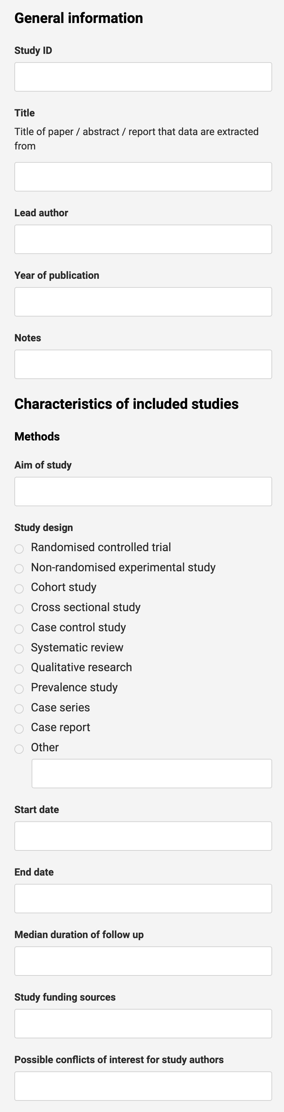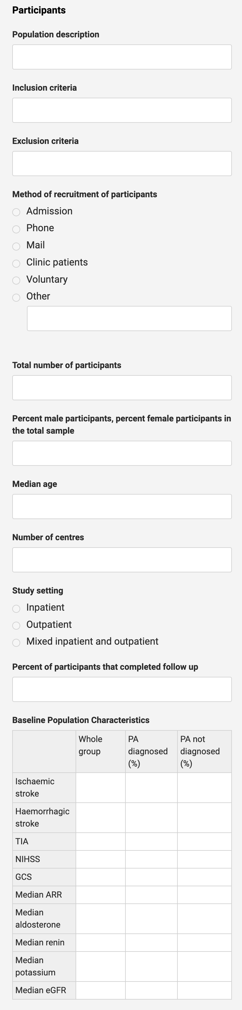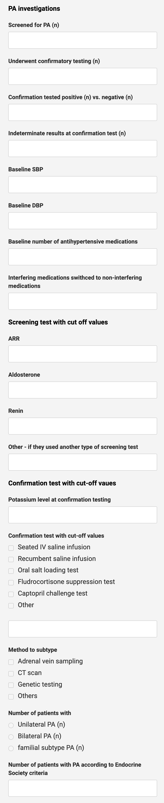Figure S3. COVIDENCE data extraction template
JBI Critical Appraisal Checklist for Studies reporting prevalence data
Reviewer______________________________________ Date_______________________________
Author_______________________Year_________ Record Number_________

 | Yes | No | Unclear | Not applicable
- Was the sample frame appropriate to address the target population? | □ | □ | □ | □
- Were study participants sampled in an appropriate way? | □ | □ | □ | □
- Was the sample size adequate? | □ | □ | □ | □
- Were the study subjects and the setting described in detail? | □ | □ | □ | □
- Was the data analysis conducted with sufficient coverage of the identified sample? | □ | □ | □ | □
- Were valid methods used for the identification of the condition? | □ | □ | □ | □
- Was the condition measured in a standard, reliable way for all participants? | □ | □ | □ | □
- Was there appropriate statistical analysis? | □ | □ | □ | □
- Was the response rate adequate, and if not, was the low response rate managed appropriately? | □ | □ | □ | □
Overall appraisal: Include □ Exclude □ Seek further info □
Comments (Including reason for exclusion)

Figure S4. JBI Critical Appraisal Checklist for Studies reporting prevalence data

- Supplemental Tables and Supporting information

First author | SBP non PA, mmHg, mean ± SD, median [min, max] | SBP in PA, mmHg, mean ± SD, median [min, max] | DBP non PA, mmHg, mean ± SD, median [min, max] | DBP in PA, mmHg, mean ± SD, median [min, max] | Aldosterone level in PA, median pmol/L | Renin level in PA, median mU/L | ARR in PA, median pmol/L per mIU/L | Potassium in PA, mean ±SD, mmol/L
Miyaji¹⁴ | 162.0 +/- 31.6 | 179.9 ± 26.1 | 89.2 +/- 20.3 | 101.8 ± 15.7 | Not reported | Not reported | Not reported | 3.7 ± 0.4
Tang¹⁵ | 148.9 +/-29.6 | 180.0 ± 30.9 | 94.1 +/- 20.5 | 125.9 ± 24.5 | 639 (IQR 597, 1195) | 2.40 (IQR 2.08, 10.77) | 266 (IQR 57, 5955) | 3.13 ± 0.50
Nguyen⁴ | 137 [126, 149] | 145 [138, 147] | 80.0 [74.0, 86.0] | 87.0 [84.3 – 92.8] | 416 (271, 521) | 0.08 (0.07, 0.14) | 343 (319, 609) | 3.78 ± 0.55
Table S1. Characteristics of patients without primary aldosteronism and with primary aldosteronism
Abbreviations: ARR = aldosterone to renin ratio; DBP = diastolic blood pressure; IQR = Interquartile range; PA = primary aldosteronism; SBP = systolic blood pressure
Conversion factors: Aldosterone; 1ng/dL = 27.7 pmol/L, 1ng/dL = 10pg/mL. Renin: plasma renin activity 1 ng/mL/h = direct renin concentration 8.2 mU/L

