**Supplementary Information**

**Dispersion and fate of methane emissions from cold seeps on Hikurangi Margin, New Zealand**

C.S. Law*1,2, C. Collins1, A. Marriner1, S.J. Bury1, J. Brown1,3, G. Rickard1

1 National Institute of Water and Atmospheric Research, Wellington, New Zealand

2 Department of Marine Science, University of Otago, New Zealand

3 Now at Department of Earth Sciences, University College London, United Kingdom

**Supplementary Figures**

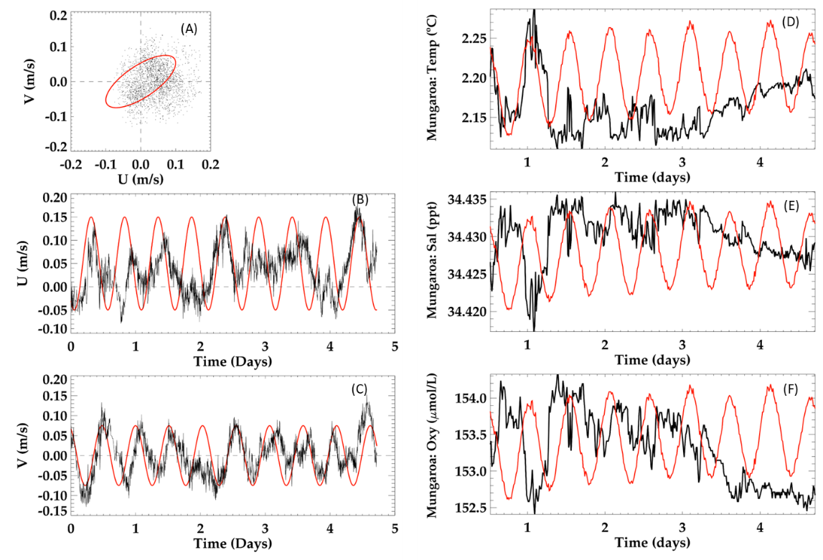

**Figure S1**. (A) Depth-averaged flow determined by an ADCP at 15 m above seafloor over a 5-day

deployment at Maungaroa relative to N-S direction (U) and E-W direction (V), with U in (B) and V in (C).

The red sinusoidal curves in frames (B) and (C) show the M2 tidal forcing used in the Gerris model simulation to drive the U and V model flows, respectively. Bottom water properties are shown in figures on the right-hand side including (D) Temperature, (E) Salinity and (F) Dissolved Oxygen. The red curves in frames (D), (E), and (F) show the measured pressure at the depth of the records, confirming the dominant M2 signal.

**Figure S2.** Potential methane oxidation rate (nmol/l/d) plotted against *in situ* dissolved methane concentration (nnmo/l).

**Tables**

**Table S1. Example of data for a single depth profile at Maungaroa. The full dataset can be found at** [https://zenodo.org/records/10373095](https://aus01.safelinks.protection.outlook.com/?url=https%3A%2F%2Fzenodo.org%2Frecords%2F10373095&data=05%7C02%7CCliff.Law%40niwa.co.nz%7Cf3465657aea548b95b9c08dc010eda62%7C41caed736a0c468aba499ff6aafd1c77%7C0%7C0%7C638386410509838564%7CUnknown%7CTWFpbGZsb3d8eyJWIjoiMC4wLjAwMDAiLCJQIjoiV2luMzIiLCJBTiI6Ik1haWwiLCJXVCI6Mn0%3D%7C3000%7C%7C%7C&sdata=rTgbPP3oekwBsR%2BGr3edk8MUxEpbhMqBv%2F9eiJxjBcg%3D&reserved=0)

|  |  |  |  |  |  |  |  |  |  |  |  |
| --- | --- | --- | --- | --- | --- | --- | --- | --- | --- | --- | --- |
|  |  | **Longitude** | **Latitude** |  |  |  | **Dissolved** | **Dissolved** | **log** | **Methane** | **13C-CH4** |
| **CTD** | **Date:** | **degrees** | **degrees** | **Depth** | **Temp.** | **Salinity** | **Oxygen** | **methane** | **methane** | **saturation** | **isotope** |
| **Number** | **Time** | **East** | **North** | **db** | **°C** | **PSS-78** | **mmol/kg** | **nM** | **ln nM** | **%** | **‰** |
| U9281 | 2019-07-04T01:41:28+12 | 175.310 | -41.938 | 2077.47 | 2.24 | 34.64 | 34.64 | 121.5 | 4.8 | 3645.4 | - |
| U9281 | 2019-07-04T01:41:59+12 | 175.310 | -41.938 | 2077.34 | 2.24 | 34.64 | 34.64 | 123.3 | 4.8 | 3732.9 | - |
| U9281 | 2019-07-04T01:47:14+12 | 175.310 | -41.938 | 2057.76 | 2.24 | 34.64 | 34.64 | 111.4 | 4.7 | 3374.4 | - |
| U9281 | 2019-07-04T01:49:17+12 | 175.310 | -41.938 | 2039.69 | 2.24 | 34.64 | 34.64 | 82.8 | 4.4 | 2506.6 | -70.781 |
| U9281 | 2019-07-04T01:49:46+12 | 175.310 | -41.938 | 2039.87 | 2.25 | 34.64 | 34.64 | 81.0 | 4.4 | 2453.7 | - |
| U9281 | 2019-07-04T01:52:47+12 | 175.310 | -41.938 | 1981.54 | 2.41 | 34.62 | 34.62 | 21.7 | 3.1 | 659.2 | -62.899 |
| U9281 | 2019-07-04T01:53:02+12 | 175.310 | -41.938 | 1982.00 | 2.41 | 34.62 | 34.62 | 19.2 | 3.0 | 585.2 | - |
| U9281 | 2019-07-04T01:56:47+12 | 175.310 | -41.938 | 1899.78 | 2.48 | 34.61 | 34.62 | 4.1 | 1.4 | 124.6 | - |
| U9281 | 2019-07-04T02:00:21+12 | 175.310 | -41.938 | 1798.75 | 2.70 | 34.59 | 34.59 | 2.3 | 0.8 | 69.7 | -58.873 |
| U9281 | 2019-07-04T02:05:03+12 | 175.310 | -41.938 | 1598.53 | 3.15 | 34.55 | 34.55 | 1.5 | 0.4 | 47.1 | - |
| U9281 | 2019-07-04T02:10:10+12 | 175.310 | -41.938 | 1399.66 | 3.75 | 34.48 | 34.49 | 1.5 | 0.4 | 48.3 | - |
| U9281 | 2019-07-04T02:14:53+12 | 175.310 | -41.938 | 1198.43 | 4.75 | 34.41 | 34.42 | 2.1 | 0.8 | 69.0 | -53.129 |
| U9281 | 2019-07-04T02:19:45+12 | 175.310 | -41.938 | 1000.20 | 6.02 | 34.41 | 34.41 | 1.9 | 0.6 | 63.8 | - |
| U9281 | 2019-07-04T02:24:39+12 | 175.310 | -41.938 | 800.78 | 7.11 | 34.44 | 34.44 | 2.7 | 1.0 | 91.0 | - |
| U9281 | 2019-07-04T02:29:43+12 | 175.310 | -41.938 | 597.17 | 8.38 | 34.52 | 34.52 | 4.8 | 1.6 | 171.3 | - |
| U9281 | 2019-07-04T02:34:19+12 | 175.310 | -41.938 | 400.54 | 10.39 | 34.73 | 34.74 | 4.9 | 1.6 | 182.8 | - |
| U9281 | 2019-07-04T02:41:43+12 | 175.310 | -41.938 | 99.44 | 13.03 | 34.83 | 34.83 | 4.3 | 1.5 | 170.3 | - |

**Table S2.** The plume footprint, as estimated from dye concentration in the ROMS simulation, for the five release sites, and also the combined plumes, calculated from polygons of closed contours associated with various dye concentrations.

|  |  |  |  |  |  |  |
| --- | --- | --- | --- | --- | --- | --- |
|  | Area (km2) | | | | | |
| Dye Concentration | Maungaroa | Pahaua Bank | Glendhu Ridge | Uriti Ridge west | Uriti Ridge | Combined |
| 0.5 | 23.97 | 15.98 | 23.97 | 19.98 | 7.99 | 143.84 |
| 0.25 | 55.93 | 63.94 | 71.92 | 83.91 | 35.97 | 435.55 |
| 0.1 | 211.73 | 291.72 | 203.78 | 207.78 | 135.91 | 1594.38 |
| 0.05 | 583.30 | 579.46 | 335.64 | 375.61 | 303.79 | 3108.96 |
| 0.03 | 1122.70 | 871.20 | 507.47 | 599.40 | 587.60 | 4395.87 |
| 0.02 | 1550.23 | 1158.97 | 779.20 | 875.13 | 959.36 | 5670.80 |
| 0.01 | 2437.20 | 2042.26 | 1502.52 | 1482.62 | 1974.79 | 8032.74 |
| 0.005 | 3995.28 | 2957.49 | 2621.48 | 2369.91 | 2910.27 | 11341.78 |

**Table S3.** Plume volume, as estimated from dye concentration in the ROMS simulation, for the five release sites and also the combined plumes, calculated from the polygons of closed contours associated with various dye concentrations.

|  |  |  |  |  |  |  |
| --- | --- | --- | --- | --- | --- | --- |
|  | Volume (km3) | | | | | |
| Dye Concentration | Maungaroa (A) | Pahaua Bank (B) | Glendhu Ridge (C) | Uriti Ridge west (D) | Uriti Ridge (E) | Combined |
| 0.5 | 8.44 | 4.21 | 8.74 | 6.69 | 1.63 | 47.85 |
| 0.25 | 19.66 | 17.52 | 26.40 | 28.54 | 7.59 | 141.12 |
| 0.1 | 76.43 | 78.33 | 74.94 | 71.93 | 28.68 | 503.02 |
| 0.05 | 212.84 | 153.41 | 123.44 | 130.48 | 65.03 | 974.13 |
| 0.03 | 406.19 | 229.40 | 186.75 | 206.70 | 124.43 | 1355.94 |
| 0.02 | 559.83 | 305.30 | 289.68 | 303.22 | 196.89 | 1731.13 |
| 0.01 | 875.12 | 541.30 | 556.90 | 519.05 | 401.89 | 2451.06 |
| 0.005 | 1437.84 | 782.50s | 969.41 | 828.97 | 600.99 | 3467.50 |

Note: The volume of the ‘Methane plumes’ are lower compared to the areas because they tend to be less than 1 km in height.

**Animations**

The following animations of the model output are available at [https://zenodo.org/records/10373095](https://aus01.safelinks.protection.outlook.com/?url=https%3A%2F%2Fzenodo.org%2Frecords%2F10373095&data=05%7C02%7CCliff.Law%40niwa.co.nz%7Cf3465657aea548b95b9c08dc010eda62%7C41caed736a0c468aba499ff6aafd1c77%7C0%7C0%7C638386410509838564%7CUnknown%7CTWFpbGZsb3d8eyJWIjoiMC4wLjAwMDAiLCJQIjoiV2luMzIiLCJBTiI6Ik1haWwiLCJXVCI6Mn0%3D%7C3000%7C%7C%7C&sdata=rTgbPP3oekwBsR%2BGr3edk8MUxEpbhMqBv%2F9eiJxjBcg%3D&reserved=0).

* Mooring sensor data in **Fig S1ABC.nc** and **Fig S1DEF.nc**
* **Total_tracer_concentration_1year.gif** -This animation shows the advection of all the tracers released in the model simulation for the entire model period (January 2013 – December 2013) and model domain.
* **Total_tracer_concentration_1year_zoom.gif** - This animation is similar to the one above but the domain in limited to the area around the methane seep locations.
* **sim13_bottom_current_speed_zoom.gif** - This animation shows the bottom currents for the entire model period (January 2013 – December 2013) for an area around the methane seep locations.