**Effect of TGF-β3 On Wound Healing of Bone Cell Monolayer in Static and Hydrodynamic Shear Stress Conditions**

Hawra Al-Attar1, Laila A. Damiati2*, Saeed Heidari Keshel3, Cristina Tuinea-Bobe1,4, Samar Damiati5, Morvarid Saeinasab1, Farshid Sefat1, 4*

1 Department of Biomedical and Electronics Engineering, School of Engineering, University of Bradford, Bradford, UK

2 Department of Biological Sciences, Collage of Science, University of Jeddah, Jeddah, Saudi Arabia

3 Department of Tissue Engineering and Applied Cell Sciences, School of Advanced Technologies in Medicine, Shahid Beheshti University of Medical Sciences, Tehran, Iran

4 Interdisciplinary Research Centre in Polymer Science & Technology (IRC Polymer), University of Bradford, Bradford, UK

5 Department of Chemistry, College of Sciences, University of Sharjah, Sharjah, United Arab Emirates

**\*Corresponding Author:**

**Farshid Sefat,** [F.Sefat1@Bradford.ac.uk](mailto:F.Sefat1@Bradford.ac.uk)

**Laila A. Damiati,** Ladamiati@uj.edu.sa

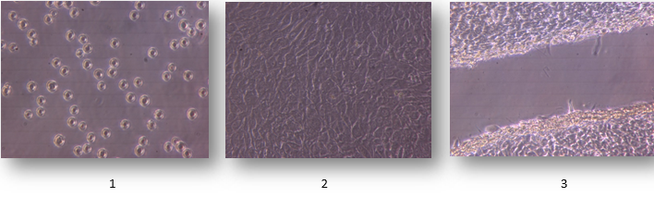

Supplement Figure 1: Growth of human bone cells (MG63) in culture flask: (1) after cell passage (2) confluence cell monolayer (after 48 hrs. in culture) and (3) wounded cells ready for the test; X 100 magnification.

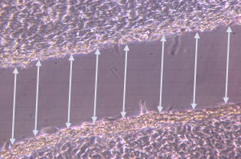

Supplement Figure 2: Measurement of wound closure width on cultured MG63 bone cell monolayer using ImageJ software