Supplementary Material

Casson Shear Thinning Model
In addition to the power law model used in the main text, shear thinning fluids such as cerebrospinal fluid (CSF) can also be modeled using Casson’s method, where viscosity (µ [mPa·s]) and shear rate ($\dot{γ}$ [s⁻¹]) from which a yield stress (τ_{y} [mPa]) and viscosity constant (K_{v} [mPa·s]) can be calculated.
$\sqrt{μ}=\sqrt{\frac{τ_{y}}{\dot{γ}}}+\sqrt{K_{v}}$ (S-1)
While the Casson model fit low-shear rate data relatively well, it consistently underestimated the infinite shear viscosity observed in our experimental data. Therefore, the power law model was sufficient for the main text of this article. Using the Casson model, however, one can calculate and compare the τ_{y} necessary to induce flow of non-Newtonian CSF and how it is influenced by its proteinous and cellular constituents. The fitting data from these experiments is collected in Table S-1.
Using the Casson model, there was observed a positive relationship between τ_{y} and both protein and cellular concentrations (Figures S-1 and S-2). As concentrations of both increased, the yield stress of the fluid also increased. The viscosity constant, K_{v}, however, was relatively the same across samples regardless of protein or cellular concentration (Figures S-3 and S-4).
These data further enhance the understanding of non-Newtonian, shear thinning behavior of CSF with elevated protein or cellular concentrations. Particularly at low shear rates, the shear thinning behavior and yield stress of the fluid should be considered, especially when in the presence of elevated protein or cellular concentrations. This is especially true for flows that are unsteady, where a yield stress may be required to induce flow.

Supplementary Figures and Tables

Table S-1:
Sample | Protein | Cells/mL  (x10⁶) | Cell size  (µm) | τ_{y}  (mPa) | K_{v}  (mPa·s)
1* | +++ | 2.2 | 7.4 | -- | --
2* | Trace | 0.4 | 11.9 | -- | --
3* | +++ | 396.0 | 10.7 | -- | --
4* | + | 10.1 | 8.6 | -- | --
5* | ++ | 408.0 | 11.2 | -- | --
6* | ++ | 59.1 | 11.4 | -- | --
7 | ++ | 10.3 | 8.7 | 0.54 | 0.82
8 | + | 1.3 | 7.9 | 0.02 | 0.92
9 | +++ | 5.6 | 10.7 | 1.07 | 0.71
10 | ++ | 1.9 | 7.8 | 0.35 | 0.76
11 | Trace | 1.5 | 11.2 | 0.00 | 0.90
12 | +++ | 28.1 | 7.6 | 0.23 | 0.90
13 | Trace | 0.9 | 9 | 0.02 | 0.85
14 | Negative | 1.0 | 9.6 | 0.18 | 0.80
15 | Trace | 0.8 | 10.8 | 0.03 | 0.85
16 | Trace | 0.4 | 8.3 | 0.01 | 0.93
17 | +++ | 12.1 | 9.2 | 0.14 | 0.89
18 | +++ | 1.2 | 10.3 | 0.63 | 0.76
19 | + | 2.0 | 8.2 | 1.55 | 0.71
20 | +++ | 275.0 | 11.2 | 1.27 | 1.06
21 | Trace | 3.2 | 9.1 | 0.01 | 0.94
22 | ++ | 3.8 | 8.1 | 0.63 | 0.77
23 | Negative | 3.1 | 8.6 | 0.00 | 0.90
24 | ++ | 30.9 | 8.7 | 0.25 | 0.78
25 | ++ | 25.9 | 10.7 | 0.17 | 0.86
26 | ++ | 10.2 | 9.4 | 0.06 | 0.97
27 | +++ | 387.0 | 9.9 | 1.35 | 0.79
28 | +++ | 142.0 | 10.1 | 0.92 | 0.80
29** | +++ | 2300.0 | 11.2 | 0.64 | 3.63
30 | Negative | 1.7 | 8.6 | 0.45 | 0.88
31 | ++ | 54.1 | 7.3 | 0.24 | 0.83
32 | +++ | 346.0 | 9.8 | 0.98 | 0.94
Average | ++ | 71.8 | 9.4 | 0.45 | 0.96
* Samples 1-6 were not tested for shear rheology as the volume of these samples was too low (less than 8 mL).
** Sample 29 is an outlier approaching content of whole blood and is excluded from summary analysis.

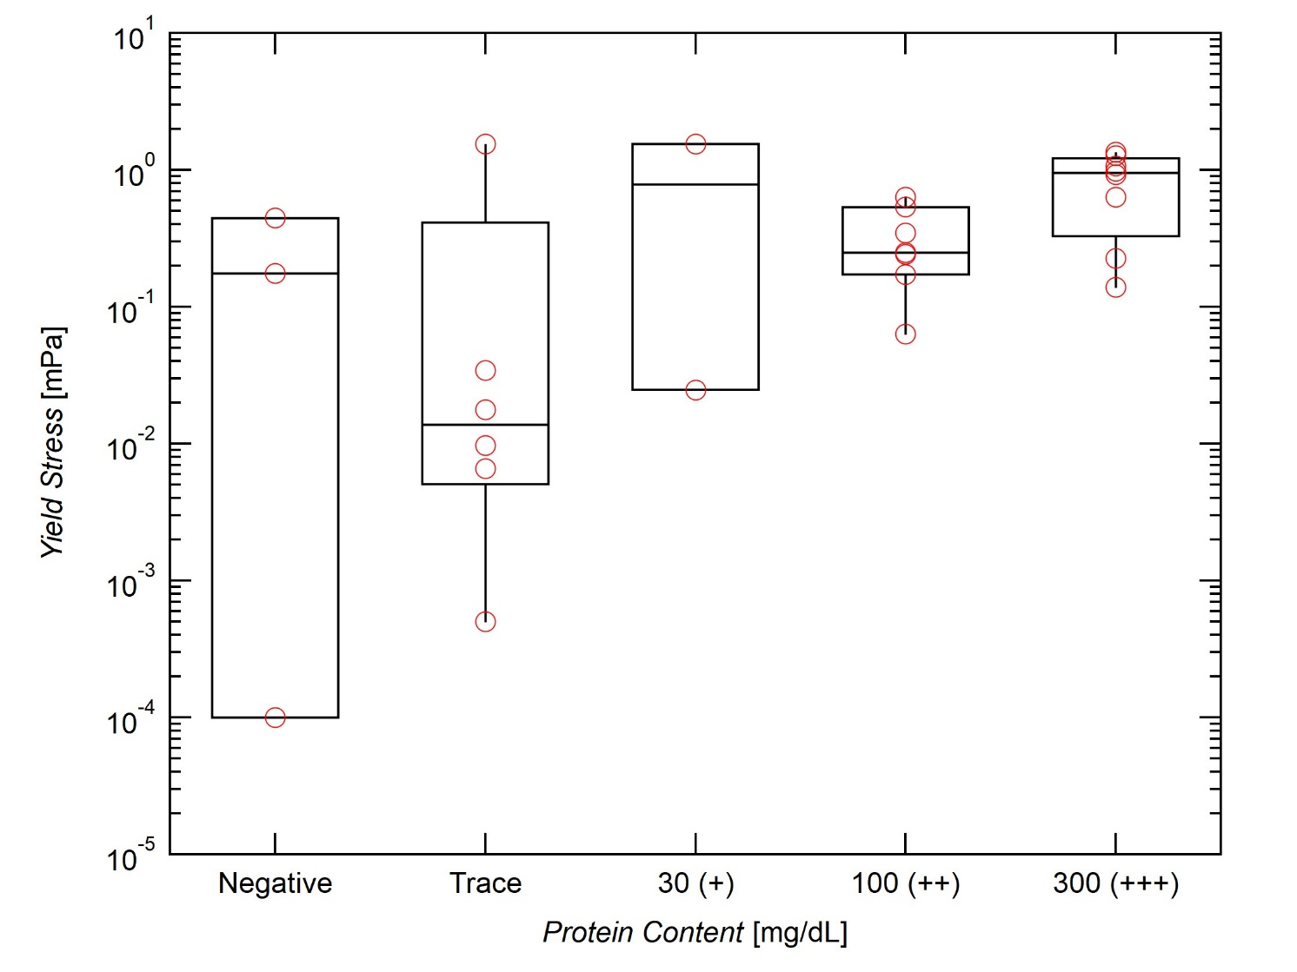
Figure S-1: Effect of protein concentration on yield stress (τ_{y}). τ_{y} increases with increasing protein content.

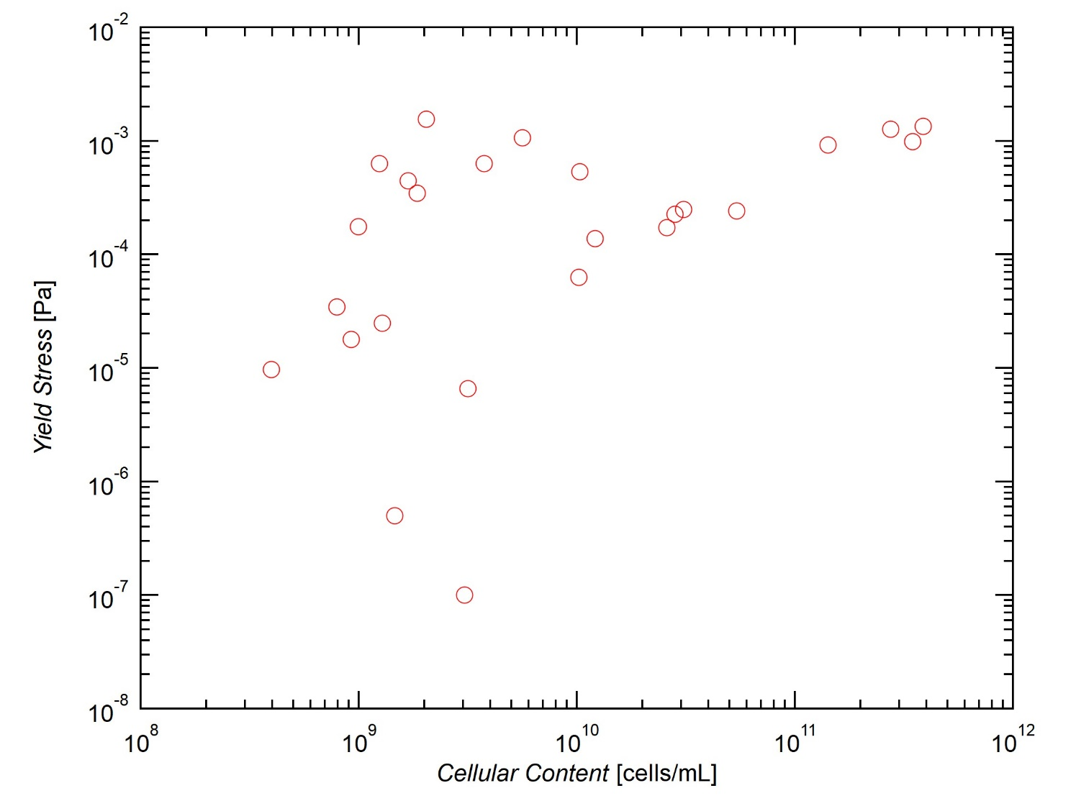
Figure S-2: Effect of cellular content on yield stress (τ_{y}). τ_{y} increases with increasing cellular concentration.
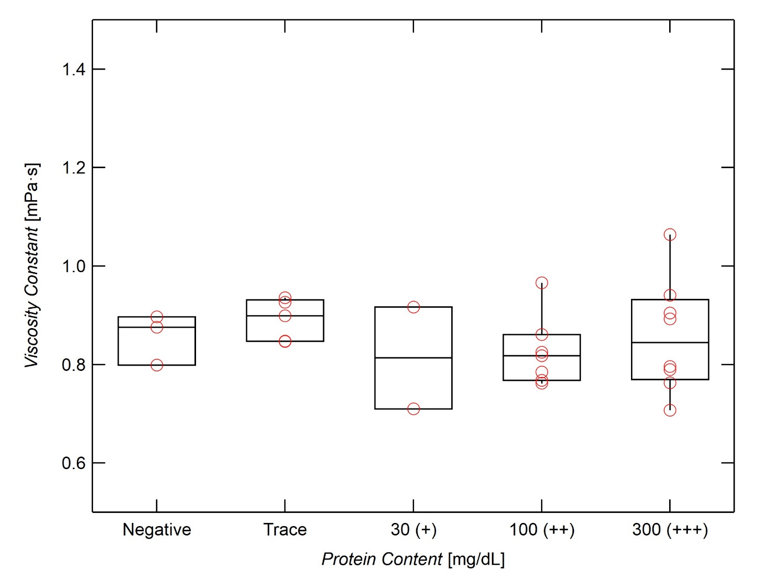
Figure S-3: Effect of protein content on viscosity constant, K_{v}. Protein content has little effect on K_{v}.
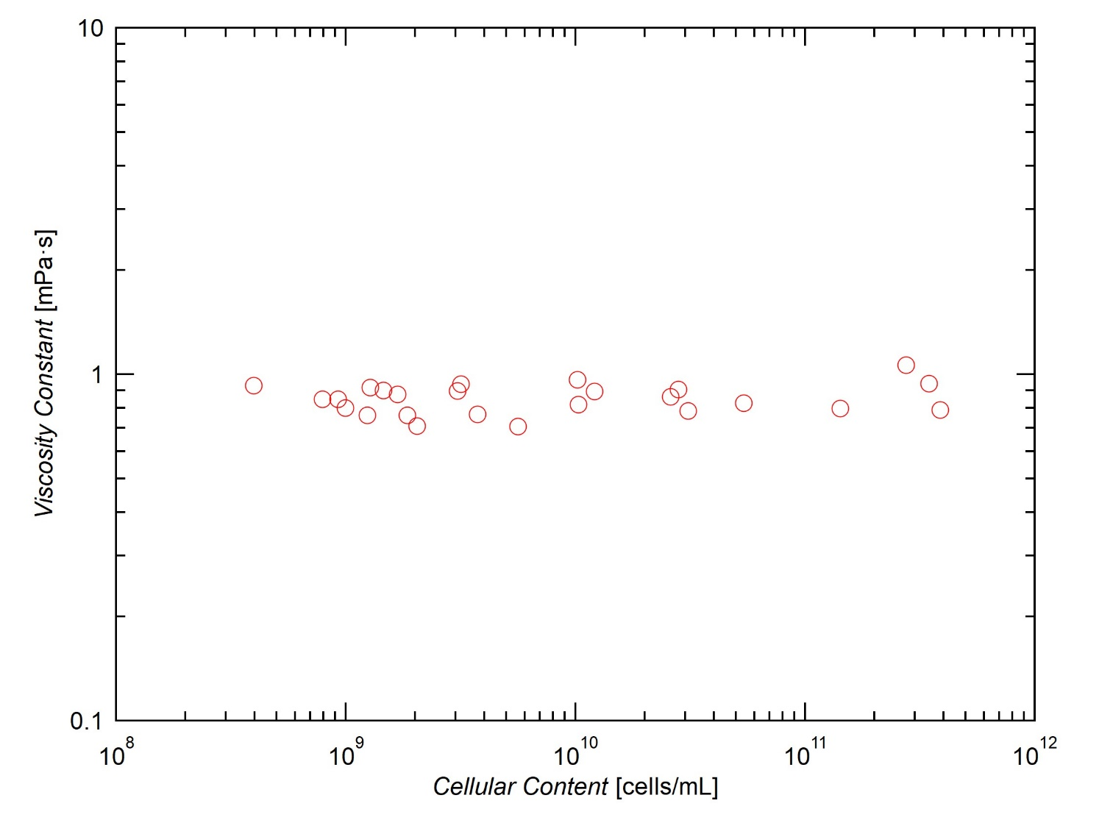
Figure S-4: Effect of cellular content on viscosity constant, K_{v}. Cellular content has little effect on K_{v}.

