Supplementary Material
Optical water characterization and atmospheric correction assessment of estuarine and coastal waters around the AERONET-OC Bahia Blanca

SeaPRISM-measured spectral aerosol optical depth (AOD) at the BB-AERONET site
In order to characterize the in situ atmospheric conditions of the BB site, the spectral distribution of the Aerosol optical depth (AOD) are shown in Figure S1.A. AOD generally decreases with as the wavelength increases, showing more variability towards shorter wavelength while changes slowly at longer ones. For instance, AOD at 560 nm ranges from 0.0185 to 0.3736 with an average of 0.0704+ 0.0402, while its range from 0.0117 to 0.2236, with an average of 0.0491+0.0266. The Ångström Exponent (AE) of AOD over the visible region was calculated using AOD from 440 to 865 nm as a function of AOD at 560 nm. The histogram distribution of Ångström Exponent is shown in Figure S1.B, and varies from 0 to 1.8 with a median of 0.76 indicating that small size aerosol particles are present.

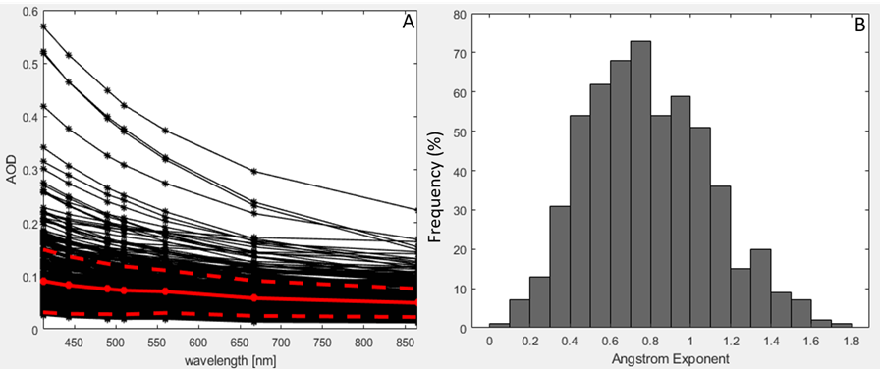
Supplementary Figure 1. SeaPRISM-measured spectral aerosol optical depth (AOD) (A) and histogram of Ångström Exponent values (B).
Supplementary Figure 2 Scatterplots of the match-up exercise of the atmospheric correction algorithm (AC) retrieval and the in situ Lwn (412, 667 nm). Colors indicate the OWT: OWT 3 in green, OWT 4 in yellow.

