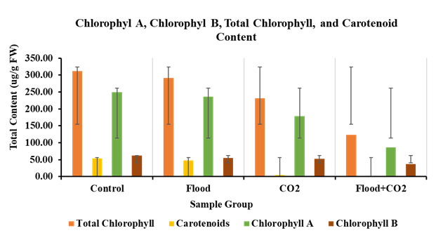
Fig S1: Effect of flooding and CO2 treatment on the photosynthetic pigmentation of plants.

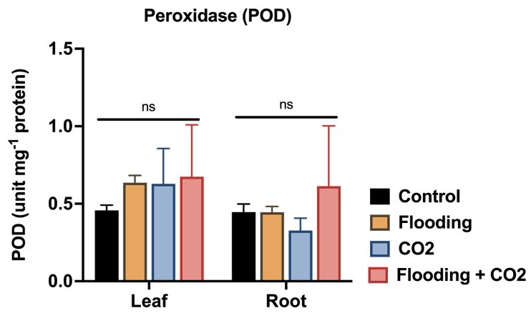
Fig S2: Peroxidase enzyme activities in soybean plants after Flooding and CO2 application.
Fig S3: α-Glucosidase extracellular enzyme activities in soybean plants after Flooding and CO2 application.
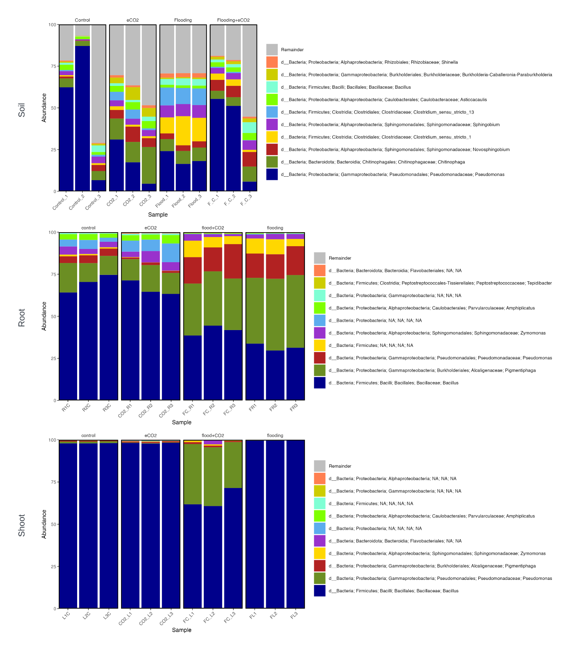
Fig S4: Taxonomical bar plots of genus level bacterial relative abundance for 16S samples
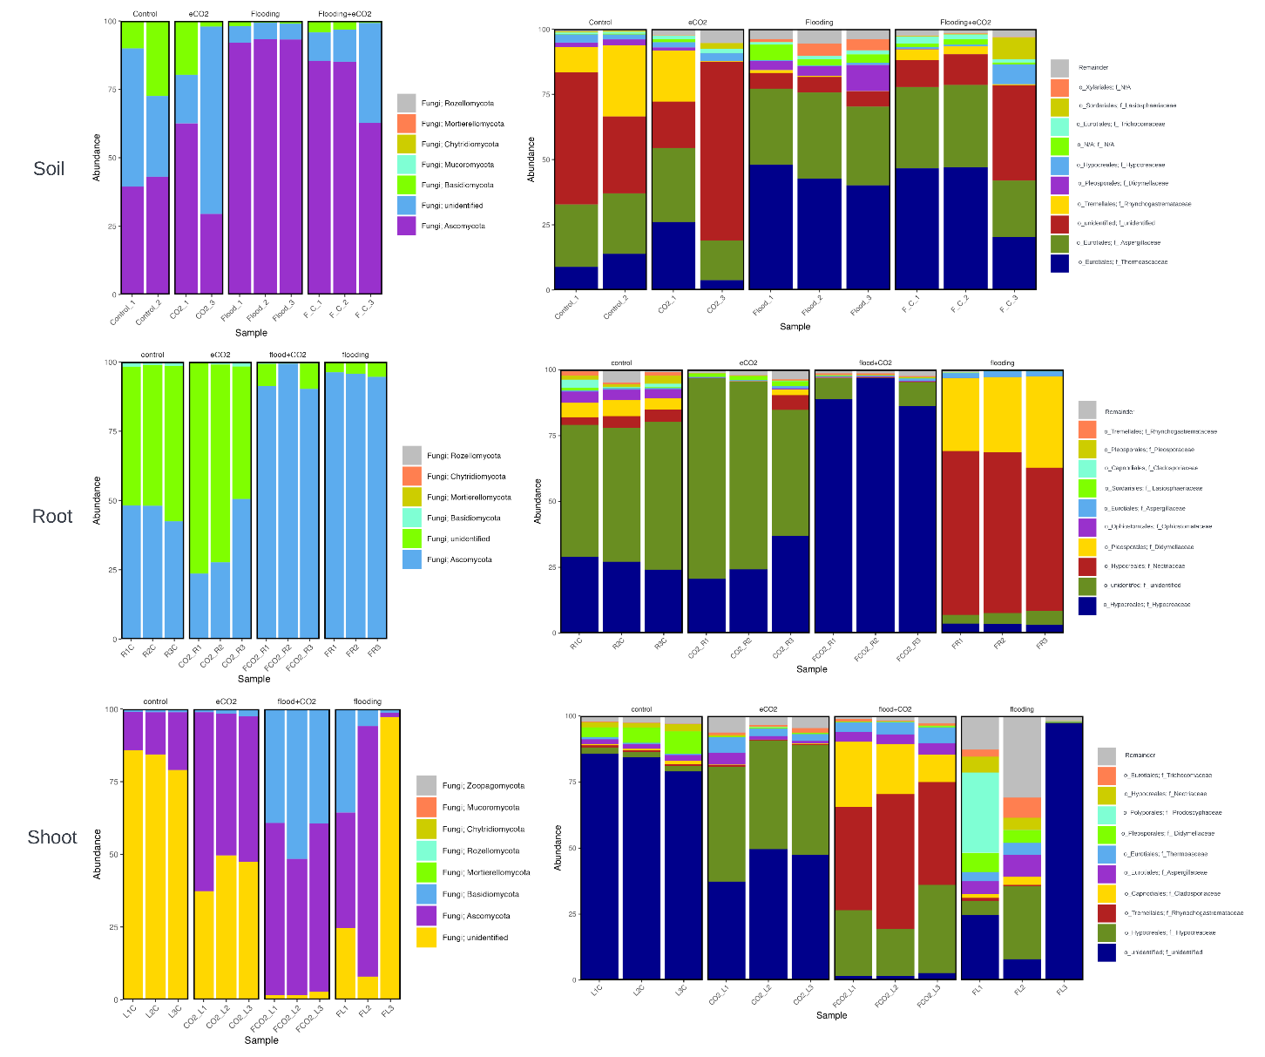
Fig S5: Taxonomical bar plots showing Phylum level represented on the left and family level represented on the right. The top shows Soil, middle Root, and bottom Shoot of fungal samples

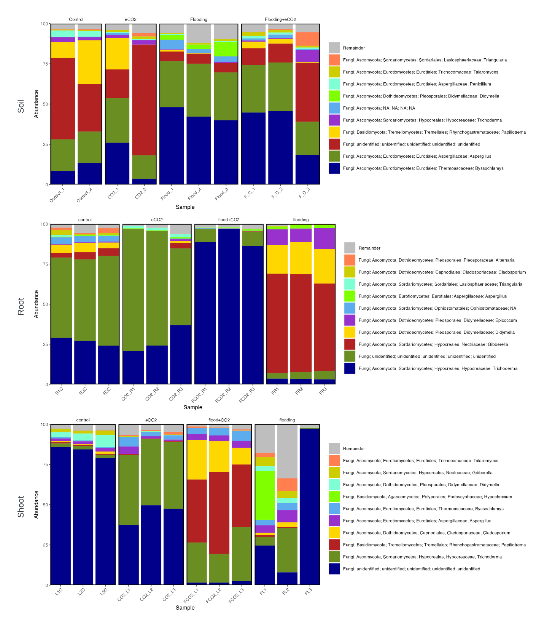
Fig S6: Taxonomical bar plots of genus level fungal relative abundance for ITS samples

Table S1: Plant growth attributes of different treatments compared to control soybean plants.
 | Control (1) | Flood and CO2 | CO2 | Flood
Leaves (#) | 10 | 4 | 4 | 13
Shoot (in.) | 6.25 | 7 | 6.75 | 17.5
Root (in.) | 9.5 | 6 | 9 | 8
Internode (in.) | 2.25 | 2.25 | 2.75 | 2.4
Biomass (g) | 4.2 | 1.8 | 2.0 | 2.6
Chlorophyll (SPAD) | 45.7 | 47.75 | 38.9 | 22.9
pH | 5.54 | 5.84 | 5.62 | 5.74

Table S2: Novogene filtering and quality control F001, 16S soil samples.
Sample | NovoID | Raw Reads | Clean Reads | Raw Base (G) | Clean Base (G) | Error Rate (%) | Q20 (%) | Q30 (%) | GC Content (%)
Control_3 | FKDN220186460-1A | 163795 | 163739 | 0.08 | 0.08 | 0.03 | 97.07 | 91.73 | 52.6
Control_2 | FKDN220186459-1A | 183047 | 183047 | 0.09 | 0.09 | 0.03 | 97.04 | 91.57 | 52.79
CO2_1 | FKDN220186440-1A | 177887 | 177872 | 0.09 | 0.09 | 0.03 | 97.15 | 91.87 | 51.7
Control_1 | FKDN220186458-1A | 161226 | 161218 | 0.08 | 0.08 | 0.03 | 96.94 | 91.53 | 52.84
Flood_3 | FKDN220186451-1A | 176631 | 176628 | 0.09 | 0.09 | 0.03 | 97.19 | 92.01 | 51.98
Flood_2 | FKDN220186450-1A | 174015 | 174011 | 0.09 | 0.09 | 0.03 | 97.11 | 91.85 | 51.88
Flood_1 | FKDN220186449-1A | 174799 | 174792 | 0.09 | 0.09 | 0.03 | 97.16 | 91.95 | 52.15
CO2_3 | FKDN220186442-1A | 180298 | 180283 | 0.09 | 0.09 | 0.03 | 97.21 | 91.94 | 52.26
CO2_2 | FKDN220186441-1A | 178807 | 178807 | 0.09 | 0.09 | 0.03 | 97.39 | 92.19 | 52.71
F_C_2 | FKDN220186432-1A | 186485 | 186485 | 0.09 | 0.09 | 0.03 | 97.22 | 91.96 | 52.51
F_C_1 | FKDN220186431-1A | 169697 | 169697 | 0.08 | 0.08 | 0.03 | 97.04 | 91.56 | 52.61
F_C_3 | FKDN220186433-1A | 169962 | 169958 | 0.08 | 0.08 | 0.03 | 97.22 | 91.89 | 52.72

Table S3: Novogene filtering and quality control F002, 16S shoot and root samples.
Sample |  | NovoID |  | Raw Reads | Clean Reads | Raw Base (G) | Clean Base (G) | Error Rate (%) | Q20 (%) | Q30 (%) | GC Content (%)
 | FCO2_R1 |  | FKDN220186425-1A | 170609 | 170606 | 0.09 | 0.09 | 0.03 | 96.77 | 91.22 | 52.83
 | FCO2_R2 |  | FKDN220186426-1A | 171035 | 171031 | 0.09 | 0.09 | 0.03 | 96.69 | 90.93 | 52.85
 | FCO2_R3 |  | FKDN220186427-1A | 179599 | 179595 | 0.09 | 0.09 | 0.03 | 96.91 | 91.55 | 52.89
 | FCO2_L1 |  | FKDN220186428-1A | 161978 | 161977 | 0.08 | 0.08 | 0.03 | 97.2 | 92.18 | 52.8
 | FCO2_L2 |  | FKDN220186429-1A | 183482 | 183481 | 0.09 | 0.09 | 0.03 | 97.18 | 92.13 | 52.68
 | FCO2_L3 |  | FKDN220186430-1A | 171701 | 171700 | 0.09 | 0.09 | 0.03 | 97.15 | 92.07 | 52.77
 | CO2_R1 |  | FKDN220186434-1A | 182119 | 182117 | 0.09 | 0.09 | 0.03 | 97.1 | 91.88 | 53.52
 | CO2_R2 |  | FKDN220186435-1A | 181668 | 181666 | 0.09 | 0.09 | 0.03 | 97.13 | 92 | 53.83
 | CO2_R3 |  | FKDN220186436-1A | 183575 | 183575 | 0.09 | 0.09 | 0.03 | 96.97 | 91.55 | 53.42
 | CO2_L1 |  | FKDN220186437-1A | 167928 | 167928 | 0.08 | 0.08 | 0.03 | 97.46 | 92.74 | 53.58
 | CO2_L2 |  | FKDN220186438-1A | 151021 | 151020 | 0.08 | 0.08 | 0.03 | 97.52 | 92.82 | 53.56
 | CO2_L3 |  | FKDN220186439-1A | 166459 | 166458 | 0.08 | 0.08 | 0.03 | 97.48 | 92.76 | 53.59
 | FR1 |  | FKDN220186443-1A | 169295 | 169294 | 0.08 | 0.08 | 0.03 | 97.02 | 91.85 | 52.38
 | FR2 |  | FKDN220186444-1A | 187806 | 187803 | 0.09 | 0.09 | 0.03 | 97.05 | 91.86 | 52.23
 | FR3 |  | FKDN220186445-1A | 186798 | 186797 | 0.09 | 0.09 | 0.03 | 96.8 | 91.4 | 52.55
 | FL1 |  | FKDN220186446-1A | 158426 | 158426 | 0.08 | 0.08 | 0.03 | 97.54 | 92.84 | 53.63
 | FL2 |  | FKDN220186447-1A | 189531 | 189530 | 0.09 | 0.09 | 0.03 | 97.52 | 92.83 | 53.59
 | FL3 |  | FKDN220186448-1A | 162967 | 162966 | 0.08 | 0.08 | 0.03 | 97.43 | 92.72 | 53.6
 | R1C |  | FKDN220186452-1A | 170404 | 170393 | 0.09 | 0.09 | 0.03 | 96.85 | 91.38 | 53.64
 | R2C |  | FKDN220186453-1A | 165551 | 165539 | 0.08 | 0.08 | 0.03 | 96.99 | 91.63 | 53.3
 | R3C |  | FKDN220186454-1A | 171072 | 171059 | 0.09 | 0.09 | 0.03 | 97.09 | 91.91 | 53.42
 | L1C |  | FKDN220186455-1A | 152392 | 152392 | 0.08 | 0.08 | 0.03 | 97.48 | 92.75 | 53.57
 | L2C |  | FKDN220186456-1A | 182280 | 182279 | 0.09 | 0.09 | 0.03 | 97.5 | 92.78 | 53.54
 | L3C |  | FKDN220186457-1A | 160649 | 160649 | 0.08 | 0.08 | 0.03 | 97.44 | 92.67 | 53.55

Table S4: Novogene filtering and quality control F005, ITS soil samples.
Sample | NovoID | Raw Reads | Clean Reads | Raw Base (G) | Clean Base (G) | Error Rate (%) | Q20 (%) | Q30 (%) | GC Content (%)
Flood_3 | FKDN220186451-1A | 188670 | 176116 | 0.09 | 0.09 | 0.04 | 95.85 | 89.83 | 57.08
F_C_1 | FKDN220186431-1A | 175692 | 173707 | 0.09 | 0.09 | 0.03 | 95.17 | 88.65 | 59.38
F_C_3 | FKDN220186433-1A | 169656 | 168298 | 0.08 | 0.08 | 0.03 | 95.55 | 89.6 | 53.79
Flood_2 | FKDN220186450-1A | 161623 | 151315 | 0.08 | 0.08 | 0.03 | 96.81 | 92.15 | 57.45
Control_1 | FKDN220186458-1A | 188754 | 188217 | 0.09 | 0.09 | 0.03 | 96.56 | 91.46 | 51.19
F_C_2 | FKDN220186432-1A | 186689 | 177605 | 0.09 | 0.09 | 0.04 | 94.37 | 86.96 | 59.85
CO2_1 | FKDN220186440-1A | 158864 | 155889 | 0.08 | 0.08 | 0.03 | 95.71 | 89.53 | 55.59
Flood_1 | FKDN220186449-1A | 179382 | 149829 | 0.09 | 0.07 | 0.03 | 96.97 | 92.27 | 57.88
CO2_3 | FKDN220186442-1A | 157217 | 150948 | 0.08 | 0.08 | 0.03 | 97.09 | 92.53 | 47.25
Control_2 | FKDN220186459-1A | 169288 | 169061 | 0.08 | 0.08 | 0.03 | 96.29 | 90.88 | 52.31

Table S5: Novogene filtering and quality control F003, ITS shoot and root samples.
Sample | NovoID | Raw Reads | Clean Reads | Raw Base (G) | Clean Base (G) | Error Rate (%) | Q20 (%) | Q30 (%) | GC Content (%)
CO2_L3 | FKDN220186439-1A | 168599 | 167732 | 0.08 | 0.08 | 0.03 | 97.15 | 92.24 | 50.65
R1C | FKDN220186452-1A | 179108 | 178979 | 0.09 | 0.09 | 0.03 | 97.19 | 92.51 | 47.01
R2C | FKDN220186453-1A | 166885 | 166816 | 0.08 | 0.08 | 0.03 | 97.25 | 92.56 | 46.82
FL3 | FKDN220186448-1A | 167159 | 151060 | 0.08 | 0.08 | 0.03 | 96.96 | 91.18 | 58.7
FR1 | FKDN220186443-1A | 164490 | 164371 | 0.08 | 0.08 | 0.03 | 97.07 | 91.94 | 48.16
FR2 | FKDN220186444-1A | 180968 | 180903 | 0.09 | 0.09 | 0.03 | 97.03 | 91.85 | 48.2
L3C | FKDN220186457-1A | 188447 | 187655 | 0.09 | 0.09 | 0.03 | 97.22 | 92.27 | 49.94
FCO2_R1 | FKDN220186425-1A | 163025 | 162949 | 0.08 | 0.08 | 0.03 | 97.41 | 92.81 | 52.34
FCO2_R2 | FKDN220186426-1A | 179100 | 179066 | 0.09 | 0.09 | 0.03 | 97.41 | 92.81 | 52.19
FCO2_R3 | FKDN220186427-1A | 176455 | 175949 | 0.09 | 0.09 | 0.03 | 97.31 | 92.62 | 52.28
FCO2_L1 | FKDN220186428-1A | 181870 | 181472 | 0.09 | 0.09 | 0.03 | 97.45 | 92.85 | 50.08
FCO2_L2 | FKDN220186429-1A | 184802 | 184387 | 0.09 | 0.09 | 0.03 | 97.45 | 92.82 | 49.05
FCO2_L3 | FKDN220186430-1A | 186210 | 185717 | 0.09 | 0.09 | 0.03 | 97.3 | 92.57 | 50.92
L2C | FKDN220186456-1A | 170920 | 170166 | 0.09 | 0.09 | 0.03 | 97.01 | 91.75 | 49.7
L1C | FKDN220186455-1A | 166747 | 165495 | 0.08 | 0.08 | 0.03 | 97.15 | 92.06 | 51.02
R3C | FKDN220186454-1A | 162493 | 161885 | 0.08 | 0.08 | 0.03 | 97.21 | 92.48 | 46.42
CO2_R1 | FKDN220186434-1A | 161748 | 161730 | 0.08 | 0.08 | 0.03 | 97.5 | 93.18 | 43.88
CO2_R2 | FKDN220186435-1A | 167556 | 167528 | 0.08 | 0.08 | 0.03 | 97.44 | 93.1 | 44.64
CO2_R3 | FKDN220186436-1A | 140959 | 140514 | 0.07 | 0.07 | 0.03 | 97.45 | 93.06 | 45.07
CO2_L1 | FKDN220186437-1A | 159981 | 159477 | 0.08 | 0.08 | 0.03 | 97.03 | 92.1 | 50.5
CO2_L2 | FKDN220186438-1A | 171671 | 169057 | 0.09 | 0.08 | 0.03 | 97.26 | 92.44 | 51.19
FR3 | FKDN220186445-1A | 179699 | 179655 | 0.09 | 0.09 | 0.03 | 96.95 | 91.68 | 48.01
FL1 | FKDN220186446-1A | 171601 | 168058 | 0.09 | 0.08 | 0.03 | 96.95 | 91.73 | 48.53
FL2 | FKDN220186447-1A | 151870 | 150330 | 0.08 | 0.08 | 0.03 | 96.56 | 91.12 | 50.74

Table S6: denoising, merging and chimera check for F001, 16S soil samples.
sample-id | input | filtered | percentage of input passed filter | denoised | merged | percentage of input merged | non-chimeric | percentage of input non-chimeric
CO2_1 | 177887 | 163902 | 92.14 | 162343 | 155589 | 87.47 | 150651 | 84.69
CO2_2 | 178807 | 166203 | 92.95 | 163425 | 146078 | 81.7 | 116745 | 65.29
CO2_3 | 180298 | 166400 | 92.29 | 164406 | 154404 | 85.64 | 148278 | 82.24
Control_1 | 161226 | 147396 | 91.42 | 146217 | 140307 | 87.03 | 135416 | 83.99
Control_2 | 183047 | 168150 | 91.86 | 166175 | 155595 | 85 | 131890 | 72.05
Control_3 | 163795 | 150323 | 91.78 | 148703 | 139033 | 84.88 | 131294 | 80.16
F_C_1 | 169697 | 155606 | 91.7 | 154534 | 150117 | 88.46 | 146085 | 86.09
F_C_2 | 186485 | 172451 | 92.47 | 171108 | 165838 | 88.93 | 159574 | 85.57
F_C_3 | 169962 | 156662 | 92.17 | 154857 | 146550 | 86.23 | 140998 | 82.96
Flood_1 | 174799 | 160879 | 92.04 | 159044 | 151596 | 86.73 | 144635 | 82.74
Flood_2 | 174015 | 159915 | 91.9 | 158032 | 150094 | 86.25 | 142080 | 81.65
Flood_3 | 176631 | 162728 | 92.13 | 161012 | 153262 | 86.77 | 147350 | 83.42

Table S7: denoising, merging and chimera check for F002, 16S shoot and root samples.
sample-id | input | filtered | percentage of input passed filter | denoised | merged | percentage of input merged | non-chimeric | percentage of input non-chimeric
CO2_L1 | 167928 | 156011 | 92.9 | 155230 | 153292 | 91.28 | 150347 | 89.53
CO2_L2 | 151021 | 140543 | 93.06 | 139833 | 137755 | 91.22 | 134443 | 89.02
CO2_L3 | 166459 | 154714 | 92.94 | 153840 | 151357 | 90.93 | 145877 | 87.64
CO2_R1 | 182119 | 167154 | 91.78 | 160825 | 136069 | 74.71 | 70519 | 38.72
CO2_R2 | 181668 | 166670 | 91.74 | 163427 | 150577 | 82.89 | 134982 | 74.3
CO2_R3 | 183575 | 167102 | 91.03 | 163298 | 150084 | 81.76 | 130364 | 71.01
FC_L1 | 161978 | 148877 | 91.91 | 148132 | 141899 | 87.6 | 128282 | 79.2
FC_L2 | 183482 | 168679 | 91.93 | 167952 | 162141 | 88.37 | 151063 | 82.33
FC_L3 | 171701 | 157468 | 91.71 | 156864 | 148586 | 86.54 | 133214 | 77.58
FC_R1 | 170609 | 153619 | 90.04 | 150814 | 136421 | 79.96 | 117339 | 68.78
FC_R2 | 171035 | 154800 | 90.51 | 152086 | 138237 | 80.82 | 120571 | 70.49
FC_R3 | 179599 | 163788 | 91.2 | 161675 | 151469 | 84.34 | 139537 | 77.69
FL1 | 158426 | 147655 | 93.2 | 146956 | 145326 | 91.73 | 138649 | 87.52
FL2 | 189531 | 176358 | 93.05 | 175747 | 174370 | 92 | 169173 | 89.26
FL3 | 162967 | 151382 | 92.89 | 151079 | 150706 | 92.48 | 146932 | 90.16
FR1 | 169295 | 155123 | 91.63 | 149795 | 120412 | 71.13 | 60570 | 35.78
FR2 | 187806 | 172118 | 91.65 | 166757 | 136863 | 72.87 | 65606 | 34.93
FR3 | 186798 | 169155 | 90.56 | 165720 | 147799 | 79.12 | 107487 | 57.54
L1C | 152392 | 141634 | 92.94 | 140844 | 138871 | 91.13 | 135394 | 88.85
L2C | 182280 | 169697 | 93.1 | 168881 | 166851 | 91.54 | 163401 | 89.64
L3C | 160649 | 149103 | 92.81 | 148358 | 146184 | 91 | 141053 | 87.8
R1C | 170404 | 153802 | 90.26 | 149781 | 135188 | 79.33 | 117906 | 69.19
R2C | 165551 | 151032 | 91.23 | 147682 | 136652 | 82.54 | 123423 | 74.55
R3C | 171072 | 156826 | 91.67 | 154035 | 144857 | 84.68 | 135389 | 79.14

Table S8: denoising, merging and chimera check for F005, ITS soil samples.
sample-id | input | filtered | percentage of input passed filter | denoised | merged | percentage of input merged | non-chimeric | percentage of input non-chimeric
CO2_1 | 158864 | 131219 | 82.6 | 128693 | 125630 | 79.08 | 121374 | 76.4
CO2_3 | 157217 | 136943 | 87.1 | 135078 | 128164 | 81.52 | 126330 | 80.35
Control_1 | 188754 | 162069 | 85.86 | 161243 | 157718 | 83.56 | 154076 | 81.63
Control_2 | 169288 | 143856 | 84.98 | 143172 | 140007 | 82.7 | 132634 | 78.35
F_C_1 | 175692 | 141583 | 80.59 | 139504 | 134487 | 76.55 | 127155 | 72.37
F_C_2 | 186689 | 136772 | 73.26 | 132239 | 125704 | 67.33 | 120287 | 64.43
F_C_3 | 169656 | 135482 | 79.86 | 133988 | 130304 | 76.8 | 125591 | 74.03
Flood_1 | 179382 | 144910 | 80.78 | 140573 | 127345 | 70.99 | 113396 | 63.21
Flood_2 | 161623 | 133860 | 82.82 | 129436 | 123383 | 76.34 | 106485 | 65.88
Flood_3 | 188670 | 139273 | 73.82 | 135333 | 129248 | 68.5 | 105500 | 55.92

Table S9: denoising, merging and chimera check for F003, ITS shoot and root samples.
sample-id | input | filtered | percentage of input passed filter | denoised | merged | percentage of input merged | non-chimeric | percentage of input non-chimeric
CO2_L1 | 159981 | 142809 | 89.27 | 142510 | 141698 | 88.57 | 140871 | 88.05
CO2_L2 | 171671 | 155038 | 90.31 | 154150 | 152668 | 88.93 | 151880 | 88.47
CO2_L3 | 168599 | 152536 | 90.47 | 151967 | 150889 | 89.5 | 150196 | 89.08
CO2_R1 | 161748 | 145176 | 89.75 | 144953 | 144547 | 89.37 | 144475 | 89.32
CO2_R2 | 167556 | 150102 | 89.58 | 149921 | 149249 | 89.07 | 148857 | 88.84
CO2_R3 | 140959 | 126660 | 89.86 | 126214 | 125225 | 88.84 | 123712 | 87.76
FCO2_L1 | 181870 | 166329 | 91.45 | 165656 | 164634 | 90.52 | 163007 | 89.63
FCO2_L2 | 184802 | 168454 | 91.15 | 167831 | 166405 | 90.05 | 164286 | 88.9
FCO2_L3 | 186210 | 169205 | 90.87 | 168481 | 167378 | 89.89 | 165655 | 88.96
FCO2_R1 | 163025 | 150204 | 92.14 | 150027 | 149648 | 91.79 | 149292 | 91.58
FCO2_R2 | 179100 | 164819 | 92.03 | 164602 | 164151 | 91.65 | 163733 | 91.42
FCO2_R3 | 176455 | 161738 | 91.66 | 161289 | 160470 | 90.94 | 159839 | 90.58
FL1 | 171601 | 153680 | 89.56 | 152793 | 151333 | 88.19 | 150068 | 87.45
FL2 | 151870 | 133610 | 87.98 | 132693 | 131039 | 86.28 | 129741 | 85.43
FL3 | 167159 | 146336 | 87.54 | 144780 | 141131 | 84.43 | 139303 | 83.34
FR1 | 164490 | 150296 | 91.37 | 149949 | 149057 | 90.62 | 146744 | 89.21
FR2 | 180968 | 164933 | 91.14 | 164701 | 163523 | 90.36 | 161599 | 89.3
FR3 | 179699 | 163770 | 91.14 | 163655 | 162585 | 90.48 | 161739 | 90.01
L1C | 166747 | 150823 | 90.45 | 150119 | 148501 | 89.06 | 148138 | 88.84
L2C | 170920 | 155006 | 90.69 | 154403 | 153356 | 89.72 | 149976 | 87.75
L3C | 188447 | 170659 | 90.56 | 169946 | 168467 | 89.4 | 168098 | 89.2
R1C | 179108 | 160247 | 89.47 | 160060 | 159447 | 89.02 | 159252 | 88.91
R2C | 166885 | 150429 | 90.14 | 150231 | 149449 | 89.55 | 149211 | 89.41
R3C | 162493 | 145756 | 89.7 | 145218 | 143739 | 88.46 | 143246 | 88.16

Table S10: ASV counts.
 |  | Control | CO2 | Flooding + CO2 | Flooding
Bacterial (16S) | Soil | 407,775 | 395,286 | 445,424 | 433,288
 | Root | 345,594 | 380,432 | 421,705 | 309,938
 | Shoot | 436,886 | 448,289 | 434,248 | 463,021
 | Total | 1,190,255 | 1,224,007 | 1,301,377 | 1,206,247
Fungal (ITS) | Soil | 198,732 | 230,816 | 344,389 | 116,326
 | Root | 336,065 | 418,822 | 413,417 | 460,892
 | Shoot | 409,182 | 411,483 | 488,375 | 393,257
 | Total | 943,979 | 1,061,121 | 1,246,181 | 970,475

Table S11: Shannon vector values
Sample ID |  |  | Shannon entropy | Average
Fungi | Shoot | Control-1 | 2.793720564 | 2.8889061
 |  | Control-2 | 2.847367437
 |  | Control-3 | 3.025630186
 |  | CO2 -1 | 2.840982608 | 2.8027604
 |  | CO2 -2 | 2.729409269
 |  | CO2 -3 | 2.837889214
 |  | Flooding + CO2 -1 | 2.528235168 | 2.553284
 |  | Flooding + CO2 -2 | 2.450388453
 |  | Flooding + CO2 -3 | 2.681228315
 |  | Flooding -1 | 4.685432917 | 3.6631749
 |  | Flooding -2 | 4.732318859
 |  | Flooding -3 | 1.571772983
 | Root | Control -1 | 2.779060895 | 2.7961939
 |  | Control -2 | 2.750811947
 |  | Control -3 | 2.858708948
 |  | CO2 -1 | 1.80186702 | 1.9479611
 |  | CO2 -2 | 1.931182686
 |  | CO2 -3 | 2.110833446
 |  | Flooding + CO2 -1 | 0.753117507 | 0.6797407
 |  | Flooding + CO2 -2 | 0.328869575
 |  | Flooding + CO2 -3 | 0.95723497
 |  | Flooding -1 | 2.129216176 | 2.197736
 |  | Flooding -2 | 2.193015429
 |  | Flooding -3 | 2.270976305
 | Soil | Control -1 | 3.451457019 | 3.6466776
 |  | Control -2 | 3.841898246
 |  | Control -3
 |  | CO2 -1 | 3.934720195 | 3.5781547
 |  | CO2 -2
 |  | CO2 -3 | 3.221589139
 |  | Flooding + CO2 -1 | 3.498703975 | 3.6679879
 |  | Flooding + CO2 -2 | 3.461713881
 |  | Flooding + CO2 -3 | 4.043545774
 |  | Flooding -1 | 3.733514984 | 3.6700592
 |  | Flooding -2 | 3.588017871
 |  | Flooding -3 | 3.6886448
Bacteria | Shoot | Control-1 | 0.719329586 | 0.70132
 |  | Control-2 | 0.62538432
 |  | Control-3 | 0.759245984
 |  | CO2 -1 | 0.737115268 | 0.7849923
 |  | CO2 -2 | 0.813515816
 |  | CO2 -3 | 0.804345783
 |  | Flooding + CO2 -1 | 1.904471767 | 1.6969729
 |  | Flooding + CO2 -2 | 1.729815532
 |  | Flooding + CO2 -3 | 1.456631501
 |  | Flooding -1 | 0.739524944 | 0.5244001
 |  | Flooding -2 | 0.491874841
 |  | Flooding -3 | 0.341800554
 | Root | Control -1 | 6.575702203 | 5.6822698
 |  | Control -2 | 5.328634619
 |  | Control -3 | 5.142472604
 |  | CO2 -1 | 6.043346992 | 6.1818344
 |  | CO2 -2 | 6.412474769
 |  | CO2 -3 | 6.089681574
 |  | Flooding + CO2 -1 | 6.383921653 | 6.0352542
 |  | Flooding + CO2 -2 | 6.092337271
 |  | Flooding + CO2 -3 | 5.629503578
 |  | Flooding -1 | 5.859715029 | 5.6672238
 |  | Flooding -2 | 5.563559078
 |  | Flooding -3 | 5.578397426
 | Soil | Control -1 | 3.666322642 | 4.2596094
 |  | Control -2 | 1.410432931
 |  | Control -3 | 7.702072495
 |  | CO2 -1 | 5.518197857 | 6.0811961
 |  | CO2 -2 | 5.953367954
 |  | CO2 -3 | 6.772022418
 |  | Flooding + CO2 -1 | 4.037746509 | 5.1600275
 |  | Flooding + CO2 -2 | 4.317601038
 |  | Flooding + CO2 -3 | 7.124735033
 |  | Flooding -1 | 5.689995647 | 5.7526192
 |  | Flooding -2 | 5.752106105
 |  | Flooding -3 | 5.81575593

