Supplementary Material

Drug-loaded hybrid hydrogels for sonodynamic-chemodyanmic therapy and tumor metastasis suppression

Xiaoying Wang1#, Liyun Zhu2#, Jianhui Zhou2, Lingzhou Zhao3*, Jingchao Li2*, Changcun Liu3*

1Office of Hospital Infection and Disease Control and Prevention, Shanghai General Hospital, Shanghai Jiao Tong University School of Medicine, Shanghai 200080, China

2College of Biological Science and Medical Engineering, Donghua University, Shanghai 201620, China

3Department of Nuclear Medicine, Shanghai General Hospital, Shanghai Jiao Tong University School of Medicine, Shanghai 200080, China

#**These authors contributed equally to this work.**

**\*Correspondence:**zlz-330@163.com (L. Zhao), jcli@dhu.edu.cn (J. Li), changcunwlj@163.com (C. Liu)

## Supplementary Figures

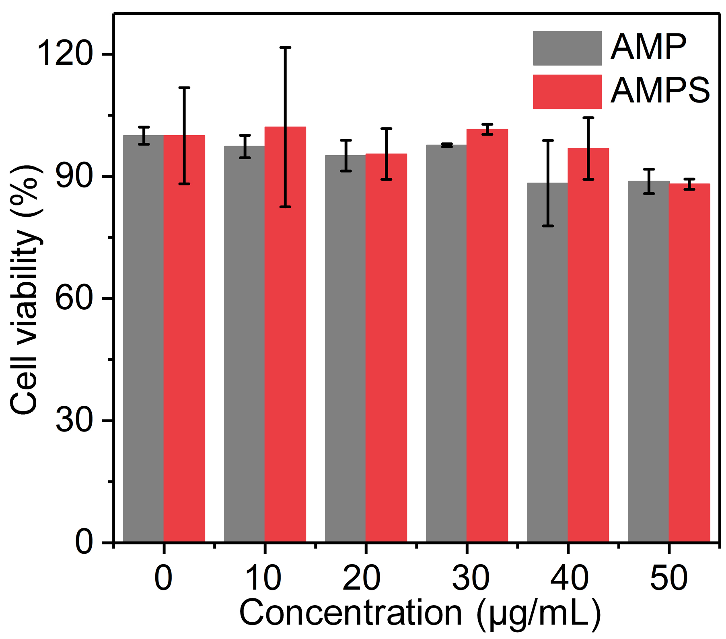

**Supplementary Figure 1.** Cell viability of 4T1 cells after incubation with AMP and AMPS hydrogels for 24 h.

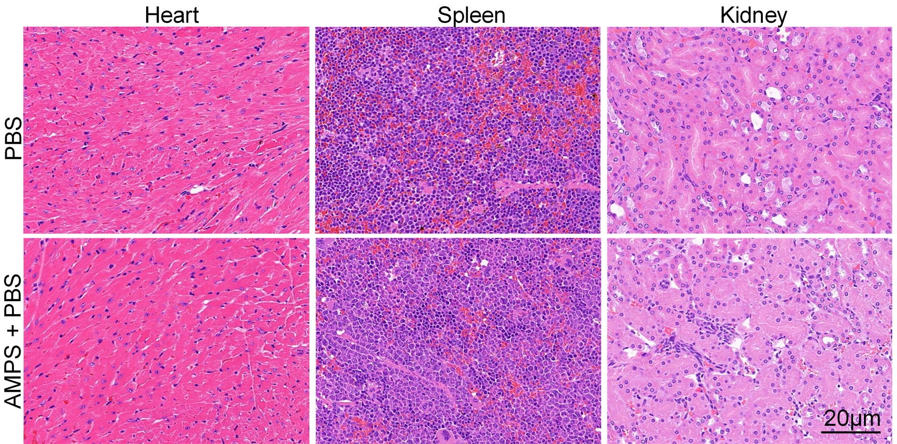

**Supplementary Figure 2.** H&E staining images of heart, spleen and kidney in PBS and AMPS + US groups.