Supplemental Materials
Variation in stem bark conductance to water vapor in Neotropical plant species

Eleinis Ávila-Lovera^{1,2} and Klaus Winter¹
¹Smithsonian Tropical Research Institute, PO Box 0843-03092, Balboa, Ancon, Panama
²School of Biological Sciences, University of Utah, Salt Lake City, UT 84112, USA

Table S1. List of study species, family, growth form, leaf habit, site and g_{bark} values (separate excel file).
Figure S1. Photos of the set up to dehydrate stems and measure g_{bark}. It is important to note that these experiments were conducted in the home of the first author because of the Covid-19 lockdown in 2020-2021 in Panama.
Figure S2. Histogram showing the distribution of g_{bark} values. Most values are concentrated between 0 and 10 mmol m⁻² s⁻¹.
Figure S3. Bark conductance values among families studied.
Figure S4. Bark conductance as a function of leaf habit. There was no statistical difference between leaf habits (p = 0.340).
Figure S5. Mean monthly precipitation (mm) and temperature (°C) in the six sites studied. Gamboa common garden (GCC), Nueva Arenosa (NAR), Panama City (PC), Parque Nacional Altos de Campana (PNAC), and Parque Natural Metropolitano (PNM), and Parque Nacional Soberanía (PNS).

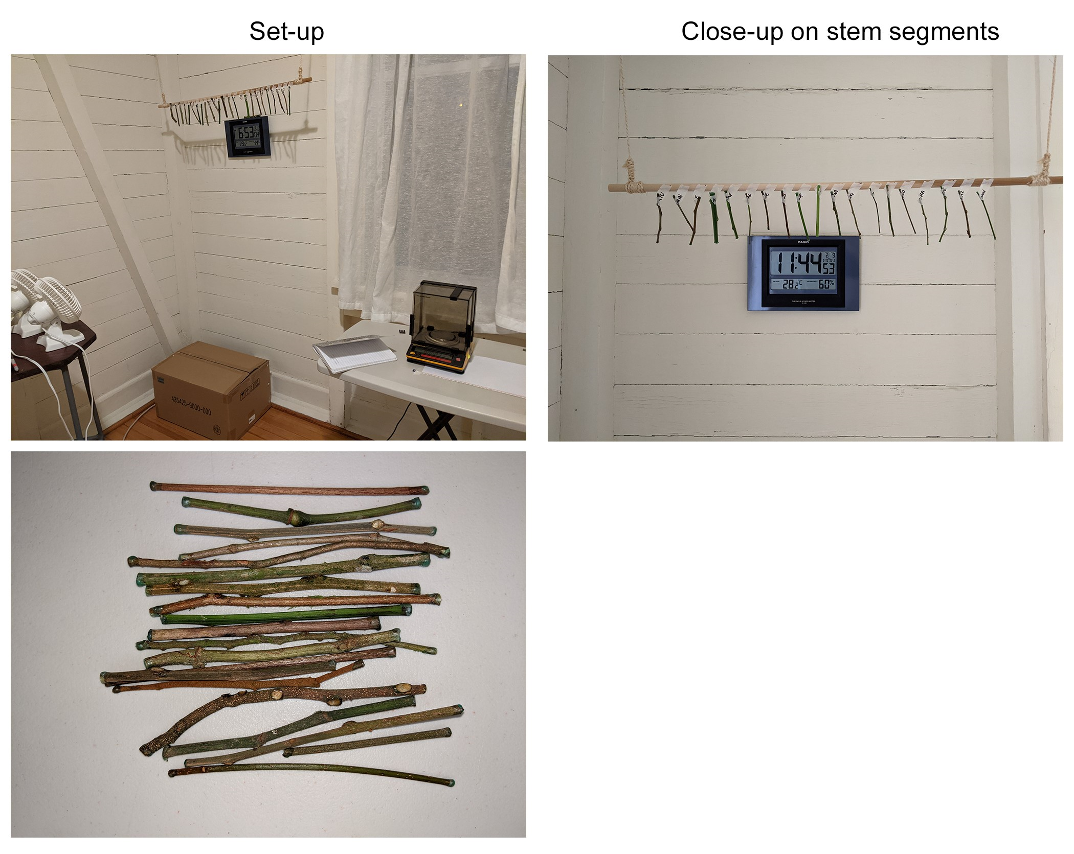
Figure S1
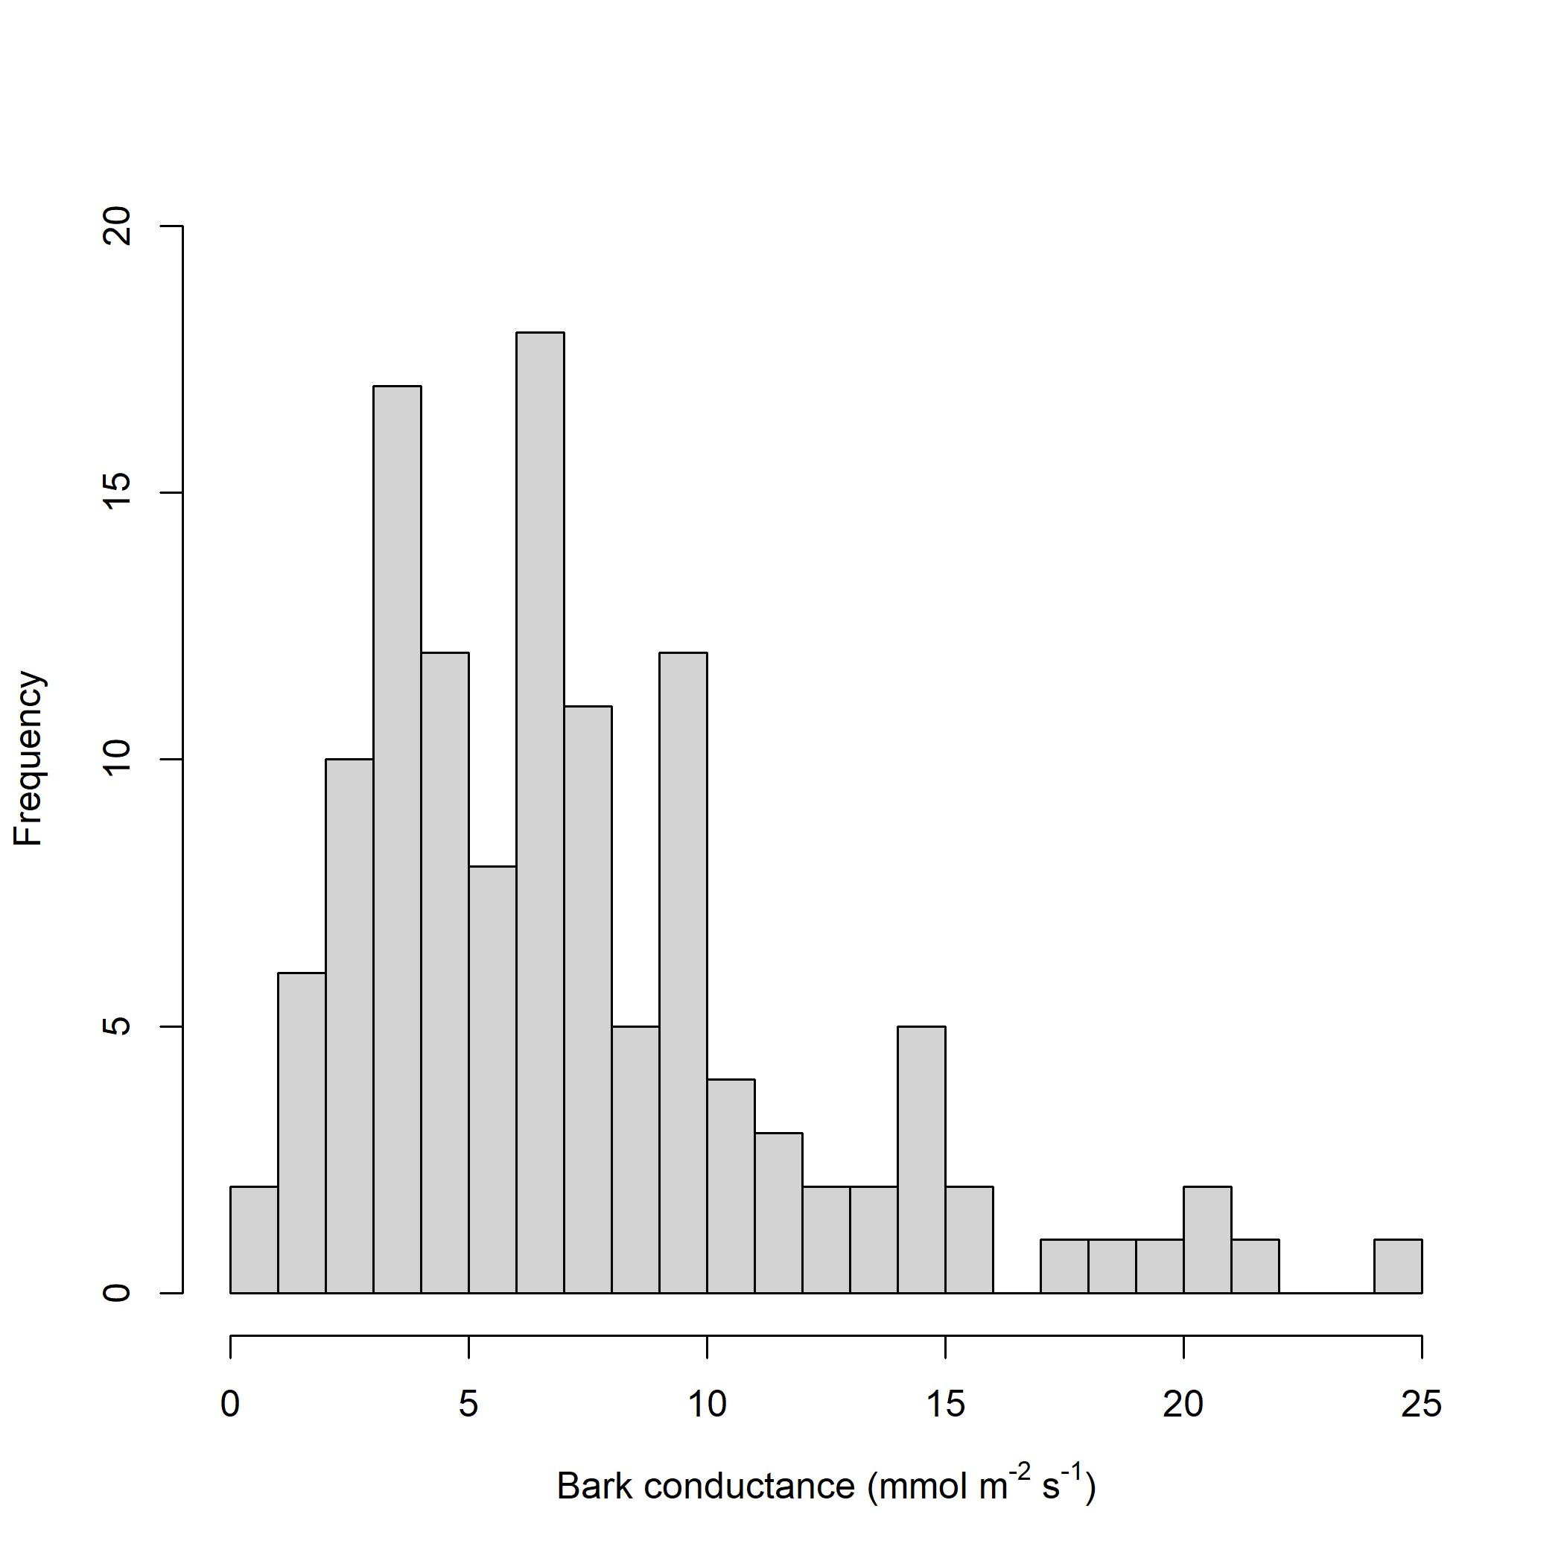
Figure S2

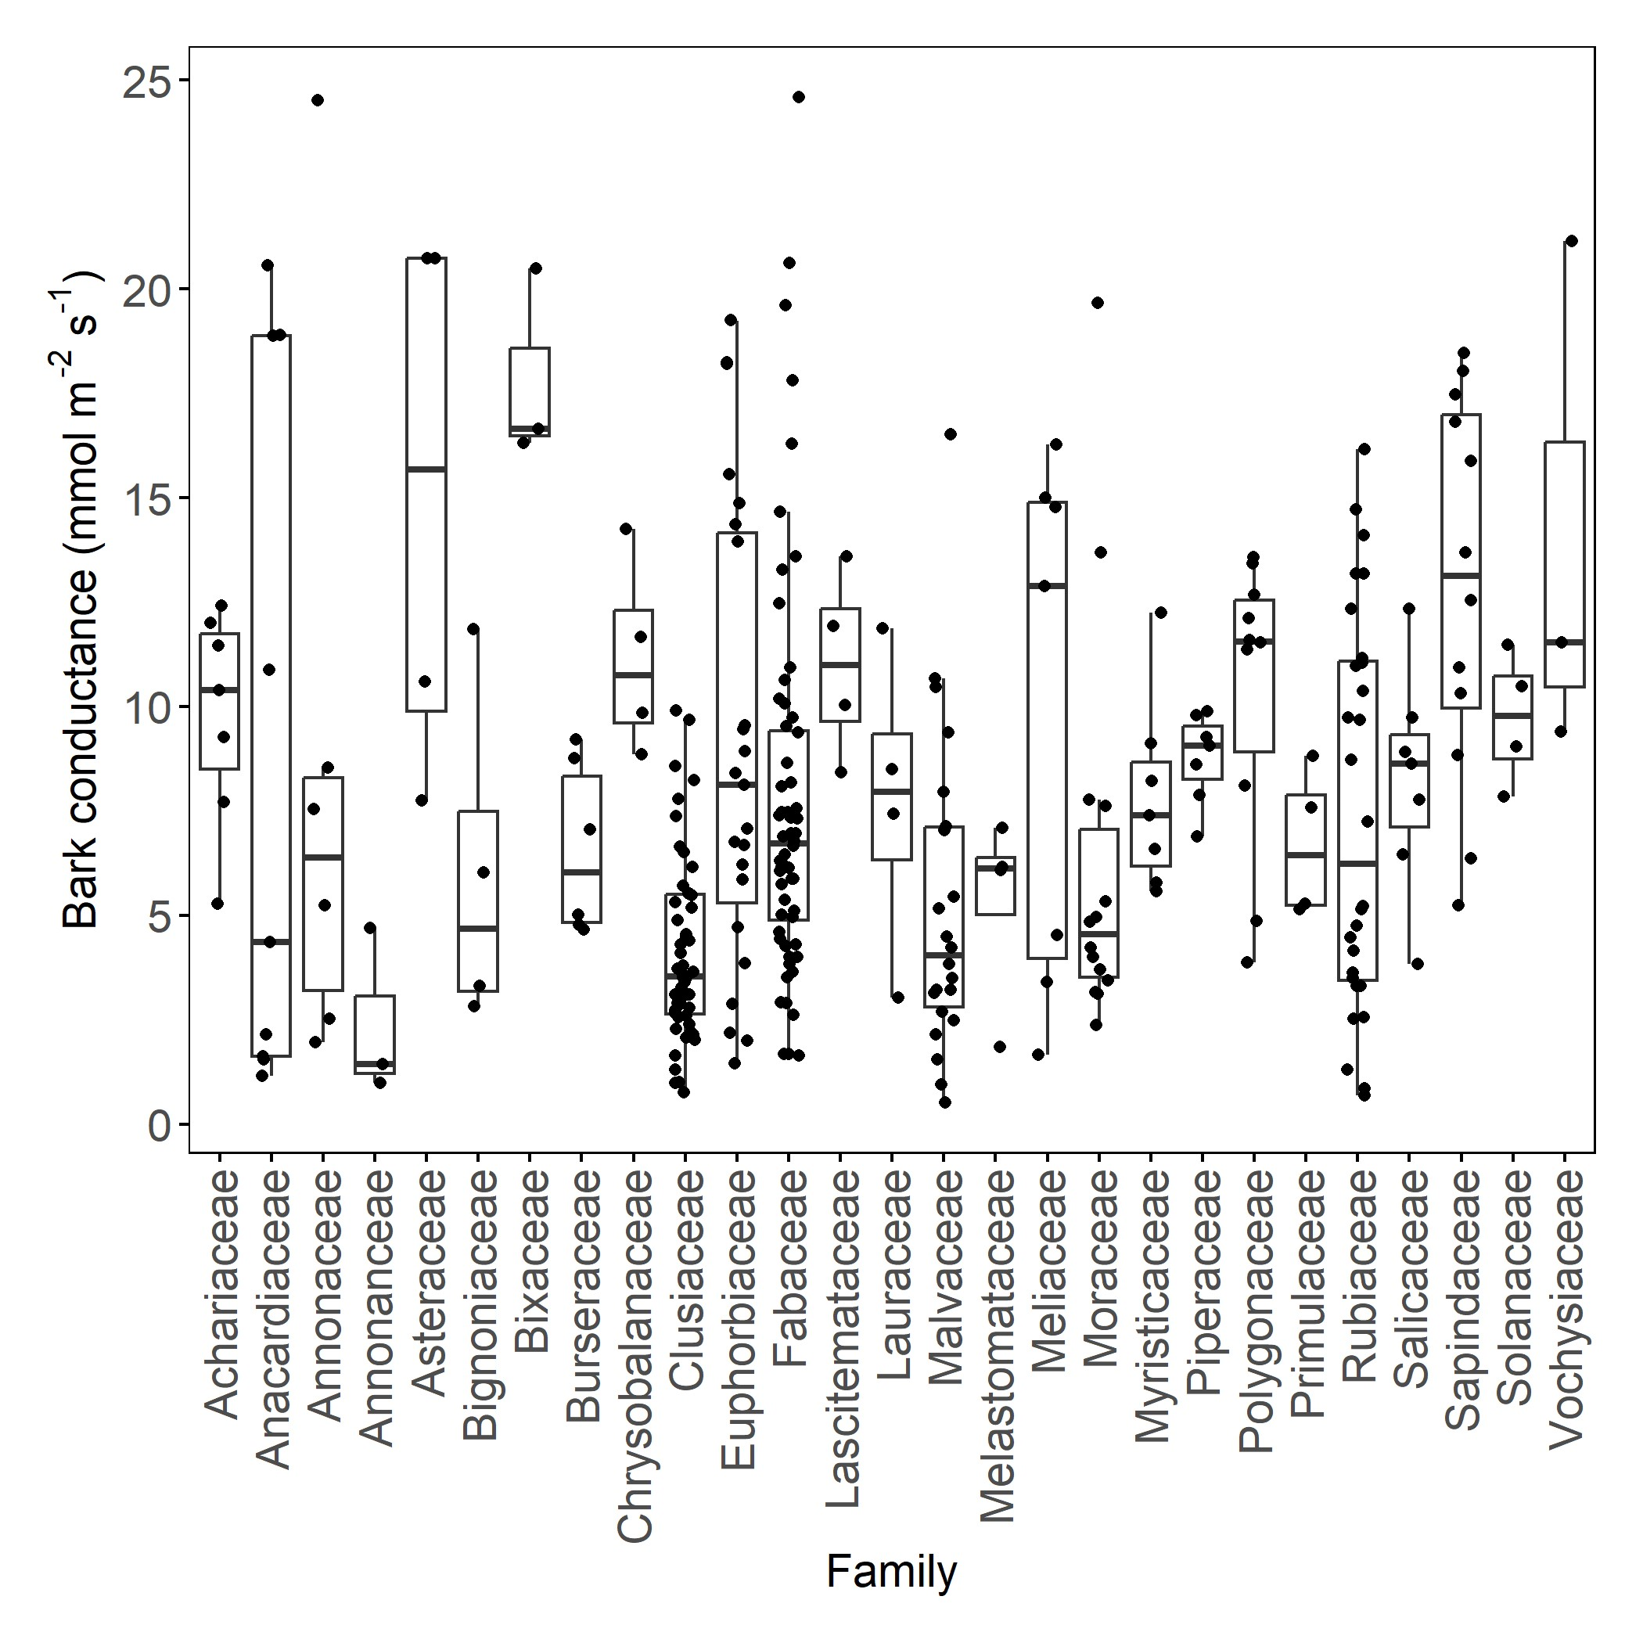
Figure S3

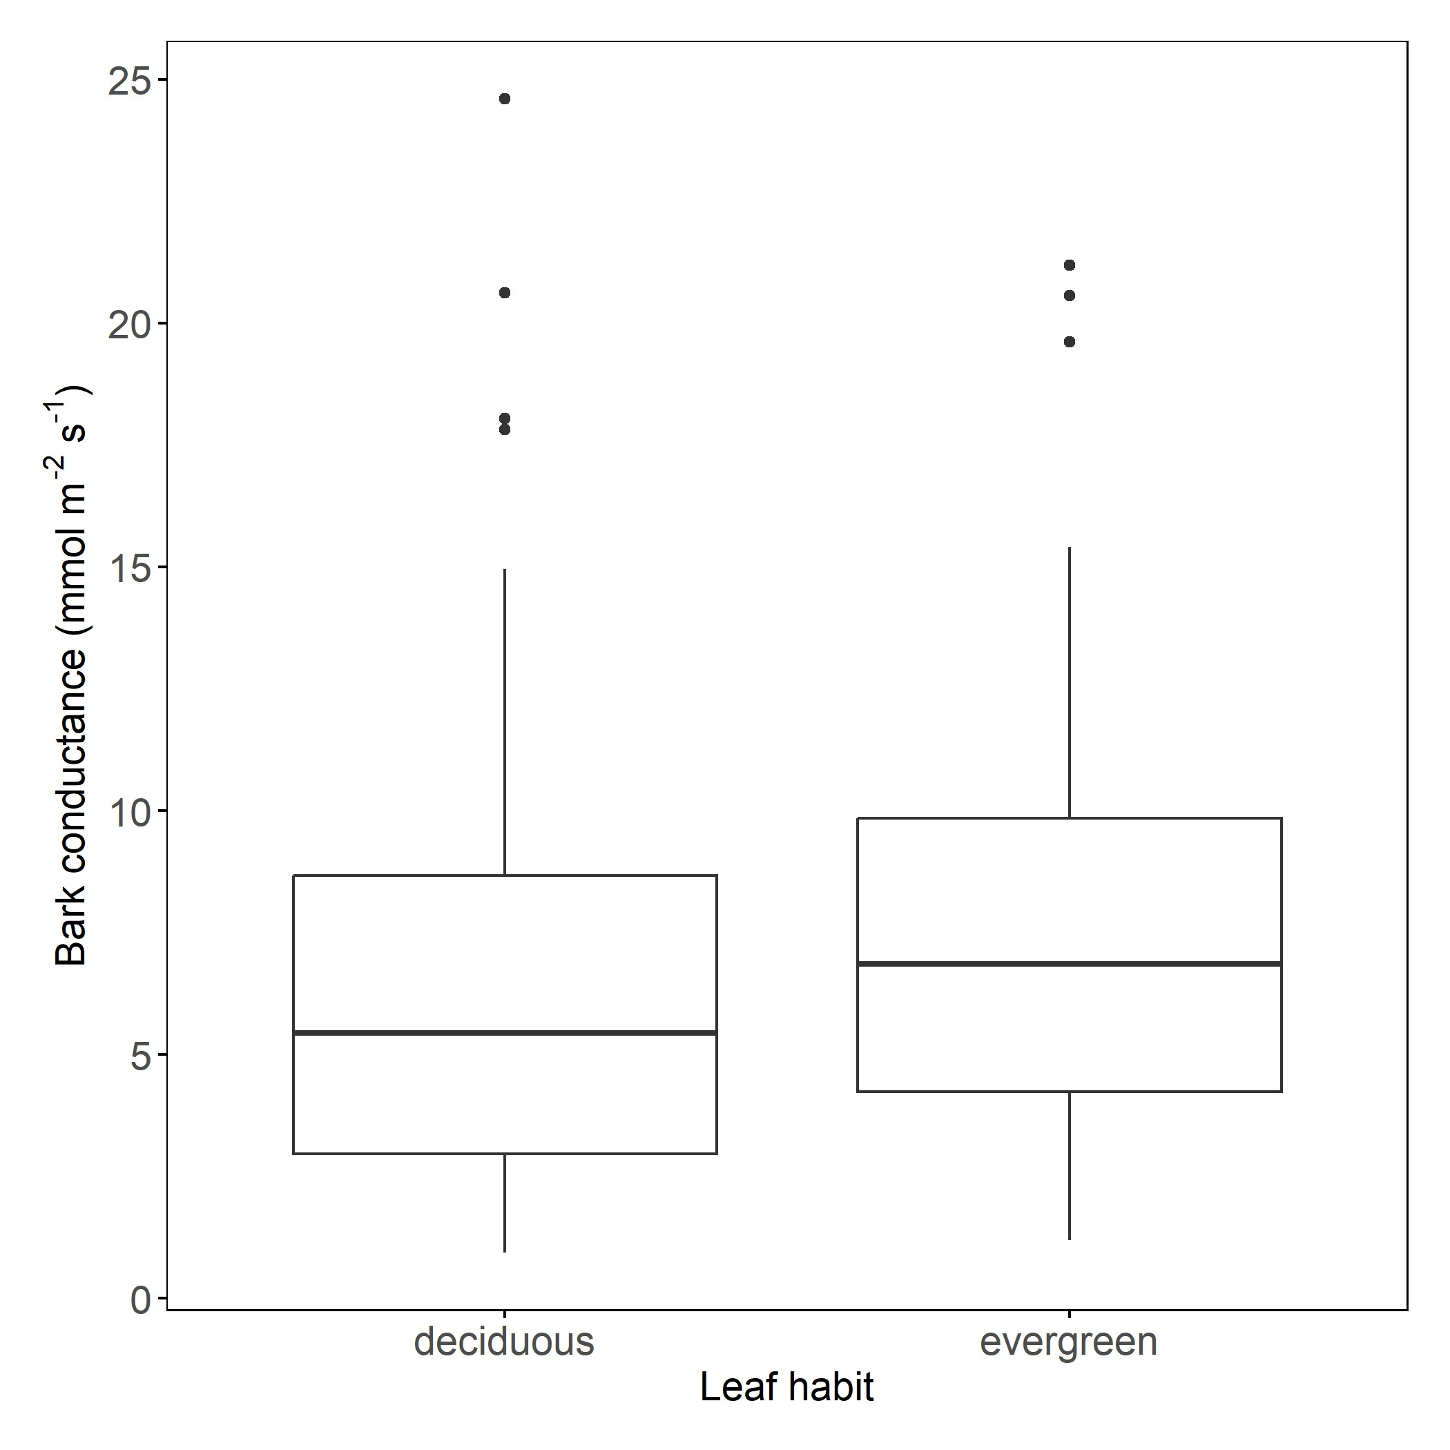
Figure S4

Figure S5

