Supplementary Material

Contribution of surface and lateral forcing to the Arabian Gulf warming trend

Panagiotis Vasou1, George Krokos2, Sabique Langodan1,3, Sarantis Sofianos4, and Ibrahim Hoteit1*

1Earth Science and Engineering Department, King Abdullah University of Science and Technology (KAUST), Thuwal, Saudi Arabia

2Institute of Oceanography, Hellenic Centre for Marine Research, Anavyssos, 19013, Greece

3Environmental Protection Department, Saudi Aramco, Dhahran 31261, Saudi Arabia

4Environmental Physics Division, National and Kapodistrian University of Athens, Athens, Greece

**\* Correspondence:**Ibrahim Hoteit  
[ibrahim.hoteit@kaust.edu.sa](mailto:ibrahim.hoteit@kaust.edu.sa)

# Trends Comparison with satellite derived data

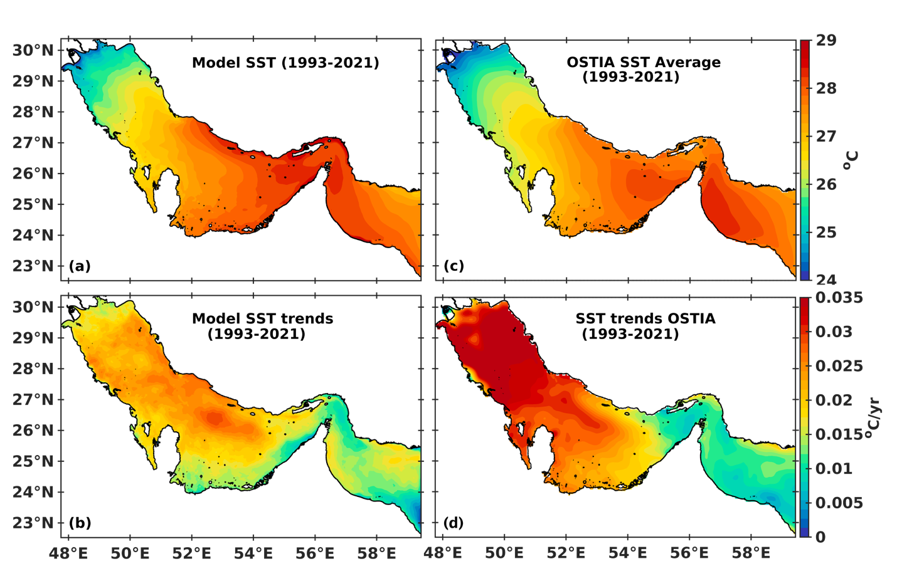

**Figure S1.** Upper panel: Spatial SST comparison between the (a) daily modeled and (c) satellite derived (OSTIA) data, time averaged over the model simulation period (1993-2021). Lower panel (b, d): The associated spatial trends between the two SST estimates.

# Comparison with CTD observations

Climatological average profiles in different areas of the Gulf were compared with the model outputs in winter and summer (Figure S1). For the comparison, we utilized a total of 3915 conductivity-temperature-depth (CTD) casts from the Gulf, spanning a time period of 25 years (1993-2016) available from the World Ocean Database 2018 (WOD18; Boyer et al., 2018). The results showed that the model is able to reproduce the spatial and temporal variability of the mean temperature and salinity and demonstrated a reasonable agreement with in-situ measurements throughout the water column. Their standard deviations also showed good agreement in the entire water column, suggesting a good representation of the intraseasonal and interannual variability for both variables. The largest deviations were observed in the northern parts of the Gulf, and especially in the deeper layers (below 40 m) during summer, while a temperature bias is observed in the southern-central region during winter for the intermediate depths (35-50 m). It should be noted that in these areas, large inconsistencies between the model bathymetry and in-situ depths were observed, especially in the southern shallow banks. Despite these differences, the vertical profiles show a significant improvement in their mean properties and similar agreement in standard deviation in the southern parts of the Gulf during both seasons. The comparison shows further improvement in the southeastern parts in the vicinity of the strait, especially for temperature profiles, which is of particular importance for the analysis presented in this study related to the heat exchanges patterns through the strait.

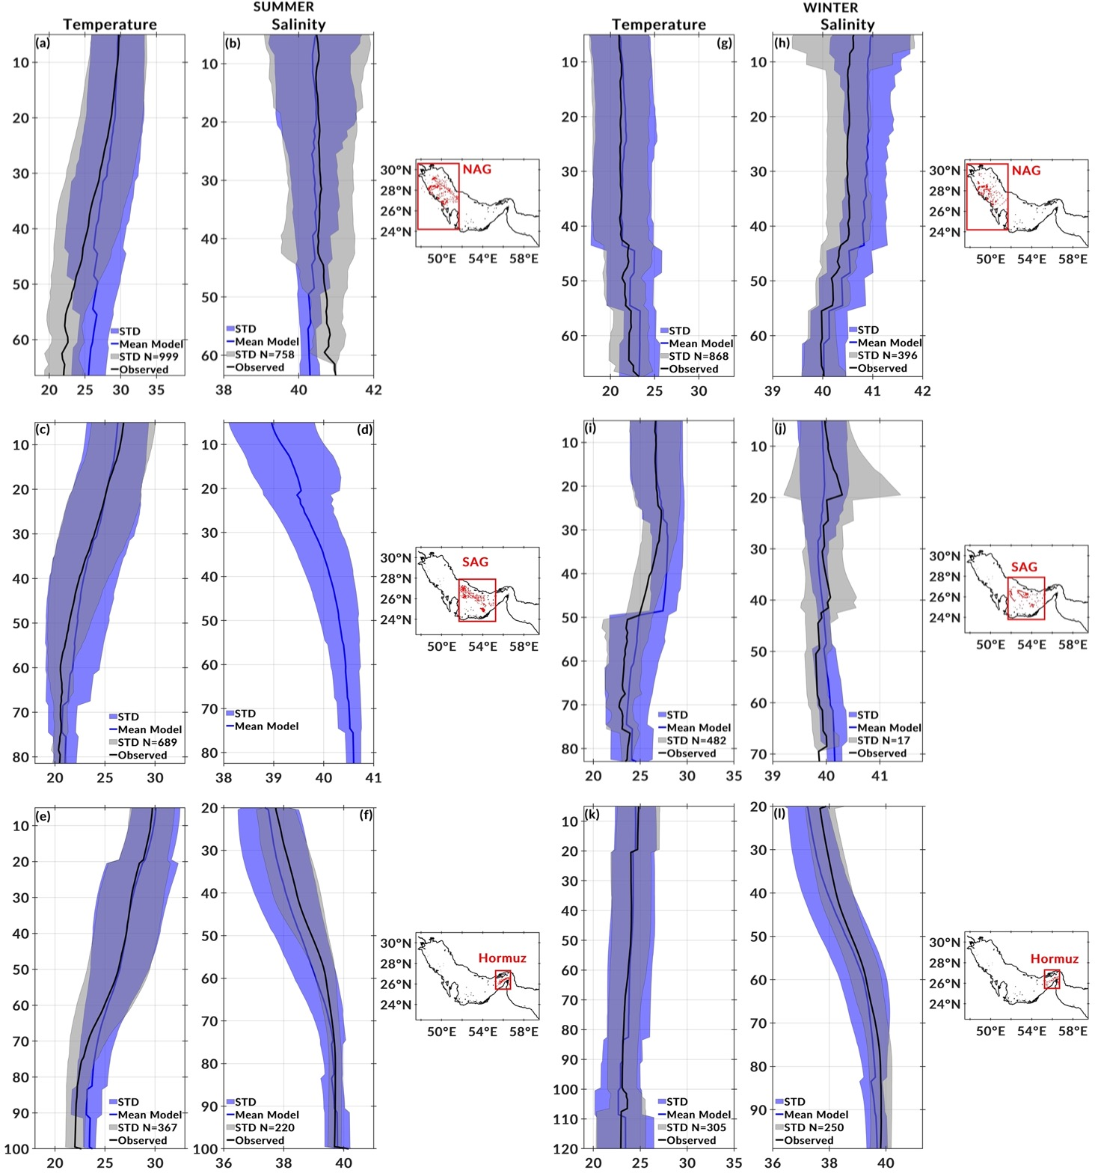

**Figure S2**. ﻿﻿Mean vertical profiles of potential temperature θ and salinity S, from CTD observations available during 1993-2021 (black lines) and the model results (blue lines)﻿over (upper panel) the north Arabian Gulf, (middle panel) the southern Arabian Guld and (lower panel) Strait of Hormuz, in (left panel) summer and in (right panel) winter; note different axis scales. Shading shows the corresponding standard deviation and N denotes the number of observations considered.

**References**

Boyer, T. P., Baranova, O. K., Coleman, C., Garcia, H. E., Grodsky, A., Locarnini, R. A., et al. (2018): World Ocean Database 2018. A.V. Mishonov, Technical Ed., NOAA Atlas NESDIS 87. https://www.ncei.noaa.gov/sites/default/files/2020-04/wod_intro_0.pdf