Supplementary Material

**Lesion-Aware Attention Network for Nephrotic Retinopathy Diagnosis with Optical Coherence Tomography Images**

**Yuliang Liu1,2,Fenghang Zhang1,2,Xizhan Gao1,2*,Tingting Liu3*,Jiwen Dong1,2**

1School of Information Science and Engineering,University of Jinan,Jinan,China

2Shandong Provincial Key Laboratory of Network‐based Intelligent Computing,Jinan,China

3Shandong Eye Institute,Shandong First Medical University & Shandong Academy of Medical Sciences,Jinan,China

**\* Correspondence:**

XizhanGao, School of Information Science and Engineering,University of Jinan,Jinan,China. Tingting Liu,Shandong Eye Institute,Shandong First Medical University & Shandong Academy of Medical Sciences,Jinan,China.

[ise_gaoxz@ujn.edu.cn](mailto:ise_gaoxz@ujn.edu.cn); [tingtingliu@vip.sina.com](mailto:tingtingliu@vip.sina.com)

# Supplementary Figures and Tables

## Supplementary Figures

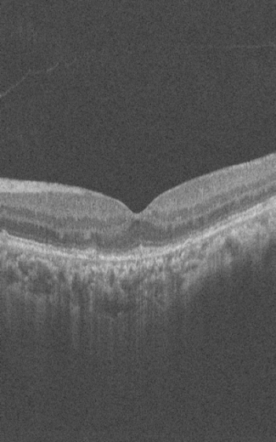 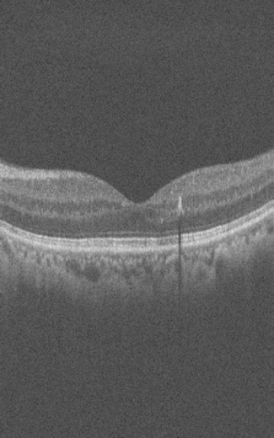 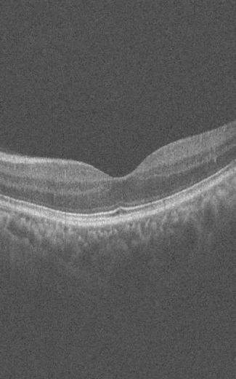

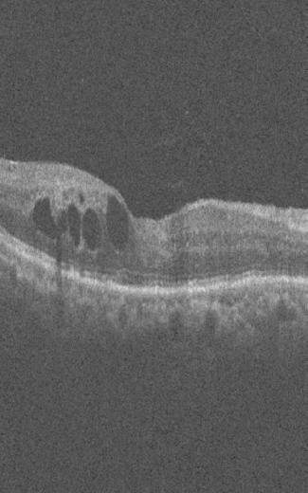 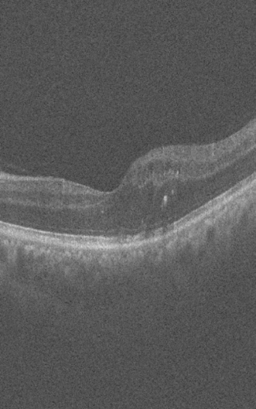 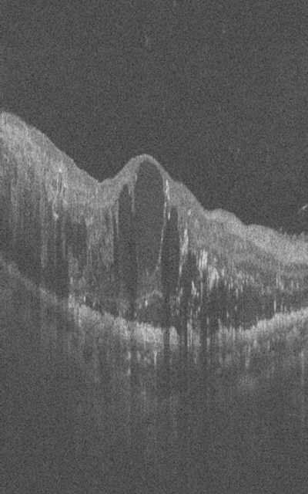

**Figure 1.** The raw dataset can't be freely available in the manuscript, the appendix, nor a publicrepository because of ethical restrictions. We attach 3 pictures of different categories as a supplementary introduction.