Supplementary Material

A new experimental method to measure and calculate the tensile strength of concrete

# Supplementary Figures



**Supplementary Figure 1.** Concrete specimen splitting test.

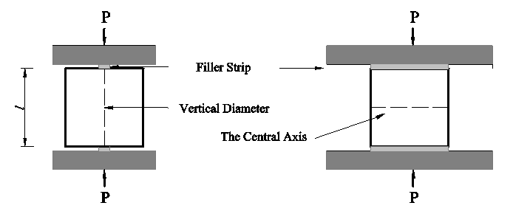

(A) Cube splitting test of concrete

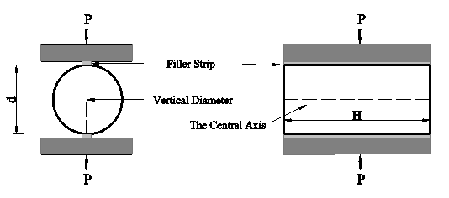

(B) Cylinder splitting test of concrete

**Fig. 1.** Concrete specimen splitting test.

**Supplementary Figure 2.** Cylinder transverse splitting method

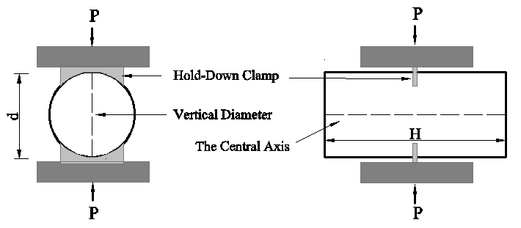

**Fig. 2.** Cylinder transverse splitting method.

**Supplementary Figure 3.** Grading curves of sand and rubber particles..



**Fig. 3.** Grading curves of sand and rubber particles.

**Supplementary Figure 4.** Cube splitting test..

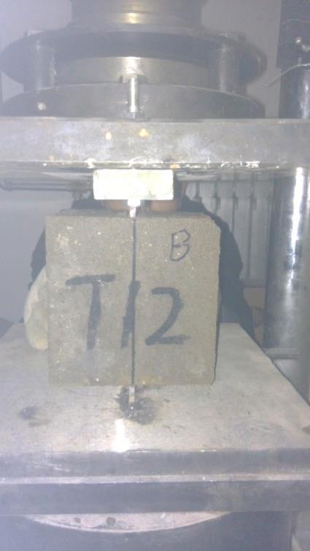

**Fig. 4.** Cube splitting test.

**Supplementary Figure 5.** Schematic diagram of the test fixture: ① pressing plate; ② stiffening rib; ③ pressure cutter; and ④ connecting bolt.

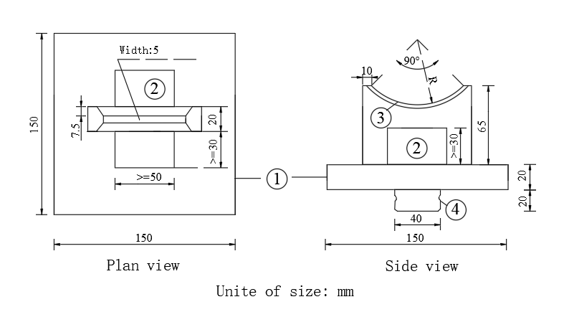

**Fig. 5.** Schematic diagram of the test fixture: ① pressing plate; ② stiffening rib; ③ pressure cutter; and ④ connecting bolt.

**Supplementary Figure 6.** Setup installation.

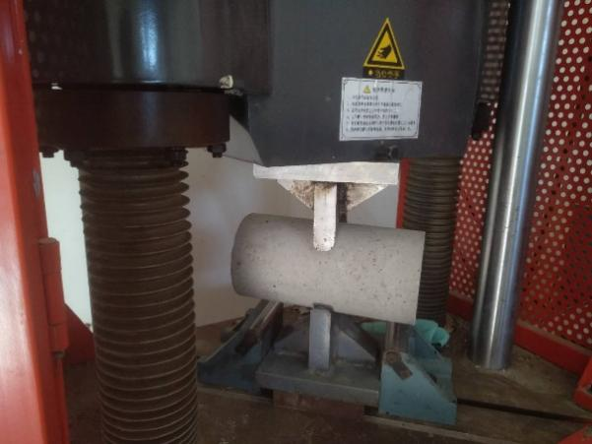

**Fig. 6.** Setup installation.

**Supplementary Figure 7.** Transverse splitting position of cylinder specimen (D = 100 mm, L = 200 mm, l = 50 mm).

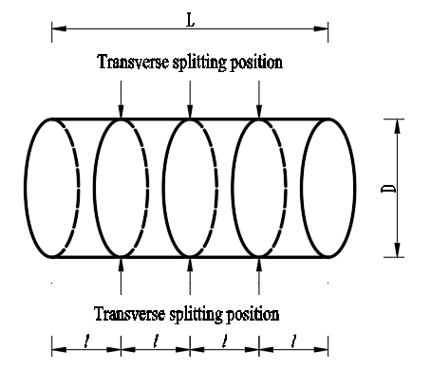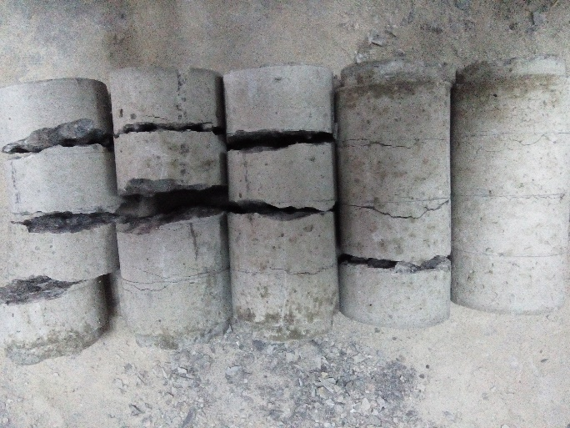

(A) (B)

**Fig. 7.** Transverse splitting position of cylinder specimen (D = 100 mm, L = 200 mm, l = 50 mm).

**Supplementary Figure 8.** Stress distribution of a cubic concrete specimen.

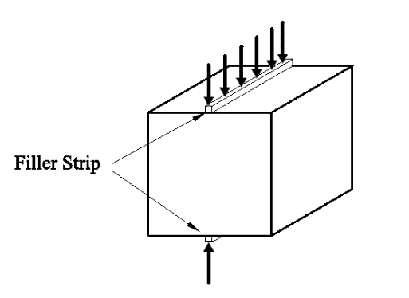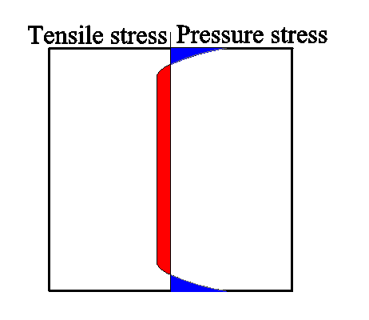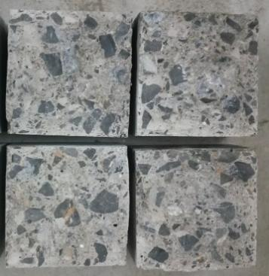

(A) (B) (C)

**Fig. 8.** Stress distribution of a cubic concrete specimen.

**Supplementary Figure 9.** Stress distribution of a cylindrical concrete specimen.

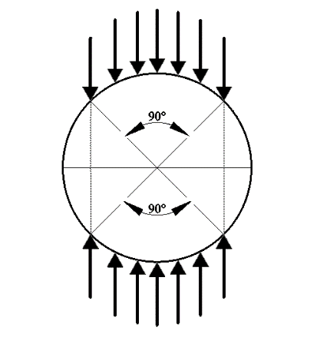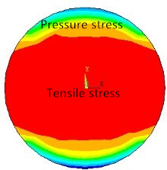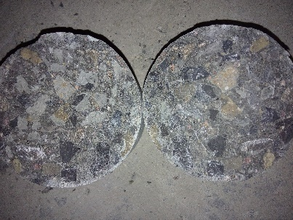

(A) (B) (C)

**Fig. 9.** Stress distribution of a cylindrical concrete specimen.

**Supplementary Figure 10.** Relationship between splitting strength (NC) and W/C.

(A) First batch

(B) Second batch

(C) Third batch

**Fig. 10.** Relationship between splitting strength (NC) and W/C.

**Supplementary Figure 11.** Relationship between splitting strength (CRC) and W/C.

(A) CRC with 5% rubber particles (3–6 mm)

(B) CRC with 5% rubber particles (1–3 mm)

(C) CRC with 10% rubber particles (3–6 mm)

(D) CRC with 10% rubber particles (1–3 mm)

(E) CRC with 15% rubber particles (3–6 mm)

(F) CRC with 15% rubber particles (1–3 mm)

**Fig. 11.** Relationship between splitting strength (CRC) and W/C.

**Supplementary Figure 12.** Relationship between splitting strength (CRC) and content of rubber particles.

(A) CRC with 0.35W/C and rubber particles 3~6mm

(B) CRC with 0.35W/C and rubber particles 1~3mm

(C) CRC with 0.42W/C and rubber particles 3~6mm

(D) CRC with 0.42W/C and rubber particles 1~3mm

(E) CRC with 0.74W/C and rubber particles 3~6mm

(F) CRC with 0.74W/C and rubber particles 1~3mm

**Fig. 12.** Relationship between splitting strength (CRC) and content of rubber particles.

**Supplementary Figure 13.** Linear fitting of Ep. (6).



(A) NC



(B) CRC (3-6mm rubber particles)



(C) CRC (1-3mm rubber particles)



(D) All concrete

**Fig. 13.** Linear fitting of Ep. (6).

**Supplementary Figure 14.** Linear fitting of Ep. (6).



**Fig. 14.** Distribution of ratio of calculated and tested cube splitting strength.