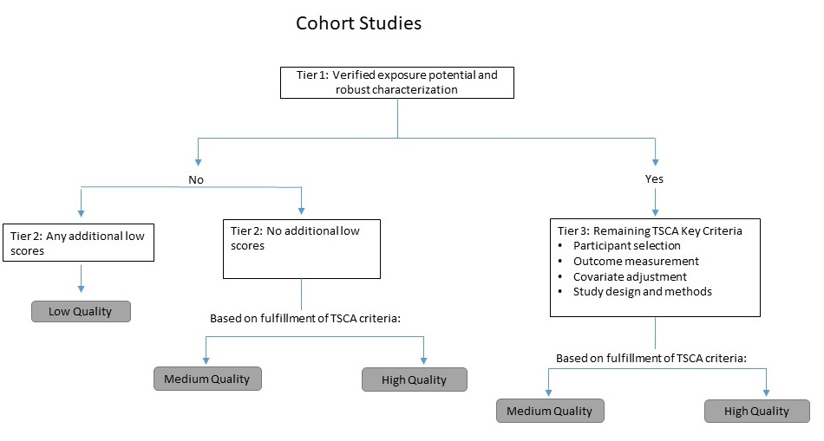

**Figure S.2. Study Quality Evaluation Approach – Cohort**