Supplementary Material

Article Title

**Biddut Bhattacharjee*, Md Mahfuzur Rahman, Ryan E. Hibbs and Michael H. B. Stowell\***

**Correspondence:** Corresponding Authors: [biddut.bhattacharjee@colorado.edu](mailto:biddut.bhattacharjee@colorado.edu) or [stowellm@colorado.edu](mailto:stowellm@colorado.edu)

## Supplementary Web Accessible Data.

## The controller code, STL files as well as an operations manual are freely available on GitHub at https://github.com/Stowell-Lab/photoflashV1.

## Supplementary Figures and Videos

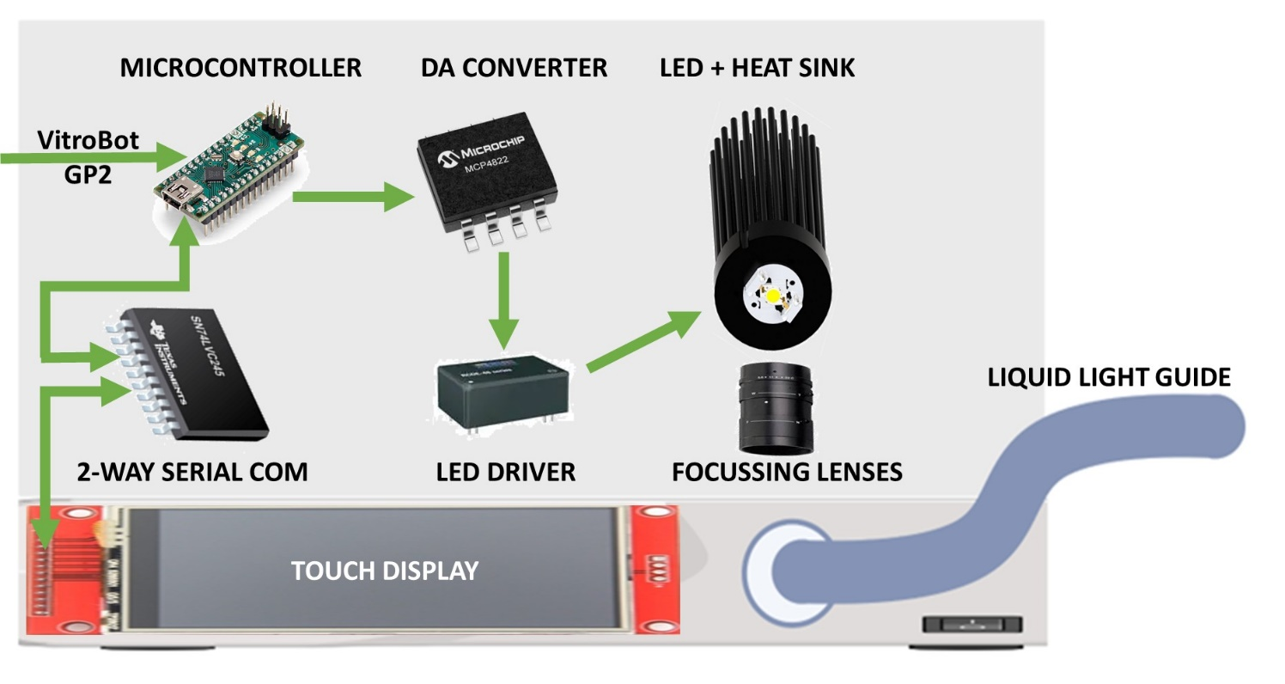

**Supplementary Figure 1.** Schematic and components of the LED control electronics. Refer to Table 4 for manufacturing part numbers.

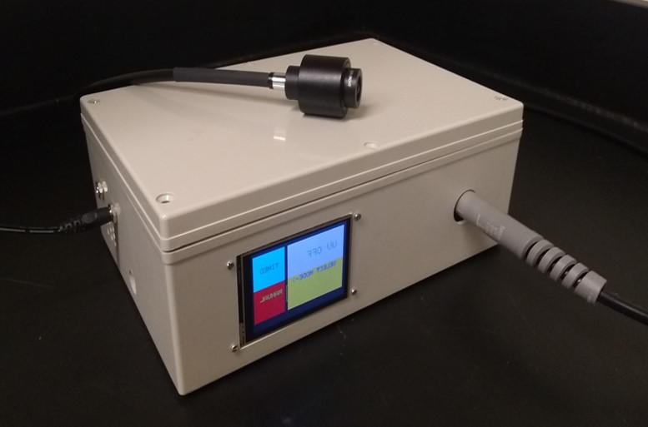

**Supplementary Figure 2.** Photograph of the fully assembled LED system**.**



**Supplementary Video 1.** Video ofVitroBot Mark IV in operation with the LED light source**.**



**Supplementary Video 2.** Video of GP2 in operation with the LED light source.