Supplementary Material

Groundwater springs in the German Wadden Sea tidal flat: A fast-track terrestrial transfer route for nutrients and dissolved organic matter (DOM)
Roger Carvalho da Silva¹, Michael Seidel¹, Thorsten Dittmar^{1,2}, Hannelore Waska^{1,*}

¹Institute for Chemistry and Biology of the Marine Environment (ICBM), Carl von Ossietzky University of Oldenburg, 26129 Oldenburg, Germany

² Helmholtz Institute for Functional Marine Biodiversity at the University of Oldenburg
(HIFMB), 26129 Oldenburg, Germany

*Correspondence:
Hannelore Waska
hannelore.waska@uol.de

Contents: 3 Tables, 3 Figures
Supplementary Table 1: Distribution of physico-chemical parameters through the campaigns in the different locations. Numbers in brackets are sample numbers (n). b.d. = below detection limit. For each campaign, maximum values are in bold, and minimum values are italic. NA= not sampled.
Campaign | Salinity | Temperature (°C) | O₂ (µM) | FDOM (RFU) | Fe(II) (µM) | TDN (µM) | DOC (µM)
June 2018
- Nearshore springs (0) | NA | NA | NA | NA | NA | NA | NA
- Middle springs (0) | NA | NA | NA | NA | NA | NA | NA
- Offshore springs (4) | 0.5±0.1 | 14.3±0.5 | 180.7±64.6 | 10.3±8.7 | 0 | 109.2±25.1 | 54.1±14.9
August 2018
- Nearshore springs (0) | NA | NA | NA | NA | NA | NA | NA
- Middle springs (0) | NA | NA | NA | NA | NA | NA | NA
- Offshore springs (9) | 1±1.7 | 21.7±3.3 | 55.8±49.9 | 9.7±11.9 | 1.8±5.5 | 88.7±100.5 | 69.8±49.6
February 2019
- Nearshore springs (5) | 1.4±0.6 | 10.7±0.5 | 68.4±41.1 | 35.9±10.9 | b.d. | 272.2±181.6 | 119.9±15.4
- Middle springs (11) | 0.5±0.8 | 9.6±0.5 | 158±100.7 | 16.3±25.3 | b.d. | 452.7±310 | 71.4±48.2
- Offshore springs (18) | 0.2±0.2 | 8.7±1.3 | 112.8±58.6 | 6.5±5.3 | b.d. | 406.1±258.8 | 52.8±11.5
Beach porewater (3) | 2.2±0.6 | 7.9±1 | 8.5±3.4 | 227.7±193.8 | 30.4±42.4 | 111±105 | 573±371.2
Tidal porewater (13) | 1.1±3.5 | 8.4±1.4 | 130.4±79.1 | 7.9±14.9 | 1.5±5.5 | 237.2±142.5 | 57.7±28.5
Lake (2) | 0 | 5.4 | 373±0.2 | 280.1±5.2 | b.d. | 48.8±5.5 | 1328.3±4.6
Seawater (4) | 22.1±5.8 | 10.5±1.3 | 374.8±83.5 | 89.2±23.9 | b.d. | 56.5±14.8 | 296±56.7
March 2019
Weser (n3) | 19.6±12.1 | 6.5±0.1 | NA | 117.2±109.8 | NA | 134.2±109.2 | 304.4±202.1
Elbe (n3) | 9.8±10 | 7.1±0.1 | NA | 118.1±45.7 | NA | 236.9±93.5 | 350.5±104.6
November 2019
- Nearshore springs (25) | 1.2±0.5 | 8.5±0.7 | 149.6±46.4 | 52.2±44.2 | b.d | 192±141.6 | 100.5±50.1
- Middle springs (12) | 0.4±0.2 | 8.3±1 | 183.2±29.1 | 8.3±4.9 | b.d | 369.6±65.3 | 36.6±15.9
- Offshore springs (25) | 0.8±0.6 | 8.3±0.9 | 170.2±44.5 | 22.1±32.5 | b.d | 577.9±327.9 | 55.8±41
Beach porewater (2) | 1.2±0.7 | 9.2±0.4 | 51.8±4.8 | 198.6±22.1 | 3.4±4.8 | 24.5±1.9 | 330.3±157.4
Lake (1) | 0 | 7.3 | 140.8±0 | 285.4 | b.d | 48.5 | 1464.8
Seawater (2) | 17±1.5 | 7.7±0.5 | 384.1±49 | 145.2±79.9 | b.d. | 76.1±21.6 | 379.7±7.2
Sahlenburg Well (1) | 0.2 | 10.4 | 71.8 | 113.8 | b.d. | 891.8 | 255.8
Spieka Well (1/2) | 0.2 | 10.3 | 89.0 | 421.8 | b.d. | 16.6±0.1 | 195.2±5.6
Water channel (1) | 0.2 | 4.4 | 404.8±0 | 292.1 | b.d. | 49.2 | 517.0
July 2020
- Nearshore springs (21) | 2.3±3.8 | 17.1±2.6 | 132.6±60.4 | 42.4±26.9 | b.d. | 158.6±101.6 | 129.5±74.5
- Middle springs (23) | 1.4±2.8 | 18.8±2.3 | 130.6±72 | 43.7±50.2 | 7.0±20.7 | 318±398.6 | 131.5±129.6
- Offshore springs (21) | 1.3±2.9 | 19.0±2.0 | 145.7±60 | 12.8±21.2 | b.d. | 476.9±376.2 | 60.3±67
Beach porewater (2) | 2.0±1.0 | 20.0±1.4 | 74.5±14.5 | 745.6±943 | 15.5±21.9 | 223±192.3 | 1256.7±287
Tidal porewater (5) | 6.9±8.7 | 22.1±3.1 | 109±108 | 200.3±190.9 | 9±15.4 | 74.5±19.9 | 551.2±444.9
Lake (1) | 0.1 | 22.0 | 30.4 | 464.2 | 7.1 | 66.7 | 2021.5
Seawater (2) | 24.7±1.2 | 19.3±0.5 | 276.3±2.4 | 113.2±20 | b.d. | 37±8.4 | 358.8±64.2

Supplementary Table 2: Distribution of molecular DOM parameters through the campaigns in the different locations. For each campaign, maximum values are in bold, and minimum values are italic. NA= not sampled.
Campaign | m/z | H/C | O/C | AImod | N/C | I_{DEG} | I_{Terr}
June 2018
- Nearshore springs (0) | NA | NA | NA | NA | NA | NA | NA
- Middle springs (0) | NA | NA | NA | NA | NA | NA | NA
- Offshore springs (4) | 381.1±5.9 | 1.293±0.041 | 0.392±0.018 | 0.265±0.012 | 0.005±0.001 | 0.806±0.019 | 0.340±0.014
August 2018
- Nearshore springs (0) | NA | NA | NA | NA | NA | NA | NA
- Middle springs (0) | NA | NA | NA | NA | NA | NA | NA
- Offshore springs (9) | 382.5±14.4 | 1.284±0.023 | 0.380±0.027 | 0.273±0.017 | 0.007±0.004 | 0.833±0.039 | 0.380±0.082
February 2019
- Nearshore springs (5) | 381.9±6.3 | 1.242±0.019 | 0.400±0.008 | 0.288±0.005 | 0.012±0.002 | 0.838±0.015 | 0.339±0.013
- Middle springs (11) | 389±8.5 | 1.281±0.038 | 0.397±0.012 | 0.265±0.018 | 0.008±0.004 | 0.847±0.021 | 0.308±0.028
- Offshore springs (18) | 387.8±5.6 | 1.292±0.015 | 0.392±0.006 | 0.262±0.007 | 0.006±0.002 | 0.843±0.018 | 0.307±0.025
Beach porewater (3) | 379.6±8.8 | 1.133±0.078 | 0.427±0.019 | 0.346±0.045 | 0.011±0.003 | 0.829±0.051 | 0.483±0.090
Tidal porewater (13) | 391.3±11 | 1.297±0.031 | 0.396±0.012 | 0.258±0.018 | 0.006±0.003 | 0.844±0.040 | 0.294±0.041
Lake (2) | 371.6±1.4 | 1.219±0.003 | 0.422±0.004 | 0.297±0.0002 | 0.007±0.0001 | 0.590±0.008 | 0.513±0.008
Seawater (4) | 365.6±12.3 | 1.221±0.027 | 0.417±0.023 | 0.296±0.007 | 0.020±0.002 | 0.751±0.03 | 0.389±0.042
March 2019
Weser (n3) | 382.8±3.0 | 1.168±0.031 | 0.457±0.002 | 0.308±0.021 | 0.018±0.003 | 0.581±0.007 | 0.314±0.064
Elbe (n3) | 377.7±4.3 | 1.172±0.009 | 0.455±0.006 | 0.306±0.008 | 0.015±0.002 | 0.552±0.012 | 0.331±0.032
November 2019
- Nearshore springs (25) | 379.2±13.7 | 1.261±0.035 | 0.392±0.008 | 0.283±0.024 | 0.010±0.003 | 0.812±0.034 | 0.357±0.077
- Middle springs (12) | 396.6±6.6 | 1.288±0.014 | 0.398±0.010 | 0.259±0.008 | 0.007±0.001 | 0.853±0.026 | 0.278±0.025
- Offshore springs (25) | 390.2±9.6 | 1.274±0.019 | 0.396±0.011 | 0.269±0.012 | 0.009±0.002 | 0.847±0.023 | 0.305±0.041
Beach porewater (2) | 362.6±2.5 | 1.217±0.008 | 0.384±0.0001 | 0.320±0.005 | 0.008±0.002 | 0.770±0.039 | 0.520±0.039
Lake (1) | 356.5 | 1.263 | 0.398 | 0.284 | 0.008 | 0.530 | 0.526
Seawater (2) | 370.1±10.3 | 1.190±0.041 | 0.432±0.002 | 0.307±0.029 | 0.021±0.002 | 0.789±0.012 | 0.387±0.076
Sahlenburg Well (1) | 389.3 | 1.187 | 0.438 | 0.302 | 0.019 | 0.872 | 0.374
Spieka Well (2) | 352.9±2.3 | 1.080±0.003 | 0.362±0.004 | 0.407±0.004 | 0.008±0.001 | 0.84±0.004 | 0.632±0.013
Water channel (1) | 386.6 | 1.268 | 0.395 | 0.275 | 0.010 | 0.817 | 0.320
July 2020
- Nearshore springs (21) | 376.4±12.4 | 1.267±0.031 | 0.389±0.009 | 0.280±0.022 | 0.011±0.003 | 0.799±0.025 | 0.351±0.048
- Middle springs (23) | 381.5±14.3 | 1.264±0.043 | 0.387±0.010 | 0.283±0.026 | 0.008±0.002 | 0.817±0.064 | 0.377±0.100
- Offshore springs (21) | 383.9±14.7 | 1.305±0.024 | 0.381±0.013 | 0.260±0.010 | 0.009±0.003 | 0.842±0.033 | 0.306±0.041
Beach porewater (2) | 357±14.3 | 1.062±0.020 | 0.414±0.032 | 0.400±0.004 | 0.016±0.001 | 0.833±0.002 | 0.586±0.026
Tidal porewater (5) | 376.3±13.3 | 1.187±0.074 | 0.409±0.025 | 0.320±0.043 | 0.011±0.006 | 0.780±0.032 | 0.464±0.106
Lake (1) | 372.1 | 1.148 | 0.460 | 0.327 | 0.008 | 0.666 | 0.537
Seawater (2) | 337.4±2.4 | 1.257±0.001 | 0.375±0.001 | 0.298±0.003 | 0.023±0.001 | 0.672±0.009 | 0.442±0.014

Supplementary Table 3: Distribution of molecular DOM parameters through the campaigns in the different locations (cont’d). For each campaign, maximum values are in bold, and minimum values are italic. S/C*1000 is a molecular sulfur ratio multiplied by 1000 for better visualization (Pohlabeln et al., 2017). Compound classes (e.g. aromatic, highly unsaturated, unsaturated, unsaturated with N, and saturated) are in % contribution based on intensity-weighed molecular formulae. NA= not sampled.
Campaign | S/C*1000 | Aromatic | Highly unsaturated | Unsaturated | Unsaturated with N | Saturated
June 2018
- Nearshore springs (0) | NA | NA | NA | NA | NA | NA
- Middle springs (0) | NA | NA | NA | NA | NA | NA
- Offshore springs (4) | 3.049±0.452 | 3.2±1.9 | 82.7±1.3 | 12.5±2.1 | 0.3±0.2 | 0.9±1.0
August 2018
- Nearshore springs (0) | NA | NA | NA | NA | NA | NA
- Middle springs (0) | NA | NA | NA | NA | NA | NA
- Offshore springs (9) | 3.282±1.768 | 4.6±2.5 | 81.5±4.2 | 13.0±2.6 | 0.7±0.8 | 0.3±0.1
February 2019
- Nearshore springs (5) | 2.991±0.319 | 6.4±0.8 | 84.2±0.9 | 8.8±1.2 | 0.2±0.04 | 0.2±0.1
- Middle springs (11) | 3.251±0.284 | 3.3±2.4 | 84.2±3.8 | 11.6±4.1 | 0.9±2.0 | 0.4±0.3
- Offshore springs (18) | 2.928±0.368 | 2.4±0.9 | 84.8±2.4 | 11.6±1.8 | 0.6±1.0 | 0.5±0.4
Beach porewater (3) | 2.122±0.581 | 17.3±9.0 | 77.0±7.1 | 5.3±2.5 | 0.1±0.02 | 0.3±0.1
Tidal porewater (13) | 3.005±0.812 | 2.8±2.4 | 82.9±4.7 | 13.3±4.6 | 0.4±0.2 | 0.5±0.7
Lake (2) | 2.258±0.380 | 12.3±0.3 | 72.4±0.9 | 15±0.4 | 0.2±0.04 | 0.2±0.2
Seawater (4) | 4.233±0.200 | 11.6±0.9 | 75.5±3.1 | 12.4±2.4 | 0.8±0.2 | 0.4±0.4
March 2019
Weser (3) | 3.733±0.159 | 12.1±2.7 | 81.4±1.6 | 6.5±1.2 | 0.4±0.2 | 0
Elbe (3) | 3.998±0.232 | 11.3±1.0 | 82±0.9 | 6.7±0.3 | 0.3±0.1 | 0
November 2019
- Nearshore springs (25) | 2.549±0.310 | 6.1±4.7 | 82.1±4.5 | 10.9±1.1 | 0.5±0.3 | 0.3±0.1
- Middle springs (12) | 2.188±0.494 | 1.9±0.5 | 85.7±2.4 | 11.6±2.1 | 1.1±0.7 | 0.2±0.07
- Offshore springs (25) | 2.190±0.642 | 3.2±2.5 | 85.4±2.6 | 10.5±1.1 | 0.7±0.5 | 0.3±0.2
Beach porewater (2) | 2.143±0.351 | 12.9±2.1 | 75.8±2.9 | 10.3±0.8 | 0.2±0.1 | 0.4±0.1
Lake (1) | 2.781 | 11.8 | 67.1 | 20.6 | 0.4 | 0.2
Seawater (2) | 3.563±0.540 | 12.9±5.2 | 76.6±4 | 10.1±1.0 | 1.0±0.2 | 0.2±0.2
Sahlenburg Well (1) | 3.059 | 7.4 | 86.0 | 6.5 | 0.2 | 0.0
Spieka Well (2) | 1.355±0.522 | 30.3±0.9 | 64±0.3 | 5.5±0.6 | 0.1±0.01 | 0.1±0.004
Water channel (1) | 2.452 | 4.3 | 84.5 | 10.4 | 0.5 | 0.2
July 2020
- Nearshore springs (21) | 2.894±0.379 | 6.4±3.6 | 80.7±3.6 | 12.1±2.8 | 0.7±0.8 | 0.3±0.1
- Middle springs (23) | 2.679±0.900 | 6.2±4.7 | 81.1±4.3 | 11.8±2.3 | 0.7±1.1 | 0.4±0.3
- Offshore springs (21) | 2.243±0.392 | 3.0±2.0 | 81.5±5.0 | 14.4±3.2 | 2.0±1.6 | 0.5±0.5
Beach porewater (2) | 2.058±1.275 | 28.7±1.0 | 66.4±1.9 | 4.6±0.9 | 0.4±0.5 | 0.2±0.1
Tidal porewater (5) | 2.709±0.759 | 13.9±8.7 | 76.8±6.8 | 8.9±2.8 | 0.3±0.4 | 0.2±0.1
Lake (1) | 2.185 | 16.3 | 74.0 | 9.5 | 0.3 | 0.2
Seawater (2) | 3.502±0.262 | 12.7±0.4 | 68.8±0.1 | 17.9±0.6 | 1.1±0.1 | 0.2±0.02

Supplementary Figure 1: TDN vs NOx for all sample types. Feb 19 samples were stored frozen, Nov 19 and Jul 20 samples were poisoned with HgCl₂ and stored in the fridge.
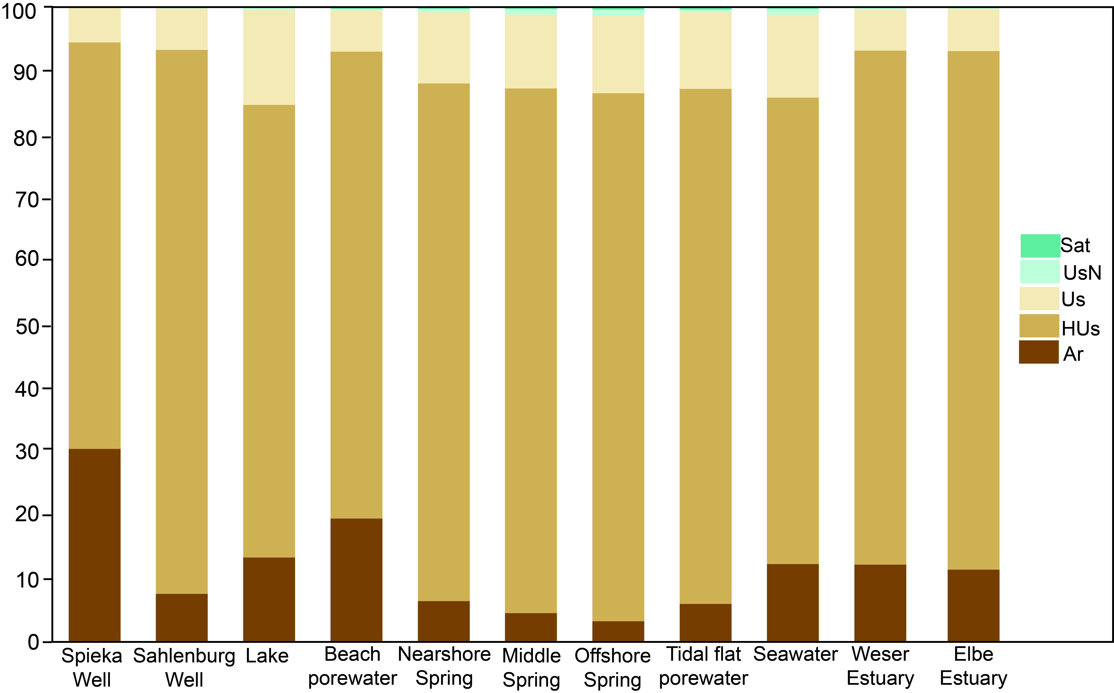
Supplementary Figure 2: DOM compound group distribution amongst different endmembers, all campaigns combined.

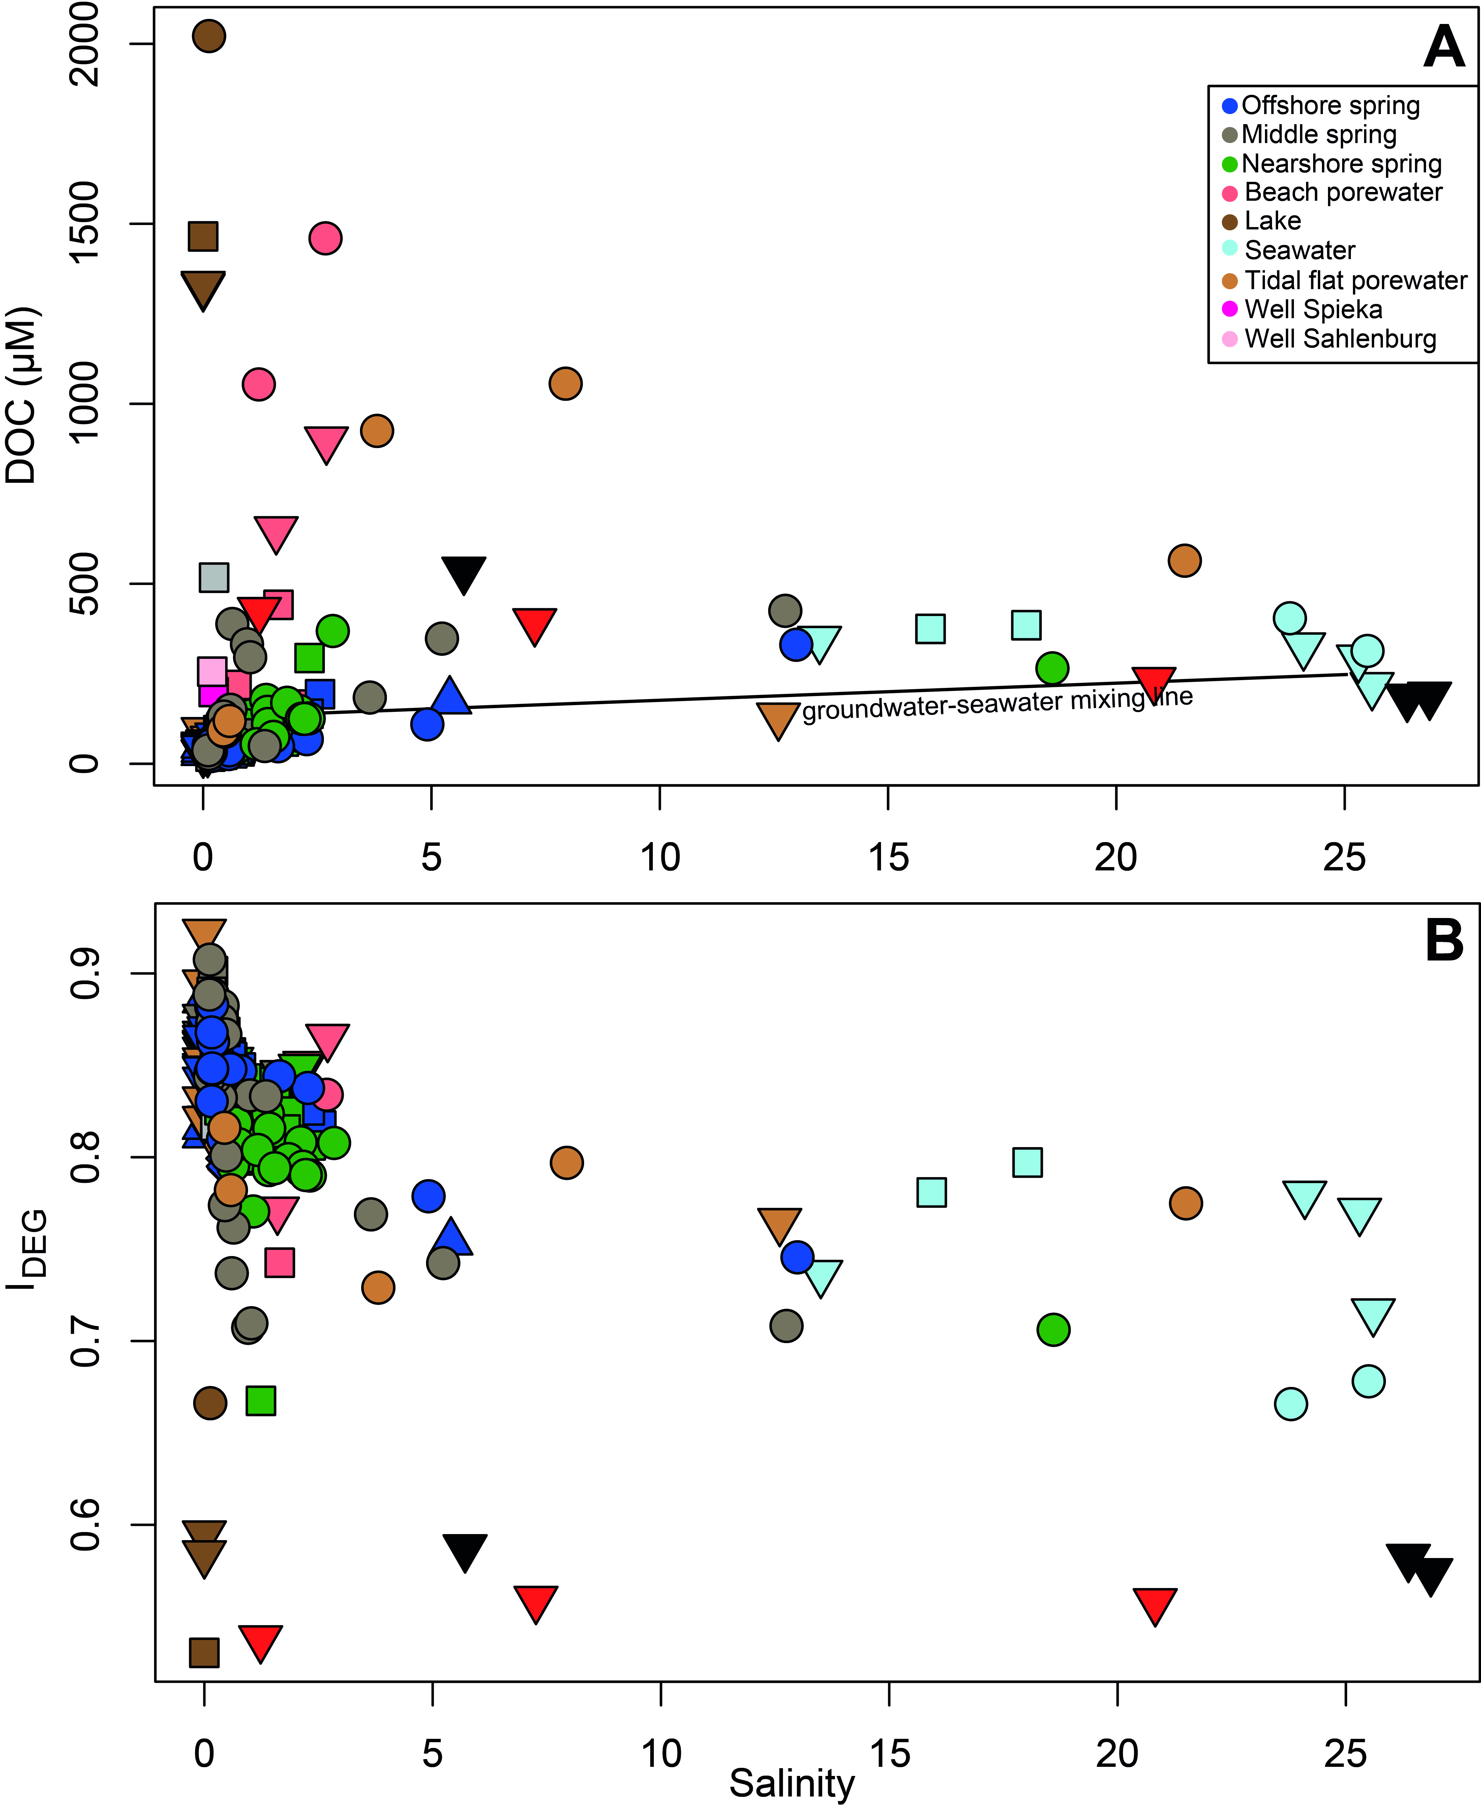
Supplementary Figure 3: Scatter plots of salinity vs. DOC concentrations (A) and I_{DEG} (B) for all sampling campaigns and all endmembers. The groundwater-seawater mixing line was plotted between the Sahlenburg and Spieka wells and the seawater samples with the highest salinities, respectively.

