Nanogold sol plasmon di-scattering assay for trace carbendazim in tea coupled aptamer with Au³⁺-glyoxal-carbon dot nanocatalytic reaction
Hongyan Bai ^{1,2}, Ran Zhang ^{1,2}, Chongning Li^{1,2*}, Aihui Liang ^{2*}
¹ School of Public Health, Guilin Medical University, Guilin 541199, China; ²Guangxi Key Laboratory of Environmental Pollution Control Theory and Technology, Guilin 541006, China.

FIGURE S1. RRS Spectra of CD_{Fe}-GX-HCl-HAuCl₄ Catalytic System at Different Time. (A) CD_{Fe} (80 min)-53.3 μg/mL HAuCl₄-1.2 mmol/L HCl-3.48 mmol/L GX, a-h curves represent 0, 8, 16, 32, 40, 48, 60 and 72 μg/L CD_{Fe}. (B) CD_{Fe} (100 min)-53.3 μg/mL HAuCl₄-1.2 mmol/L HCl-3.48 mmol/L GX, a-g curves represent 0, 16, 32, 40, 48, 72 and 80 μg/L CD_{Fe}. (C) CD_{Fe} (120 min)-53.3 μg/mL HAuCl₄-1.2 mmol/L HCl-3.48 mmol/L GX, a-f curves represent 0, 8, 16, 32, 64 and 80 μg/L CD_{Fe}. (D) CD_{Fe} (150 min)-53.3 μg/mL HAuCl₄-1.2 mmol/L HCl-3.48 mmol/L GX, a-f curves represent 0, 8, 16, 32, 60 and 72 μg/L CD_{Fe}.

FIGURE S2. RRS Spectra of CD_{Fe}-GX-HCl-HAuCl₄ Catalytic System at Different Temperatures. (A) CD_{Fe} (140℃)-53.3 μg/mL HAuCl₄-1.2 mmol/L HCl-3.48 mmol/L GX, a-f curves represent 0, 0.8, 1.6, 2.4, 3 and 3.6 mg/L CD_{Fe。} (B) CD_{Fe} (160℃)-53.3 μg/mL HAuCl₄-1.2 mmol/L HCl-3.48 mmol/LGX, a-f curves represent 0, 0.8, 1.6, 2, 2.4 and 3.6 mg/L CD_{Fe。}(C) CD_{Fe} (180℃)-53.3 μg/mL HAuCl₄-1.2 mmol/L HCl-3.48 mmol/L GX, a-f curves represent 0, 8, 16, 32, 64 and 80 μg/L CD_{Fe。}(D) CD_{Fe} (200℃)-53.3 μg/mL HAuCl₄-1.2 mmol/L HCl-3.48 mmol/L GX, a-f curves represent 0, 16, 24, 32, 72 and 96 μg/L CD_{Fe。}

FIGURE S3. RRS Spectra of CD_{Fe}-GX-HCl-HAuCl₄ Catalytic System with Different Fer Dosages. (A)CD_{Fe} (0.012 g)-53.3 μg/mL HAuCl₄-1.2 mmol/L HCl-3.48 mmol/L GX, a-f curves represent 0, 5.33, 10.67, 32, 40 and 55 μg/L CD_{Fe}. (B) CD_{Fe} (0.018 g)-53.3 μg/mL HAuCl₄-1.2 mmol/L HCl-3.48 mmol/L GX, a-f curves represent 0, 8, 16, 32, 64 and 80 μg/L CD_{Fe}. (C) CD_{Fe} (0.024 g)-53.3 μg/mL HAuCl₄-1.2 mmol/L HCl-3.48 mmol/L GX, a-f curves represent 0, 10.67, 42.67, 53.3, 85.3 and 106.67 μg/L CD_{Fe}. (D) CD_{Fe} (0.03 g)-53.3 μg/mL HAuCl₄-1.2 mmol/L HCl-3.48 mmol/L GX, a-f curves represent 0, 26.67, 53.3, 66.67, 106.67 and 120 μg/L CD_{Fe}. (E) CD_{Fe} (0.045 g)-53.3 μg/mL HAuCl₄-1.2 mmol/L HCl-3.48 mmol/L GX, a-g curves represent 0, 20, 40, 100, 120, 160 and 180 μg/L CD_{Fe}.

FIGURE S4. Effect of reaction time/reaction temperature/Fer dosage on k. (A) 0.018 g Fer-x h-180℃, (B) 0.018 g Fer-2 h-x℃, (C) x g Fer-2 h-180℃.

A
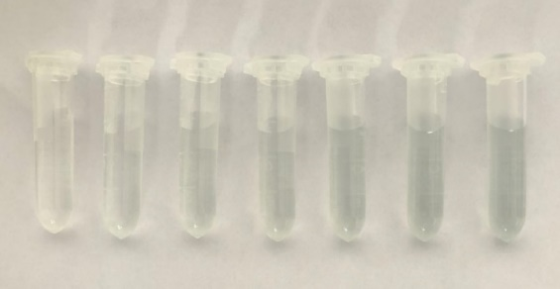
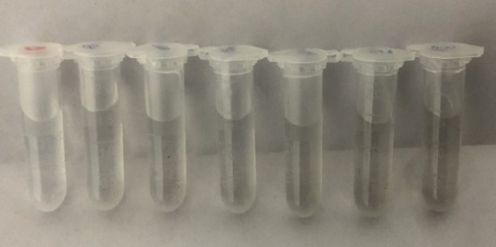

FIGURE S5. Fluorescence/RRS/Abs spectrum of CD_{Fe}/CD_{HM}. (A) The fluorescence spectrum of CD_{Fe} under different excitation wavelengths, 128 mg/L CD_{Fe}. (B) CD_{Fe} fluorescence spectrum, the a-g curves represent 0, 16, 32, 60, 72, 96 and 128 mg/L CD_{Fe}, respectively. (C) CD_{HM} fluorescence spectrum, a-g curves represent 0, 8, 16, 60, 32, 48, 64 and 96 mg/L CD_{HM} respectively. (D) CD_{Fe} RRS spectrum, a-f curves represent 0, 24 40, 72, 80 and 96 mg/L CD_{Fe} respectively. (E) CD_{HM} RRS spectrum, a-h curves represent 0, 8, 16, 24, 48, 64, 96 and 128 mg/L CD_{HM}. (F) CD_{Fe} Abs spectrum, a-g curves represent 0, 16, 32, 48, 60, 96 and 128 mg/L CD_{Fe}. (G) CD_{HM} Abs spectrum, a-g curves represent 0, 32, 48, 64, 96, 128 and 160 mg/L CD_{HM} respectively.

FIGURE S6. Selection of conditions. (A) The influence of CD_{Fe} concentration on the ∆I. (B) The influence of Apt_{CBZ} on the system ∆I. (C) The influence of glyoxal concentration on the ∆I of the system. (D) The effect of HAuCl₄ concentration on the ∆I of the system. (E) The influence of the concentration of HCl on the ∆I of the system. (F) The influence of temperature on the ∆I of the system. (G) The effect of time on the ∆I of the system.

TABLE S1. Influence of coexisting substances on SERS determination of CBZ
Interfering ion | Tolerate limit | Relative error (%) | Interfering ion | Tolerate limit | Relative error (%)
Mg²⁺ | 100 | -9.79 | Ca²⁺ | 100 | -6.81
Cr²⁺ | 100 | 0.34 | Ba²⁺ | 100 | 0.03
HCO₃²⁻ | 100 | 6.96 | NH₄⁻ | 100 | 5.0
Al³⁺ | 100 | -7.43 | Cu²⁺ | 50 | -7.08
HPO₄²⁻⁻ | 50 | 3.61 | P₂O₇⁴⁻ | 50 | -1.55
Fe³⁺ | 50 | 2.83 | Zn²⁺ | 50 | 5.12
BSA | 50 | 8.77 | HSA | 10 | 9.43
CO₃²⁻ | 10 | 0.66 | PF | 100 | 4.9
OTC | 100 | 5.3 | triadimefon | 100 | 5.3
Isocarbophos | 100 | 4.8 | Benzoic acid | 100 | 2.6

