Supplementary Material

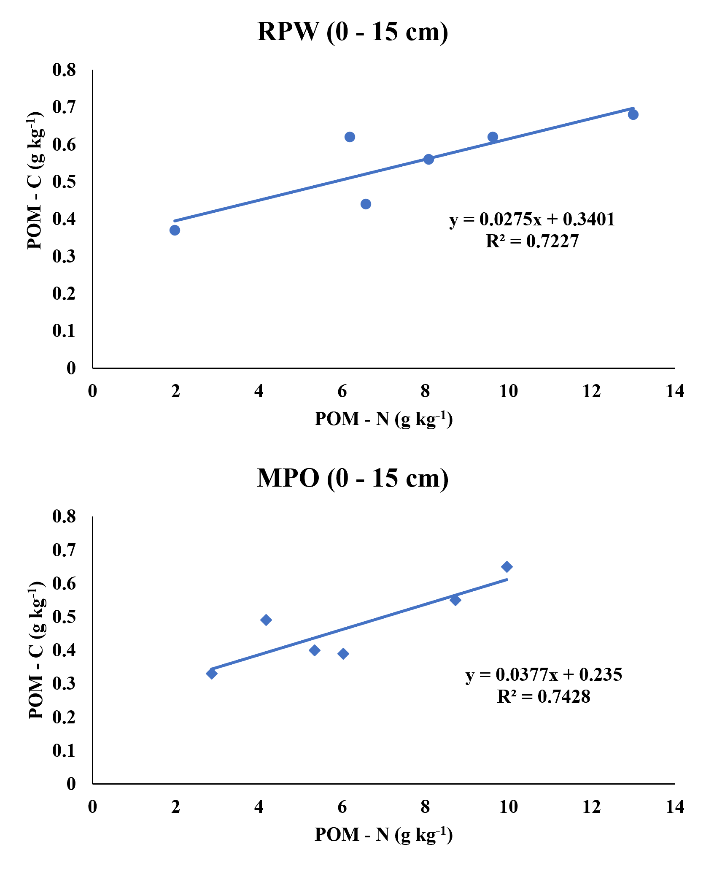
Figure S1. Correlation of POMC and POMN in top soil (0-15 cm) under rice-potato-wheat (RPW) and maize-potato-onion (MPO) cropping systems
Note: POM-C: Particulate Organic Matter Carbon; POM-N: Particulate Organic Matter Nitrogen

