Supplementary material

**Is Australia weird? A cross-continental comparison of biological, geological and climatological features**

Habacuc Flores-Moreno, Rhiannon L Dalrymple, Will K Cornwell, Gordana Popovic, Shinichi Nakagawa, Joe Atkinson, Julia Cooke, Shawn W Laffan, Stephen P Bonser, Lisa E Schwanz, Angela J Crean, David J Eldridge, Michael Garratt, Robert C Brooks, Adriana Vergés, Alistair GB Poore, David R Cohen, Graeme F Clark, Alex Sen Gupta, Peter B Reich, J Hans C Cornelissen, Joseph M Craine, Frank A. Hemmings, Ülo Niinemets, Josep Peñuelas, Angela T Moles

*File contains:*

Supplementary Materials and Methods

Supplementary References

Tables S1-S7

Figures S1-S19

Supplementary Materials and Methods

Data

We compiled global datasets on soil geochemistry, edaphic attributes, climate (marine and terrestrial), plant traits, animal traits (birds and mammals), terrestrial gross primary productivity (GPP), net primary productivity (NPP; marine and terrestrial), frequency of fire, rates of litter decomposition and rates of marine herbivory for six continents. Overall, our study encompasses data on 85 abiotic and biotic characteristics on a global scale (Table S1 lists all dependent variables, whether they are spatially explicit or not, units, sample size, as well as χ2, P-values and False Discovery Rate (FDR) corrected P-values for the tests). These datasets were the largest, most complete datasets available at the time. Climate, soil edaphology and productivity datasets have the highest global coverage; marine herbivory and decomposition have the lowest global coverage. We have selected datasets with good global coverage, some of which are derived from direct sampling, and others are modelled gridded datasets based on available information. We acknowledge that for many datasets, coverage of data will be variable in different parts of the world (please refer to the primary sources for more details on each).

We derived a terrestrial global map of geographical units greater than 1,000,000 km2 (Figure S1). For the marine environment, we derived marine continental areas from the Marine Ecoregions of the World Map (Spalding et al., 2007) (Figure S1). From this marine map, we only included geographic units that were no more than 200 km away from a continental land mass. Some of the datasets included in our study contain geographical coordinates. For these datasets, we assigned continent of origin to their replicates using their geographical coordinates. For assigning continent of origin to the birds and mammals datasets we used the IUCN species ranges list (IUCN, 2014).

*Terrestrial climate.* Terrestrial climate data was obtained from a 10 minute resolution (approximately 18.5 km at the equator) gridded data set (New et al., 2002). We extracted data on diurnal temperature range, number of frost cover days, precipitation, number of wet days, sunshine percent, mean annual temperature, mean wind speed velocity, interannual variation in precipitation, number of rainy days in driest month and mean annual maximum temperature. Data on mean annual precipitation (MAP) and potential evapotranspiration (PET) used to calculate aridity were obtained from the updated version from this gridded dataset (Harris et al., 2014).

*Marine Climate and nutrient.* We obtained monthly averaged SST temperature at a ¼° resolution (approximately 25 km) for 1982-2014 from NOAA SST OI v2 (Reynolds et al., 2002). We extracted Mean nitrate, phosphate and silicate data at 1° resolution from the world ocean atlas 2009 (Garcia et al., 2010).

*Stream sediment geochemistry.* We were able to obtained sediment geochemical data for Australia (de Caritat et al., 2012), Europe (De Vos et al., 2006), North America (Smith, 1997), China (that represents ~21% of the land surface area of continental Asia; Liu et al., 2015), and eastern Brazil (that is ~4% of the land surface area of South America; Lins et al., 2005) . For these databases, a 1.5 to 2-mm or <2mm fraction of the stream sediments was collected and total multi-element geochemical analysis performed using a combination of X-ray fluorescence spectrometry, instrumental neutron activation analysis or mixed acid digestion followed by ICP-MS or other spectrometric methods. Major trace elements were included in the database.

*Soils edaphic properties.* Soil data for the 30 top cm of soil were extracted from a global dataset gridded to a 0.5 minute resolution (Harmonised World Soils database version 1.2; Nachtergaele et al., 2008). We randomly subsampled 500,000 rows and ran the analyses on this subset of data.

*Soil Phosphorus.* Data for organic phosphorus, secondary phosphorus and labile inorganic phosphorus were extracted from a 0.5 minute resolution dataset for the top 50 cm of soil (Yang et al., 2014). In this dataset soil phosphorus information was derived using a combination of databases on parent material from global lithology maps, and soil P measurements as well as current models of P transformation during pedogenesis (Yang et al., 2014). For the global scope of our study the Yang et al. (2014) dataset represented the best available option. However, results should be viewed with caution as although currently conversion factors in soil P measurement exist, these are region specific and no consistent pH-threshold for soil P among regions exist as of now. These data have no explicit temporal component, but nominally were derived for the preindustrial period ca. 1850 (Yang et al., 2014). Data for total soil phosphorus were extracted from He et al. (2021) at a 0.5°degree resolution (~ 55 km)

*Soil Nitrogen.* Data on soil total nitrogen was obtained from the ISRIC-WISE Harmonized Global Soil Profile dataset (Batjes, 2009). This database contains reclassified soil profiles descriptions according to the legend of the soil map of the world (Batjes, 2009). Soil profiles included in this dataset come from the period 1925-2005 and for the specific subset of the data used in this study have a median maximum depth of 140 cm (Batjes, 2009).

*Plants.* We compiled data for all plant traits from the TRY database (Kattge et al., 2011) and source studies therein (Shipley, 1995; Cornelissen, 1996; Bahn et al., 1999; Hickler, 1999; Medlyn et al., 1999; Medlyn and Jarvis, 1999; Niinemets, 1999; Pyankov et al., 1999; Fonseca et al., 2000; Medlyn et al., 2001; Niinemets, 2001; Shipley and Vu, 2002; Anand et al., 2003; Cornelissen et al., 2003; McDonald et al., 2003; Ogaya and Peñuelas, 2003; Pillar and Sosinski, 2003; Quested et al., 2003; Cornelissen et al., 2004; Díaz et al., 2004; Wright et al., 2004; Bakker et al., 2005; Louault et al., 2005; Overbeck, 2005; Bakker et al., 2006; Cavender-Bares et al., 2006; Cornwell et al., 2006; Kazakou et al., 2006; Ogaya and Penuelas, 2006; Preston et al., 2006; Wright et al., 2006; Ackerly and Cornwell, 2007; Blanco et al., 2007; Duarte et al., 2007; Garnier et al., 2007; Müller et al., 2007; Ogaya and Peñuelas, 2007; Overbeck and Pfadenhauer, 2007; Swaine, 2007; Wright et al., 2007; Cornwell et al., 2008a; Kleyer et al., 2008; Kurokawa and Nakashizuka, 2008; Ogaya and Peñuelas, 2008; Pakeman et al., 2008; Reich et al., 2008; Sardans et al., 2008a; Sardans et al., 2008b; Shiodera et al., 2008; van Bodegom et al., 2008; Baker et al., 2009; Cornwell and Ackerly, 2009; Craine et al., 2009; Fortunel et al., 2009; Fyllas et al., 2009; Kattge et al., 2009; Pakeman et al., 2009; Patiño et al., 2009; Poorter et al., 2009; Poorter, 2009; Reich et al., 2009; Freschet et al., 2010b; a; Laughlin et al., 2010; Messier et al., 2010; Ordoñez et al., 2010a; Ordoñez et al., 2010b; Peñuelas et al., 2010a; Peñuelas et al., 2010b; Willis et al., 2010; Wright et al., 2010; Onoda et al., 2011; Gutiérrez and Huth, 2012). We used data for seven continuous plant traits (specific leaf area, plant height, seed mass, leaf area, leaf Nmass, leaf Pmass, and leaf Cmass) and six binary plant traits (possession of compound vs simple leaves, evergreen vs deciduous leaf phenology, woody vs herbaceous growth form, C3 vs C4 or CAM photosynthetic pathway, biotic vs abiotic seed dispersal, and ability to fix nitrogen or not). The TRY data were supplemented with data from previous compilations on plant height (Moles et al., 2009), seed mass (Moles et al., 2007), and woody vs herbaceous growth form (Zanne et al., 2014). Appendix S1 lists the original publications associated with the TRY records used. The replicates in the analyses were species-site combinations, where “sites” were defined as 0.1° grid squares. Where we had multiple observations for the same trait for a species within the same 0.1° grid square, we used the geometric mean to calculate a single species-site combination, with the exception of plant height, for which we used the maximum value (to avoid problems associated with the indeterminate growth of plants, and the fact that the majority of individuals of each species are small seedlings or juvenile plants, as per Moles et al. (2009)).

*Mammals and Birds.* We collected data for mammals and birds life history characteristics. For mammals we collected data on adult body mass, age at first reproduction, maximum longevity, neonatal mass, weaning mass, litter size, litters per year, and basal metabolic rate from Jones et al. (2009).  For the mammals database, we calculated mass-specific production rates of neonates (Annual production rate to birth) and weaned offspring (annual production rate to weaning) following Sibly and Brown (2007). We only included terrestrial mammals in our analysis because Australia has only one freshwater mammal, the platypus, and because marine mammals move between Australia and other continents. Neither of these allow for a fair comparison with other continents; the former predetermines difference and the later similarity.

For birds, we collected data on adult body mass (for females) from Lislevand et al. (2007) and data on sexual maturity, growth rate, maximum longevity, clutch size, clutches per year, hatch mass, and egg mass from the ANAGE database (De Magalhaes and Costa, 2009). For birds, we calculated hatching productivity, as the product of hatch mass by clutch size by clutches per year, divided by adult body mass.

*NPP and GPP.* Net primary production andterrestrial gross primary production data were collected from the 0.5 minutes resolution MOD17A3 gridded dataset (Zhao et al., 2005). Marine NPP is a derived product based on MODIS chlorophyll and temperature data and SeaWiFS photosynthetically available radiation (Behrenfeld and Falkowski, 1997). The terrestrial GPP and NPP data were averaged for the period from 2000-2013.

*Marine herbivory.* We obtained estimates of the impact of marine herbivores from the global synthesis of 613 grazer exclusion experiments in Poore et al.(2012). The degree to which herbivores control primary producers (algae and seagrasses) was calculated as the log response ratio of biomass or % cover of those producers in the absence of herbivores divided by the same metric in the presence of herbivores (Poore et al., 2012).

*Decomposition.* We obtained data on decomposition rates (*k*) from Cornwell et al. (2008b). The species decomposition constant (*k*) was calculated from species-site combination data on percent mass loss for each successive harvest, and decomposition constants (k) were calculated for each species-experiment combination (Cornwell et al., 2008b).

*Fire*. Frequency of fire was determined from MODIS derived burnt area data (MCD64 product; Giglio et al., 2016), downloaded for the period November 2000 to August 2019. The sum of fire events across the time series for each cell was calculated. We then extracted the sum of fire events within a 100 km radius of each of site locations; where data was NA for a site, fire frequency of 0 was allocated.

Analyses

Our main aim was to determine whether 85 features of Australia’s biotic and abiotic environment were distinctive from those of other continents. The six continents we have compared are as follows: Africa, Asia, Australia, Europe, North America, South America.

*Regression analyses.* The databases used for our comparison can be divided into two groups: spatially explicit databases, where every record has assigned latitude and longitude, and non-spatial databases, where records are assigned to a continent. For each variable in both types of datasets, we ran linear mixed effect models with a fixed effect for *Australia-ness* (whether or not the observations belong to the Australian continent) and a random effect for continent. For the spatially explicit data, we used Akaike information criterion (AIC) values to identify the best spatial correlation structure (i.e. Spherical, Exponential, Gaussian, Linear, Rational) for each variable. Then we used the selected correlation structure for each observation in each continent to account for the effect of spatial autocorrelation between observations. For both, the spatially explicit and non-spatial analyses, we calculated P-values for the univariate models using likelihood ratio statistics (Table S1, S2). We used the False discovery rate test to control for multiple testing (Table S1, S2), however P-values reported in the main text are not corrected for multiple testing.

All spatial data was accessed, not in raw form, but interpolated over a grid. Although the analyses we have carried out do not explicitly account for this, it does account for the spatial correlation such processing induces. Data are available at several grid levels and we took a random subsample of these data, with the size of the sample being the largest which allowed analyses to be done in standard R packages (~ 500,000 rows). We found no systematic effect of different samples when spatial correlation is taken into account.

*KSI distinctiveness index*

To compare how distinct each continent is to the global mean for our different variables, we calculated a KSI index (Cornwell et al., 2014).

$$D_{i,j}= max⁡|{F\left(x\right)}_{i}- {F\left(x\right)}_{j}|$$

This test compares the distribution between a continent and every other continent based on the maximum difference in their cumulative distributions Fi(x) and Fj(x). Then the likelihood that the two distributions come from the same underlying distribution is then a monotonic function of the KSI test

$$I_{i,j}= \sqrt{\left(\frac{n_{i}*n_{j}}{n_{i}+n_{j}}\right)* D_{i,j}}$$

where ni and nj are the number of samples in the two groups (Kolmogoroff, 1933). With increasing values of I, it becomes increasingly unlikely that samples in the continent of interest come from the same underlying distribution as samples in the global distribution. We then compare I for all continents. The continents with the largest value of I has the highest probability of differing in its values distribution to the rest of the continents and as such is the most distinctive.

*Z-values analyses.* To compare how different each continent is to the global mean for our different variables, we calculated z-scores for each variable. We did this for all the variables in each category (i.e. geochemistry, soil edaphological properties, terrestrial climate, plants, animals and ecosystem processes).  Z-scores are calculated as $z= {{\overset{_}{x}}_{Continent}- {\overset{_}{x}}_{Global}}/{2×{SD}_{Global}}$  (Gelman, 2008) where ‘ ${\overset{_}{x}}_{Global}$ is global data for the variable, including the data for the ‘ ${\overset{_}{x}}_{Continent}$. Australian data is included in calculating the global means.  We standardised the z-scores for each variable relative to the global mean and variance for that particular variable. To explore if Australia tends to be more different overall from the other continents, we applied non-parametric Kruskal-Wallis test to the absolute value of these z-scores. We then applied a post-hoc Dunn’s multiple comparison non-parametric test to identify the patterns of similarity and differences between all of the continents. If Australia is more distinct overall (i.e. being more different to the global means of the variables), we would expect to see significant difference between continents, and that differences in pair-wise comparisons with Australia are driving this. To plot how similar continents are among each other, we calculated the correlation values for the z-scores among each continent pair for each trait category within each of the major datasets. We only plotted correlations with r ≥ 0.45.

*Biogeographic realm*

We also ran these analyses using biogeographic realms as the units of comparison (instead of continent). The biogeographic realms we have compared follow Holt et al. (2013) for terrestrial datasets and Costello et al. (2017) for marine datasets. Analyses comparing biogeographic realms could not be run on bird or mammal data as these datasets were non-spatial and animals were assigned to continent in which they were endemic, and these data could not be split into biogeographic realms in those continents where there are multiple realms.

We have applied the linear mixed effect models described above, using biogeographic realms as the unit of comparison and random effect, rather than continent. When biogeographic realm was included in the linear mixed effect models, Australia was significantly different from the other realms in 15 of 74 variables, which reduced to five after correction for multiple testing (concentration of manganese, magnesium, sodium and copper in the soil, and nitrogen concentration per unit leaf mass; Table S1, S2; Figs. S10–S16).

The distinctiveness analyses using the KSI test shows that the Australian (n = 21) and Palearctic realms (n = 19) had the highest number of distinct variables among all realms (Table S5). Much like in the continental comparison, the Australian realm distinctiveness was mainly related to soil variables that relate to nutrient content (e.g. soil organic content, pH and bulk density) and functional traits of plants (N-fixing capacity, SLA and Leaf N). The Palearctic realm distinctiveness was related to the functional traits of plants (leaf phenology and life form), terrestrial climate (e.g. maximum and mean temperature, precipitation, diurnal temperature range) and geochemistry.

We also applied the Kruskall-Wallis comparison of absolute z scores to terrestrial biogeographic realms. These results do not support the notion that the Australian biogeographic realm more different from global means than the other realms. There are significant differences between terrestrial realms (P < 0.0001) of the world in how much they vary from the global mean, but post-hoc testing reveal that the differences are mostly not driven by Australia (Table S7; Fig. S18). We found no significant differences between marine realms (P = 0.72; Fig S19) .

**References**

Ackerly, D.D., and Cornwell, W.K. (2007). A trait-based approach to community assembly: partitioning of species trait values into within- and among-community components. *Ecology Letters* 10(2)**,** 135-145. doi: 10.1111/j.1461-0248.2006.01006.x.

Anand, M., Ma, K., and Okonski, A. (2003). The Science of the Total Environment 311. 247-259.

Bahn, M., Wohlfahrt, G., Haubner, E., Horak, I., Michaeler, W., Rottmar, K., et al. (1999). Leaf photosynthesis, nitrogen contents and specific leaf area of 30 grassland species in differently managed mountain ecosystems in the Eastern Alps. Pages 247-255 in A. Cernusca, U. Tappeiner, and N. Bayfield, editors. Land-use changes in European mountain ecosystems. ECOMONT- Concept and Results. Blackwell Wissenschaft, Berlin.

Baker, T.R., Phillips, O.L., Laurance, W.F., Pitman, N.C.A., Almeida, S., Arroyo, L., et al. (2009). Do species traits determine patterns of wood production in Amazonian forests? *Biogeosciences* 6**,** 297-307.

Bakker, C., Bodegom, P.M., Nelissen, H.J.M., Ernst, W.H.O., and Aerts, R. (2006). Plant responses to rising water tables and nutrient management in calcareous dune slacks. *Plant Ecology* 185(1)**,** 19-28. doi: 10.1007/s11258-005-9080-5.

Bakker, C., Rodenburg, J., and Bodegom, P.M. (2005). Effects of Ca- and Fe-rich Seepage on P Availability and Plant Performance in Calcareous Dune Soils. *Plant and Soil* 275(1-2)**,** 111-122. doi: 10.1007/s11104-005-0438-1.

Batjes, N. (2009). Harmonized soil profile data for applications at global and continental scales: updates to the WISE database. *Soil Use and Management* 25(2)**,** 124-127.

Behrenfeld, M.J., and Falkowski, P.G. (1997). Photosynthetic rates derived from satellite‐based chlorophyll concentration. *Limnology and oceanography* 42(1)**,** 1-20.

Blanco, C.C., Sosinski, E.E., dos Santos, B.R.C., da Silva, M.A., and Pillar, V.D. (2007). On the overlap between effect and response plant functional types linked to grazing. *Community Ecology* 8**,** 57-65.

Cavender-Bares, J., Keen, A., and Miles, B. (2006). Phylogenetic structure of floridian plant communities depends on taxonomic and spatial scale. *Ecology* 87(sp7)**,** S109-S122. doi: 10.1890/0012-9658(2006)87[109:PSOFPC]2.0.CO;2.

Cornelissen, J.H.C. (1996). An Experimental Comparison of Leaf Decomposition Rates in a Wide Range of Temperate Plant Species and Types. *Journal of Ecology* 84(4)**,** 573-582. doi: 10.2307/2261479.

Cornelissen, J.H.C., Cerabolini, B., Castro-Díez, P., Villar-Salvador, P., Montserrat-Martí, G., Puyravaud, J.P., et al. (2003). Functional traits of woody plants: correspondence of species rankings between field adults and laboratory-grown seedlings? *Journal of Vegetation Science* 14(3)**,** 311-322. doi: 10.1111/j.1654-1103.2003.tb02157.x.

Cornelissen, J.H.C., Quested, H.M., Gwynn-Jones, D., Van Logtestijn, R.S.P., De Beus, M.A.H., Kondratchuk, A., et al. (2004). Leaf digestibility and litter decomposability are related in a wide range of subarctic plant species and types. *Functional Ecology* 18(6)**,** 779-786. doi: 10.1111/j.0269-8463.2004.00900.x.

Cornwell, W.K., and Ackerly, D.D. (2009). Community assembly and shifts in plant trait distributions across an environmental gradient in coastal California. *Ecological Monographs* 79(1)**,** 109-126. doi: 10.1890/07-1134.1.

Cornwell, W.K., Cornelissen, J.H.C., Amatangelo, K., Dorrepaal, E., Eviner, V.T., Godoy, O., et al. (2008a). Plant species traits are the predominant control on litter decomposition rates within biomes worldwide. *Ecology Letters* 11(10)**,** 1065-1071. doi: 10.1111/j.1461-0248.2008.01219.x.

Cornwell, W.K., Cornelissen, J.H.C., Amatangelo, K., Dorrepaal, E., Eviner, V.T., Godoy, O., et al. (2008b). Plant species traits are the predominant control on litter decomposition rates within biomes worldwide. *Ecology letters* 11(10)**,** 1065-1071.

Cornwell, W.K., Schwilk, D.W., and Ackerly, D.D. (2006). A trait-based test for habitat filtering: Convex Hull Volume. *Ecology* 87(6)**,** 1465-1471. doi: 10.1890/0012-9658(2006)87[1465:ATTFHF]2.0.CO;2.

Cornwell, W.K., Westoby, M., Falster, D.S., FitzJohn, R.G., O'Meara, B.C., Pennell, M.W., et al. (2014). Functional distinctiveness of major plant lineages. *Journal of Ecology* 102(2)**,** 345-356. doi: <https://doi.org/10.1111/1365-2745.12208>.

Costello, M.J., Tsai, P., Wong, P.S., Cheung, A.K.L., Basher, Z., and Chaudhary, C. (2017). Marine biogeographic realms and species endemicity. *Nature Communications* 8(1)**,** 1057. doi: 10.1038/s41467-017-01121-2.

Craine, J.M., Elmore, A.J., Aidar, M.P.M., Bustamante, M., Dawson, T.E., Hobbie, E.A., et al. (2009). Global patterns of foliar nitrogen isotopes and their relationships with climate, mycorrhizal fungi, foliar nutrient concentrations, and nitrogen availability. *New Phytologist* 183(4)**,** 980-992. doi: 10.1111/j.1469-8137.2009.02917.x.

de Caritat, P., Reimann, C., NGSA Project Team, and GEMAS Project Team (2012). Comparing results from two continental geochemical surveys to world soil composition and deriving Predicted Empirical Global Soil (PEGS2) reference values. *Earth and Planetary Science Letters* 319–320**,** 269-276. doi: <http://dx.doi.org/10.1016/j.epsl.2011.12.033>.

De Magalhaes, J.P., and Costa, J. (2009). A database of vertebrate longevity records and their relation to other life‐history traits. *Journal of evolutionary biology* 22(8)**,** 1770-1774.

De Vos, W., Tarvainen, T., Salminen, R., Reeder, S., De Vivo, B., Demetriades, A., et al. (2006). *Geochemical Atlas of Europe: Part 2: Interpretation of geochemical maps, additional tables, figures, maps, and related publications.* Geological Survey of Finland.

Díaz, S., Hodgson, J.G., Thompson, K., Cabido, M., Cornelissen, J.H.C., Jalili, A., et al. (2004). The plant traits that drive ecosystems: Evidence from three continents. *Journal of Vegetation Science* 15(3)**,** 295-304. doi: 10.1111/j.1654-1103.2004.tb02266.x.

Duarte, L.d.S., Carlucci, M.B., Hartz, S.M., and Pillar, V.D. (2007). Plant dispersal strategies and the colonization of Araucaria forest patches in a grassland-forest mosaic. *Journal of Vegetation Science* 18(6)**,** 847-858. doi: 10.1111/j.1654-1103.2007.tb02601.x.

Falster, D., Gallagher, R., Wenk, E.H., Wright, I.J., Indiarto, D., Andrew, S.C., et al. (2021). AusTraits, a curated plant trait database for the Australian flora. *Scientific Data* 8(1)**,** 254. doi: 10.1038/s41597-021-01006-6.

Fonseca, C.R., Overton, J.M., Collins, B., and Westoby, M. (2000). Shifts in trait-combinations along rainfall and phosphorus gradients. *Journal of Ecology* 88(6)**,** 964-977. doi: 10.1046/j.1365-2745.2000.00506.x.

Fortunel, C., Garnier, E., Joffre, R., Kazakou, E., Quested, H., Grigulis, K., et al. (2009). Leaf traits capture the effects of land use changes and climate on litter decomposability of grasslands across Europe. *Ecology* 90(3)**,** 598-611. doi: 10.1890/08-0418.1.

Freschet, G.T., Cornelissen, J.H.C., Van Logtestijn, R.S.P., and Aerts, R. (2010a). Evidence of the ‘plant economics spectrum’ in a subarctic flora. *Journal of Ecology* 98(2)**,** 362-373. doi: 10.1111/j.1365-2745.2009.01615.x.

Freschet, G.T., Cornelissen, J.H.C., van Logtestijn, R.S.P., and Aerts, R. (2010b). Substantial nutrient resorption from leaves, stems and roots in a subarctic flora: what is the link with other resource economics traits? *New Phytologist* 186(4)**,** 879-889. doi: 10.1111/j.1469-8137.2010.03228.x.

Fyllas, N.M., Patino, S., Baker, T.R., Bielefeld Nardoto, G., Martinelli, L.A., Quesada, C.A., et al. (2009). Basin-wide variations in foliar properties of Amazonian forest: phylogeny, soils and climate *Biogeosciences* 6**,** 2677-2708.

Garcia, H., Locarnini, R., Boyer, T., and Antonov, J. (2010). World Ocean Atlas 2009, vol. 4, Nutrients (Phosphate, Nitrate, Silicate), NOAA Atlas NESDIS, vol. 71. *US Gov. Print. Off., Washington, DC*.

Garnier, E., Lavorel, S., Ansquer, P., Castro, H., Cruz, P., Dolezal, J., et al. (2007). Assessing the Effects of Land-use Change on Plant Traits, Communities and Ecosystem Functioning in Grasslands: A Standardized Methodology and Lessons from an Application to 11 European Sites. *Annals of Botany* 99(5)**,** 967-985. doi: 10.1093/aob/mcl215.

Gelman, A. (2008). Scaling regression inputs by dividing by two standard deviations. *Statistics in medicine* 27(15)**,** 2865-2873.

Giglio, L., Boschetti, L., Roy, D., Hoffmann, A.A., and Humber, M. (2016). Collection 6 MODIS Burned Area Product User’s Guide Version 1.0. *NASA EOSDIS Land Processes DAAC: Sioux Falls, SD, USA*.

Gutiérrez, A.G., and Huth, A. (2012). Successional stages of primary temperate rainforests of Chiloé Island, Chile. *Perspectives in Plant Ecology, Evolution and Systematics* 14(4)**,** 243-256. doi: <http://dx.doi.org/10.1016/j.ppees.2012.01.004>.

Harris, I., Jones, P., Osborn, T., and Lister, D. (2014). Updated high‐resolution grids of monthly climatic observations–the CRU TS3. 10 Dataset. *International Journal of Climatology* 34(3)**,** 623-642.

He, X., Augusto, L., Goll, D.S., Ringeval, B., Wang, Y., Helfenstein, J., et al. (2021). Global patterns and drivers of soil total phosphorus concentration. *Earth Syst. Sci. Data* 13(12)**,** 5831-5846. doi: 10.5194/essd-13-5831-2021.

Hickler, T. (1999). Plant functional types and community characteristics along environmental gradients on Öland's Great Alvar (Sweden) Masters Thesis, University of Lund, Sweden.

Holt, B.G., Lessard, J.-P., Borregaard, M.K., Fritz, S.A., Araújo, M.B., Dimitrov, D., et al. (2013). An Update of Wallace’s Zoogeographic Regions of the World. *Science* 339(6115)**,** 74. doi: 10.1126/science.1228282.

IUCN (2014). "The IUCN Red List of Threatened Species.Version 2014.1".).

Kate E. Jones, J.B., Marcel Cardillo, Susanne A. Fritz, Justin O'Dell, C. David L. Orme, Kamran Safi, Wes Sechrest, Elizabeth H. Boakes, Chris Carbone, Christina Connolly, Michael J. Cutts, Janine K. Foster, Richard Grenyer, Michael Habib, Christopher A. Plaster, Samantha A. Price, Elizabeth A. Rigby, Janna Rist, Amber Teacher, Olaf R. P. Bininda-Emonds, John L. Gittleman, Georgina M. Mace, and Andy Purvis. (2009). PanTHERIA: a species-level database of life history, ecology, and geography of extant and recently extinct mammals. *Ecology* 90(2648).

Kattge, J., Diaz, S., Lavorel, S., Prentice, I.C., Leadley, P., Bönisch, G., et al. (2011). TRY–a global database of plant traits. *Global change biology* 17(9)**,** 2905-2935.

Kattge, J., Knorr, W., Raddatz, T., and Wirth, C. (2009). Quantifying photosynthetic capacity and its relationship to leaf nitrogen content for global-scale terrestrial biosphere models. *Global Change Biology* 15(4)**,** 976-991. doi: 10.1111/j.1365-2486.2008.01744.x.

Kazakou, E., Vile, D., Shipley, B., Gallet, C., and Garnier, E. (2006). Co-variations in litter decomposition, leaf traits and plant growth in species from a Mediterranean old-field succession. *Functional Ecology* 20(1)**,** 21-30. doi: 10.1111/j.1365-2435.2006.01080.x.

Kleyer, M., Bekker, R.M., Knevel, I.C., Bakker, J.P., Thompson, K., Sonnenschein, M., et al. (2008). The LEDA Traitbase: a database of life-history traits of the Northwest European flora. *Journal of Ecology* 96(6)**,** 1266-1274. doi: 10.1111/j.1365-2745.2008.01430.x.

Kolmogoroff, A. (1933). *Grundbegriffe der wahrscheinlichkeitsrechnung.* Berlin: Julius Springer.

Kurokawa, H., and Nakashizuka, T. (2008). Leaf herbivory and decomposability in a Malaysian tropical rainforest. *Ecology* 89(9)**,** 2645-2656. doi: 10.1890/07-1352.1.

Laughlin, D.C., Leppert, J.J., Moore, M.M., and Sieg, C.H. (2010). A multi-trait test of the leaf-height-seed plant strategy scheme with 133 species from a pine forest flora. *Functional Ecology* 24(3)**,** 493-501. doi: 10.1111/j.1365-2435.2009.01672.x.

Lins, C., de Souza, F., de Oliveira, J., and Frizzo, S. (2005). International Geochemical Mapping Pilot Project. *CPRM-Geological Survey of Brazil,(480 pp.* [*http://www.cprm.gov.br/publique/media/rel_mapa_geoquimico.pdf*](http://www.cprm.gov.br/publique/media/rel_mapa_geoquimico.pdf) *(last access 5 March 2014))*.

Lislevand, T., Figuerola, J., and Székely, T. (2007). Avian body sizes in relation to fecundity, mating system, display behavior, and resource sharing. *Ecology* 88(6)**,** 1605-1605.

Liu, X., Wang, X., de Caritat, P., and Salminen, R. (2015). Reprint of" Comparison of datasets obtained by global-scale geochemical sampling in Australia, China and Europe". *Journal of Geochemical Exploration* 154**,** 6-16.

Louault, F., Pillar, V.D., Aufrère, J., Garnier, E., and Soussana, J.F. (2005). Plant traits and functional types in response to reduced disturbance in a semi-natural grassland. *Journal of Vegetation Science* 16(2)**,** 151-160. doi: 10.1111/j.1654-1103.2005.tb02350.x.

McDonald, P.G., Fonseca, C.R., Overton, J.M., and Westoby, M. (2003). Leaf-size divergence along rainfall and soil-nutrient gradients: is the method of size reduction common among clades? *Functional Ecology* 17(1)**,** 50-57. doi: 10.1046/j.1365-2435.2003.00698.x.

Medlyn, B.E., Badeck, F.W., De Pury, D.G.G., Barton, C.V.M., Broadmeadow, M., Ceulemans, R., et al. (1999). Effects of elevated [CO2] on photosynthesis in European forest species: a meta-analysis of model parameters. *Plant, Cell & Environment* 22(12)**,** 1475-1495. doi: 10.1046/j.1365-3040.1999.00523.x.

Medlyn, B.E., Barton, C.V.M., Broadmeadow, M.S.J., Ceulemans, R., De Angelis, P., Forstreuter, M., et al. (2001). Stomatal conductance of forest species after long-term exposure to elevated CO2 concentration: a synthesis. *New Phytologist* 149(2)**,** 247-264. doi: 10.1046/j.1469-8137.2001.00028.x.

Medlyn, B.E., and Jarvis, P.G. (1999). Design and use of a database of model parameters from elevated [CO2] experiments. *Ecological Modelling* 124(1)**,** 69-83. doi: <http://dx.doi.org/10.1016/S0304-3800(99)00148-9>.

Messier, J., McGill, B.J., and Lechowicz, M.J. (2010). How do traits vary across ecological scales? A case for trait-based ecology. *Ecology Letters* 13(7)**,** 838-848. doi: 10.1111/j.1461-0248.2010.01476.x.

Moles, A.T., Ackerly, D.D., Tweddle, J.C., Dickie, J.B., Smith, R., Leishman, M.R., et al. (2007). Global patterns in seed size. *Global Ecology and Biogeography* 16(1)**,** 109-116.

Moles, A.T., Warton, D.I., Warman, L., Swenson, N.G., Laffan, S.W., Zanne, A.E., et al. (2009). Global patterns in plant height. *Journal of Ecology* 97(5)**,** 923-932.

Müller, S., Overbeck, G., Pfadenhauer, J., and Pillar, V. (2007). Plant Functional Types of Woody Species Related to Fire Disturbance in Forest–Grassland Ecotones. *Plant Ecology* 189(1)**,** 1-14. doi: 10.1007/s11258-006-9162-z.

Nachtergaele, F., Van Velthuizen, H., Verelst, L., Batjes, N., Dijkshoorn, K., Van Engelen, V., et al. (2008). Harmonized world soil database. *Food and Agriculture Organization of the United Nations*.

New, M., Lister, D., Hulme, M., and Makin, I. (2002). A high-resolution data set of surface climate over global land areas. *Climate research* 21(1)**,** 1-25.

Niinemets, Ü. (1999). Components of leaf dry mass per area – thickness and density – alter leaf photosynthetic capacity in reverse directions in woody plants. *New Phytologist* 144(1)**,** 35-47. doi: 10.1046/j.1469-8137.1999.00466.x.

Niinemets, Ü. (2001). Global-scale climatic controls of leaf dry mass per area, density, and thickness in trees and shrubs. *Ecology* 82(2)**,** 453-469. doi: 10.1890/0012-9658(2001)082[0453:GSCCOL]2.0.CO;2.

Ogaya, R., and Penuelas, J. (2006). Contrasting foliar responses to drought in Quercus ilex and Phillyrea latifolia. *Biologia Plantarum* 50(3)**,** 373-382. doi: 10.1007/s10535-006-0052-y.

Ogaya, R., and Peñuelas, J. (2003). Comparative field study of Quercus ilex and Phillyrea latifolia: photosynthetic response to experimental drought conditions. *Environmental and Experimental Botany* 50(2)**,** 137-148. doi: <http://dx.doi.org/10.1016/S0098-8472(03)00019-4>.

Ogaya, R., and Peñuelas, J. (2007). Tree growth, mortality, and above-ground biomass accumulation in a holm oak forest under a five-year experimental field drought. *Plant Ecology* 189(2)**,** 291-299. doi: 10.1007/s11258-006-9184-6.

Ogaya, R., and Peñuelas, J. (2008). Changes in leaf δ13C and δ15N for three Mediterranean tree species in relation to soil water availability. *Acta Oecologica* 34(3)**,** 331-338. doi: <http://dx.doi.org/10.1016/j.actao.2008.06.005>.

Onoda, Y., Westoby, M., Adler, P.B., Choong, A.M.F., Clissold, F.J., Cornelissen, J.H.C., et al. (2011). Global patterns of leaf mechanical properties. *Ecology Letters* 14(3)**,** 301-312. doi: 10.1111/j.1461-0248.2010.01582.x.

Ordoñez, J.C., van Bodegom, P.M., Witte, J.-P.M., Bartholomeus, R.P., van Dobben, H.F., and Aerts, R. (2010a). Leaf habit and woodiness regulate different leaf economy traits at a given nutrient supply. *Ecology* 91(11)**,** 3218-3228. doi: 10.1890/09-1509.1.

Ordoñez, J.C., van Bodegom, P.M., Witte, J.P.M., Bartholomeus, R.P., van Hal, J.R., and Aerts, R. (2010b). Plant Strategies in Relation to Resource Supply in Mesic to Wet Environments: Does Theory Mirror Nature? *The American Naturalist* 175(2)**,** 225-239. doi: 10.1086/649582.

Overbeck, G.E. (2005). Effect of fire on vegetation dynamics and plant types in subtropical grassland in southern Brazil. Department für Ökologie. PhD Thesis Technische Universität München, Freising.

Overbeck, G.E., and Pfadenhauer, J. (2007). Adaptive strategies in burned subtropical grassland in southern Brazil. *Flora* 202**,** 27-49.

Pakeman, R.J., Garnier, E., Lavorel, S., Ansquer, P., Castro, H., Cruz, P., et al. (2008). Impact of abundance weighting on the response of seed traits to climate and land use. *Journal of Ecology* 96(2)**,** 355-366. doi: 10.1111/j.1365-2745.2007.01336.x.

Pakeman, R.J., Lepš, J., Kleyer, M., Lavorel, S., Garnier, E., and the, V.c. (2009). Relative climatic, edaphic and management controls of plant functional trait signatures. *Journal of Vegetation Science* 20(1)**,** 148-159. doi: 10.1111/j.1654-1103.2009.05548.x.

Patiño, S., Lloyd, J., Paiva, R., Baker, T.R., Quesada, C.A., Mercado, L.M., et al. (2009). Branch xylem density variations across the Amazon Basin. *Biogeosciences* 6**,** 545-568.

Peñuelas, J., Sardans, J., LlusiÀ, J., Owen, S.M., Carnicer, J., Giambelluca, T.W., et al. (2010a). Faster returns on ‘leaf economics’ and different biogeochemical niche in invasive compared with native plant species. *Global Change Biology* 16(8)**,** 2171-2185. doi: 10.1111/j.1365-2486.2009.02054.x.

Peñuelas, J., Sardans, J., Llusia, J., Owen, S.M., Silva, J., and Niinemets, Ü. (2010b). Higher Allocation to Low Cost Chemical Defenses in Invasive Species of Hawaii. *Journal of Chemical Ecology* 36(11)**,** 1255-1270. doi: 10.1007/s10886-010-9862-7.

Pillar, V.D., and Sosinski, E.E. (2003). An improved method for searching plant functional types by numerical analysis. *Journal of Vegetation Science* 14(3)**,** 323-332. doi: 10.1111/j.1654-1103.2003.tb02158.x.

Poore, A.G.B., Campbell, A.H., Coleman, R.A., Edgar, G.J., Jormalainen, V., Reynolds, P.L., et al. (2012). Global patterns in the impact of marine herbivores on benthic primary producers. *Ecology Letters* 15(8)**,** 912-922.

Poorter, H., Niinemets, Ü., Poorter, L., Wright, I.J., and Villar, R. (2009). Causes and consequences of variation in leaf mass per area (LMA): a meta-analysis. *New Phytologist* 182(3)**,** 565-588. doi: 10.1111/j.1469-8137.2009.02830.x.

Poorter, L. (2009). Leaf traits show different relationships with shade tolerance in moist versus dry tropical forests. *New Phytologist* 181(4)**,** 890-900. doi: 10.1111/j.1469-8137.2008.02715.x.

Preston, K.A., Cornwell, W.K., and DeNoyer, J.L. (2006). Wood density and vessel traits as distinct correlates of ecological strategy in 51 California coast range angiosperms. *New Phytologist* 170(4)**,** 807-818. doi: 10.1111/j.1469-8137.2006.01712.x.

Pyankov, V.I., Kondratchuk, A.V., and Shipley, B. (1999). Leaf structure and specific leaf mass: the alpine desert plants of the Eastern Pamirs, Tadjikistan. *New Phytologist* 143(1)**,** 131-142. doi: 10.1046/j.1469-8137.1999.00435.x.

Quested, H.M., Cornelissen, J.H.C., Press, M.C., Callaghan, T.V., Aerts, R., Trosien, F., et al. (2003). Decomposition of sub-Arctic plants with differing nitrogen economies: A functional role for hemiparasites. *Ecology* 84(12)**,** 3209-3221. doi: 10.1890/02-0426.

Reich, P., Oleksyn, J., and Wright, I. (2009). Leaf phosphorus influences the photosynthesis–nitrogen relation: a cross-biome analysis of 314 species. *Oecologia* 160(2)**,** 207-212. doi: 10.1007/s00442-009-1291-3.

Reich, P.B., Tjoelker, M.G., Pregitzer, K.S., Wright, I.J., Oleksyn, J., and Machado, J.-L. (2008). Scaling of respiration to nitrogen in leaves, stems and roots of higher land plants. *Ecology Letters* 11(8)**,** 793-801. doi: 10.1111/j.1461-0248.2008.01185.x.

Reynolds, R.W., Rayner, N.A., Smith, T.M., Stokes, D.C., and Wang, W. (2002). An improved in situ and satellite SST analysis for climate. *Journal of climate* 15(13)**,** 1609-1625.

Sardans, J., Peñuelas, J., and Ogaya, R. (2008a). Drought-Induced Changes in C and N Stoichiometry in a Quercus ilex Mediterranean Forest. *Forest Science* 54(5)**,** 513-522.

Sardans, J., Peñuelas, J., Prieto, P., and Estiarte, M. (2008b). Changes in Ca, Fe, Mg, Mo, Na, and S content in a Mediterranean shrubland under warming and drought. *Journal of Geophysical Research: Biogeosciences* 113(G3)**,** G03039. doi: 10.1029/2008JG000795.

Shiodera, S., Rahajoe, J.S., and Kohyama, T. (2008). Variation in longevity and traits of leaves among co-occurring understorey plants in a tropical montane forest. *Journal of Tropical Ecology* 24(02)**,** 121-133. doi: doi:10.1017/S0266467407004725.

Shipley, B. (1995). Structured Interspecific Determinants of Specific Leaf Area in 34 Species of Herbaceous Angiosperms. *Functional Ecology* 9(2)**,** 312-319. doi: 10.2307/2390579.

Shipley, B., and Vu, T.-T. (2002). Dry matter content as a measure of dry matter concentration in plants and their parts. *New Phytologist* 153(2)**,** 359-364. doi: 10.1046/j.0028-646X.2001.00320.x.

Sibly, R.M., and Brown, J.H. (2007). Effects of body size and lifestyle on evolution of mammal life histories. *Proceedings of the National Academy of Sciences* 104(45)**,** 17707-17712.

Smith, S.M. (1997). "National Geochemical Database reformatted data from the National Uranium Resource Evaluation (NURE) hydrogeochemical and stream sediment reconnaissance (HSSR) program". US Geological Survey, US Dept. of the Interior).

Spalding, M.D., Fox, H.E., Allen, G.R., Davidson, N., Ferdaña, Z.A., Finlayson, M.A.X., et al. (2007). Marine ecoregions of the world: a bioregionalization of coastal and shelf areas. *BioScience* 57(7)**,** 573-583.

Swaine, E.K. (2007). Ecological and evolutionary drivers of plant community assembly in a Bornean rain forest. PhD Thesis, University of Aberdeen, Aberdeen.

van Bodegom, P.M., Sorrell, B.K., Oosthoek, A., Bakker, C., and Aerts, R. (2008). Separating the effects of partial submergence and soil oxygen demand on plant physiology. *Ecology* 89(1)**,** 193-204. doi: 10.1890/07-0390.1.

Willis, C.G., Halina, M., Lehman, C., Reich, P.B., Keen, A., McCarthy, S., et al. (2010). Phylogenetic community structure in Minnesota oak savanna is influenced by spatial extent and environmental variation. *Ecography* 33(3)**,** 565-577. doi: 10.1111/j.1600-0587.2009.05975.x.

Wright, I.J., Ackerly, D.D., Bongers, F., Harms, K.E., Ibarra-Manriquez, G., Martinez-Ramos, M., et al. (2007). Relationships Among Ecologically Important Dimensions of Plant Trait Variation in Seven Neotropical Forests. *Annals of Botany* 99(5)**,** 1003-1015. doi: 10.1093/aob/mcl066.

Wright, I.J., Reich, P.B., Atkin, O.K., Lusk, C.H., Tjoelker, M.G., and Westoby, M. (2006). Irradiance, temperature and rainfall influence leaf dark respiration in woody plants: evidence from comparisons across 20 sites. *New Phytologist* 169(2)**,** 309-319. doi: 10.1111/j.1469-8137.2005.01590.x.

Wright, I.J., Reich, P.B., Westoby, M., Ackerly, D.D., Baruch, Z., Bongers, F., et al. (2004). The worldwide leaf economics spectrum. *Nature* 428(6985)**,** 821-827.

Wright, S.J., Kitajima, K., Kraft, N.J.B., Reich, P.B., Wright, I.J., Bunker, D.E., et al. (2010). Functional traits and the growth–mortality trade-off in tropical trees. *Ecology* 91(12)**,** 3664-3674. doi: 10.1890/09-2335.1.

Yang, X., Post, W.M., Thornton, P.E., and Jain, A. (2014). "Global gridded soil phosphorus distribution maps at 0.5-degree resolution", in: *Oak Ridge National Laboratory Distributed Active Archive Center.* (Oak Ridge, Tennessee, USA: Oak Ridge National Laboratory ).

Zanne, A.E., Tank, D.C., Cornwell, W.K., Eastman, J.M., Smith, S.A., FitzJohn, R.G., et al. (2014). Three keys to the radiation of angiosperms into freezing environments. *Nature* 506(7486)**,** 89-92.

Zhao, M., Heinsch, F.A., Nemani, R.R., and Running, S.W. (2005). Improvements of the MODIS terrestrial gross and net primary production global data set. *Remote sensing of Environment* 95(2)**,** 164-176.

|  |  |  |  |  |  |  |  |  |  |  |  |  |
| --- | --- | --- | --- | --- | --- | --- | --- | --- | --- | --- | --- | --- |
| Table S1. Comparison of abiotic characteristics between Australia and other continents (excluding Antarctica). | | | | | | | | | | | | |
|  |  |  |  |  |  | Continents | | | Biogeographic realms | | |
| Category | Database | Dependent variable | Spatially explicit | Units | n | χ2 | P-value | FDR-corrected P-value | χ2 | P-value | FDR-corrected P-value |
| Climate | Terrestrial climate | Diurnal temperature range | Yes | °C | 1755 | 3.09 | 0.079 | 0.249 | 3.09 | 0.039 | 0.241 |
| Climate | Terrestrial climate | No. days ground frost | Yes | days | 1755 | 1.25 | 0.264 | 0.510 | 1.44 | 0.231 | 0.611 |
| Climate | Terrestrial climate | Precipitation | Yes | mm | 1755 | 0.40 | 0.526 | 0.688 | 0.46 | 0.500 | 0.854 |
| Climate | Terrestrial climate | Wet days | Yes | days | 1755 | 0.32 | 0.573 | 0.727 | 0.01 | 0.904 | 0.924 |
| Climate | Terrestrial climate | Aridity | Yes | MAP/PET | 1548 | 0.70 | 0.404 | 0.629 | 0.56 | 0.456 | 0.854 |
| Climate | Terrestrial climate | Sunshine percent | Yes | % | 1755 | 2.13 | 0.144 | 0.350 | 0.94 | 0.331 | 0.720 |
| Climate | Terrestrial climate | Mean temperature | Yes | °C | 1755 | 0.60 | 0.437 | 0.629 | 0.40 | 0.526 | 0.854 |
| Climate | Terrestrial climate | Mean wind velocity | Yes | m s-1 | 1760 | 1.04 | 0.307 | 0.550 | 1.94 | 0.162 | 0.500 |
| Climate | Terrestrial climate | Interannual variation in precipitation | Yes | CV | 1755 | 0.18 | 0.668 | 0.767 | 0.03 | 0.857 | 0.924 |
| Climate | Terrestrial climate | Number of rainy days in driest month | Yes | days | 1755 | 0.22 | 0.639 | 0.765 | 0.04 | 0.847 | 0.924 |
| Climate | Terrestrial climate | Maximum temperature | Yes | °C | 1755 | 0.35 | 0.554 | 0.713 | 1.11 | 0.292 | 0.675 |
| Climate | Marine climate and nutrients | Mean sea surface temperature | Yes | °C | 1697 | 0.61 | 0.436 | 0.629 | 0.19 | 0.662 | 0.878 |
| Climate | Marine climate and nutrients | Mean nitrate concentration | Yes | µM l-1 | 1254 | 0.70 | 0.403 | 0.629 | 0.07 | 0.795 | 0.924 |
| Climate | Marine climate and nutrients | Mean phosphate concentration | Yes | µM l-1 | 1616 | 0.19 | 0.663 | 0.767 | 0.07 | 0.786 | 0.924 |
| Climate | Marine climate and nutrients | Mean silicate concentration | Yes | µM l-1 | 1422 | 0.94 | 0.332 | 0.564 | 0.69 | 0.405 | 0.789 |
| Geochemistry | Soil N | Total nitrogen | No | g m-2 | 17666 | 2.65 | 0.103 | 0.292 | 2.00 | 0.157 | 0.500 |
| Geochemistry | Soil P | Total phosphorus | Yes | g m-2 | 3397 | 2.75 | 0.097 | 0.292 | 1.26 | 0.261 | 0.652 |
| Geochemistry | Soil P | Secondary phosphorus | Yes | g m-2 | 1668 | 1.12 | 0.290 | 0.536 | 0.84 | 0.360 | 0.740 |
| Geochemistry | Soil P | Organic phosphorus | Yes | g m-2 | 1668 | 2.01 | 0.156 | 0.368 | 1.86 | 0.172 | 0.509 |
| Geochemistry | Soil P | Labile inorganic phosphorus | Yes | g m-2 | 1668 | 0.28 | 0.597 | 0.735 | 0.50 | 0.479 | 0.854 |
| Geochemistry | Geochemistry | Aluminium | No | mg kg-1 | 20271 | 2.32 | 0.128 | 0.320 | 2.15 | 0.142 | 0.478 |
| Geochemistry | Geochemistry | Barium | No | mg kg-1 | 20271 | 3.57 | 0.059 | 0.196 | 3.86 | 0.049 | 0.247 |
| Geochemistry | Geochemistry | Calcium | No | mg kg-1 | 20271 | 7.28 | 0.007 | 0.074 | 6.58 | 0.010 | 0.106 |
| Geochemistry | Geochemistry | Cobalt | No | mg kg-1 | 13591 | 1.33 | 0.249 | 0.492 | 1.58 | 0.208 | 0.573 |
| Geochemistry | Geochemistry | Chromium | No | mg kg-1 | 20268 | 0.19 | 0.667 | 0.767 | 0.01 | 0.912 | 0.924 |
| Geochemistry | Geochemistry | Copper | No | mg kg-1 | 20271 | 1.91 | 0.167 | 0.374 | 11.26 | 0.001 | 0.019 |
| Geochemistry | Geochemistry | Iron | No | mg kg-1 | 20244 | 0.50 | 0.479 | 0.646 | 2.16 | 0.142 | 0.478 |
| Geochemistry | Geochemistry | Lead | No | mg kg-1 | 18766 | 1.61 | 0.204 | 0.445 | 0.37 | 0.544 | 0.857 |
| Geochemistry | Geochemistry | Magnesium | No | mg kg-1 | 20268 | 4.81 | 0.028 | 0.146 | 9.80 | 0.002 | 0.030 |
| Geochemistry | Geochemistry | Manganese | No | mg kg-1 | 20256 | 6.62 | 0.010 | 0.085 | 21.99 | 0.0001 | 0.002 |
| Geochemistry | Geochemistry | Nickel | No | mg kg-1 | 20271 | 0.11 | 0.737 | 0.824 | 0.16 | 0.688 | 0.878 |
| Geochemistry | Geochemistry | Potassium | No | mg kg-1 | 20264 | 4.73 | 0.030 | 0.146 | 5.75 | 0.017 | 0.157 |
| Geochemistry | Geochemistry | Sodium | No | mg kg-1 | 20250 | 16.94 | 0.0001 | 0.003 | 15.94 | 0.0001 | 0.002 |
| Geochemistry | Geochemistry | Scandium | No | mg kg-1 | 19412 | 0.07 | 0.790 | 0.839 | 0.04 | 0.843 | 0.924 |
| Geochemistry | Geochemistry | Strontium | No | mg kg-1 | 10269 | 8.68 | 0.003 | 0.042 | 5.32 | 0.021 | 0.173 |
| Geochemistry | Geochemistry | Thorium | No | mg kg-1 | 20121 | 1.37 | 0.242 | 0.490 | 0.35 | 0.556 | 0.857 |
| Geochemistry | Geochemistry | Titanium | No | mg kg-1 | 20098 | 1.40 | 0.237 | 0.490 | 0.88 | 0.348 | 0.736 |
| Geochemistry | Geochemistry | Uranium | No | mg kg-1 | 19807 | 3.79 | 0.052 | 0.196 | 4.26 | 0.039 | 0.241 |
| Geochemistry | Geochemistry | Vanadium | No | mg kg-1 | 20263 | 0.63 | 0.428 | 0.629 | 1.58 | 0.209 | 0.573 |
| Geochemistry | Geochemistry | Zinc | No | mg kg-1 | 20185 | 4.06 | 0.044 | 0.187 | 4.88 | 0.027 | 0.200 |
| Soil | Edaphic properties | Base saturation | Yes | % | 1931 | 0.79 | 0.373 | 0.622 | 0.02 | 0.896 | 0.924 |
| Soil | Edaphic properties | Bulk density | Yes | kg dm-3 | 1931 | 4.67 | 0.031 | 0.146 | 3.96 | 0.047 | 0.247 |
| Soil | Edaphic properties | Calcium carbonate | Yes | % | 1931 | 1.13 | 0.287 | 0.536 | 0.06 | 0.807 | 0.924 |
| Soil | Edaphic properties | Gypsum | Yes | % | 1931 | 0.03 | 0.865 | 0.886 | 0.39 | 0.531 | 0.854 |
| Soil | Edaphic properties | Cation exchange capacity (clay) | Yes | cmol kg-1 | 1931 | 0.12 | 0.727 | 0.824 | 0.06 | 0.811 | 0.924 |
| Soil | Edaphic properties | Cation exchange capacity (soil) | Yes | cmol kg-1 | 1931 | 0.57 | 0.450 | 0.629 | 0.13 | 0.718 | 0.901 |
| Soil | Edaphic properties | Clay fraction | Yes | % | 1931 | 0.24 | 0.626 | 0.760 | 0.27 | 0.606 | 0.878 |
| Soil | Edaphic properties | Salinity (Elcometer) | Yes | dS m-1 | 1931 | 0.29 | 0.592 | 0.735 | 0.25 | 0.620 | 0.878 |
| Soil | Edaphic properties | Sodicity (ESP) | Yes | % | 1931 | 3.55 | 0.060 | 0.196 | 0.04 | 0.833 | 0.924 |
| Soil | Edaphic properties | Gravel content | Yes | % | 1931 | 0.05 | 0.830 | 0.870 | 0.04 | 0.835 | 0.924 |
| Soil | Edaphic properties | Organic carbon | Yes | % | 1931 | 1.91 | 0.167 | 0.374 | 1.20 | 0.273 | 0.652 |
| Soil | Edaphic properties | pH (H2O) | Yes | -log(H+) | 1931 | 8.40 | 0.004 | 0.049 | 1.01 | 0.314 | 0.704 |
| Soil | Edaphic properties | Reference bulk density | Yes | kg dm-3 | 1931 | 2.68 | 0.102 | 0.292 | 0.54 | 0.463 | 0.854 |
| Soil | Edaphic properties | Sand fraction | Yes | % | 1931 | 0.02 | 0.884 | 0.895 | 0.00 | 0.974 | 0.974 |
| Soil | Edaphic properties | Silt fraction | Yes | % | 1931 | 0.04 | 0.839 | 0.870 | 0.18 | 0.674 | 0.878 |
| Soil | Edaphic properties | Total exchangeable bases | Yes | cM kg-1 | 1931 | 5.342 | 0.021 | 0.128 | 1.22 | 0.269 | 0.652 |
| Ecosystem function | Fire | Fire frequency | Yes | Sum of fire events | 10000 | 5.49 | 0.056 | 0.196 | 5.43 | 0.137 | 0.478 |

Dependent variables used for the regression analyses divided by database. The “Spatially explicit” column shows whether the regression analyses included a spatial term (see methods) or not. Sample size (n), Chi-sq value, and P-values for the likelihood ratio test of the regression analyses are also provided. Bolded cells in “P value” column denotes values that remain significant after FDR correction for multiple comparison. The “FDR-corrected P value” column shows the P values for each regression after FDR-correction for multiple comparison (see methods). CV = coefficient of variation. MAP = mean annual precipitation. PET = potential evapotranspiration. ESP = exchangeable sodium percentage. Database sources: Terrestrial climate (New et al., 2002; Harris et al., 2014); marine climate and nutrient (Reynolds et al., 2002; Garcia et al., 2010); geochemistry (Smith, 1997; Lins et al., 2005; De Vos et al., 2006; de Caritat et al., 2012; Liu et al., 2015); soil edaphic properties (Nachtergaele et al., 2008); soil phosphorus (Yang et al., 2014; He et al., 2021); soil nitrogen (Batjes, 2009).

|  |  |  |  |  |  |  |  |  |  |  |  |
| --- | --- | --- | --- | --- | --- | --- | --- | --- | --- | --- | --- |
| Table S2. Comparison of biotic characteristics between Australia and other continents (excluding Antarctica). | | | | | | | | | | | |
|  |  |  |  |  |  | Continents | | | Biogeographic realms | | |
| Category | Database | Dependent variable | Spatially explicit | Units | n | χ2 | P-value | FDR-corrected P-value | χ2 | P-value | FDR-corrected P-value |
| Plants | Plants | Leaf area | No | mm2 | 1889 | 3.67 | 0.055 | 0.196 | 2.65 | 0.104 | 0.413 |
| Plants | Plants | Specific leaf area | No | mm2 mg-1 | 2763 | 6.32 | 0.012 | 0.085 | 3.19 | 0.074 | 0.342 |
| Plants | Plants | Seed mass | No | mg | 4648 | 0.01 | 0.923 | 0.923 | 0.03 | 0.874 | 0.924 |
| Plants | Plants | Leaf N mass | No | mg g-1 | 5347 | 12.24 | 0.001 | 0.021 | 16.44 | 0.0001 | 0.002 |
| Plants | Plants | Leaf P mass | No | mg g-1 | 1736 | 6.12 | 0.013 | 0.085 | 6.85 | 0.009 | 0.106 |
| Plants | Plants | Plant height | No | m | 3320 | 1.00 | 0.317 | 0.550 | 0.77 | 0.380 | 0.760 |
| Plants | Plants | Photosynthesis | No | C3/C4/CAM | 2488 | 4.17 | 0.041 | 0.183 | 3.83 | 0.050 | 0.247 |
| Plants | Plants | Dispersal syndrome | No | abiotic/biotic | 1732 | 0.68 | 0.410 | 0.629 | 0.49 | 0.486 | 0.854 |
| Plants | Plants | Nitrogen fixing capacity | No | fixer/non-fixer | 21809 | 9.35 | 0.002 | 0.034 | 2.61 | 0.106 | 0.413 |
| Plants | Plants | Leaf form | No | simple/compound | 12488 | 0.55 | 0.458 | 0.629 | 0.19 | 0.665 | 0.878 |
| Plants | Plants | Phenology | No | evergreen/deciduous | 5453 | 1.02 | 0.313 | 0.550 | 0.22 | 0.642 | 0.878 |
| Plants | Plants | Life form | No | woody/non-woody | 11882 | 0.08 | 0.775 | 0.839 | 0.17 | 0.678 | 0.878 |
| Animals | Birds | Adult body mass | No | g | 4984 | 0.55 | 0.459 | 0.629 |  |  |  |
| Animals | Birds | Age of maturity | No | days | 1894 | 2.51 | 0.113 | 0.310 |  |  |  |
| Animals | Birds | Post hatch growth rate | No | g days-1 | 892 | 6.23 | 0.013 | 0.085 |  |  |  |
| Animals | Birds | Lifespan | No | years | 2555 | 5.20 | 0.023 | 0.130 |  |  |  |
| Animals | Birds | Ann. production rate to hatching | No | hatch mass × clutch size × clutches per year adult body mass -1 | 781 | 0.07 | 0.786 | 0.839 |  |  |  |
| Animals | Mammals | Age of maturity | No | days | 471 | 0.75 | 0.388 | 0.629 |  |  |  |
| Animals | Mammals | Lifespan | No | months | 1018 | 3.83 | 0.051 | 0.196 |  |  |  |
| Animals | Mammals | Ann. production rate to weaning | No | litter size × number of litters per year × mass of weaned young adult mass-1 | 342 | 6.81 | 0.009 | 0.085 |  |  |  |
| Animals | Mammals | Ann. production rate to birth | No | litter size × number of litters per year × mass of neonate adult mass-1 | 601 | 23.69 | 0.0001 | 0.003 |  |  |  |
| Animals | Mammals | Basal metabolic rate | No | O2 ml g-1 | 638 | 2.43 | 0.119 | 0.314 |  |  |  |
| Animals | Mammals | Adult body mass | No | g | 3129 | 0.10 | 0.747 | 0.825 |  |  |  |
| Ecosystem function | Terrestrial NPP and GPP | Net primary productivity | Yes | C mg m-2 day-1 | 7974 | 6.41 | 0.442 | 0.629 | 0.39 | 0.531 | 0.854 |
| Ecosystem function | Terrestrial NPP and GPP | Gross primary productivity | Yes | C mg m-2 day-1 | 7974 | 8.20 | 0.508 | 0.675 | 0.33 | 0.568 | 0.858 |
| Ecosystem function | Marine NPP | Net primary productivity | Yes | C mg m-2 day-1 | 7793 | 14.50 | 0.0001 | 0.003 | 0.02 | 0.885 | 0.924 |
| Ecosystem function | Decomposition | Decomposition constant | No | k* | 442 | 2.39 | 0.122 | 0.314 | 2.99 | 0.084 | 0.366 |
| Ecosystem function | Marine herbivory | Grazers impact | No | log(ungrazed biomass/grazed biomass) | 97 | 1.39 | 0.239 | 0.490 | 0.03 | 0.607 | 0.878 |

Dependent variables used for the regression analyses divided by database. The “Spatially explicit” column shows whether the regression analyses included a spatial term (see methods) or not. Sample size (n), Chi-sq value, and P-values for the likelihood ratio test of the regression analyses are also provided. Bolded cells in “P value” column denotes values that remain significant after FDR correction for multiple comparison. The “FDR-corrected P value” column shows the P values for each regression after FDR-correction for multiple comparison (see methods). Analyses comparing biogeographic realms were not run on bird or mammal data as these datasets were non-spatial; see analyses section above. Database sources: plants (Moles et al., 2007; Moles et al., 2009; Kattge et al., 2011 and sources therein; Zanne et al., 2014); birds and mammals Jones et al. (Lislevand et al., 2007; Sibly and Brown, 2007; De Magalhaes and Costa, 2009; Kate E. Jones, 2009); NPP and GPP (Behrenfeld and Falkowski, 1997; Zhao et al., 2005); marine herbivory (Poore et al., 2012); decomposition (Cornwell et al., 2008a); fire (Giglio et al., 2016).  CAM = Crassulacean acid metabolism.

**Table S3. The distinctiveness of continents across variables**. The continents rank order indicates relative distinctiveness in the KSI test for the individual variable.

|  |  |  |  |  |  |  |  |  |
| --- | --- | --- | --- | --- | --- | --- | --- | --- |
|  |  |  | Rank order | | | | | |
| Category | Database | Variable | 1 | 2 | 3 | 4 | 5 | 6 |
| Climate | Aridity | Aridity | Africa | Australia | Europe | North America | South America | Asia |
| Climate | Marine climate and nutrients | Mean silicate concentration | Asia | Europe | Australia | Africa | South America | North America |
| Climate | Marine climate and nutrients | Mean nitrate concentration | Europe | Australia | Africa | Asia | South America | North America |
| Climate | Marine climate and nutrients | Mean sea surface temperature | Europe | Africa | North America | Asia | South America | Australia |
| Climate | Marine climate and nutrients | Mean phosphate concentration | North America | Australia | Africa | South America | Europe | Asia |
| Climate | Marine herbivory | Grazers impact | Europe | Asia | Africa | South America | North America | Australia |
| Climate | Marine NPP | Net primary productivity | Asia | Africa | Australia | South America | North America | Europe |
| Climate | Terrestrial climate | Interannual variation in precipitation | Africa | Europe | North America | Australia | South America | Asia |
| Climate | Terrestrial climate | Maximum temperature | Africa | North America | Europe | South America | Australia | Asia |
| Climate | Terrestrial climate | Mean temperature | Africa | North America | South America | Asia | Europe | Australia |
| Climate | Terrestrial climate | No. days ground frost | Africa | North America | South America | Asia | Australia | Europe |
| Climate | Terrestrial climate | Number of rainy days in driest month | Africa | Europe | North America | Australia | Asia | South America |
| Climate | Terrestrial climate | Sunshine percent | Africa | Europe | Australia | North America | South America | Asia |
| Climate | Terrestrial climate | Wet days | Africa | Europe | Australia | South America | North America | Asia |
| Climate | Terrestrial climate | Diurnal temperature range | Europe | Africa | Australia | North America | South America | Asia |
| Climate | Terrestrial climate | Mean wind velocity | North America | Africa | Europe | South America | Asia | Australia |
| Climate | Terrestrial climate | Precipitation | South America | Asia | Europe | Africa | North America | Australia |
| Geochemistry | Geochemistry | Chromium | Asia | North America | Australia | Europe | South America | NA |
| Geochemistry | Geochemistry | Copper | Asia | North America | Australia | Europe | South America | NA |
| Geochemistry | Geochemistry | Potassium | Asia | North America | Australia | Europe | South America | NA |
| Geochemistry | Geochemistry | Scandium | Asia | North America | Australia | South America | NA | NA |
| Geochemistry | Geochemistry | Sodium | Asia | North America | Australia | South America | Europe | NA |
| Geochemistry | Geochemistry | Thorium | Asia | North America | Australia | Europe | NA | NA |
| Geochemistry | Geochemistry | Titatium | Asia | North America | Australia | Europe | South America | NA |
| Geochemistry | Geochemistry | Vanadium | Asia | North America | Australia | Europe | South America | NA |
| Geochemistry | Geochemistry | Zinc | Asia | Australia | North America | South America | Europe | NA |
| Geochemistry | Geochemistry | Barium | Australia | Asia | Europe | North America | South America | NA |
| Geochemistry | Geochemistry | Cobalt | Australia | North America | South America | Europe | NA | NA |
| Geochemistry | Geochemistry | Strontium | Australia | Asia | Europe | South America | NA | NA |
| Geochemistry | Geochemistry | Aluminium | Europe | Asia | North America | Australia | South America | NA |
| Geochemistry | Geochemistry | Calcium | Europe | Australia | Asia | North America | South America | NA |
| Geochemistry | Geochemistry | Iron | Europe | Asia | North America | Australia | South America | NA |
| Geochemistry | Geochemistry | Lead | Europe | Asia | North America | Australia | South America | NA |
| Geochemistry | Geochemistry | Magnesium | Europe | Asia | Australia | North America | South America | NA |
| Geochemistry | Geochemistry | Manganese | Europe | Asia | North America | Australia | South America | NA |
| Geochemistry | Geochemistry | Niquel | Europe | Australia | Asia | North America | South America | NA |
| Geochemistry | Geochemistry | Uranium | North America | Australia | Asia | Europe | NA | NA |
| Geochemistry | Soil N | Total nitrogen | Europe | Africa | North America | South America | Australia | Asia |
| Geochemistry | Soil P | Total phosphorus | Africa | Asia | North America | South America | Australia | Europe |
| Geochemistry | Soil P | Organic phosphorus | Africa | North America | South America | Europe | Australia | Asia |
| Geochemistry | Soil P | Secondary phosphorus | North America | South America | Africa | Europe | Asia | Australia |
| Geochemistry | Soil P | Labile inorganic phosphorus | South America | Europe | North America | Asia | Africa | Australia |
| Soil | Edaphic properties | Base saturation | Australia | Europe | Asia | North America | Africa | South America |
| Soil | Edaphic properties | Bulk density | Australia | South America | North America | Europe | Asia | Africa |
| Soil | Edaphic properties | Calcium carbonate | Australia | South America | Europe | Africa | North America | Asia |
| Soil | Edaphic properties | Cation exchange capacity (clay) | Australia | North America | Europe | Asia | South America | Africa |
| Soil | Edaphic properties | Cation exchange capacity (soil) | Australia | Europe | Asia | North America | South America | Africa |
| Soil | Edaphic properties | Clay fraction | Australia | North America | Europe | Asia | South America | Africa |
| Soil | Edaphic properties | Gravel content | Australia | Europe | North America | Asia | South America | Africa |
| Soil | Edaphic properties | Organic carbon | Australia | Europe | Africa | North America | Asia | South America |
| Soil | Edaphic properties | pH (H2O) | Australia | South America | Europe | Africa | North America | Asia |
| Soil | Edaphic properties | Sand fraction | Australia | Europe | Asia | North America | South America | Africa |
| Soil | Edaphic properties | Sodicity (ESP) | Australia | North America | Europe | Asia | South America | Africa |
| Soil | Edaphic properties | Gypsum | Europe | Africa | North America | Australia | Asia | South America |
| Soil | Edaphic properties | Silt fraction | North America | Australia | Europe | Asia | South America | Africa |
| Soil | Edaphic properties | Reference bulk density | South America | Australia | North America | Asia | Europe | Africa |
| Soil | Edaphic properties | Salinity (Elcometer) | South America | Australia | Europe | Asia | North America | Africa |
| Soil | Edaphic properties | Total exchangeable bases | South America | Australia | North America | Europe | Africa | Asia |
| Ecosystem function | Decomposition | Decomposition constant | South America | North America | Europe | Asia | Australia | Africa |
| Ecosystem function | Fire | Fire frequency | North America | Europe | South America | Asia | Australia | Africa |
| Ecosystem function | Terrestrial NPP and GPP | Net primary productivity | Asia | Africa | North America | Australia | Europe | South America |
| Ecosystem function | Terrestrial NPP and GPP | Gross primary productivity | Australia | Europe | Africa | Asia | North America | South America |
| Plants | Plant | Specific leaf area | Australia | South America | Europe | North America | Asia | Africa |
| Plants | Plant | Leaf N mass | Australia | Africa | North America | Europe | South America | Asia |
| Plants | Plant | Photosynthesis | Australia | Europe | Africa | Asia | South America | North America |
| Plants | Plant | Nitrogen fixing capacity | Australia | North America | Europe | Africa | Asia | South America |
| Plants | Plant | Phenology | Australia | Europe | Africa | Asia | South America | North America |
| Plants | Plant | Life form | Europe | South America | Australia | Africa | North America | Asia |
| Plants | Plant | Seed mass | North America | South America | Africa | Europe | Australia | Asia |
| Plants | Plant | Leaf area | South America | Australia | Asia | Europe | Africa | North America |
| Plants | Plant | Leaf P mass | South America | Australia | Europe | Asia | North America | Africa |
| Plants | Plant | Plant height | South America | Australia | Europe | Africa | North America | Asia |
| Plants | Plant | Dispersal syndrome | South America | Australia | North America | Europe | Africa | Asia |
| Plants | Plant | Leaf form | South America | Africa | Australia | Europe | Asia | North America |
| Animals | Birds | Adult body mass | Africa | South America | Asia | Australia | Europe | North America |
| Animals | Birds | Age of maturity | Australia | North America | Asia | Europe | Africa | South America |
| Animals | Birds | Ann. production rate to hatching | Australia | South America | Africa | Asia | North America | Europe |
| Animals | Birds | Post hatch growth rate | Australia | North America | Europe | South America | Asia | Africa |
| Animals | Birds | Lifespan | North America | Australia | Africa | Europe | Asia | South America |
| Animals | Mammals | Lifespan | Africa | North America | Australia | Asia | South America | Europe |
| Animals | Mammals | Age of maturity | Australia | Africa | North America | Europe | South America | Asia |
| Animals | Mammals | Ann. production rate to birth | Australia | North America | Europe | Asia | Africa | South America |
| Animals | Mammals | Ann. production rate to weaning | Australia | Europe | North America | Asia | South America | Africa |
| Animals | Mammals | Basal metabolic rate | Europe | Africa | North America | Australia | South America | Asia |
| Animals | Mammals | Adult body mass | North America | Asia | South America | Africa | Europe | Australia |

Table S4: Count of rank distinctiveness of continents for each level. Ranking was conducted using the Kolmogorov–Smirnov Importance (KSI) index.

|  |  |  |  |  |  |  |
| --- | --- | --- | --- | --- | --- | --- |
|  | Rank | | | | | |
| Continent | 1 | 2 | 3 | 4 | 5 | 6 |
| Australia | 26 | 17 | 17 | 10 | 7 | 8 |
| Europe | 15 | 15 | 20 | 20 | 9 | 5 |
| Africa | 13 | 11 | 11 | 8 | 7 | 15 |
| Asia | 12 | 11 | 9 | 22 | 11 | 19 |
| South America | 11 | 9 | 5 | 13 | 34 | 11 |
| North America | 8 | 22 | 23 | 12 | 12 | 7 |

Table S5: Count of rank distinctiveness of biogeographic realms for each level. Ranking was conducted using the Kolmogorov–Smirnov Importance (KSI) index.

|  |  |  |  |  |  |  |  |  |  |  |  |
| --- | --- | --- | --- | --- | --- | --- | --- | --- | --- | --- | --- |
| Ranks | | | | | | | | | | | |
| Biogeographic realms | 1 | 2 | 3 | 4 | 5 | 6 | 7 | 8 | 9 | 10 | 11 |
| Africa | 1 |  | 1 |  | 1 |  |  |  |  |  |  |
| Afrotropical | 2 | 6 | 4 | 3 | 10 | 9 | 4 | 3 | 3 |  |  |
| Asia |  |  |  | 1 | 1 | 1 |  |  |  |  |  |
| Australian | 21 | 20 | 5 | 5 | 5 | 6 | 4 | 3 |  | 2 |  |
| Europe |  | 1 |  | 2 |  |  |  |  |  |  |  |
| Madagascan |  |  |  |  |  | 1 |  |  |  |  | 1 |
| Nearctic | 7 | 17 | 13 | 11 | 8 | 6 |  | 1 |  |  |  |
| Neotropical | 8 | 4 | 12 | 18 | 7 | 5 | 3 | 3 | 2 |  |  |
| North America | 1 | 1 | 1 |  |  |  |  |  |  |  |  |
| Oriental | 1 | 1 | 2 | 5 | 5 | 8 | 14 | 5 | 2 | 1 |  |
| Palearctic | 19 | 13 | 18 | 10 | 1 | 2 |  | 1 |  |  |  |
| Panamanian | 1 |  | 2 | 3 | 2 | 2 | 3 | 7 | 23 |  |  |
| Saharo-Arabian | 5 | 3 | 8 | 5 | 7 | 2 | 2 | 2 | 9 |  |  |
| Sino-Japanese |  |  |  | 1 |  | 5 | 14 | 18 | 4 | 1 | 1 |
| South America | 1 | 1 | 1 |  |  |  |  |  |  |  |  |

**Table S6 – Post-hoc Dunn’s test of multiple comparison for Kruskall-Wallis test on z-scores of continents.** P values are adjusted using the Holm method. Z statistic refers to Dunn's pairwise z test statistic (not to be confused with the z-scores on which the analysis is based, see methods).

|  |  |  |  |
| --- | --- | --- | --- |
| **Continents compared** | | **z statistic** | **P-value** |
| Africa | Asia | 4.012 | **0.0005** |
| Africa | Australia | 0.063 | 1.000 |
| Asia | Australia | -4.245 | **0.002** |
| Africa | Europe | 0.893 | 1.000 |
| Asia | Europe | -3.343 | **0.006** |
| Australia | Europe | 0.892 | 1.000 |
| Africa | North America | 3.025 | **0.019** |
| Asia | North America | -1.058 | 1.000 |
| Australia | North America | 3.184 | **0.011** |
| Europe | North America | 2.285 | 0.167 |
| Africa | South America | 0.881 | 1.000 |
| Asia | South America | -3.343 | **0.006** |
| Australia | South America | 0.879 | 1.000 |
| Europe | South America | -0.01 | 1.000 |
| North America | South America | -2.288 | 0.166 |

**Table S7 – Post-hoc Dunn’s test of multiple comparison for Kruskall-Wallis test on Z-scores of biogeographic realms.** P values are adjusted using the Holm method. Z statistic refers to Dunn's pairwise z test statistic (not to be confused with the Z-scores on which the analysis is based, see methods).

|  |  |  |
| --- | --- | --- |
| **Biogeographic realms compared** | **z statistic** | **P-value** |
| Afrotropical - Australian | 0.699 | 1 |
| Afrotropical - Madagascan | 0.931 | 1 |
| Australian - Madagascan | 0.614 | 1 |
| Afrotropical - Nearctic | 2.946 | 0.089 |
| Australian - Nearctic | 2.475 | 0.366 |
| Madagascan - Nearctic | 0.466 | 1 |
| Afrotropical - Neotropical | -0.016 | 1 |
| Australian - Neotropical | -0.782 | 1 |
| Madagascan - Neotropical | -0.956 | 1 |
| Nearctic - Neotropical | -3.235 | **0.033** |
| Afrotropical - Oceanina | 0.45 | 1 |
| Australian - Oceanina | 0.026 | 1 |
| Madagascan - Oceanina | -0.503 | 1 |
| Nearctic - Oceanina | -1.388 | 1 |
| Neotropical - Oceanina | 0.474 | 1 |
| Afrotropical - Oriental | -0.014 | 1 |
| Australian - Oriental | -0.714 | 1 |
| Madagascan - Oriental | -0.938 | 1 |
| Nearctic - Oriental | -2.961 | 0.084 |
| Neotropical - Oriental | 0.001 | 1 |
| Oceanina - Oriental | -0.459 | 1 |
| Afrotropical - Palearctic | 0.596 | 1 |
| Australian - Palearctic | -0.114 | 1 |
| Madagascan - Palearctic | -0.664 | 1 |
| Nearctic - Palearctic | -2.588 | 0.265 |
| Neotropical - Palearctic | 0.669 | 1 |
| Oceanina - Palearctic | -0.091 | 1 |
| Oriental - Palearctic | 0.611 | 1 |
| Afrotropical - Panamanian | -0.969 | 1 |
| Australian - Panamanian | -1.745 | 1 |
| Madagascan - Panamanian | -1.425 | 1 |
| Nearctic - Panamanian | -3.974 | **0.002** |
| Neotropical - Panamanian | -1.027 | 1 |
| Oceanina - Panamanian | -1.089 | 1 |
| Oriental - Panamanian | -0.955 | 1 |
| Palearctic - Panamanian | -1.642 | 1 |
| Afrotropical - Saharo-Arabian | -2.206 | 0.754 |
| Australian - Saharo-Arabian | -3.084 | **0.056** |
| Madagascan - Saharo-Arabian | -2.057 | 1 |
| Nearctic - Saharo-Arabian | -5.309 | 0 |
| Neotropical - Saharo-Arabian | -2.358 | 0.505 |
| Oceanina - Saharo-Arabian | -1.905 | 1 |
| Oriental - Saharo-Arabian | -2.192 | 0.78 |
| Palearctic - Saharo-Arabian | -2.981 | 0.079 |
| Panamanian - Saharo-Arabian | -1.23 | 1 |

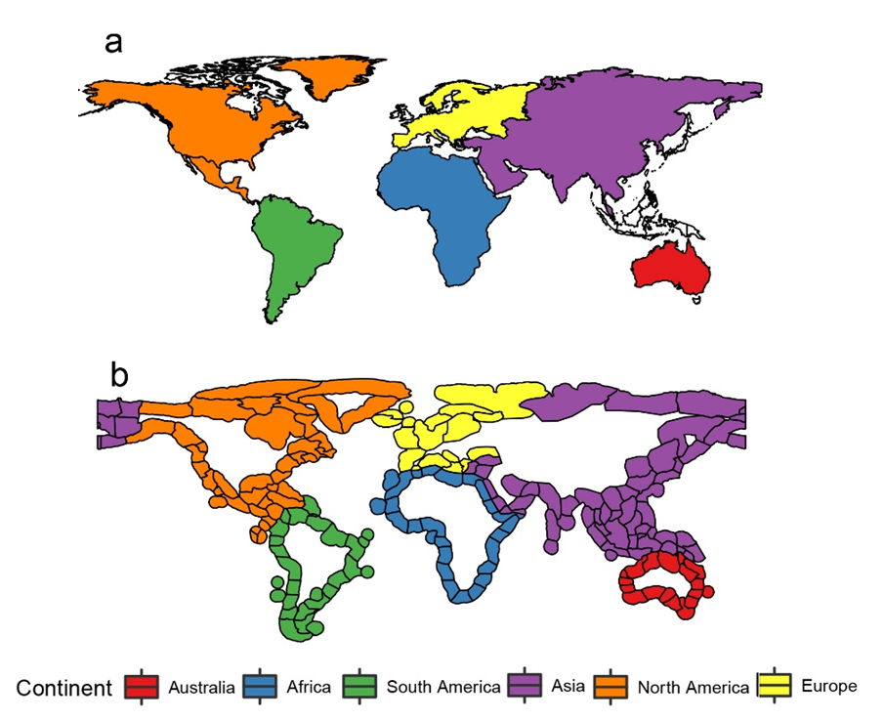

**Figure S1. Map of the terrestrial and marine regions included in this study. a,** Land masses included in this study; open polygons denote land masses < 1,000,000 km2 excluded from this study. **b,** marine regions included in this study. The same colour code for continents is followed in all figures in main text and supplementary materials.

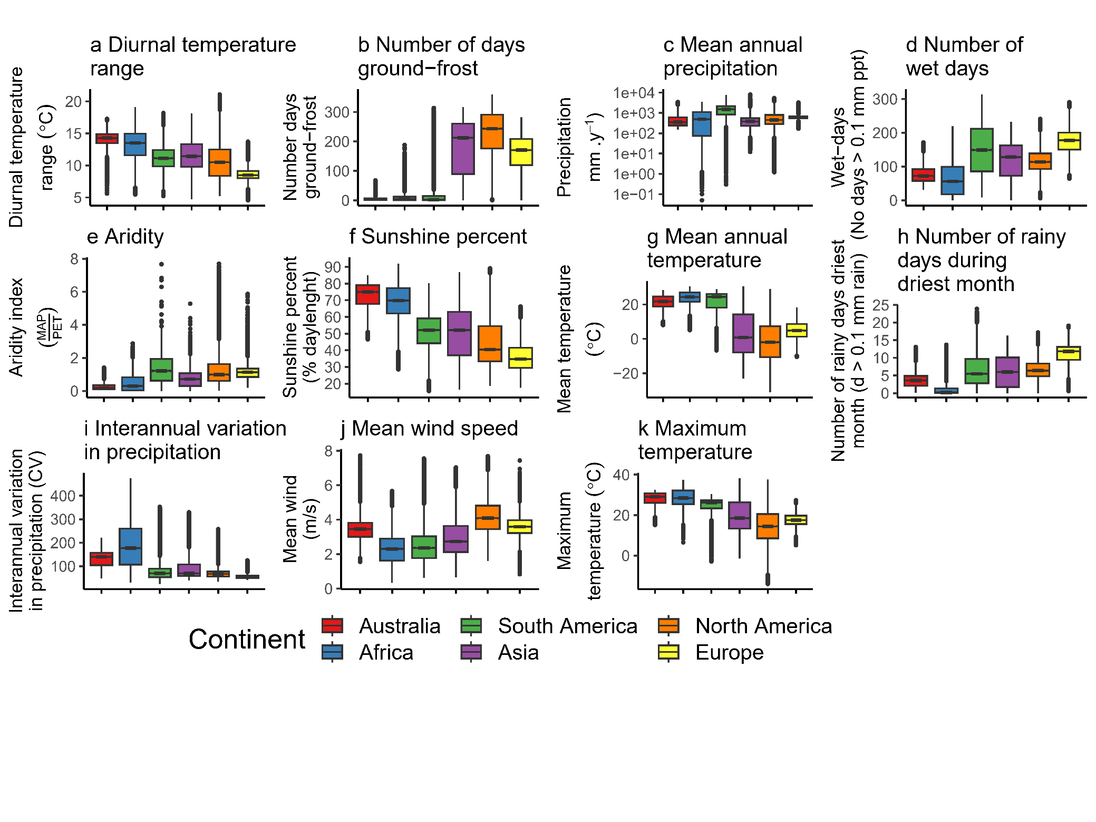

**Figure S2**. Comparison of terrestrial climate characteristics of Australia and other continents (except Antarctica). a, Diurnal temperature range. b, Number of days of ground-frost. c, Mean annual precipitation. d, Number of wet days. e, Aridity. f, Sunshine percent. g, Mean annual temperature. h, Number of rainy days during driest month. i, Interannual variation in precipitation. j, Mean wind speed. k, Maximum temperature. Asterisks after title name denotes where Australia was significantly different from other continents.

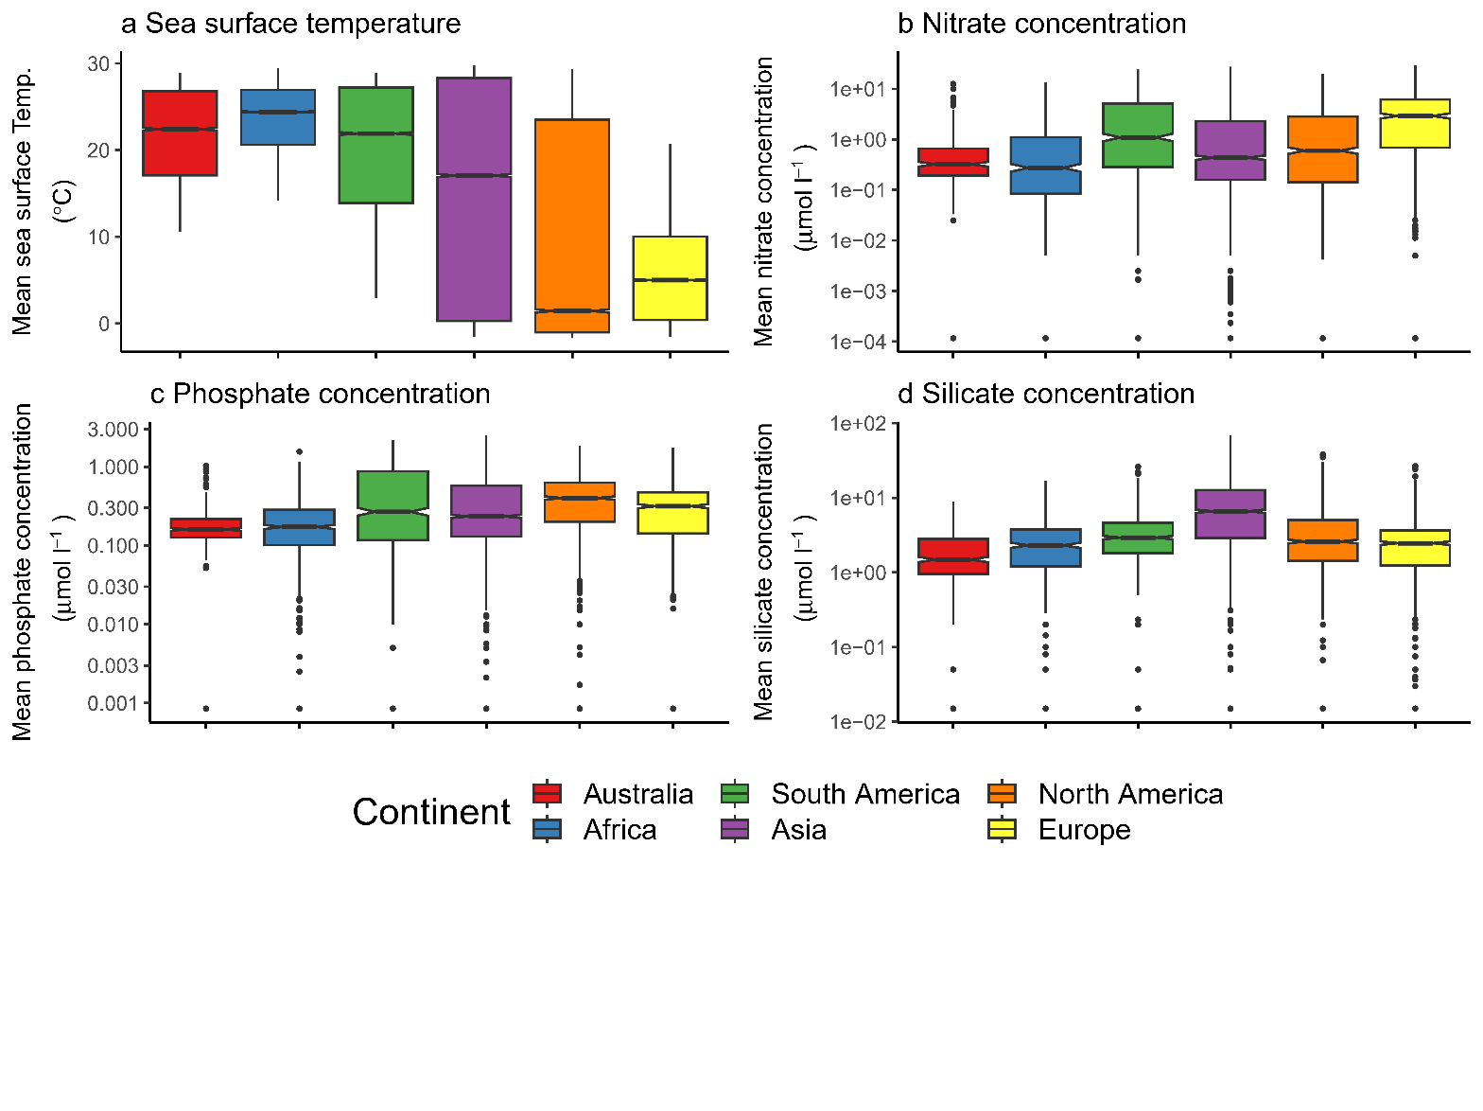

Figure S3. Comparison of marine climate characteristics of Australia and other continents (except Antarctica). a, Sea surface mean temperature. b, Marine nitrate concentration. c, Marine phosphate concentration. d, Marine silicate concentration. Asterisks after title name denotes where Australia was significantly different from other continents.

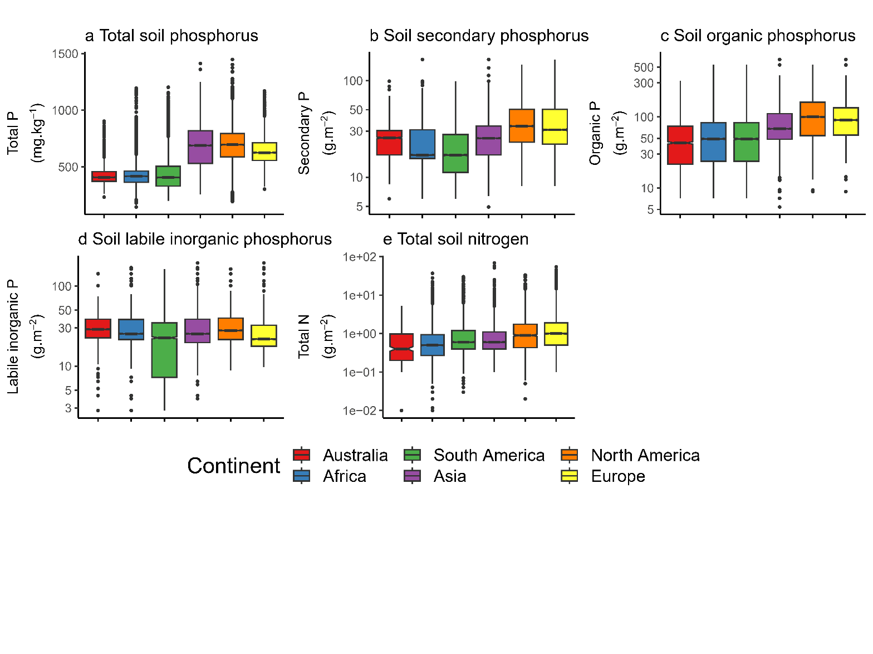

Figure S4. Comparison of soil Phosphorus forms and soil total nitrogen of Australia and other continents (except Antarctica). a, Total phosphorus. b, Secondary phosphorus. c, Organic phosphorus. d, Labile inorganic phosphorus. e, Total Nitrogen. Asterisks after title name denotes where Australia was significantly different from other continents

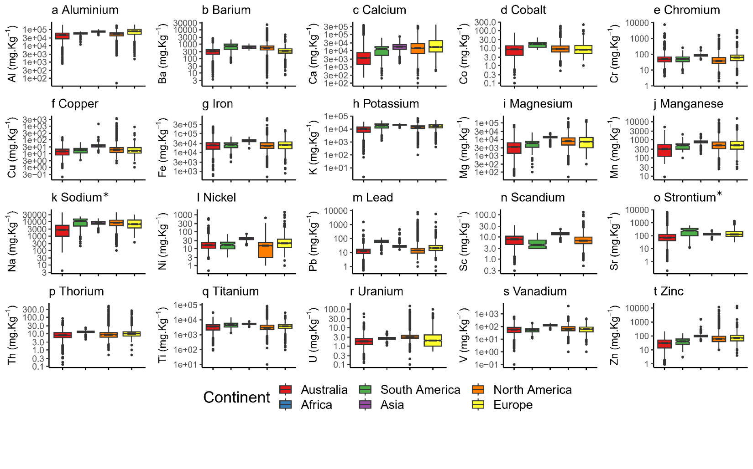

Figure S5. Comparison of soil and stream sediment geochemistry of Australia and other continents (except Antarctica). a, Aluminium. b, Barium. c, Calcium. d, Cobalt. e, Chromium. f, Copper. g, Iron. h, Potassium. i, Magnesium. j, Manganese. k, Sodium. l, Nickel. m, Lead. n, Scandium. o, Strontium. p, Thorium. q, Titanium. r, Uranium. s, Vanadium. t, Zinc. Asterisks after title name denotes where Australia remained significantly different from other continents after FDR correction.

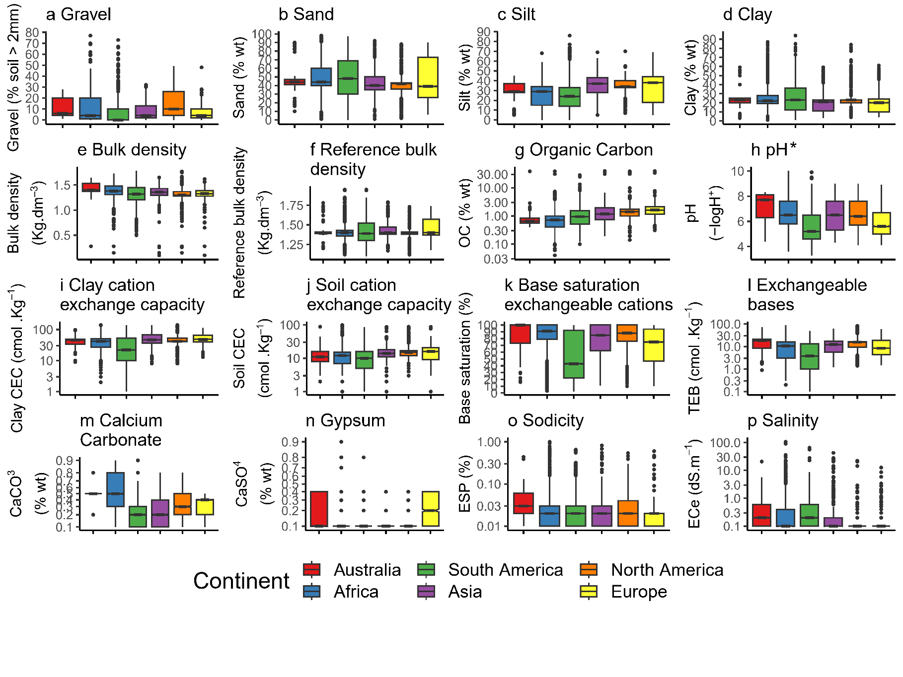

Figure S6. Comparison of soil edaphological characteristics of Australia and other continents (except Antarctica). a, Gravel content of soil. b, Sand content of soil. c, Silt content of soil. d, Clay content of soil. e, Soil bulk density. f, Soil reference bulk density. g, Soil organic carbon content. h, Soil potential of Hydrogen. i, Clay cation exchange capacity. j, Soil cation exchange capacity. k, Soil base saturation of exchangeable cations. l, Soil exchangeable bases. m, Calcium carbonate content of soil. n, Gypsum content of soil. o, Sodicity of soil. p, Salinity of soil. Asterisks after title name denotes where Australia remained significantly different from other continents after FDR correction.

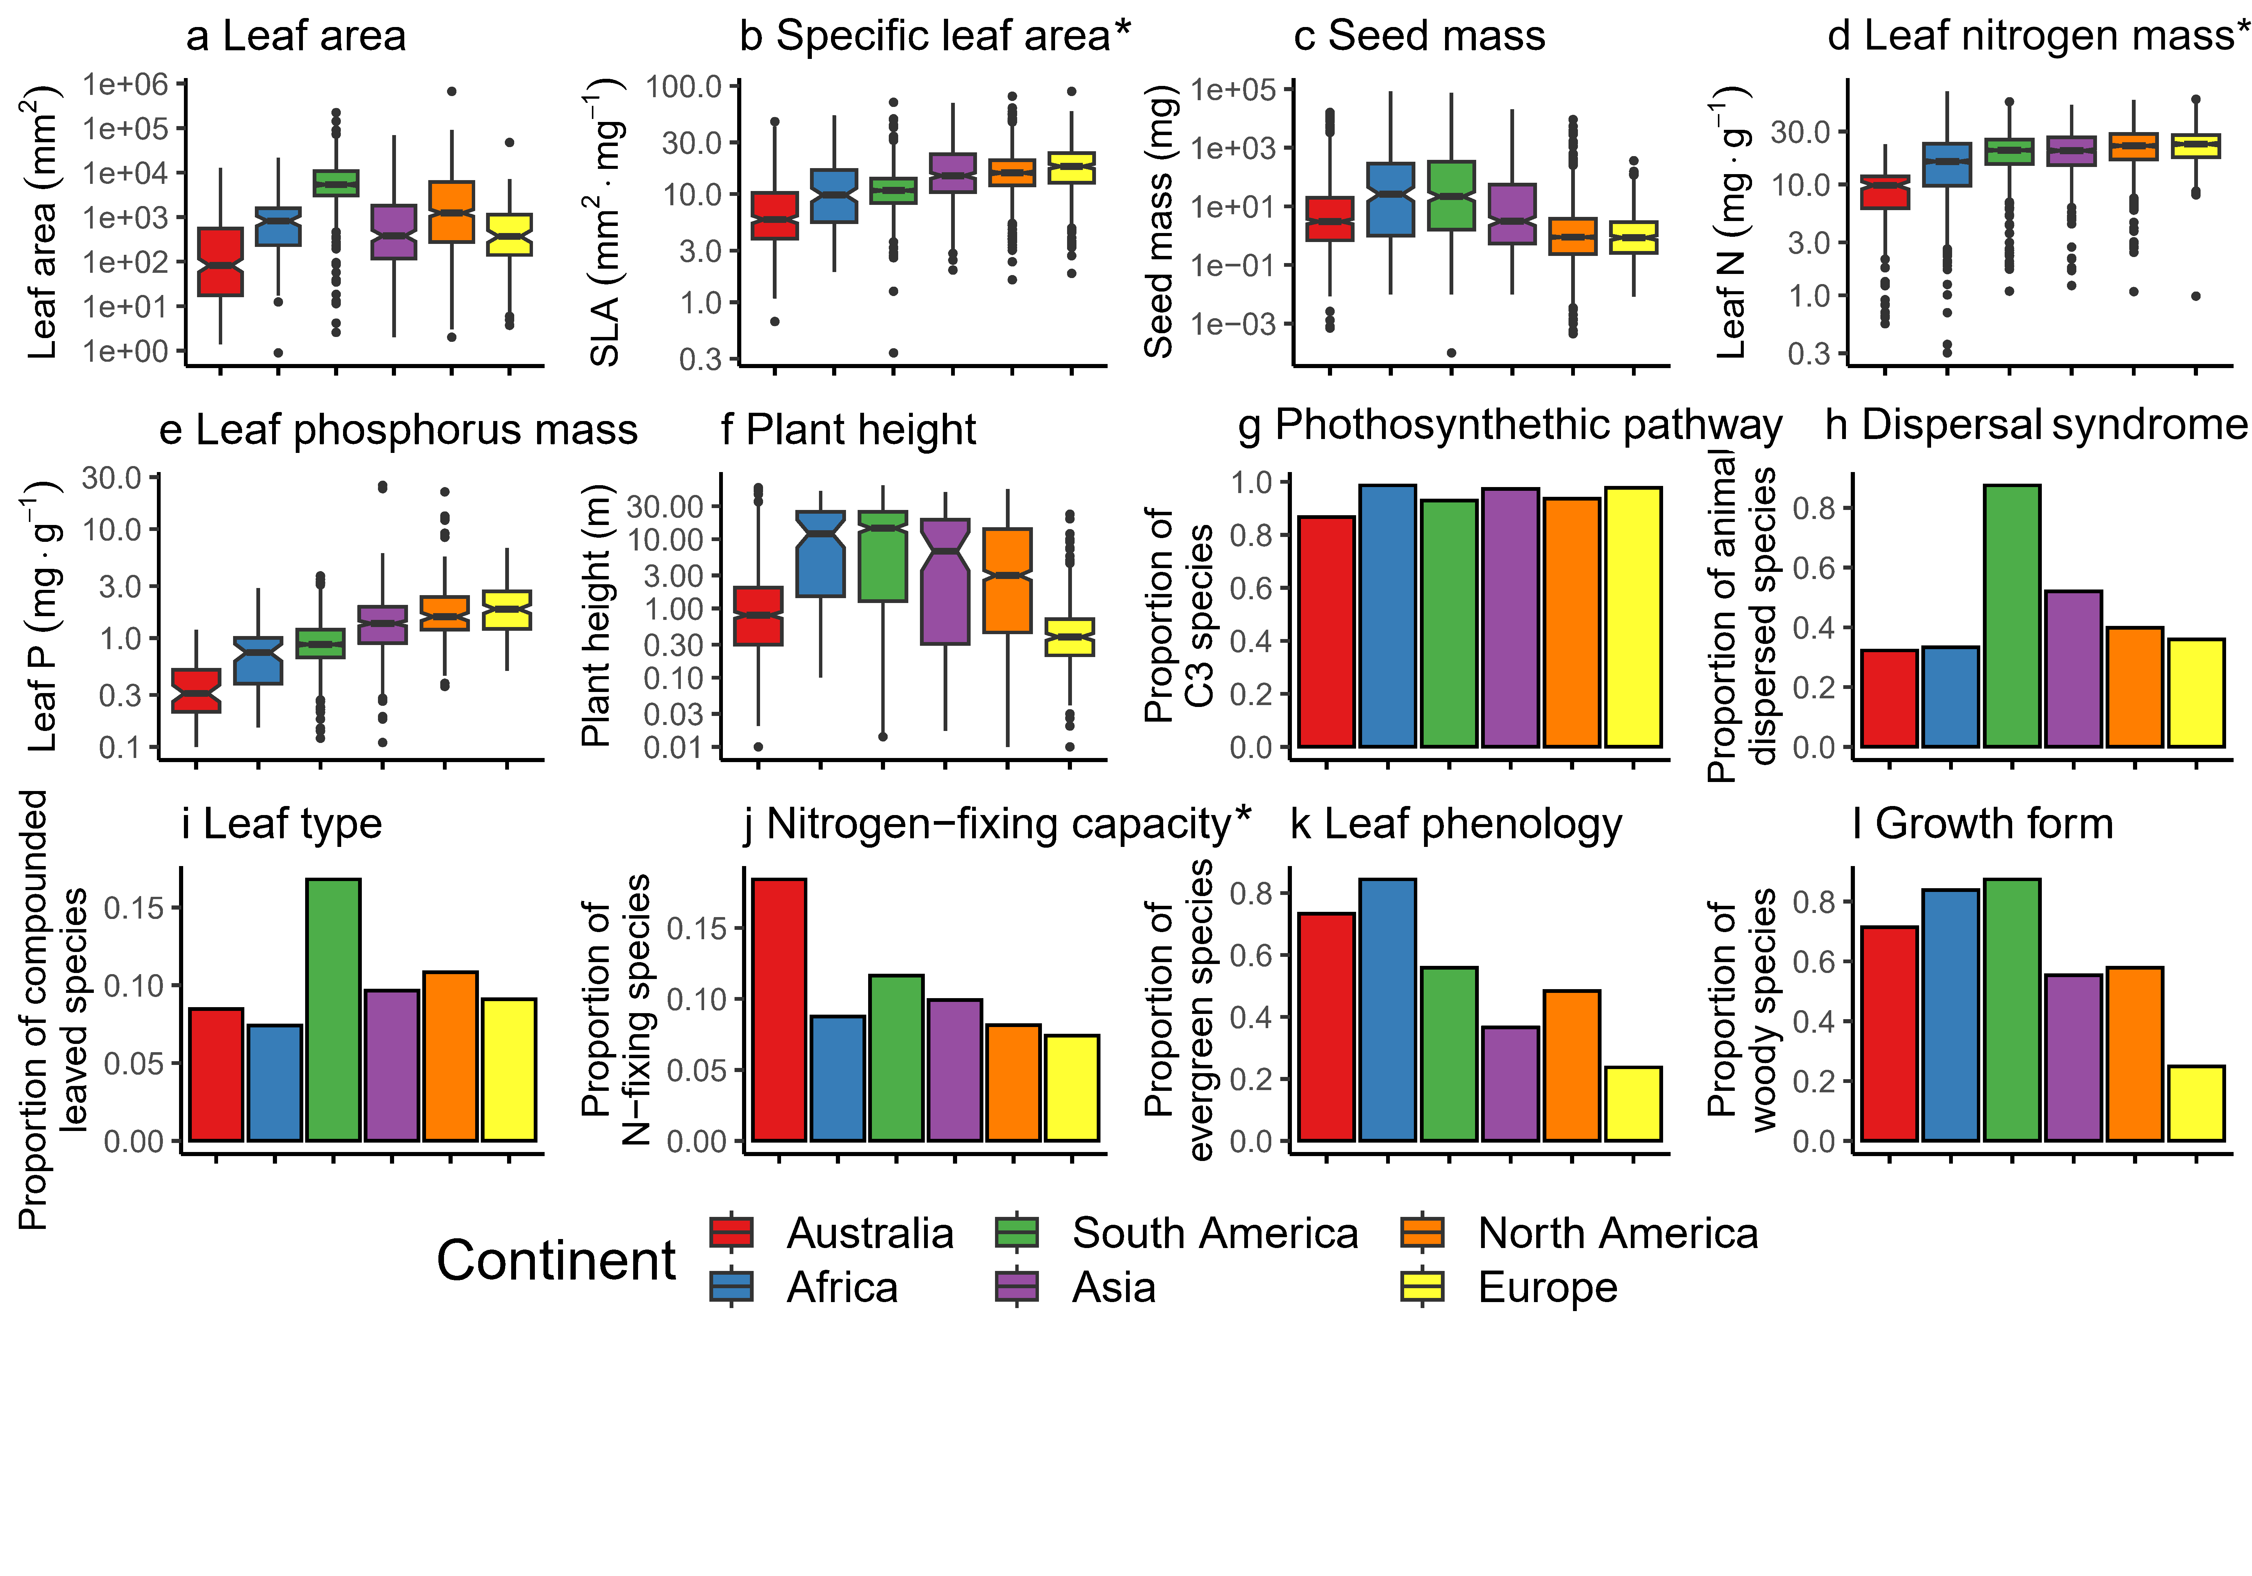

Figure S7. Comparison of plant species characteristics of Australia and other continents (except Antarctica). a, Leaf area. b, Specific leaf area. c, Seed mass. d, Leaf nitrogen content per unit mass. e, Leaf phosphorus content per unit mass. f, Plant height. g, Proportion of species with C3 photosynthetic pathway. h, Proportion of species with animal dispersal syndrome. i, Proportion of species with compound leaf type. j, Proportion of species with nitrogen fixing capacity. k, Proportion of evergreen species. l, Proportion of species with woody growth form. Asterisks after title name denotes where Australia remained significantly different from other continents after FDR correction.

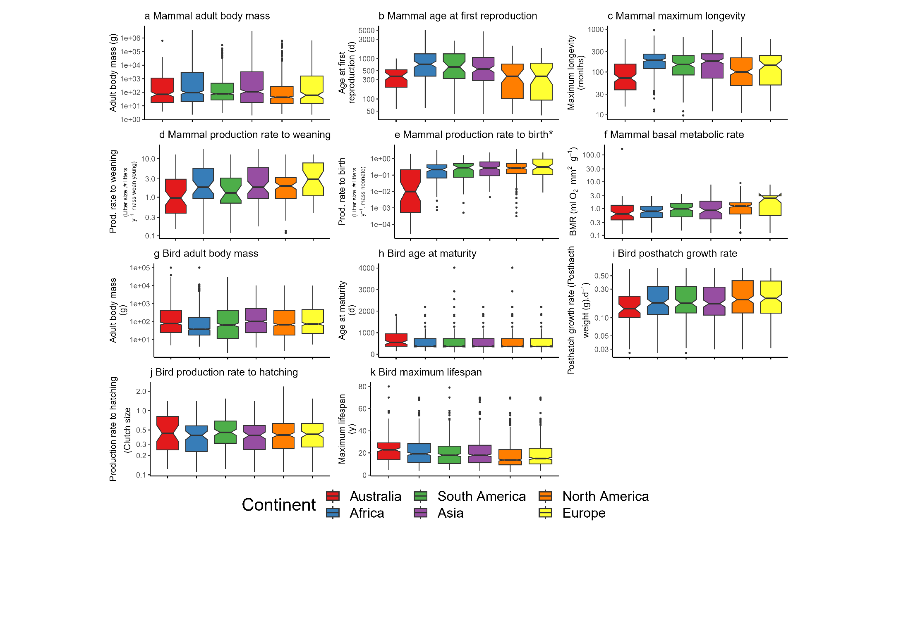

Figure S8. Comparison of vertebrate species characteristics of Australia and other continents (except Antarctica). a, Mammal adult body mass. b, Mammal age at first reproduction. c, Mammal maximum longevity. d, Mammal production rate to weaning per unit mass. e, Mammal production rate to birth per unit mass. f, Mammal basal metabolic rate. g, Bird adult body mass. h, Bird age at maturity. i, Bird post-hatch growth rate. j, Bird production rate to hatching. k, Bird maximum lifespan. Asterisks after title name denotes where Australia remained significantly different from other continents after FDR correction

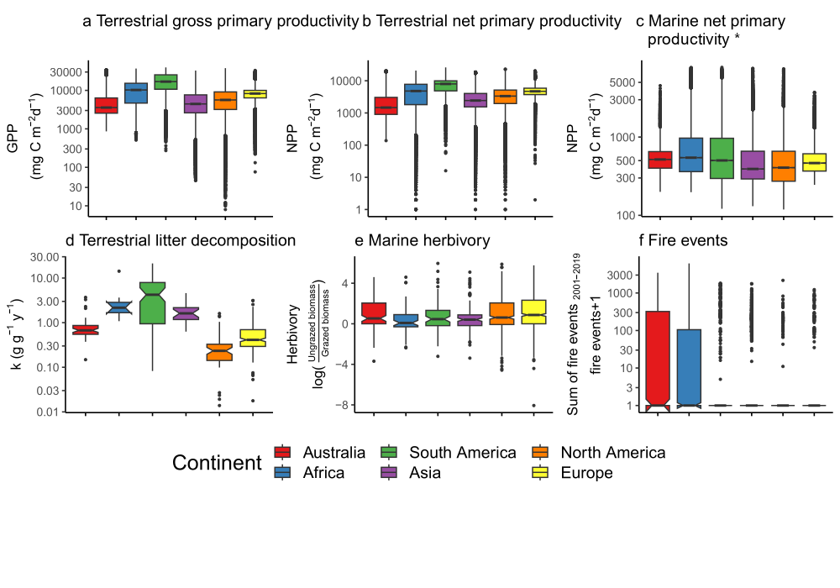

Figure S9. Comparison of terrestrial and marine ecosystem processes of Australia and other continents (except Antarctica). a, Terrestrial gross primary productivity. b, Terrestrial net primary productivity. c, Marine net primary productivity. d, Terrestrial litter decomposition. e, Marine rates of herbivory. f, Fire events. Asterisks after title name denotes where Australia remained significantly different from other continents after FDR correction.

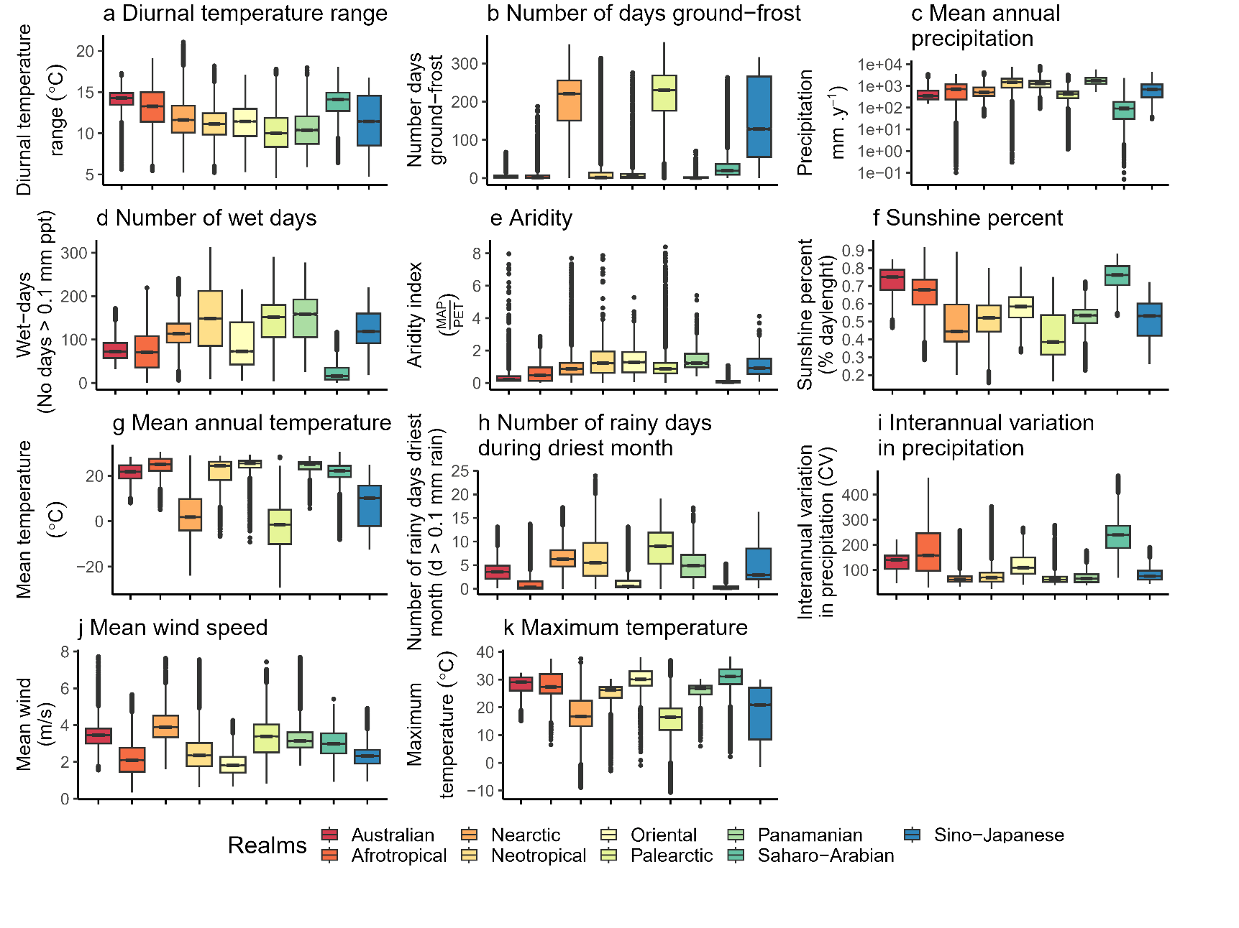

**Figure S10. Comparison of terrestrial climate characteristics of Australia and other terrestrial biogeographic realms. a,** Diurnal temperature range**. b,** Number of days ground-frost. **c,** Mean annual precipitation. **d,** Number of wet days. **e,** Aridity. **f,** Sunshine percent. **g,** Mean annual temperature. **h,** Number of rainy days during driest month. **i,** Interannual variation in precipitation. **j,** Mean wind speed. **k,** Maximum temperature.

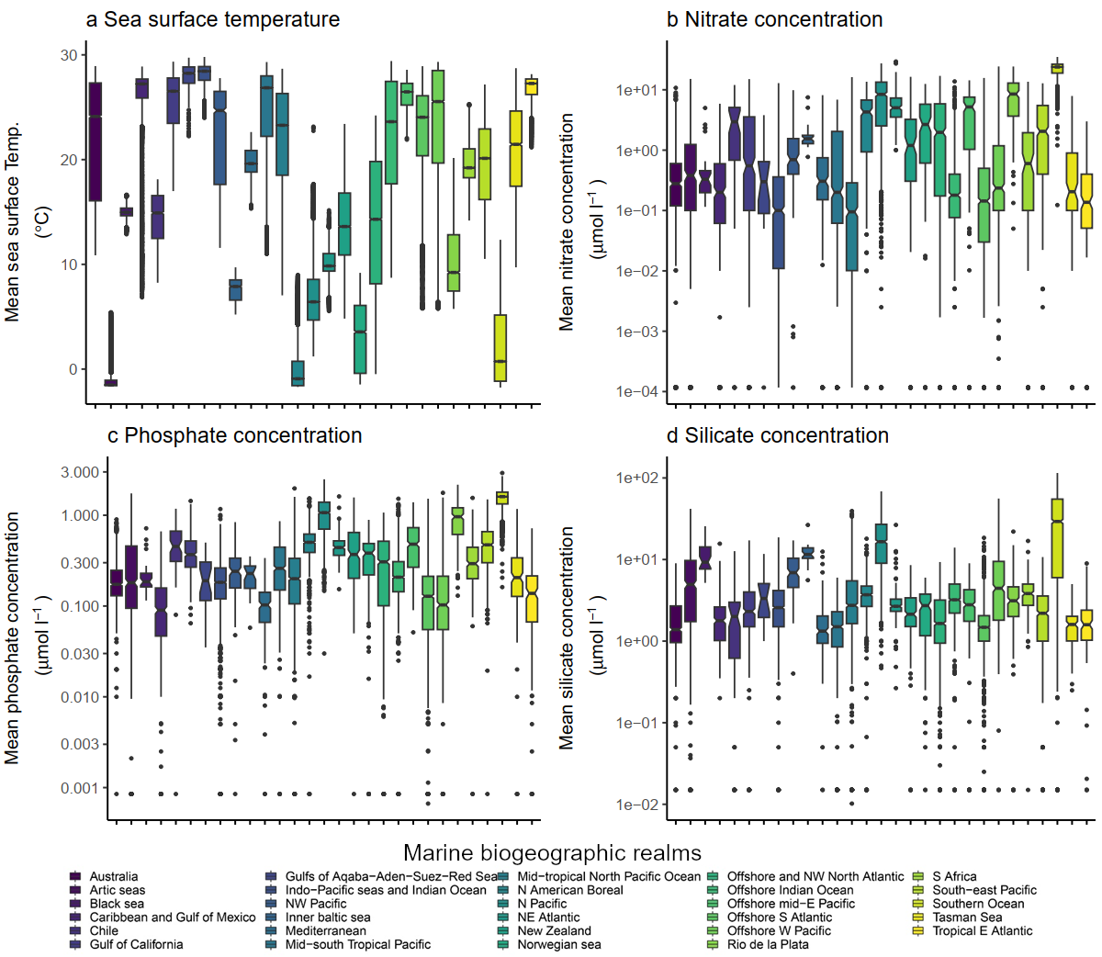

**Figure S11. Comparison of marine climate characteristics of Australia and other marine biogeographic realms. a,** Sea surface mean temperature. **b,** Marine nitrate concentration. **c,** Marine phosphate concentration. **d,** Marine silicate concentration.

**Figure S12.** Comparison of soil Phosphorus forms and soil total nitrogen of Australia and other biogeographic realms. a, Total phosphorus. b, Secondary phosphorus. c, Organic phosphorus. d, Labile inorganic phosphorus. e, Total Nitrogen.

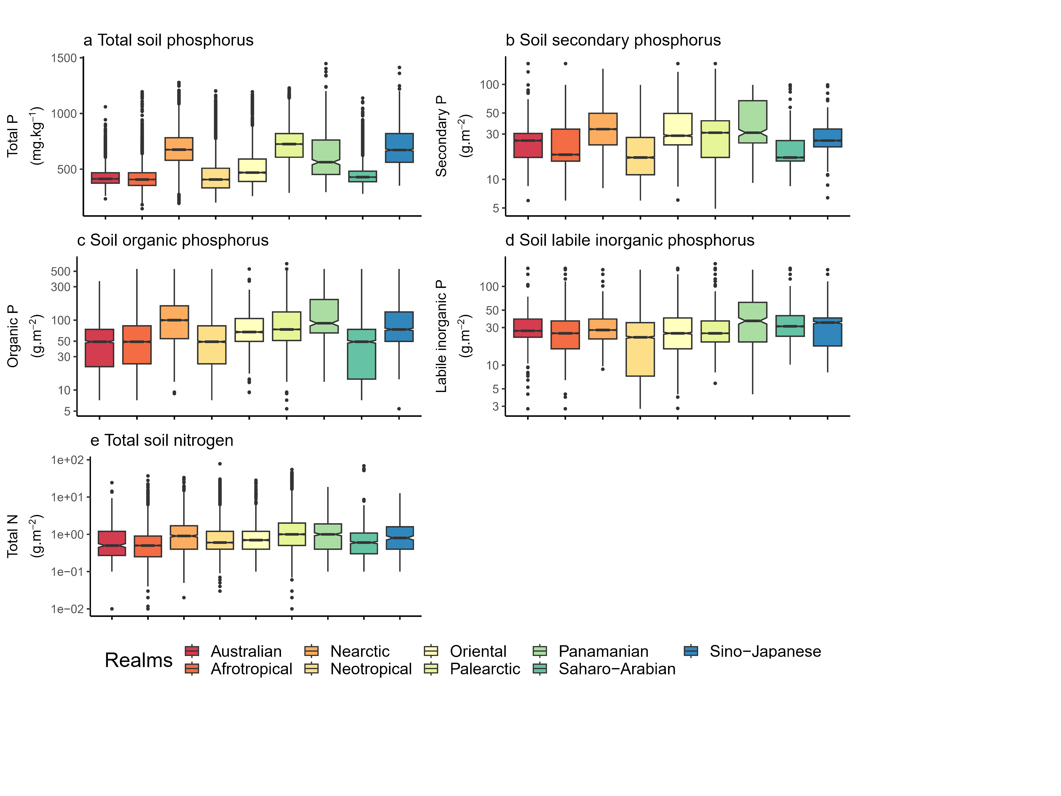

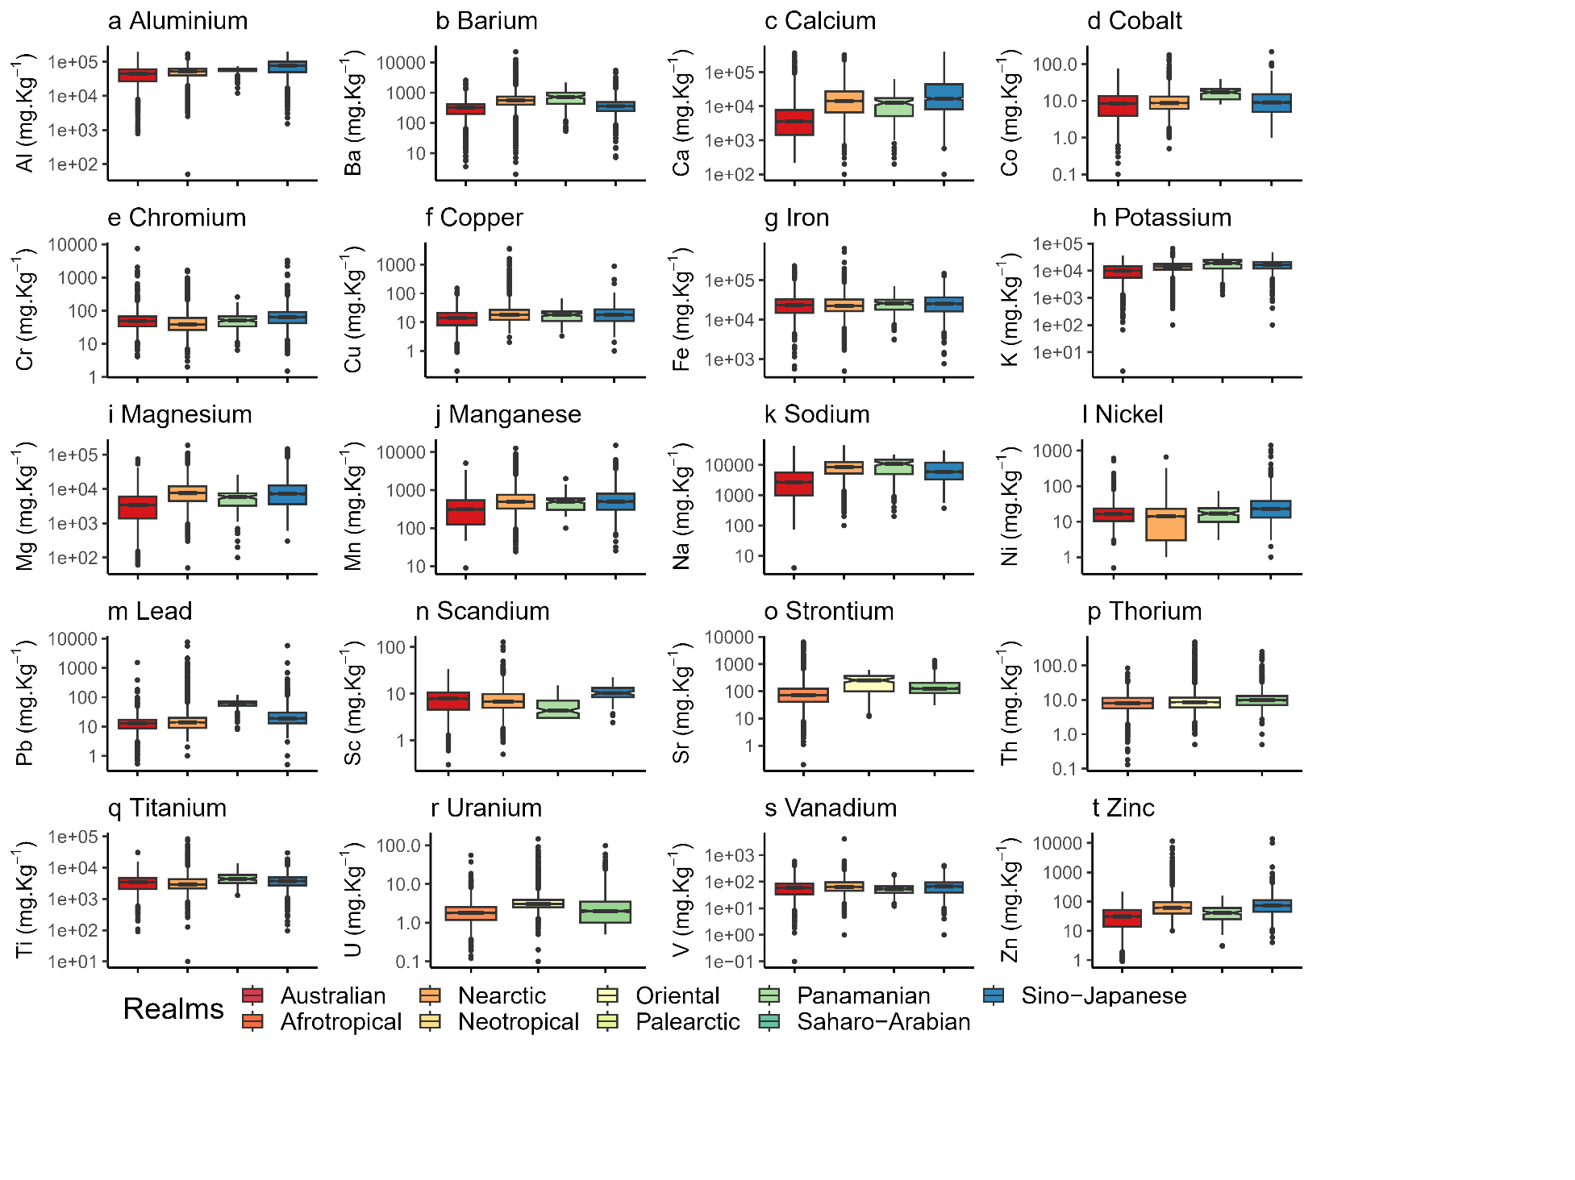

Figure S13. Comparison of soil and sediment geochemistry of Australia and other biogeographic realms. a, Aluminium. b, Barium. c, Calcium. d, Cobalt. e, Chromium. f, Copper. g, Iron. h, Potassium. i, Magnesium. j, Manganese. k, Sodium. l, Nickel. m, Lead. n, Scandium. o, Strontium. p, Thorium. q, Titanium. r, Uranium. s, Vanadium. t, Zinc. Note that not all realms are represented for all chemicals.

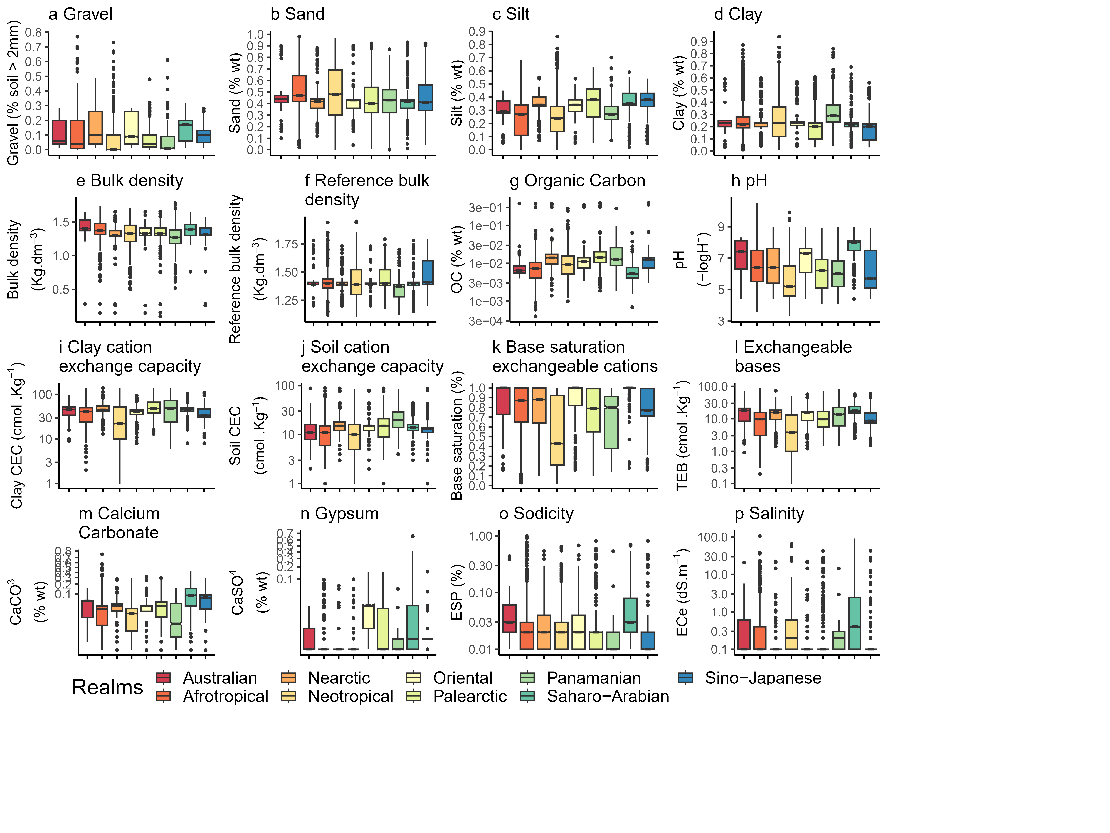

Figure S14. Comparison of soil edaphological characteristics of Australia and other biogeographic realms. a, Gravel content of soil. b, Sand content of soil. c, Silt content of soil. d, Clay content of soil. e, Soil bulk density. f, Soil reference bulk density. g, Soil organic carbon content. h, Soil potential of Hydrogen. i, Clay cation exchange capacity. j, Soil cation exchange capacity. k, Soil base saturation of exchangeable cations. l, Soil exchangeable bases. m, Calcium carbonate content of soil. n, Gypsum content of soil. o, Sodicity of soil. p, Salinity of soil.

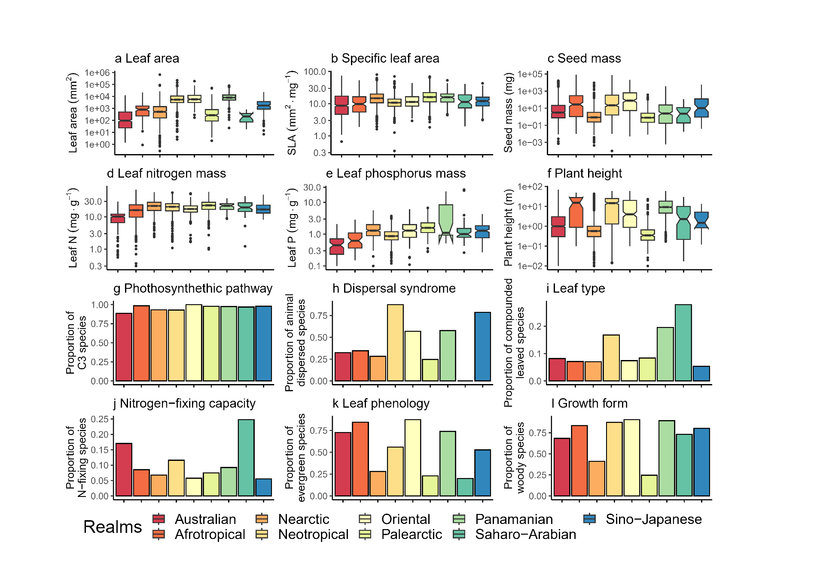

Figure S15. Comparison of plant species characteristics of Australia and other biogeographic realms. a, Leaf area. b, Specific leaf area. c, Seed mass. d, Leaf nitrogen content per unit mass. e, Leaf phosphorus content per unit mass. f, Plant height. g, Proportion of species with C3 photosynthetic pathway. h, Proportion of species with animal dispersal syndrome. i, Proportion of species with compound leaf type. j, Proportion of species with nitrogen fixing capacity. k, Proportion of evergreen species. l, Proportion of species with woody growth form.

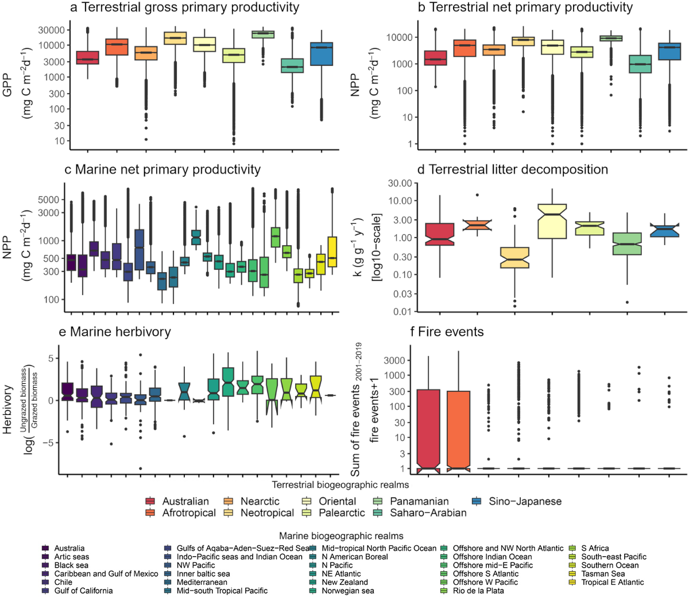

Figure S16. Comparison of terrestrial and marine ecosystem processes of Australia and other biogeographic realms. a, Terrestrial gross primary productivity. b, Terrestrial net primary productivity. c, Marine net primary productivity. d, Terrestrial litter decomposition. e, Marine rates of herbivory. f, fire events.

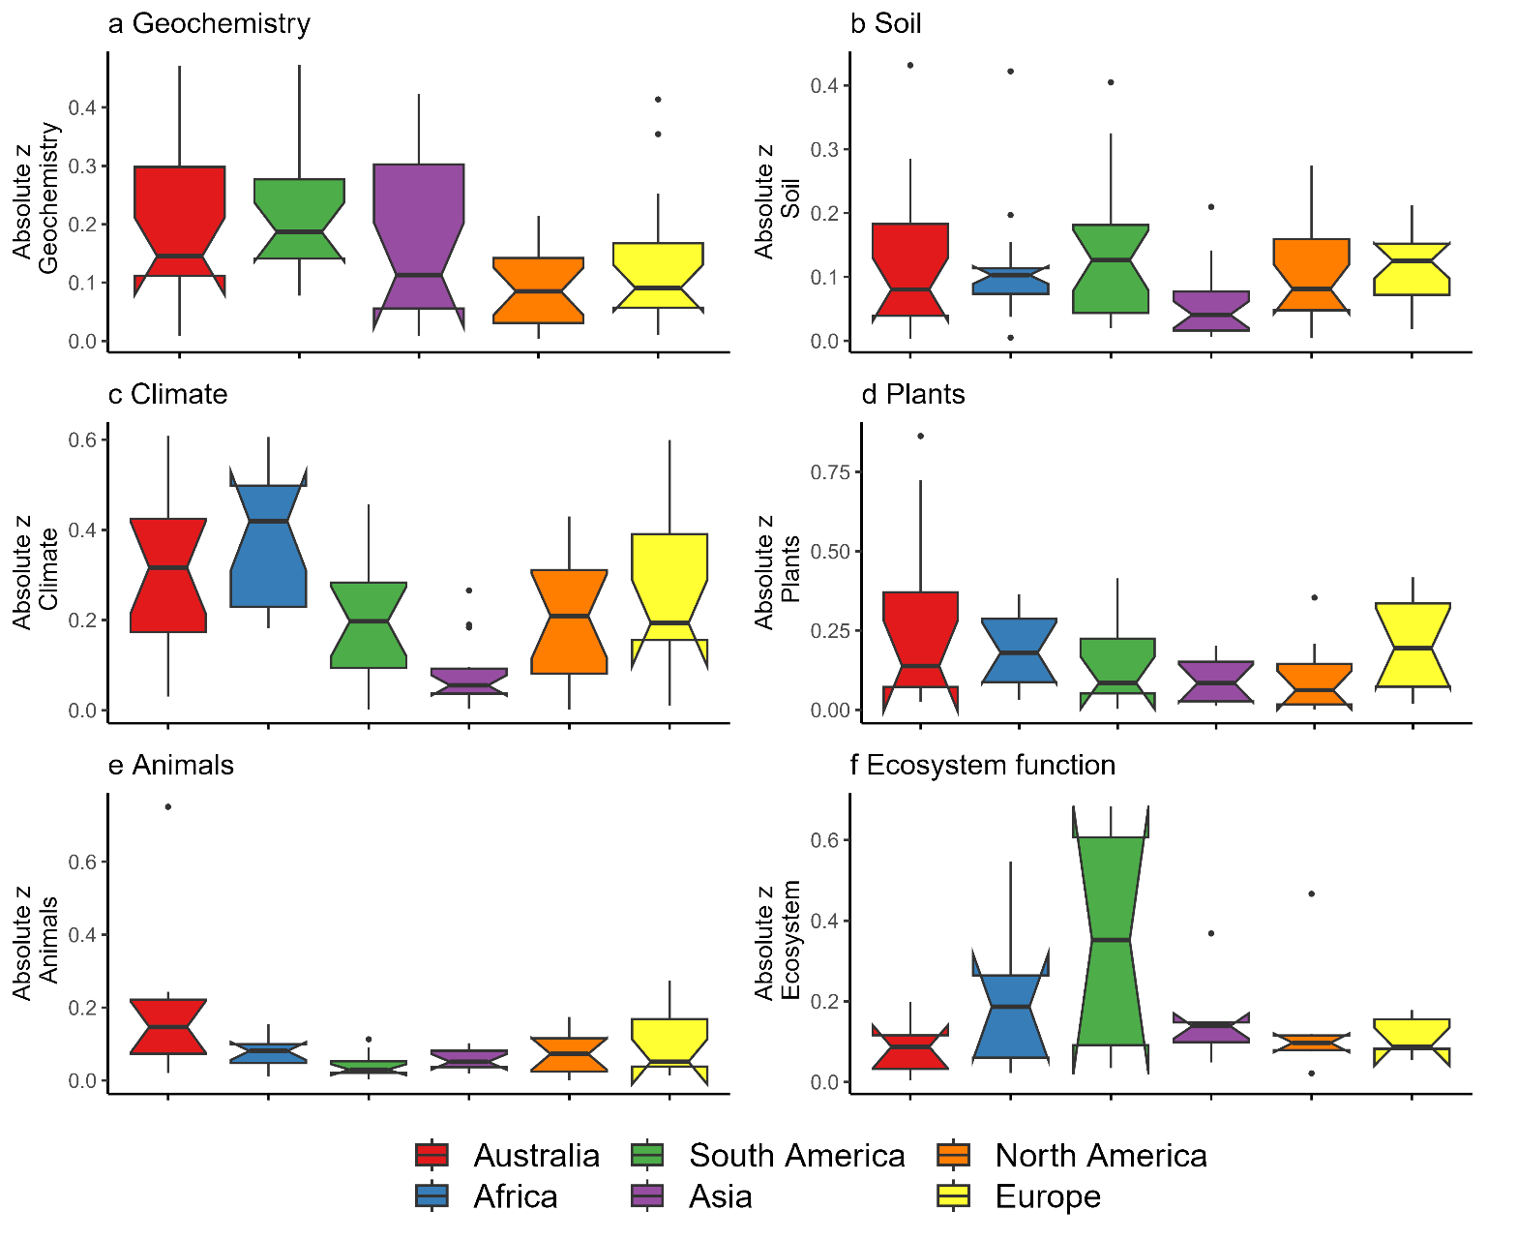

**Figure S17: Differences among continents in z scores of variables by category.** Differences among continents measured in absolute deviation from the mean value (absolute z-scores). The boxes represent the 25th, 50th and 75th percentiles. Whiskers represent the lowest and highest value still within 1.5 interquantile range of the lower or upper quartile, points represent outliers

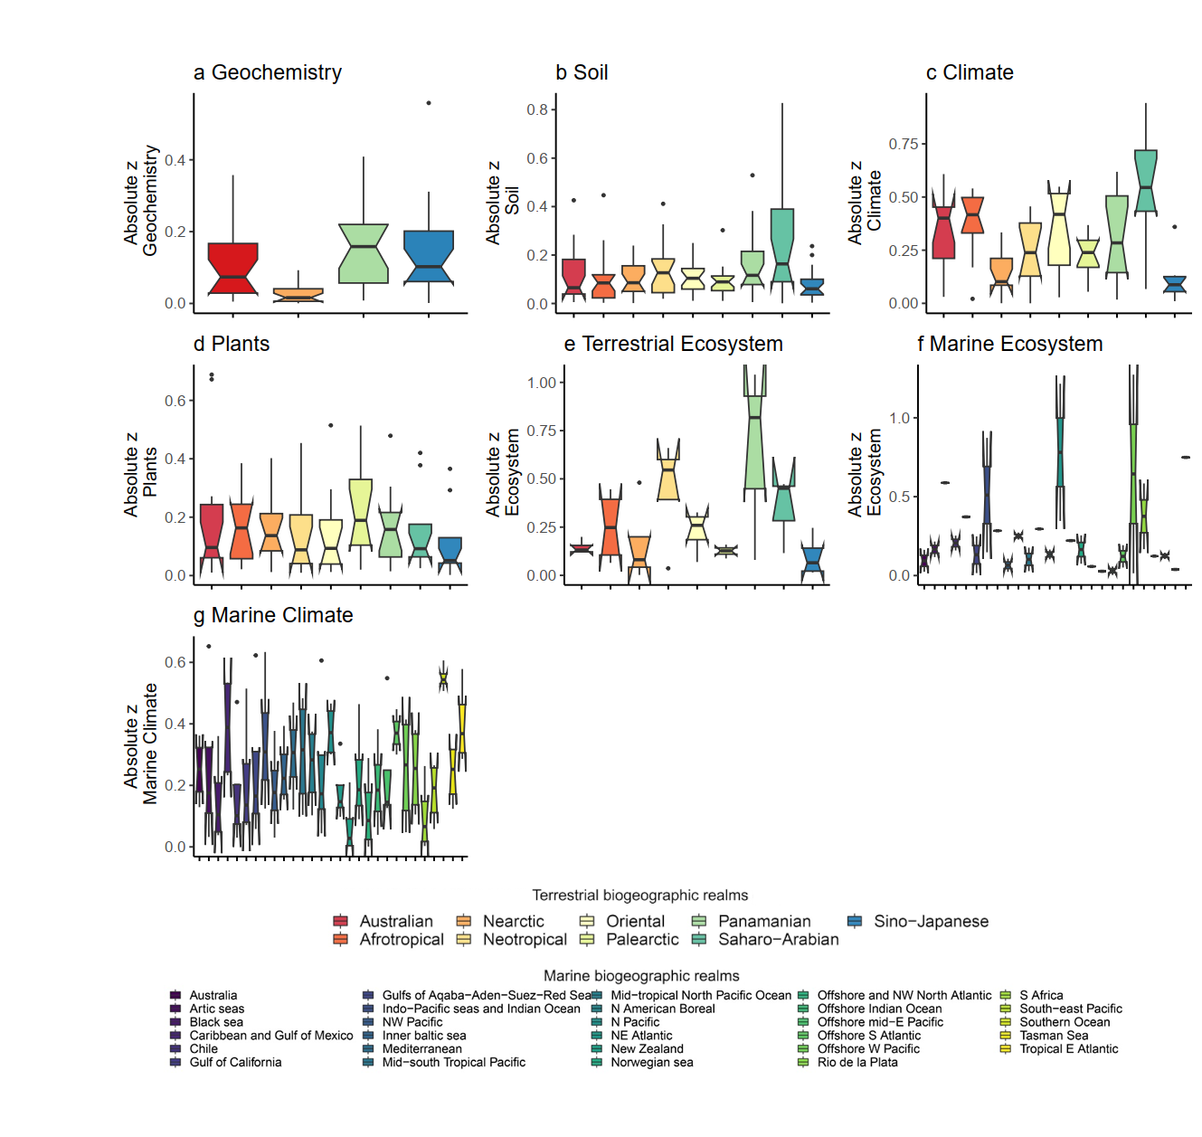

Figure S18. Differences among biogeographic realms in characteristics related to the biotic and abiotic environment. Differences among continents measured in absolute deviation from the mean value (absolute z-scores) in variables related to a, geochemistry. b, soil. c, terrestrial climate. d, plants. e, ecosystem function. f, marine ecosystem function. and g, marine climate.

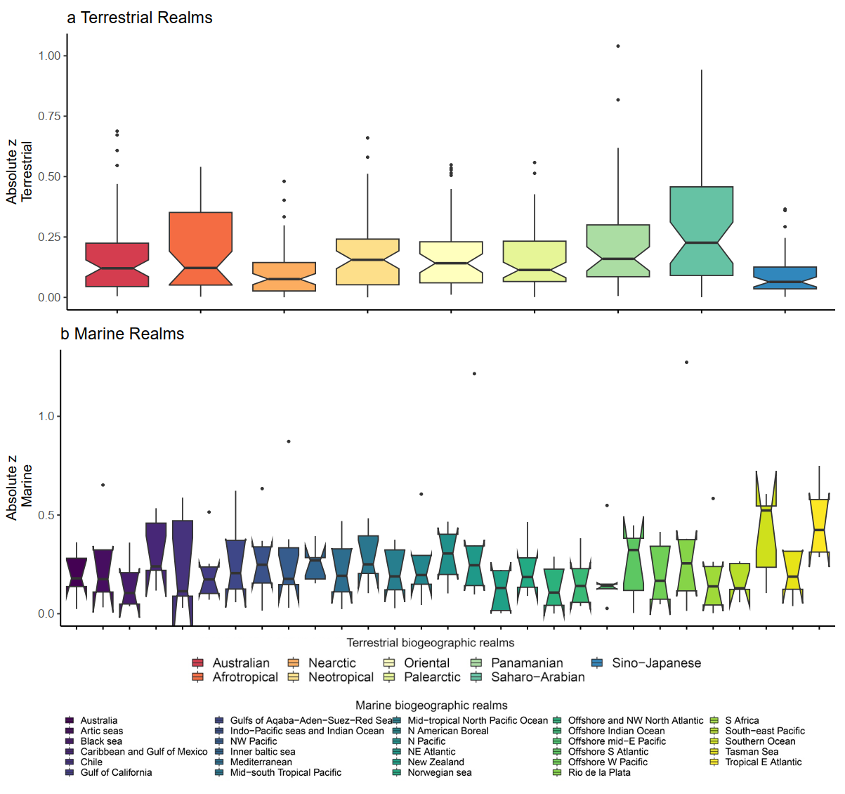

Figure S19. Differences among biogeographic realms in z-scores of all variables. a, terrestrial biogeographic realms. b, marine biogeographic realms. There are significant differences between the terrestrial realms; post-hoc testing (table S7) reveal this result is driven mainly by the closeness of the Nearctic realm to the global averages. There are significant differences between marine biogeographic realms, however formal post-hoc testing could not be completed due to insufficient sample size to allow as many pair-wise comparisons as necessary to be valid.