**Supplementary material 1**

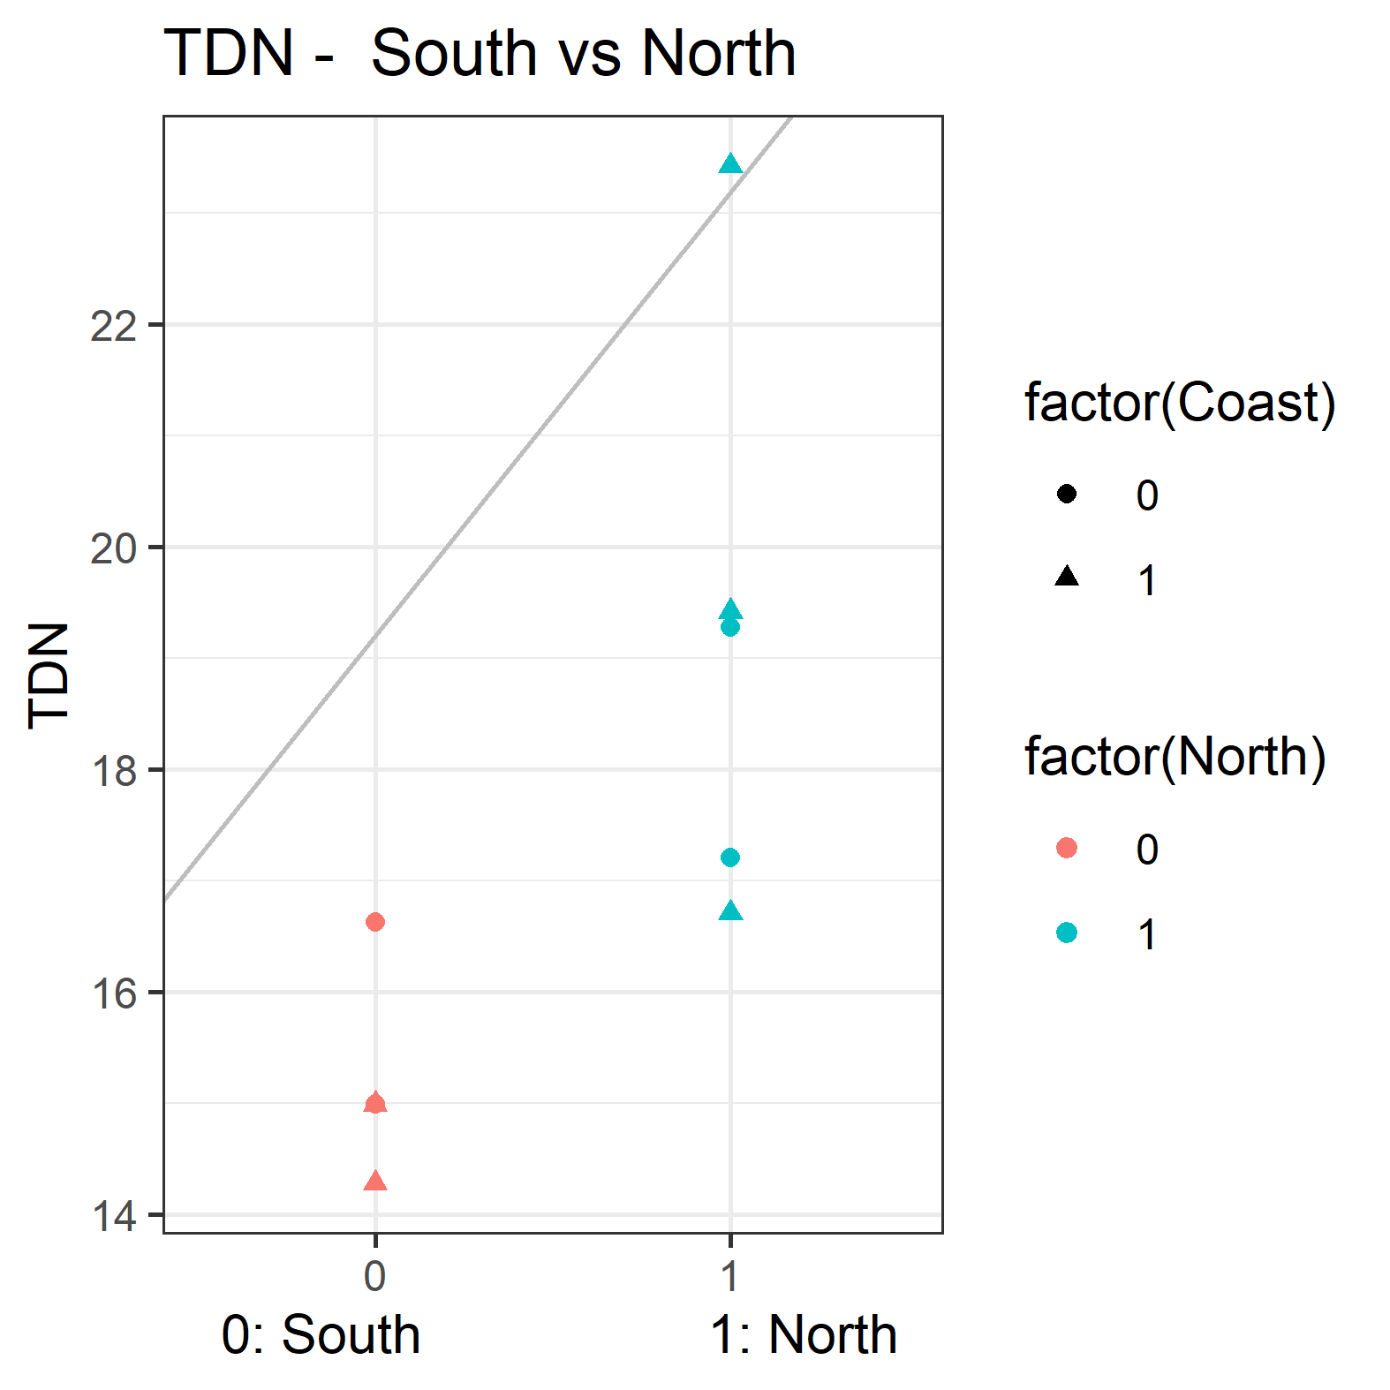

**Figure S1:** Linear regression of TDN, South vs North, (p<0.05).

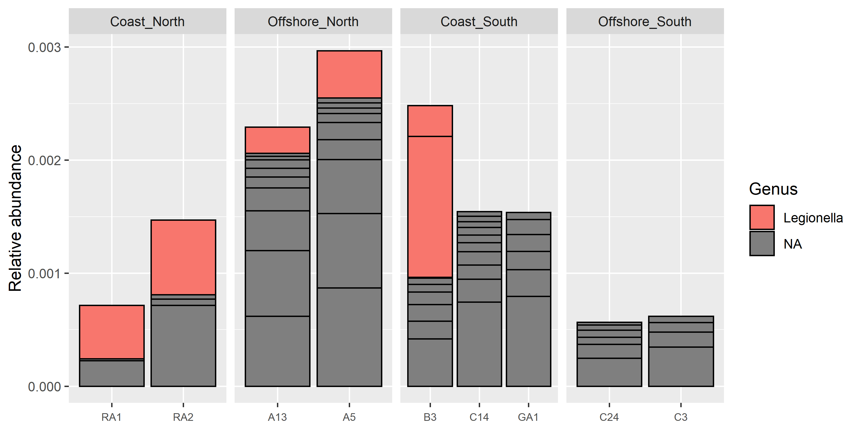

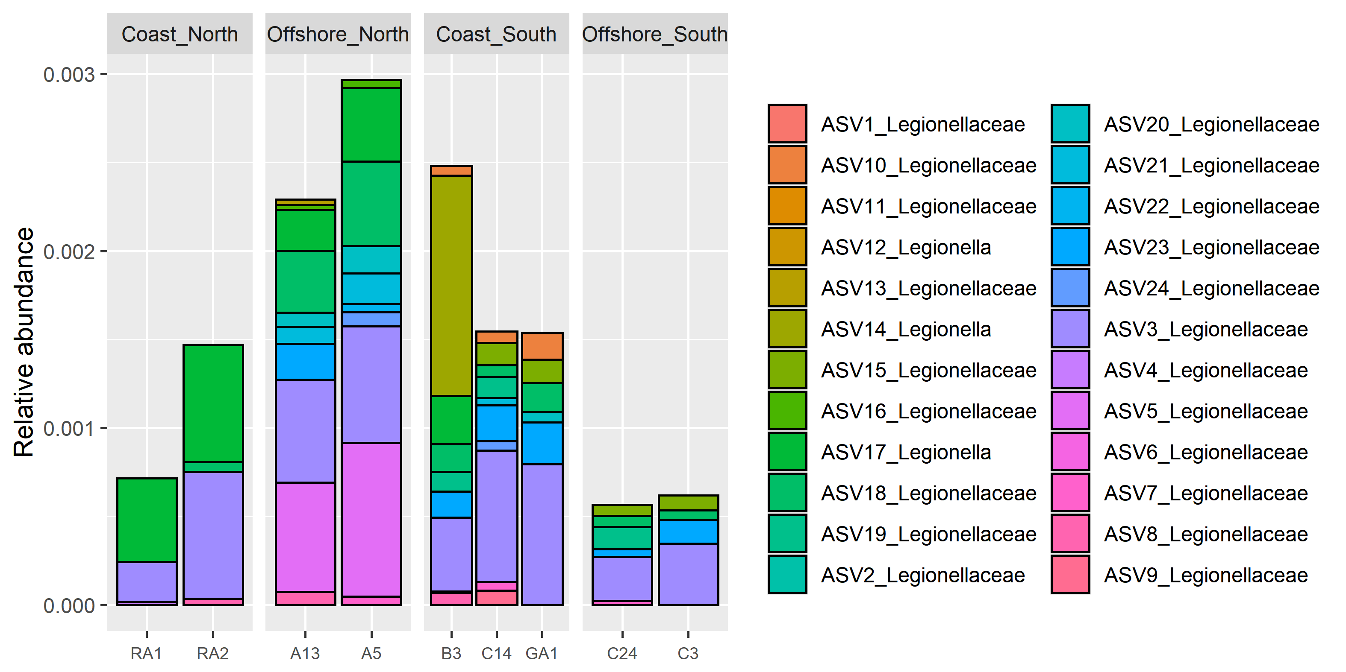

**Figure S2**: **Top:** All ASVs (24 in total) in the family Legionellaceae, colored by genus. **Bottom:** All Illumina Legionellaceae ASVs.

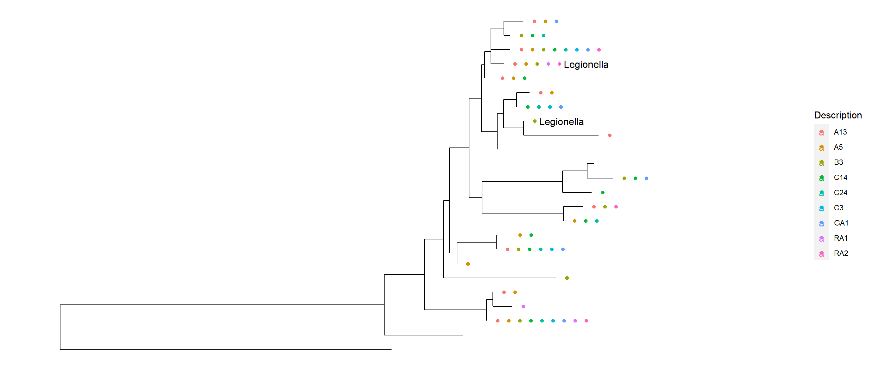

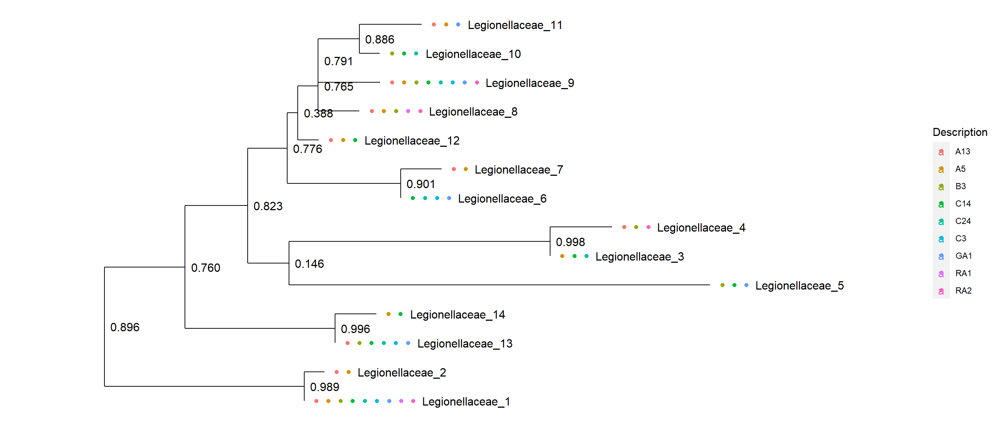

Figure S3: Top: All ASVs (24 in total) in the family Legionellaceae, genus in the tip label. Bottom: Filtered Illumina Legionellaceae ASVs, detected in ≥2 samples, (ASVs used in GLLVM). Each position in the tree represents an ASV. Colored dots denote different samples where the ASV were detected.

**Figure S4**: Result from a real time qPCR assay based on primers targeting a *Legionella* specific part of the 16S rRNA gene. The resulting bacterial concentration was calculated based on cq values in the linear regression equation of a calibration curve specific for the assay (y (log bacterial concentration) = -0,2911*x(cq value) + 10,361). The number of bacteria per ml were then calculated by dividing the bacterial concentration by the filter volume used per sample (ranging from 100-500 ml sea water/sample).

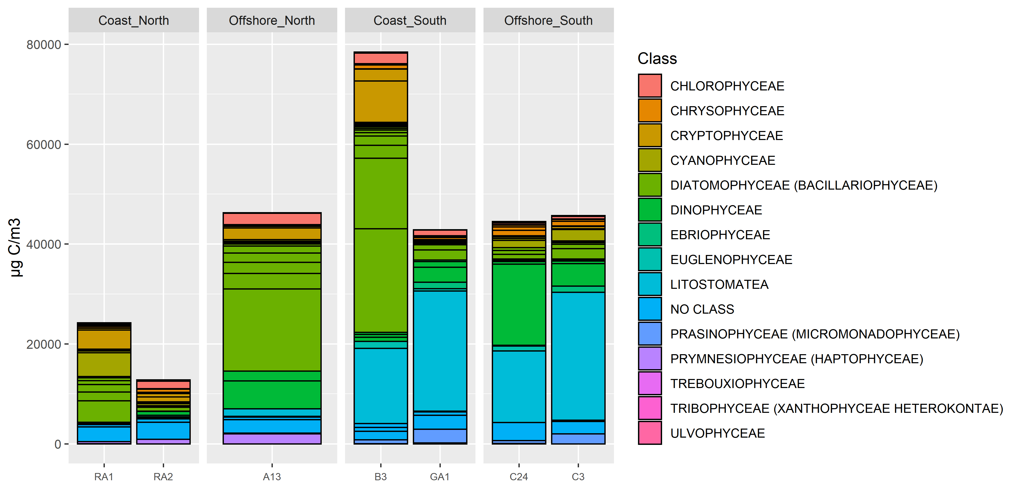

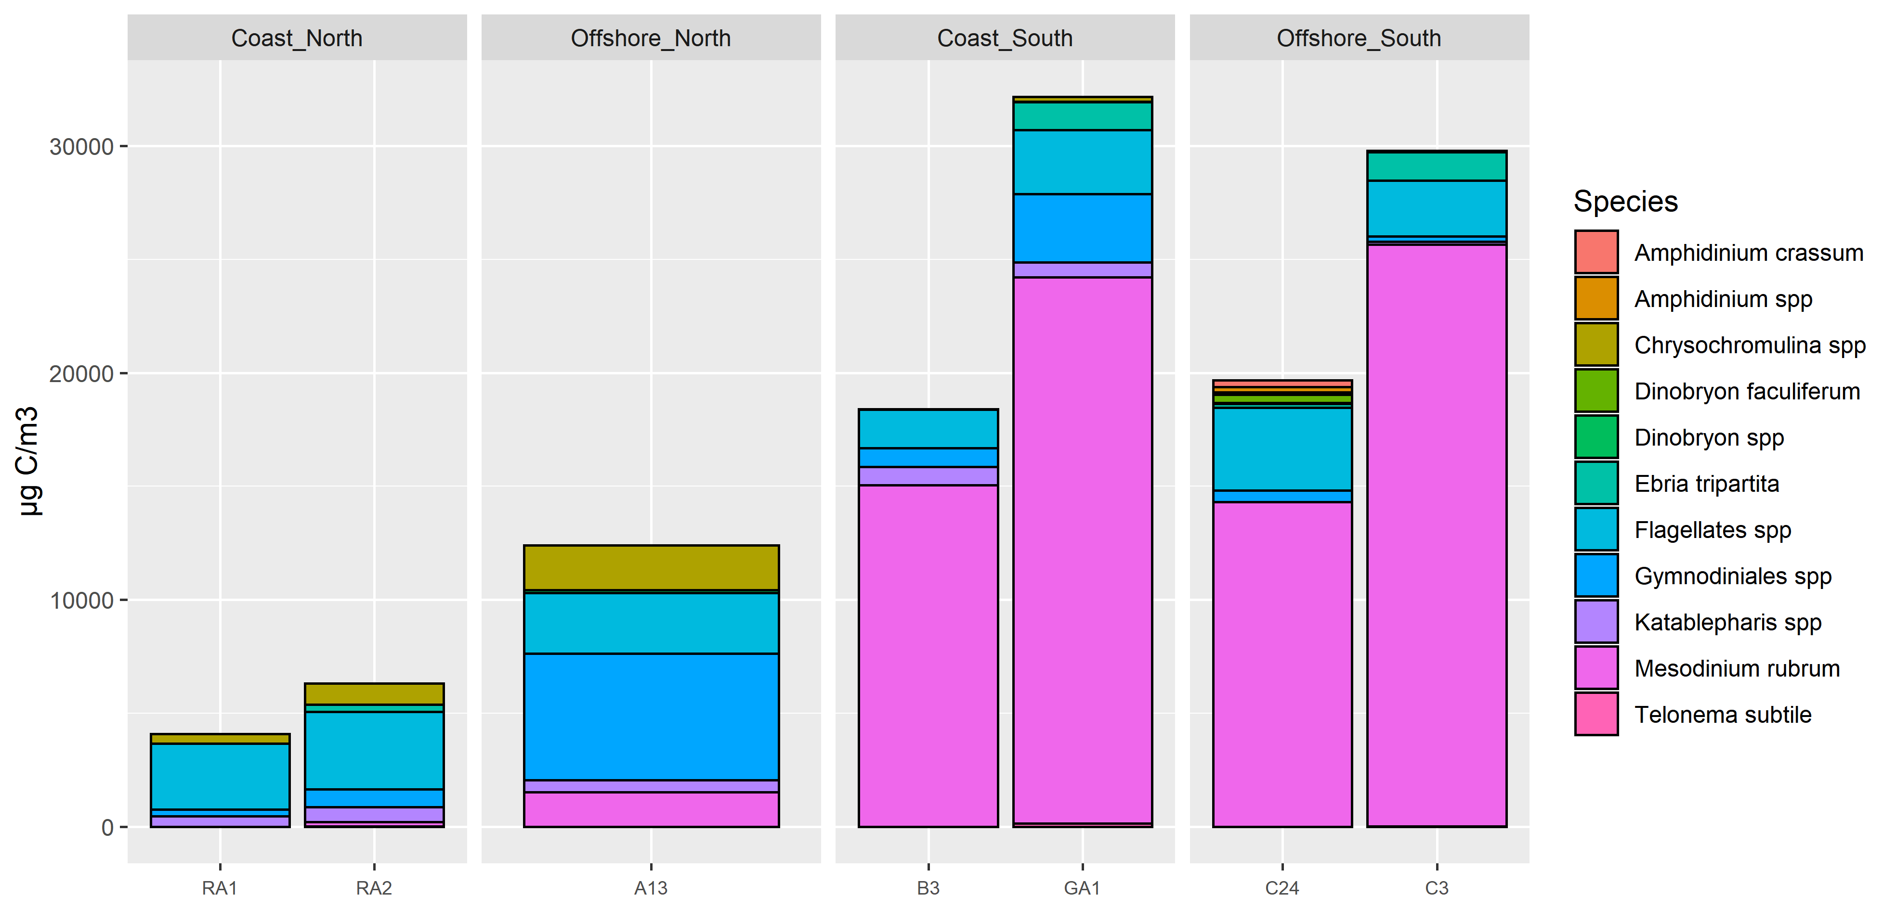

**Figure S5:** Microscopy counting of phytoplankton. **Top:** All organisms, **Bottom:** Heterotrophic protists.

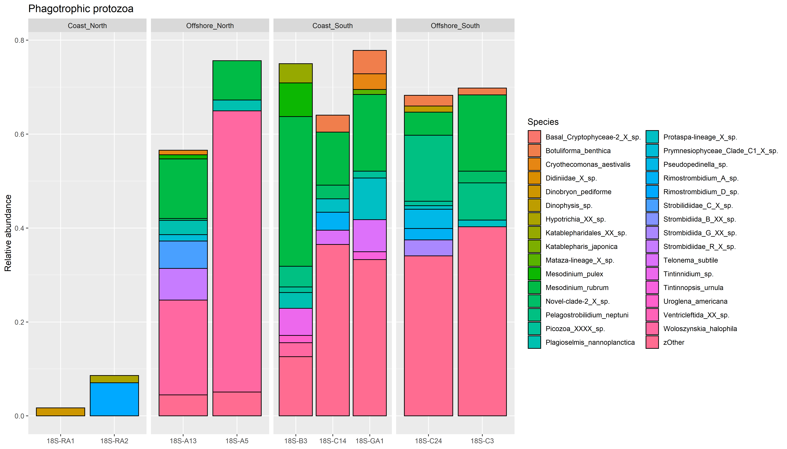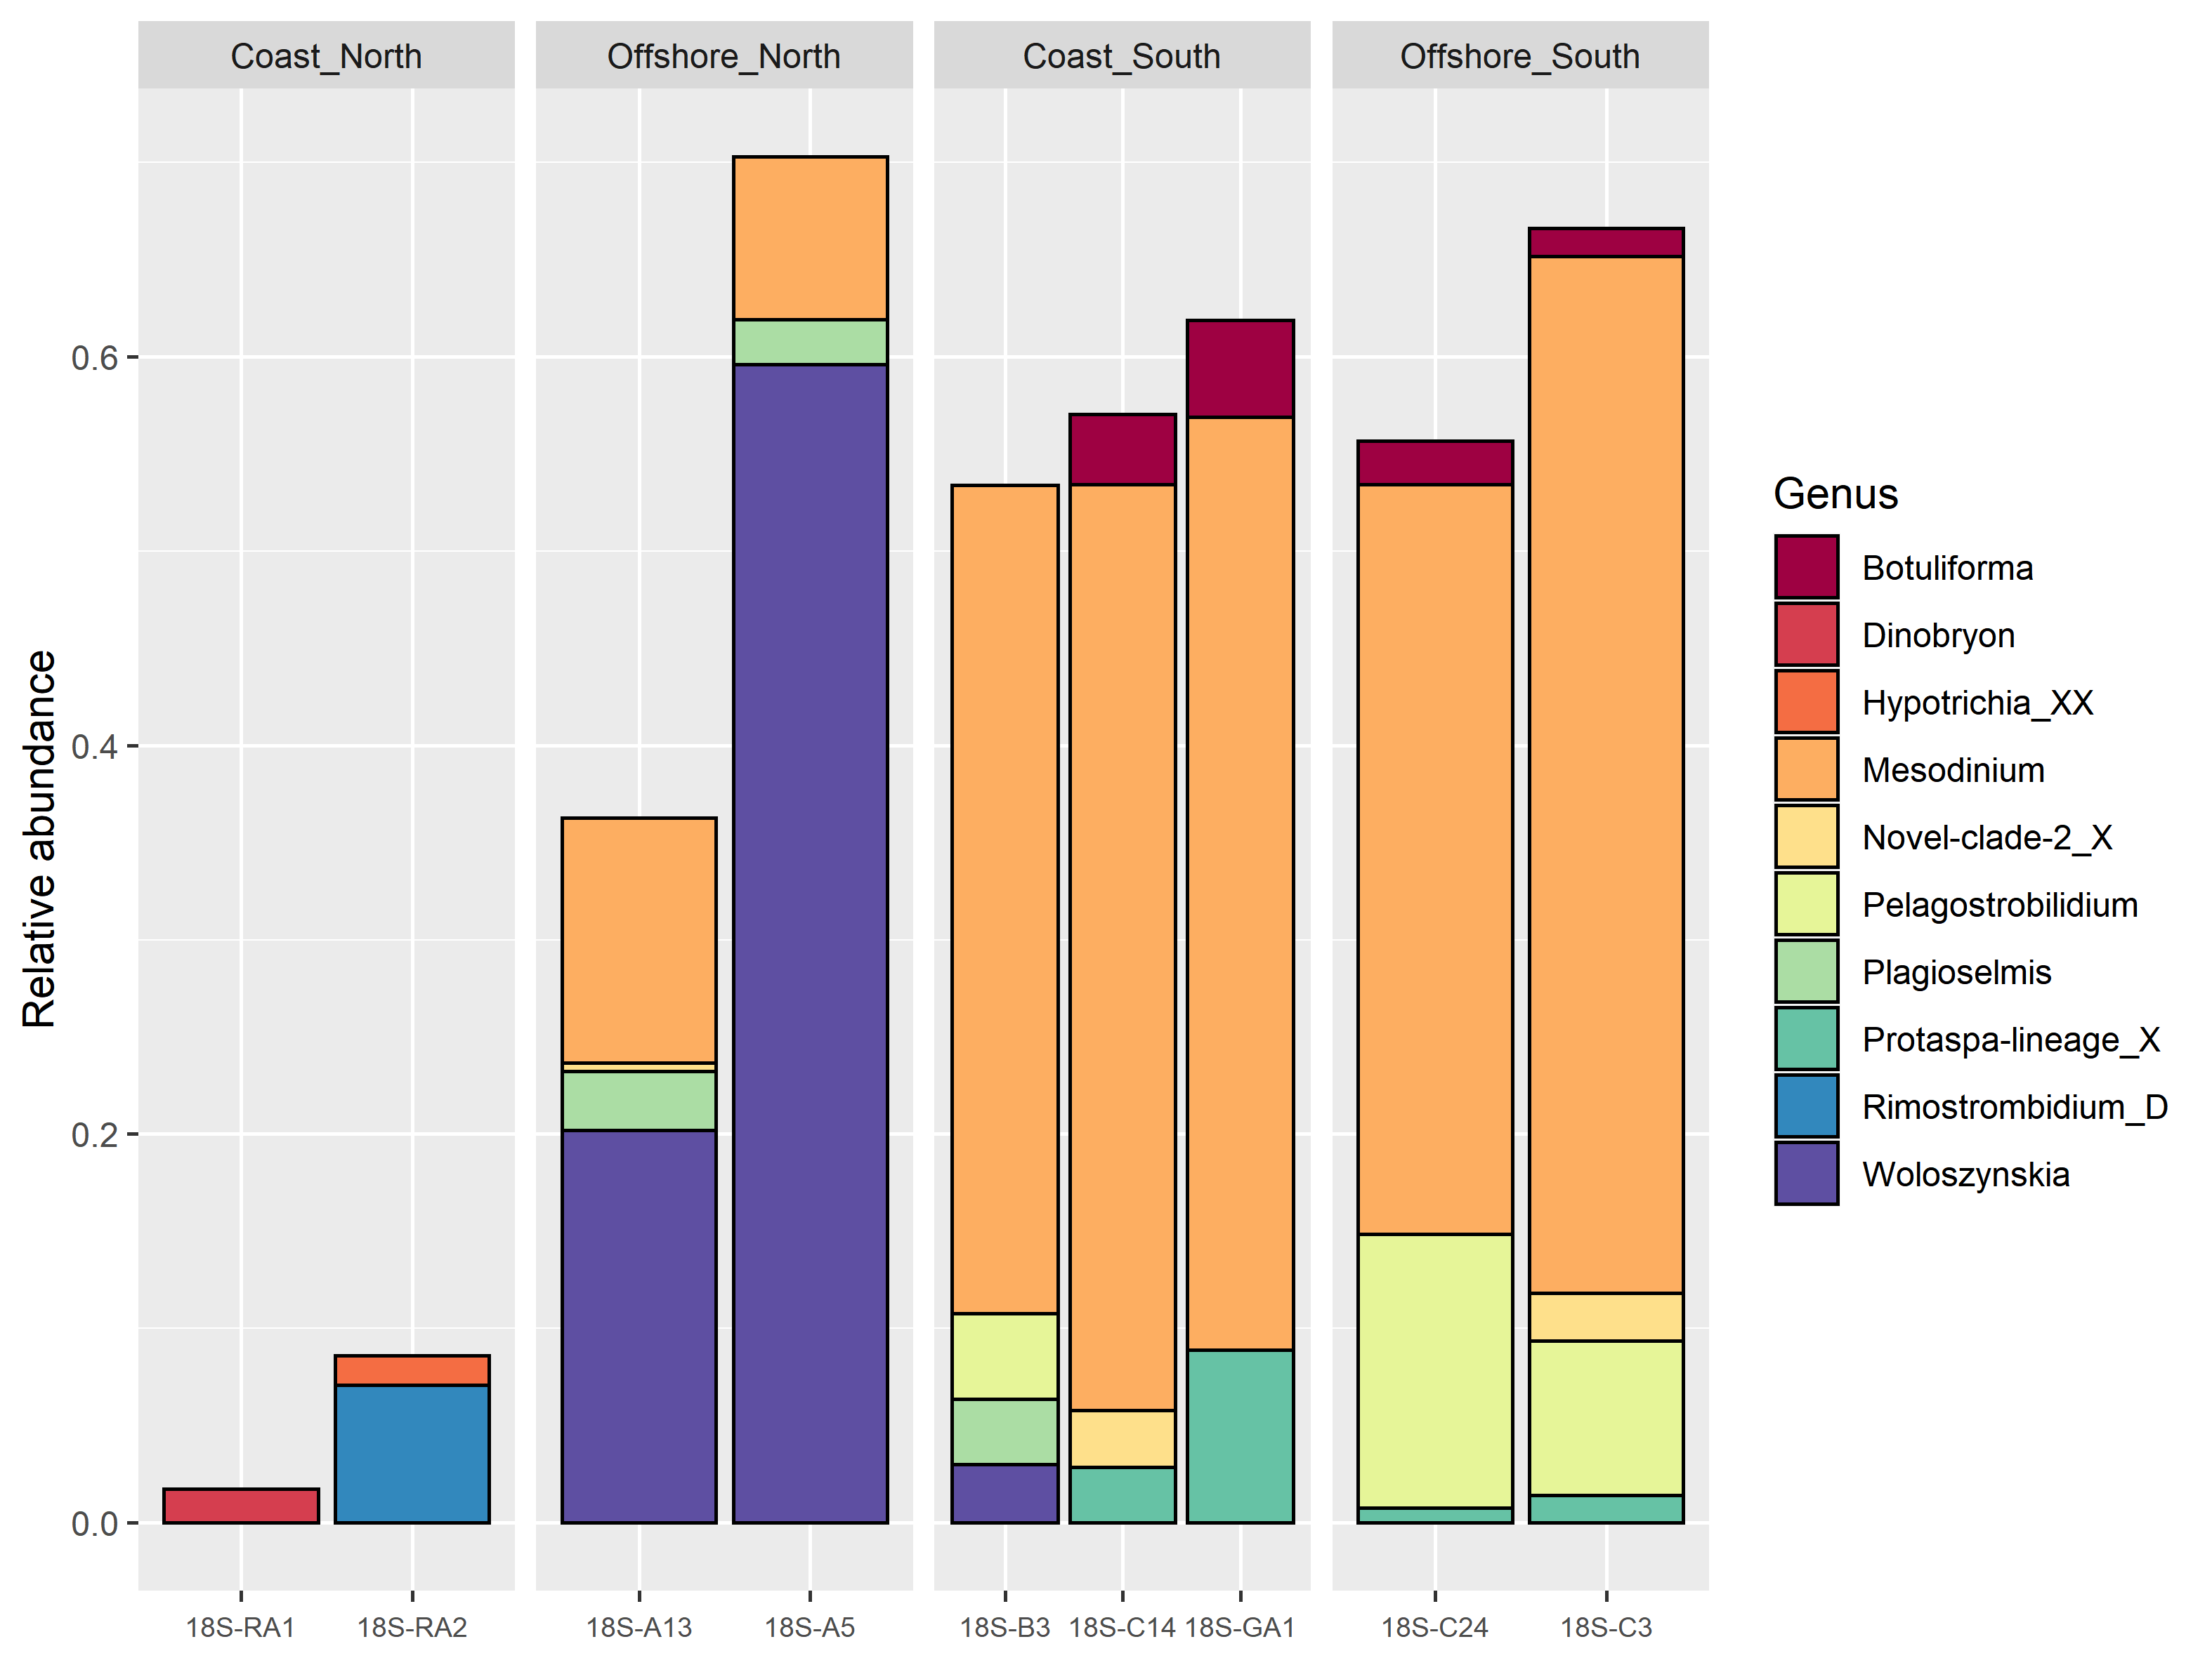

**Figure S6:** Top: Illumina relative abundance of Amplicon Sequence Variant reads (ASV) of the top 50 phagotrophic protozoa at each station. **Bottom**: Filtered reads detected in ≥3 samples. ASVs were collapsed to Genus.

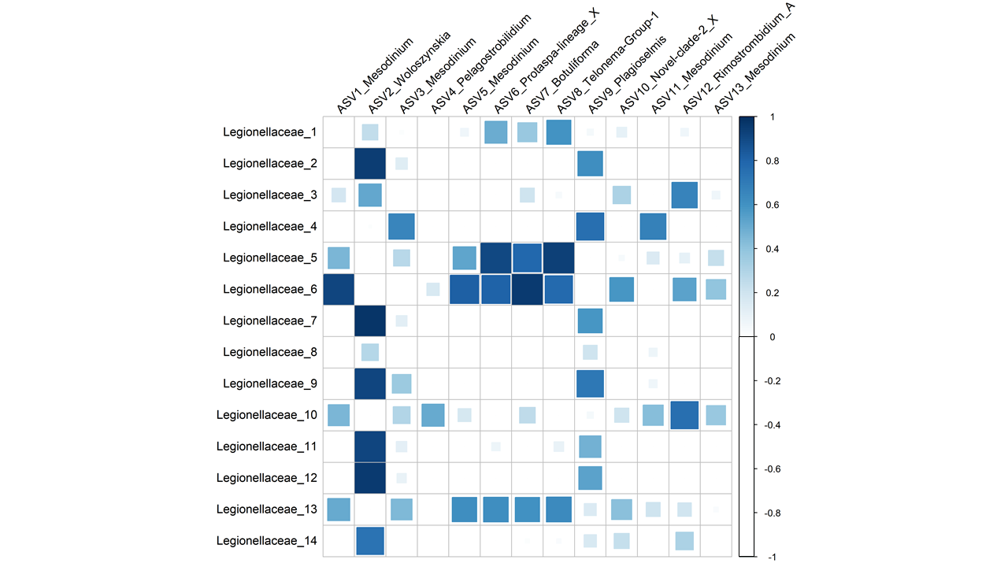

**Figure S7:** Correlations (≥0) between ASVs in the family Legionellaceae (Illumina) and ASVs (present in ≥1sample) of phagotrophic protozoa.

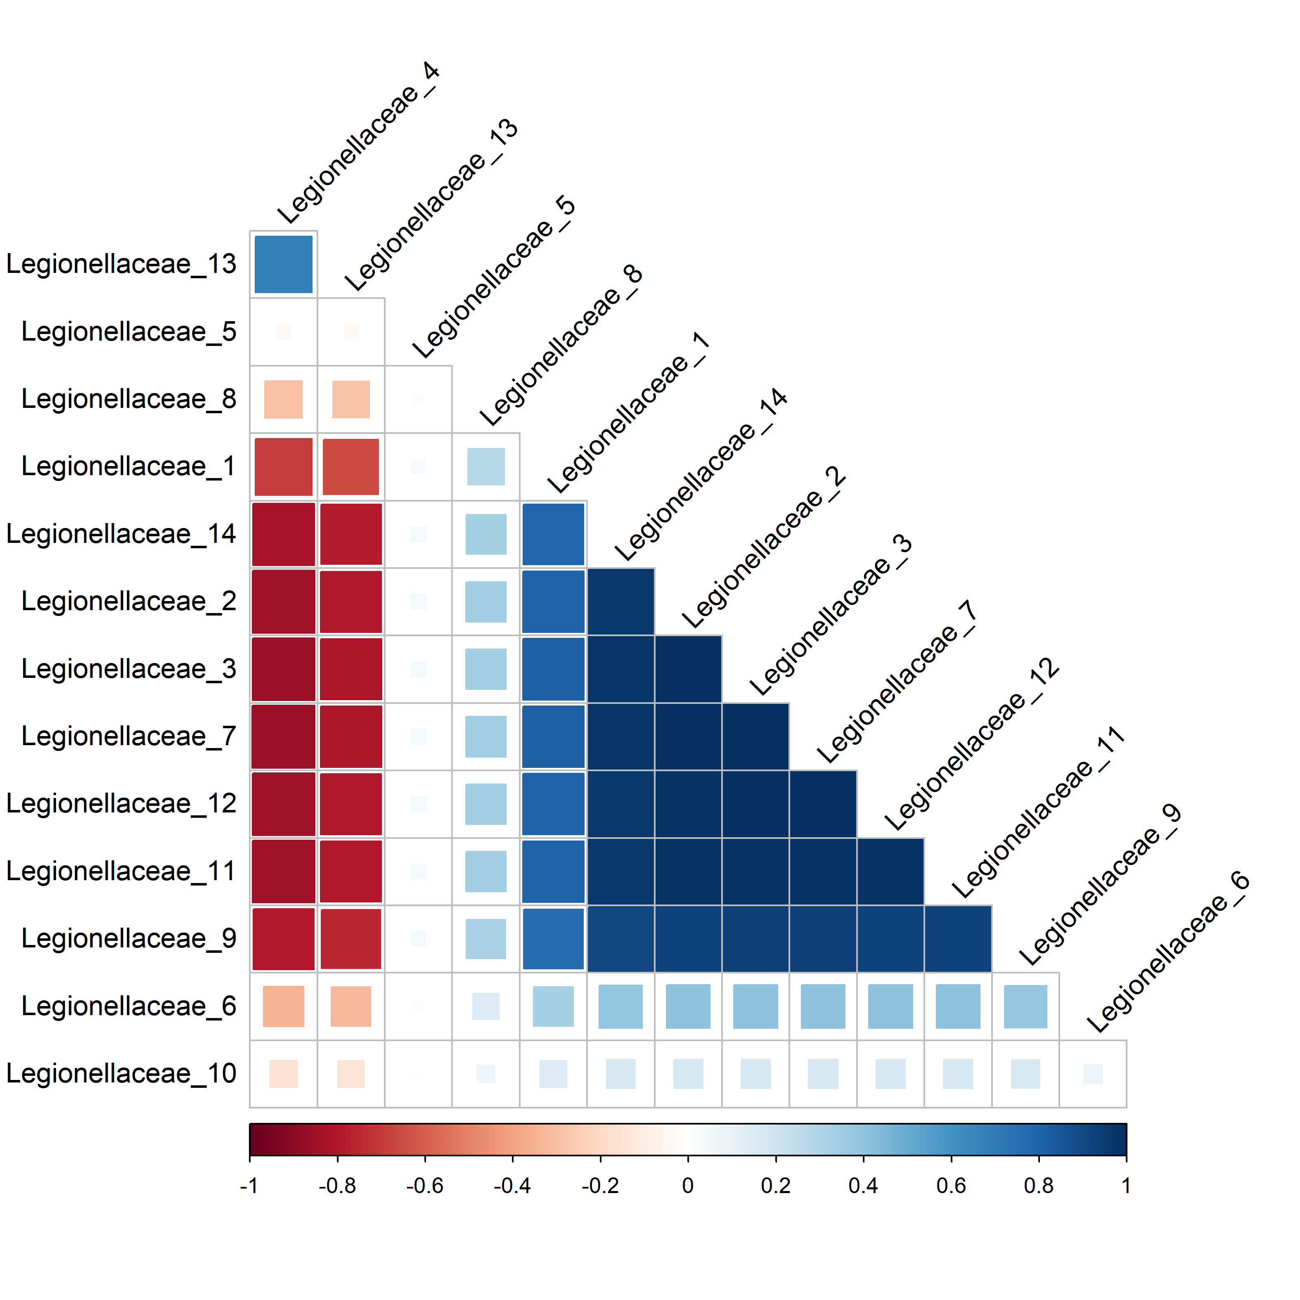

**Figure S8:** Co-variation explained in the Amplicon Sequence Variant (ASV) *Legionella* communities. Full model GLLVMs estimated taxa correlations after accounting for environmental or geographic effects.

**Table S1:** Mean and standard deviation between the Bothnian Bay (North) and Bothnian Sea (South).

|  |  |  |  |  |
| --- | --- | --- | --- | --- |
|  | mean north | mean south | sd north | sd south |
| TDN | 19.21 | 15.22 | 2.65 | 1.00 |
| TDP | 0.31 | 0.29 | 0.10 | 0.03 |
| DOC | 453.20 | 331.50 | 110.36 | 5.20 |
| Humic substances | 27.38 | 9.63 | 14.48 | 0.97 |
| Salinity | 2.32 | 5.08 | 1.30 | 0.14 |
| Temp | 10.04 | 8.67 | 3.73 | 1.33 |
| pH | 7.76 | 8.29 | 0.32 | 0.03 |
| Bacterial production | 8.64 | 4.35 | 5.56 | 1.16 |
| Chl-a | 3.19 | 2.08 | 0.37 | 0.36 |

**Table S2**: Linear regression of the individual factors Coast vs Offshore, North vs South and the combined effect of Coast and North (Coast:North). Factor levels South and Offshore are set as baseline levels in the model. Signif. codes: 0 ‘***’ 0.001 ‘**’ 0.01 ‘*’ 0.05 ‘.’ 0.1 ‘ ’ 1.

|  |  |  |  |  |  |  |
| --- | --- | --- | --- | --- | --- | --- |
| Response variable | Individual factor | Estimate | Std. Error | t value | Pr(>|t|) |  |
| Bacterial production | Coast | 5.370 | 2.595 | 2.070 | 0.0773 | . |
| Bacterial production | Coast:North | 8.3200 | 1.4727 | 5.649 | 0.000775 | *** |
| Bacterial production | North | 4.290 | 2.868 | 1.496 | 0.1783 |  |
| Chlorophyll a | Coast | 0.3137 | 0.4699 | 0.668 | 0.525699 |  |
| Chlorophyll a | Coast:North | 0.7692 | 0.4200 | 1.831 | 0.11 |  |
| Chlorophyll a | North | 1.1058 | 0.2453 | 4.508 | 0.00277 | ** |
| Humic substances | Coast | 11.860 | 8.892 | 1.334 | 0.2240 |  |
| Humic substances | Coast:North | 22.267 | 6.273 | 3.550 | 0.00935 | ** |
| Humic substances | North | 17.755 | 7.357 | 2.413 | 0.0465 | * |
| pH | Coast | -0.2325 | 0.2451 | -0.949 | 0.374 |  |
| pH | Coast:North | -0.5400 | 0.1835 | -2.943 | 0.0216 | * |
| pH | North | -0.5340 | 0.1645 | -3.247 | 0.0141 | * |
| Salinity | Coast | -0.8028 | 1.1976 | -0.670 | 0.52412 |  |
| Salinity | Coast:North | -2.3173 | 0.9638 | -2.404 | 0.04716 | * |
| Salinity | North | -2.7608 | 0.6615 | -4.174 | 0.00417 | ** |
| TDN | Coast | 0.3414 | 1.5261 | 0.224 | 0.8304 |  |
| TDN | Coast:North | 3.620 | 1.692 | 2.139 | 0.0697 | . |
| TDN | North | 3.9514 | 1.5261 | 2.589 | 0.0413 | * |
| TDP | Coast | 0.05500 | 0.05186 | 1.061 | 0.32970 |  |
| TDP | Coast:North | 0.08833 | 0.04398 | 2.008 | 0.0846 | . |
| TDP | North | 0.01000 | 0.05186 | 0.193 | 0.85345 |  |
| Temperature | Coast | 2.589 | 1.799 | 1.439 | 0.193357 |  |
| Temperature | Coast:North | 4.447 | 1.355 | 3.283 | 0.0134 | * |
| Temperature | North | 1.378 | 1.981 | 0.696 | 0.509095 |  |
| **Intercept of models with significant outcome** | **Intercept** | Estimate | Std. Error | t value | Pr(>|t|) |  |
| Humic substances | North | 9.625 | 5.484 | 1.755 | 0.1226 |  |
| pH | Coast:North | 8.1733 | 0.1059 | 77.165 | 1.62e-11 | *** |
| pH | North | 8.2900 | 0.1226 | 67.630 | 4.06e-11 | *** |
| Salinity | Coast:North | 4.3207 | 0.5564 | 7.765 | 0.00011 | *** |
| TDN | North | 15.222 | 1.052 | 14.467 | 1.8e-06 | *** |
| Temperature | Coast:North | 7.948 | 0.782 | 10.163 | 1.92e-05 | *** |
| Chlorophyll a | North | 2.0813 | 0.1828 | 11.383 | 9.05e-06 | *** |
| Humic substances | Coast:North | 12.067 | 3.622 | 3.332 | 0.01256 | * |
| Salinity | North | 5.0820 | 0.4930 | 10.307 | 1.75e-05 | *** |
| Bacterial production | Coast:North | 3.9600 | 0.8503 | 4.657 | 0.002322 | ** |

Table S3: Sampling route.

|  |  |  |  |  |
| --- | --- | --- | --- | --- |
| Station | Filtered volume (ml) | Day | Time | Notes |
| C14 | 500 | Monday | 08:00 |  |
| C24 | 500 | Monday | 15:00 |  |
| C3 | 500 | Tuesday | 07:00 |  |
| GA1 | 500 | Tuesday | 13:00 |  |
| B3 | 500 | Tuesday | 19:00 |  |
| A13 | 500 | Wednesday | 07:00 |  |
| A5 | 500 | Wednesday | 13:00 |  |
| RA1 | 100, 75, 75 | Wednesday | 19:00 | Very brown water |
| RA2 | 250 | Wednesday | 20:00 | Brown water |

**Table S4:** Coefficient estimates by Generalized linear latent variable models (GLLVMs) analysis showing average effect and uncertainty (as 95% CI) for each ASV**.**

|  |  |  |  |  |
| --- | --- | --- | --- | --- |
| ASV | Predictor | Estimate | CI2.5% | CI97.5% |
| Legionellaceae_1 | Humic_substancesloglog | -0,155 | -0,701 | 0,391 |
| Legionellaceae_2 | Humic_substancesloglog | 0,927 | 0,504 | 1,350 |
| Legionellaceae_3 | Humic_substancesloglog | 0,321 | -0,762 | 1,404 |
| Legionellaceae_4 | Humic_substancesloglog | 1,119 | 0,208 | 2,030 |
| Legionellaceae_5 | Humic_substancesloglog | -0,690 | -0,865 | -0,515 |
| Legionellaceae_6 | Humic_substancesloglog | -1,286 | -1,709 | -0,862 |
| Legionellaceae_7 | Humic_substancesloglog | 0,892 | 0,376 | 1,408 |
| Legionellaceae_8 | Humic_substancesloglog | 0,808 | 0,400 | 1,216 |
| Legionellaceae_9 | Humic_substancesloglog | 0,845 | 0,483 | 1,206 |
| Legionellaceae_10 | Humic_substancesloglog | 0,250 | -0,305 | 0,804 |
| Legionellaceae_11 | Humic_substancesloglog | 0,431 | -0,118 | 0,980 |
| Legionellaceae_12 | Humic_substancesloglog | 0,946 | 0,290 | 1,602 |
| Legionellaceae_13 | Humic_substancesloglog | -0,197 | -0,777 | 0,382 |
| Legionellaceae_14 | Humic_substancesloglog | 0,626 | -0,487 | 1,740 |
| Legionellaceae_1 | TDPlog | -0,244 | -0,877 | 0,389 |
| Legionellaceae_2 | TDPlog | -0,184 | -0,676 | 0,307 |
| Legionellaceae_3 | TDPlog | -0,672 | -1,928 | 0,585 |
| Legionellaceae_4 | TDPlog | -0,850 | -1,907 | 0,206 |
| Legionellaceae_5 | TDPlog | 0,773 | 0,570 | 0,975 |
| Legionellaceae_6 | TDPlog | 0,285 | -0,206 | 0,776 |
| Legionellaceae_7 | TDPlog | -0,072 | -0,671 | 0,527 |
| Legionellaceae_8 | TDPlog | -0,105 | -0,578 | 0,368 |
| Legionellaceae_9 | TDPlog | 0,067 | -0,352 | 0,486 |
| Legionellaceae_10 | TDPlog | -0,840 | -1,483 | -0,197 |
| Legionellaceae_11 | TDPlog | 0,520 | -0,117 | 1,157 |
| Legionellaceae_12 | TDPlog | -0,376 | -1,138 | 0,385 |
| Legionellaceae_13 | TDPlog | -0,327 | -0,999 | 0,345 |
| Legionellaceae_14 | TDPlog | -0,413 | -1,705 | 0,879 |
| Legionellaceae_1 | Coast | 1,279 | 0,605 | 1,953 |
| Legionellaceae_2 | Coast | -1,048 | -1,572 | -0,525 |
| Legionellaceae_3 | Coast | 0,096 | -1,243 | 1,435 |
| Legionellaceae_4 | Coast | 0,398 | -0,727 | 1,523 |
| Legionellaceae_5 | Coast | 1,609 | 1,394 | 1,825 |
| Legionellaceae_6 | Coast | 0,966 | 0,443 | 1,488 |
| Legionellaceae_7 | Coast | -1,075 | -1,713 | -0,437 |
| Legionellaceae_8 | Coast | -0,323 | -0,826 | 0,180 |
| Legionellaceae_9 | Coast | -0,693 | -1,140 | -0,247 |
| Legionellaceae_10 | Coast | 0,881 | 0,197 | 1,564 |
| Legionellaceae_11 | Coast | -0,797 | -1,476 | -0,118 |
| Legionellaceae_12 | Coast | -0,748 | -1,559 | 0,063 |
| Legionellaceae_13 | Coast | 1,321 | 0,605 | 2,036 |
| Legionellaceae_14 | Coast | 0,006 | -1,370 | 1,383 |
| Legionellaceae_1 | Tempnorm | -1,151 | -2,263 | -0,039 |
| Legionellaceae_2 | Tempnorm | -0,579 | -1,442 | 0,284 |
| Legionellaceae_3 | Tempnorm | 1,283 | -0,924 | 3,489 |
| Legionellaceae_4 | Tempnorm | 0,783 | -1,073 | 2,639 |
| Legionellaceae_5 | Tempnorm | -1,725 | -2,081 | -1,369 |
| Legionellaceae_6 | Tempnorm | -0,501 | -1,364 | 0,362 |
| Legionellaceae_7 | Tempnorm | -0,665 | -1,717 | 0,387 |
| Legionellaceae_8 | Tempnorm | -0,178 | -1,009 | 0,652 |
| Legionellaceae_9 | Tempnorm | -1,066 | -1,803 | -0,330 |
| Legionellaceae_10 | Tempnorm | 2,454 | 1,324 | 3,583 |
| Legionellaceae_11 | Tempnorm | -1,860 | -2,979 | -0,741 |
| Legionellaceae_12 | Tempnorm | -0,171 | -1,508 | 1,166 |
| Legionellaceae_13 | Tempnorm | -0,157 | -1,337 | 1,024 |
| Legionellaceae_14 | Tempnorm | 0,502 | -1,767 | 2,771 |
| Legionellaceae_1 | Filtervol | 1,586 | -1,060 | 4,231 |
| Legionellaceae_2 | Filtervol | -0,453 | -2,505 | 1,600 |
| Legionellaceae_3 | Filtervol | -3,545 | -8,794 | 1,703 |
| Legionellaceae_4 | Filtervol | -3,313 | -7,727 | 1,102 |
| Legionellaceae_5 | Filtervol | 2,468 | 1,621 | 3,315 |
| Legionellaceae_6 | Filtervol | 1,517 | -0,536 | 3,570 |
| Legionellaceae_7 | Filtervol | -0,255 | -2,757 | 2,247 |
| Legionellaceae_8 | Filtervol | 0,911 | -1,065 | 2,888 |
| Legionellaceae_9 | Filtervol | -0,088 | -1,840 | 1,664 |
| Legionellaceae_10 | Filtervol | -6,082 | -8,769 | -3,396 |
| Legionellaceae_11 | Filtervol | 2,238 | -0,423 | 4,900 |
| Legionellaceae_12 | Filtervol | -1,428 | -4,609 | 1,753 |
| Legionellaceae_13 | Filtervol | -1,340 | -4,149 | 1,468 |
| Legionellaceae_14 | Filtervol | -2,484 | -7,882 | 2,914 |

**Table S5:** Number of reads of each Legionellaceae ASV included in the GLLVM analysis and the corresponding ASV key.

|  |  |  |  |  |  |  |  |  |  |  |
| --- | --- | --- | --- | --- | --- | --- | --- | --- | --- | --- |
| Family_number | A13 | A5 | B3 | C14 | C24 | C3 | GA1 | RA1 | RA2 | ASV |
| Legionellaceae_1 | 203 | 263 | 182 | 341 | 111 | 125 | 168 | 122 | 252 | 9bff57fd6b18040dfd67407bba81b94f |
| Legionellaceae_2 | 216 | 347 | 0 | 0 | 0 | 0 | 0 | 0 | 0 | 7cab98bbf9568338722f9e5a53737169 |
| Legionellaceae_3 | 0 | 19 | 0 | 22 | 11 | 0 | 0 | 0 | 0 | 8b128e9b732005dae0783c6a3c918bf0 |
| Legionellaceae_4 | 26 | 0 | 30 | 0 | 0 | 0 | 0 | 0 | 13 | b9c0071a4a0d01910f452316a66b5504 |
| Legionellaceae_5 | 0 | 0 | 24 | 30 | 0 | 0 | 32 | 0 | 0 | 9553e620cb553c2a8a1a9c205490c743 |
| Legionellaceae_6 | 0 | 0 | 0 | 57 | 28 | 31 | 28 | 0 | 0 | f7bd4b7d813733af14ea4b4f89f4a4b8 |
| Legionellaceae_7 | 9 | 18 | 0 | 0 | 0 | 0 | 0 | 0 | 0 | 1b9782f79bb6f34bb5703518e0624a2f |
| Legionellaceae_8 | 81 | 166 | 119 | 0 | 0 | 0 | 0 | 253 | 233 | 6b08b339298c086bfac594e0044a1107 |
| Legionellaceae_9 | 123 | 191 | 68 | 31 | 28 | 20 | 34 | 0 | 20 | 86bf6ba2593a73582d40e0f60762cff8 |
| Legionellaceae_10 | 0 | 0 | 48 | 54 | 56 | 0 | 0 | 0 | 0 | 62ddf4d21584dddcc879dd895ea298d8 |
| Legionellaceae_11 | 27 | 61 | 0 | 0 | 0 | 0 | 13 | 0 | 0 | 2a286f7414e19e0f90ff9e4d9b6f3fc3 |
| Legionellaceae_12 | 34 | 70 | 0 | 19 | 0 | 0 | 0 | 0 | 0 | 8f8f29f28429498db407bfdeb68c604d |
| Legionellaceae_13 | 71 | 0 | 64 | 93 | 20 | 48 | 50 | 0 | 0 | cbde5fe4b37d4fa108f6e609ad159a6e |
| Legionellaceae_14 | 0 | 32 | 0 | 24 | 0 | 0 | 0 | 0 | 0 | 3516215d5db7f6781fe7331aca011932 |