Supplementary Material
Phenolic and anthocyanin content characterization related to genetic diversity analysis of Solanum tuberosum subsp tuberosum Chilotanum Group in Southern Chile.

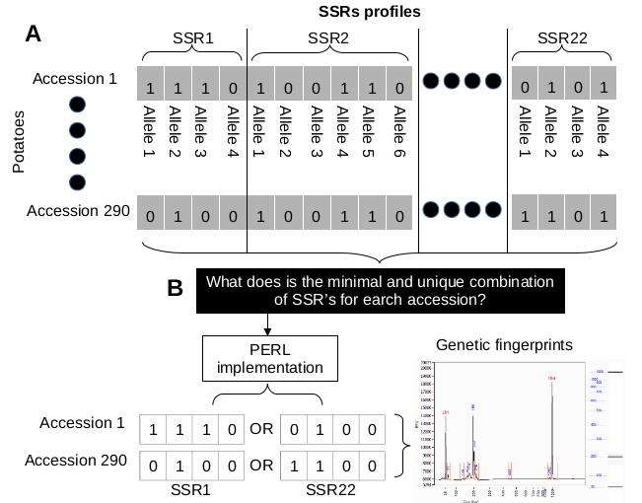
Supplementary figure 1. Calculation of the minimum and unique genetic fingerprint for the total number of accessions in this study. (A) PCR fragments were analyzed by capillary electrophoresis and scored as presence = 1 or absence = 0 of allele in CSV spreadsheet format representing a static binary matrix for the 290 potato accessions. (B) To calculate the minimum unique SSR combination representing a potato species (accession), a Perl implementation supported by a database design was designed to search for a unique PCR band profile for each species. A species can have multiple unique SSR representations that represent a genetic fingerprint marker with a PCR band profile that characterizes a potato species.

Supplementary table 1. Information about the accessions belonging to each cluster.
 | Identification of accessions | Number of accesions
Cluster A | 6,11,93,177,108,288,213,29,284,131,160,113,256,184,262,34,143,268,194,88,94,236,18,135,178,176 | 26
Cluster B | 102,261,33,64,265,89,282,259,264,91,183,81,281,255,254,137,7,39,158,111,112,23,101,74,121,162,199,225,269,280,63,169,107,69,70,72,186,10,193,197,25,27,12,44,266,118,181,245,149,198,228,2,85,156,15,19,36,62,90,73,175,238,128,244 | 64
Cluster C | 289,270,180,267,239,243,119,51,221,216,65,114,103,32,287,59,55,258,42,31,26,260,190,188,97,191,271,187,99,182,84,82,248,283,226,210,22,167,144,52,173,13,163 | 43
Cluster D | 253,251,168,146,98,96,66,174,130,136,207,37,83,279,78,277,274,195,273,275,272,257,215,204,80,276,285,286,206,61,57 | 31
Cluster E | 133,208,219,170,224,153,209,139,148,147,129,123,217,122,58,218,24,49,202,126,138,124,41,104,20,140,16,106,134,231,79,250,3 | 33
Cluster F | 8,71,53,115,233,125,234,145,157,212,230,47,76,75,77,229,141,237,9,263,120,192,92,43,196,14,68,200,205,95,110,185,246,54,116,87,151,290,159,21,161,117,203,164,165,166,60,67,86,109,241,17,223,232 | 54
Cluster G | 45,1,38,220,211,222,152,154,28,155,172,105,35,40,127,132,242,249,4,56,235,252,150,240,100,179,189,5,227,247,171,201,278,30,46,214,142,48,50 | 39
 | TOTAL | 290

Supplementary Table 2. Heat map of the probability of occurrence of any of these colors in each cluster. Bolded probabilities signify a p-value < 0.05
Skin primary color
 | A | B |  | C |  | D |  | E |  | F |  | G
White cream | 0,00 | 0,00 |  | 0,00 |  | 0,00 |  | 0,00 |  | 0,00 |  | 0,00
Yellow | 0,04 | 0,13 |  | 0,06 |  | 0,03 |  | 0,10 |  | 0,06 |  | 0,00
Orange | 0,15 | 0,10 |  | 0,06 |  | 0,17 |  | 0,10 |  | 0,20 |  | 0,00
Brown | 0,23 | 0,22 |  | 0,23 |  | 0,03 |  | 0,30 |  | 0,24 |  | 0,35
Pink | 0,04 | 0,12 |  | 0,06 |  | 0,07 |  | 0,10 |  | 0,04 |  | 0,15
Red | 0,08 | 0,05 |  | 0,14 |  | 0,14 |  | 0,13 |  | 0,08 |  | 0,23
Deep pink | 0,12 | 0,07 |  | 0,09 |  | 0,07 |  | 0,10 |  | 0,08 |  | 0,04
Purple | 0,19 | 0,18 |  | 0,14 |  | 0,34 |  | 0,07 |  | 0,26 |  | 0,19
Blackish | 0,15 | 0,13 |  | 0,23 |  | 0,14 |  | 0,10 |  | 0,04 |  | 0,04
Skin secondary color
 | A |  | B |  | C |  | D |  | E |  | F |  | G
White cream | 0,00 |  | 0,03 |  | 0,00 |  | 0,00 |  | 0,00 |  | 0,00 |  | 0,00
Yellow | 0,00 |  | 0,20 |  | 0,09 |  | 0,09 |  | 0,23 |  | 0,13 |  | 0,08
Orange | 0,17 |  | 0,07 |  | 0,00 |  | 0,09 |  | 0,00 |  | 0,00 |  | 0,08
Brown | 0,00 |  | 0,07 |  | 0,00 |  | 0,45 |  | 0,00 |  | 0,09 |  | 0,15
Pink | 0,17 |  | 0,13 |  | 0,18 |  | 0,09 |  | 0,08 |  | 0,09 |  | 0,08
Red | 0,17 |  | 0,03 |  | 0,27 |  | 0,00 |  | 0,46 |  | 0,09 |  | 0,31
Deep pink | 0,50 |  | 0,23 |  | 0,27 |  | 0,09 |  | 0,15 |  | 0,43 |  | 0,23
Purple | 0,00 |  | 0,23 |  | 0,18 |  | 0,18 |  | 0,08 |  | 0,13 |  | 0,08
Blackish | 0,00 |  | 0,00 |  | 0,00 |  | 0,00 |  | 0,00 |  | 0,04 |  | 0,00
Flesh primary color
 | A | B |  | C |  | D |  | E |  | F |  | G
White | 0,00 | 0,03 |  | 0,03 |  | 0,00 |  | 0,00 |  | 0,00 |  | 0,00
Cream | 0,44 | 0,54 |  | 0,36 |  | 0,44 |  | 0,41 |  | 0,34 |  | 0,31
Light yellow | 0,39 | 0,21 |  | 0,25 |  | 0,15 |  | 0,28 |  | 0,21 |  | 0,42
Yellow | 0,17 | 0,08 |  | 0,19 |  | 0,22 |  | 0,16 |  | 0,26 |  | 0,23
Intense yellow | 0,00 | 0,00 |  | 0,03 |  | 0,00 |  | 0,03 |  | 0,05 |  | 0,04
Red | 0,00 | 0,02 |  | 0,00 |  | 0,00 |  | 0,00 |  | 0,00 |  | 0,00
Pink | 0,00 | 0,07 |  | 0,06 |  | 0,07 |  | 0,00 |  | 0,00 |  | 0,00
Purple | 0,00 | 0,05 |  | 0,08 |  | 0,11 |  | 0,13 |  | 0,13 |  | 0,00
Blackish | 0,00 | 0,00 |  | 0,00 |  | 0,00 |  | 0,00 |  | 0,00 |  | 0,00
Flesh secondary color
Cluster | A |  | B |  | C |  | D |  | E |  | F |  | G
White | 0,00 |  | 0,00 |  | 0,00 |  | 0,10 |  | 0,00 |  | 0,14 |  | 0,00
Cream | 0,00 |  | 0,35 |  | 0,44 |  | 0,30 |  | 0,30 |  | 0,57 |  | 0,00
Light yellow | 0,00 |  | 0,12 |  | 0,00 |  | 0,10 |  | 0,10 |  | 0,00 |  | 0,00
Yellow | 0,00 |  | 0,00 |  | 0,00 |  | 0,00 |  | 0,00 |  | 0,00 |  | 0,00
Intense yellow | 0,00 |  | 0,00 |  | 0,00 |  | 0,00 |  | 0,00 |  | 0,00 |  | 0,00
Red | 0,00 |  | 0,00 |  | 0,00 |  | 0,20 |  | 0,20 |  | 0,00 |  | 0,50
Pink | 0,75 |  | 0,12 |  | 0,33 |  | 0,20 |  | 0,30 |  | 0,00 |  | 0,17
Purple | 0,25 |  | 0,41 |  | 0,22 |  | 0,10 |  | 0,10 |  | 0,29 |  | 0,33
Blackish | 0,00 |  | 0,00 |  | 0,00 |  | 0,00 |  | 0,00 |  | 0,00 |  | 0,00

Color range | 0 | 0,2 | 0,4 | 0,6 | 0,8 | 1
Significance | p<0.05

