# Supplementary data

#### Particle Size Distribution of Barite

**Figure A1** showsBarite Particle Size Distribution, which was used in the drilling fluids formulated in Table A1 and Table A2 below.

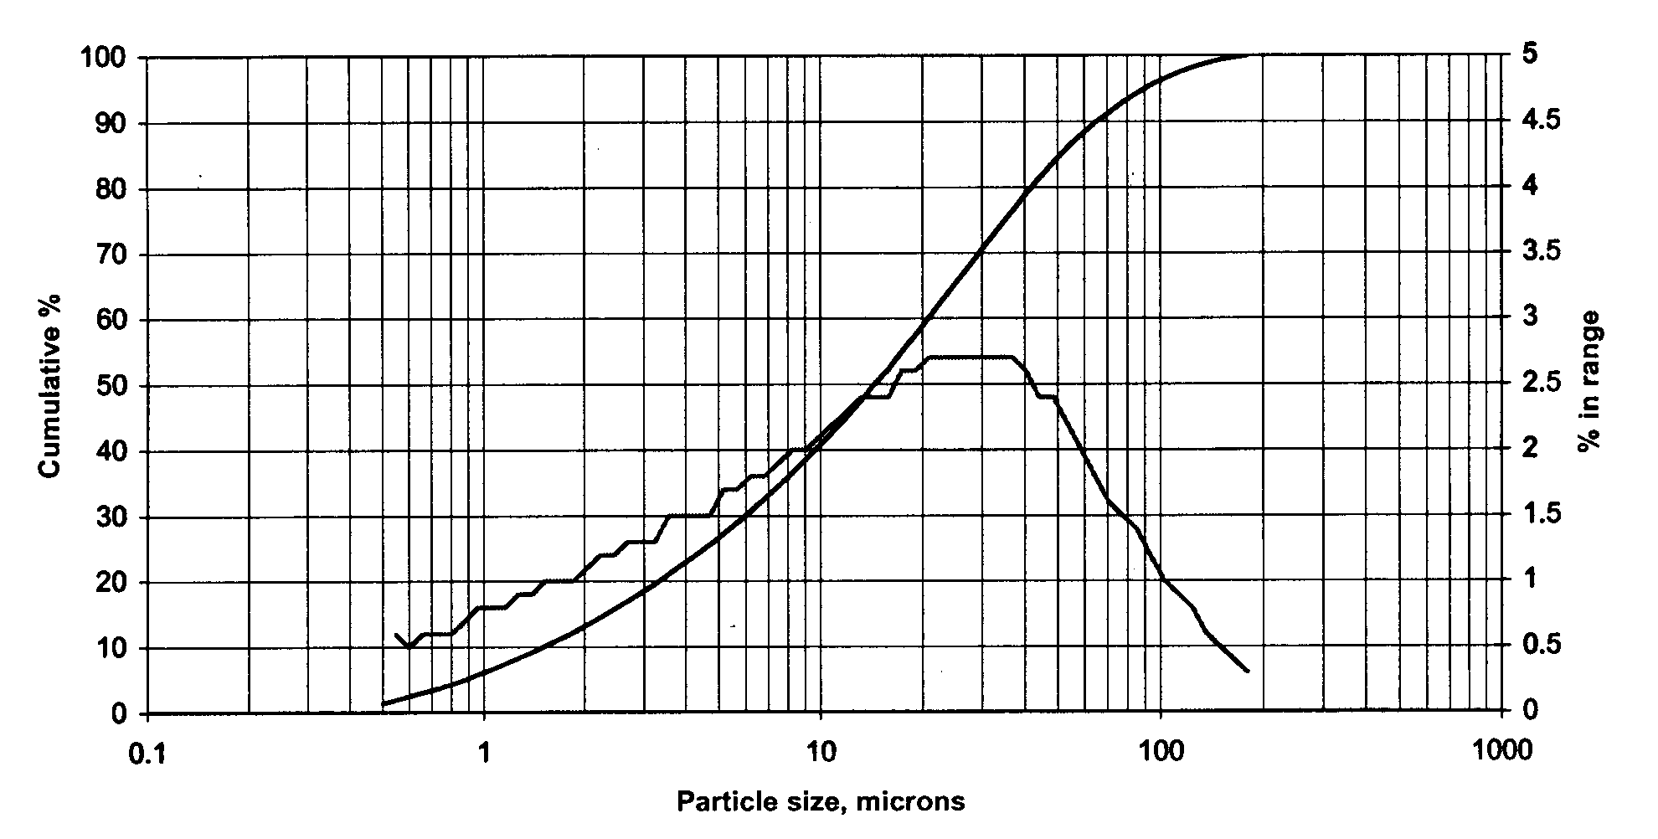

Figure A1: Particle size distribution of barite

#### Drilling fluid-1 for LCM and Swelling Evaluation

For the LCM performance study, two 1.75sg oil-based mud systems with 80/20 and 60/40 oil-water ratio (OWR) mud types were prepared. The formulation is according to MI-SWACO, which is typically used in drilling operations as provided in Table A1.

Table A1**:** Drilling fluid formulation.

|  |  |  |
| --- | --- | --- |
| **Chemicals function** | **60/40 OBM** | **80/20 OBM** |
| Base Fluid | 321 | 440 |
| Emulsifier | 30 | 20 |
| Wetting agent | 8 | 8 |
| pH modifier | 25 | 20 |
| Freshwater | 279 | 137 |
| Osmotic control | 75 | 37 |
| Fluid loss control | 10 | 10 |
| Viscosifier | 4 | 9 |
| Weighting material | 997 | 1065 |

#### Drilling fluid-2 for Barite Sagging Evaluation

For the sagging evaluations, 60/40 and 80/20 OBM drilling fluids were obtained from MI-SWACO. The drilling fluids have the same density, which is 1750 kg/m3, and different OWRs. Table A2 provides the chemical compositions and their function in the drilling fluids. The brines (water to salt ratio) of the drilling fluid systems are the same to obtain equal water phase salinity. The Barite to Water ratio of 80:20 OBM is about twice that of the 60:40 OBM.

Table A2**:** Drilling fluid formulation.

|  |  |  |
| --- | --- | --- |
| Chemical’s function | 60/40 OBM | 80/20 OBM |
| Base oil | 330.6 | 443.1 |
| Emulsifier | 25 | 25 |
| Viscosifier | 7 | 7 |
| Alkalinity | 25 | 25 |
| Filter Loss agent | 10 | 10 |
| Freshwater | 275.8 | 136.4 |
| Salt | 84.8 | 42 |
| Weight material | 990.8 | 1061.4 |

### Compressibility of drilling fluids

In an attempt to analyze the compressibility of the two oil-based drilling fluids, LCM particle-free test was performed by closing the slot. As shown in Figure A2, both fluids have the same pressure gradient. The compressibility of the mud systems was calculated to be 0.6135 GPa-1 and 0.6167 GPa-1 for 60/40 OMB and 80/20 OMB, respectively.



Figure A2: Pressure buildup without slot (closed slot)

### Bridging performance of drilling fluids (without LCM) at 100mm slot

Figure A3 shows the particle-free mud systems bridging performance at 100m slot. The result shows that the fluid system exhibits comparable performances with minor deviation. Due to the high Oil content in 80/20, the barite sagging might be faster than the 60/40 and hence, the fracture could get more barite settling to seal the fracture and show a bit higher bridging pressure, but not sable in both cases. From the results, one can expect that by increasing the fracture width, the efficiency of the barite alone in bridging the fracture is lower, and a complete loss would result.

Figure A3: Particle additive free bridging test at 100 mm opening slots

### Performance of mud systems in the presence of particle additive (Mica + LC-lube 1:1 ratio)

The bridging performance of the particle blending is shown in Figures A4-A6. Their average pressures are documented in the main paper, in Figures 13-14 compared with the pure LC-lube and Mica test results.

 Figure A4: Bridging test at 300 mm slot

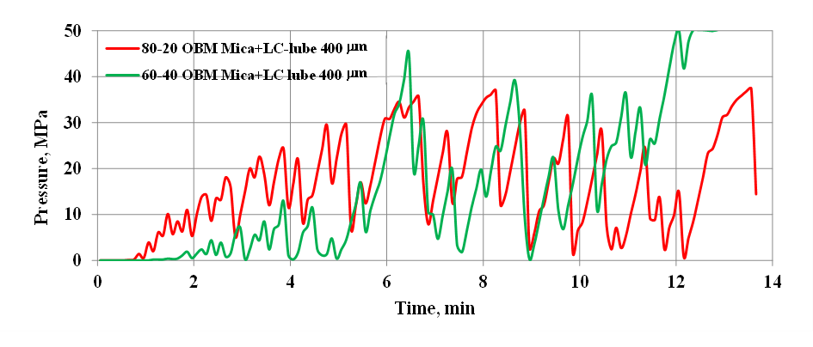

Figure A5: Bridging test at 400 mm slot



Figure A6: Bridging test at 500 mm slot

### Pellet synthesis

Table A3: Pellets mineralogical concentration in gram/percentage

|  |  |  |  |  |  |  |  |
| --- | --- | --- | --- | --- | --- | --- | --- |
| # | Pellets  Type | This paperwork  Pellets | **Mineral composition** | | | | |
| Bentonite | Feldspar | Quartz | Calcite | Others |
| 1 | Bentonite-I | This work’s pellet | 100% | - | - | - | - |
| 2 | Bentonite-II | 93.1%wt | 3.45%wt | 3.46%wt |  |  |
| 3 | Texas Austin type | This work modified version of the reference [66] | 30g | 4g | 49g | 17g | - |
| 4 | Devonian, OH | 33g | 18g | 47g | 2g |  |
| 5 | Pierre | 33g | 24g | 43g | 0g | - |
| 6 | North Sea- A | This work modified version of the reference [67] | 52.9g | 15.5g | 26.9g | 0.6g | 4.1g |
| 7 | North Sea B | 48.4g | 6.9g | 34.6g | 4.8g | 5.3g |
| 8 | North Sea C | 46.7g | 1.4g | 48.1g | 2.3g | 1.5g |

### Swelling results

Table A4: Swelling test results obtained from the 60/40 OBM mud system

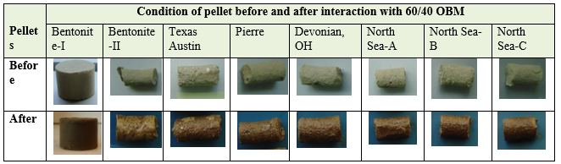

Table A5: Swelling test results obtained from the 80/20 OBM mud system

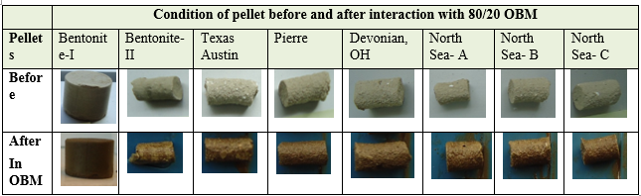

### Type of Loss/severity classification and LCM selection methods

## Table A6: Classification of Types of Loss and Severity of Loss [3]

|  |  |
| --- | --- |
| Type of Loss | Severity of Loss |
| Seepage | Less than 1.6 m3/h [10 bbl./h] |
| Partial | 1.6 to 16 m3/h [10 to 100 bbl./h] |
| Sever | More than 16m3 /h [ >100 bbl./h] |
| Total | No fluid return to the surface |

## Table A7: LCM selection methods

|  |  |  |
| --- | --- | --- |
| Authors | Rule of thumbs | Reference |
| Abraham (1977) | D50 >=1/3 of the median size of the formation pore.  The concentration of the LCM must be at least 5 percent by volume of the total solids in the final fluid mix | [47] |
| Smith et al. (1996) | D90 = Formation average pore throat | [48] |
| Vickers et al. (2006) | D90 = Largest pore throat  D75 < 2/3 of the largest pore throat  D50 = > 1/3 of the mean pore throat  D25 =1/7 of the mean pore throat  D10 > Smallest pore throat | [49] |
| Whitfill (2008) | D50 =Fracture width | [50] |