SUPPLEMENT FOR: Food insecurity and the role of food assistance programs in supporting diet quality during the COVID-19 pandemic in Massachusetts

CONTENTS

APPENDIX 1: Adjusted consumption frequency ratios for individual foods comparing food insecure at any point vs. Persistently food secure, by program participation (Table)

APPENDIX 2: Adjusted consumption frequency ratios for individual foods comparing food insecure at any point vs. Persistently food secure, by program participation (Figure)

APPENDIX 3: Foods shipped to local food pantries by the Greater Boston Food Bank from January 1, 2020, through December 31, 2020 (Table)

APPENDIX 1A: Adjusted consumption frequency ratios for individual foods comparing program participants to non-participants

 | Food Pantries:  Participants vs. Non-participants, by Food Security |  | SNAP:  Participants vs. Non-participants, by Food Security
Food item | Not Food Insecure  (95% CrI) | Food Insecure  (95% CrI) | Not Food Insecure  (95% CrI) | Food Insecure  (95% CrI)
Healthy items
Fruit | 0.775 (0.487, 1.232) | 1.189 (0.929, 1.522) | 1.137 (0.874, 1.481) | 1.12 (0.921, 1.362)
Vegetables | 0.795 (0.503, 1.261) | 1.421 (1.106, 1.826) | 1.118 (0.858, 1.45) | 1.059 (0.871, 1.291)
Whole Grains | 0.785 (0.473, 1.291) | 1.138 (0.868, 1.482) | 1.009 (0.761, 1.339) | 1.228 (0.985, 1.525)
Nuts | 0.822 (0.512, 1.317) | 1.435 (1.113, 1.859) | 1.05 (0.788, 1.392) | 1.216 (0.984, 1.508)
Legumes | 0.851 (0.54, 1.352) | 1.526 (1.19, 1.948) | 0.898 (0.688, 1.171) | 0.996 (0.815, 1.213)
Fish | 1.601 (1.09, 2.378) | 1.362 (1.11, 1.662) | 1.082 (0.865, 1.357) | 0.989 (0.836, 1.169)
Unhealthy items
Processed Meats | 1.254 (0.798, 1.943) | 1.207 (0.957, 1.53) | 1.094 (0.859, 1.402) | 0.995 (0.822, 1.204)
Beef, Pork, Lamb | 0.866 (0.553, 1.341) | 1.039 (0.821, 1.315) | 1.408 (1.092, 1.821) | 1.078 (0.892, 1.312)
Fast Food | 1.09 (0.698, 1.694) | 0.958 (0.764, 1.211) | 1.095 (0.848, 1.406) | 1.074 (0.892, 1.3)
SSBs | 0.764 (0.445, 1.298) | 1.071 (0.799, 1.425) | 1.388 (1.016, 1.901) | 1.073 (0.849, 1.35)
Sweets | 0.779 (0.473, 1.273) | 0.986 (0.759, 1.275) | 1.086 (0.816, 1.454) | 1.149 (0.93, 1.415)
Refined Grains | 0.851 (0.53, 1.361) | 1.086 (0.845, 1.402) | 1.34 (1.021, 1.766) | 1.122 (0.906, 1.384)
Full-Fat Dairy | 1.101 (0.685, 1.757) | 1.075 (0.826, 1.389) | 1.206 (0.918, 1.596) | 1.231 (0.992, 1.522)
Alcohol | 1.116 (0.736, 1.699) | 1.252 (1.001, 1.567) | 0.935 (0.738, 1.196) | 0.95 (0.791, 1.141)

APPENDIX 1B: Adjusted consumption frequency ratios for individual foods comparing food insecure at any point vs. Persistently food secure, by program participation

 | Estimated Frequency Ratio, Food Insecure at Any Point vs. Persistently Food Secure (95% CrI)
Food item | No SNAP or Pantry | Pantry, no SNAP | SNAP, no Pantry | Both Pantry and SNAP
Healthy items
Fruit | 0.739 (0.606, 0.897) | 1.134 (0.666, 1.943) | 0.728 (0.542, 0.977) | 1.117 (0.670, 1.861)
Vegetables | 0.693 (0.571, 0.842) | 1.238 (0.716, 2.096) | 0.656 (0.491, 0.875) | 1.173 (0.712, 1.921)
Whole Grains | 0.781 (0.635, 0.966) | 1.132 (0.638, 2.007) | 0.950 (0.691, 1.300) | 1.377 (0.807, 2.389)
Nuts | 0.792 (0.643, 0.979) | 1.382 (0.796, 2.420) | 0.917 (0.674, 1.257) | 1.600 (0.944, 2.694)
Legumes | 0.942 (0.780, 1.147) | 1.689 (0.983, 2.866) | 1.046 (0.785, 1.394) | 1.874 (1.136, 3.082)
Fish | 1.007 (0.857, 1.183) | 0.857 (0.540, 1.348) | 0.921 (0.726, 1.170) | 0.784 (0.513, 1.195)
Unhealthy items
Processed Meats | 1.019 (0.849, 1.225) | 0.981 (0.594, 1.657) | 0.927 (0.704, 1.216) | 0.892 (0.543, 1.459)
Beef, Pork, Lamb | 0.828 (0.689, 0.998) | 0.993 (0.594, 1.662) | 0.634 (0.482, 0.832) | 0.761 (0.471, 1.235)
Fast Food | 0.876 (0.732, 1.046) | 0.770 (0.461, 1.290) | 0.859 (0.655, 1.125) | 0.755 (0.464, 1.229)
SSBs | 0.853 (0.679, 1.068) | 1.195 (0.650, 2.220) | 0.659 (0.463, 0.929) | 0.924 (0.511, 1.641)
Sweets | 0.738 (0.603, 0.904) | 0.934 (0.529, 1.645) | 0.782 (0.568, 1.067) | 0.989 (0.575, 1.686)
Refined Grains | 0.865 (0.71, 1.062) | 1.105 (0.638, 1.913) | 0.724 (0.536, 0.980) | 0.925 (0.544, 1.547)
Full-Fat Dairy | 0.769 (0.623, 0.940) | 0.751 (0.436, 1.303) | 0.785 (0.577, 1.061) | 0.766 (0.457, 1.295)
Alcohol | 0.913 (0.768, 1.091) | 1.025 (0.638, 1.670) | 0.928 (0.706, 1.207) | 1.041 (0.660, 1.637)

APPENDIX 2: Adjusted consumption frequency ratios for individual foods, by food pantry, SNAP, and food insecurity status
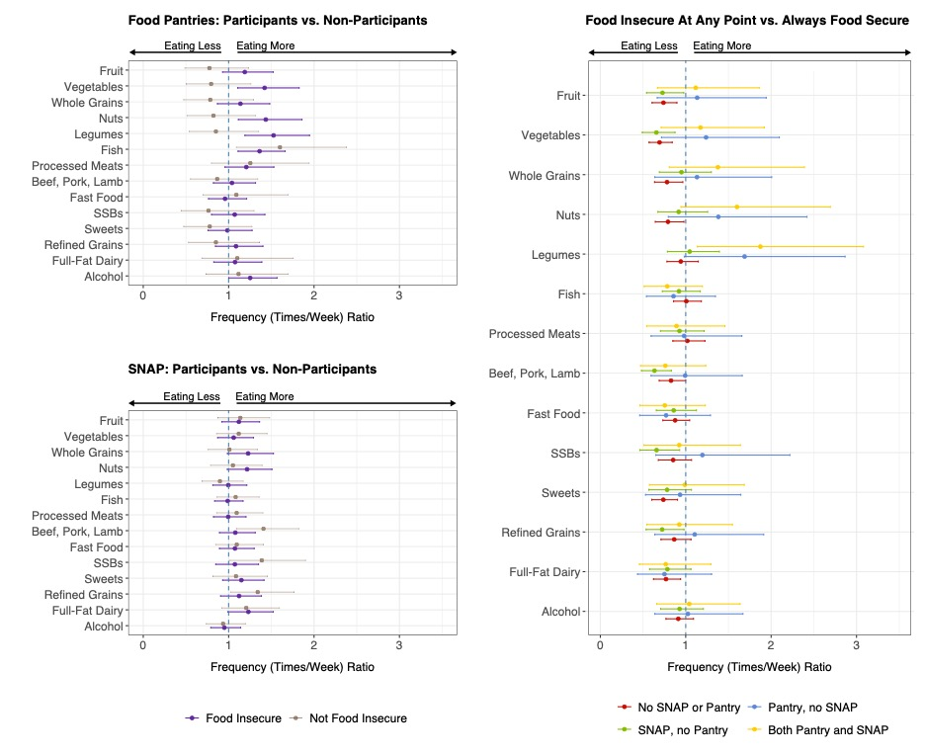

APPENDIX 3: Distribution, by weight, of foods shipped to partner food pantries by The Greater Boston Food Bank from January 1, 2020, through December 31, 2020¹

Product | Percent of total weight shipped* (%)
Fresh produce | 30%
Grains (rice, pasta, bread/bakery, cereal, etc.) | 10%
Mixed and assorted food items | 9%
Poultry | 8%
Dairy products | 7%
Non-meat protein | 7%
Complete meal/entree and soups | 6%
Juice 100% | 5%
Meat - not seafood or poultry | 5%
Fruit - canned/frozen | 4%
Vegetables - canned/frozen | 3%
Condiments/Sauces/Spices/Dressing | 3%
Seafood | 2%
Beverages - not water or soda | <1%
Snack Food/Cookies/Dessert | <1%
Soda | <1%
Non-dairy dairy substitutes | <1%
*Total weight shipped was 95 million pounds

¹ Data in this table was provided via direct communication with the Greater Boston Food Bank.

