**Supplementary Table S2.** Pharmacokinetic and drug likeliness profiling of bergapten using SwissADME tool.

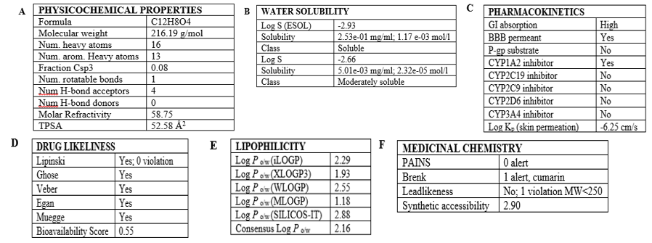**A**: represents physicochemical properties of bergapten **B:** represents water solubility, **C:** represents pharmacokinetics **D:** represents druglikeliness **E:** represents lipophilic profile **F:** reperesents medicinal likeability of bergapten.