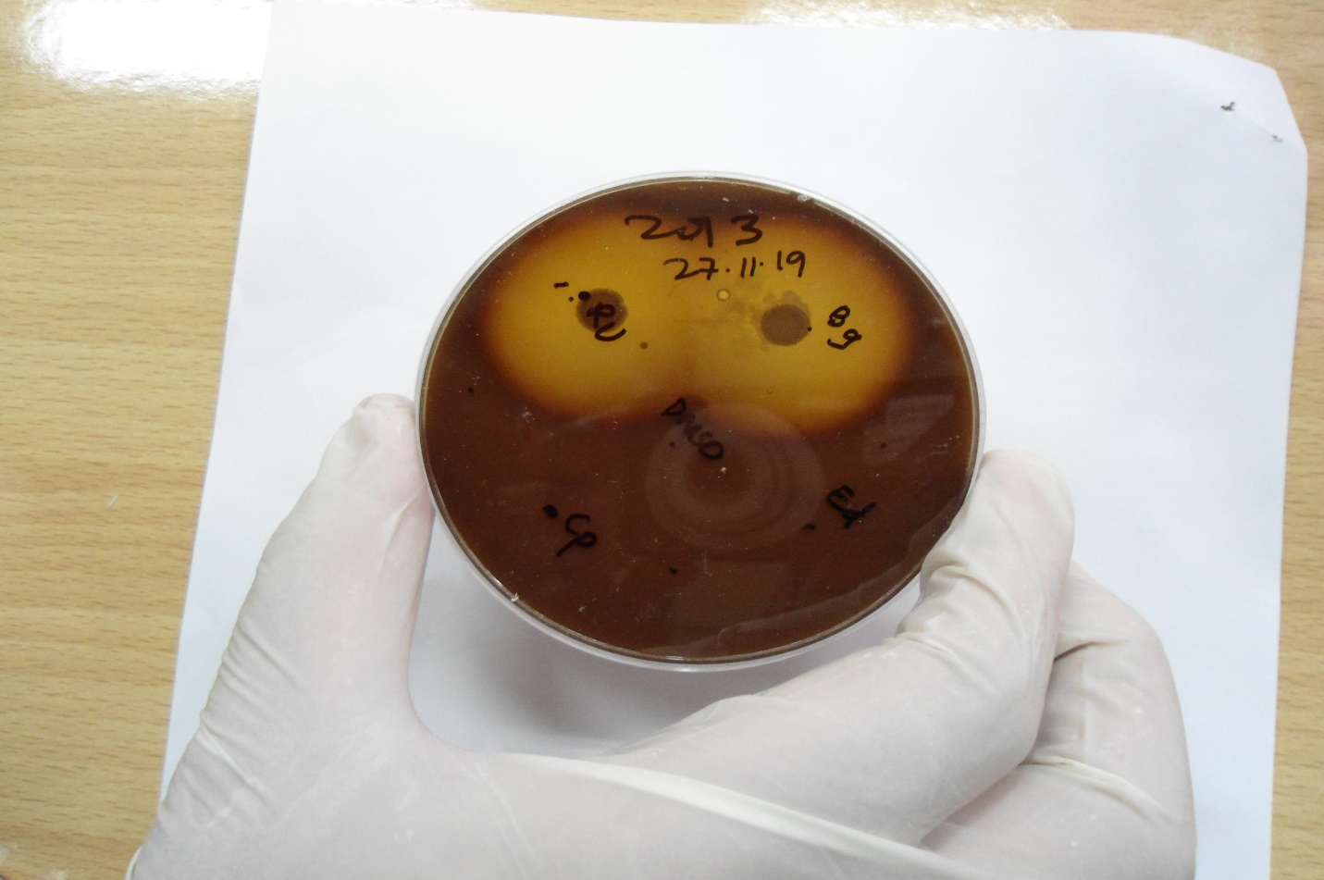

**Supplementary Figure S16:** Screening of bergapten against *H. pylori* resistant isolates.Effect of bergapten against *H. pylori* resistant isolates. Bg in figure indicates bergapten disc and marked zone of inhibition can be observed.