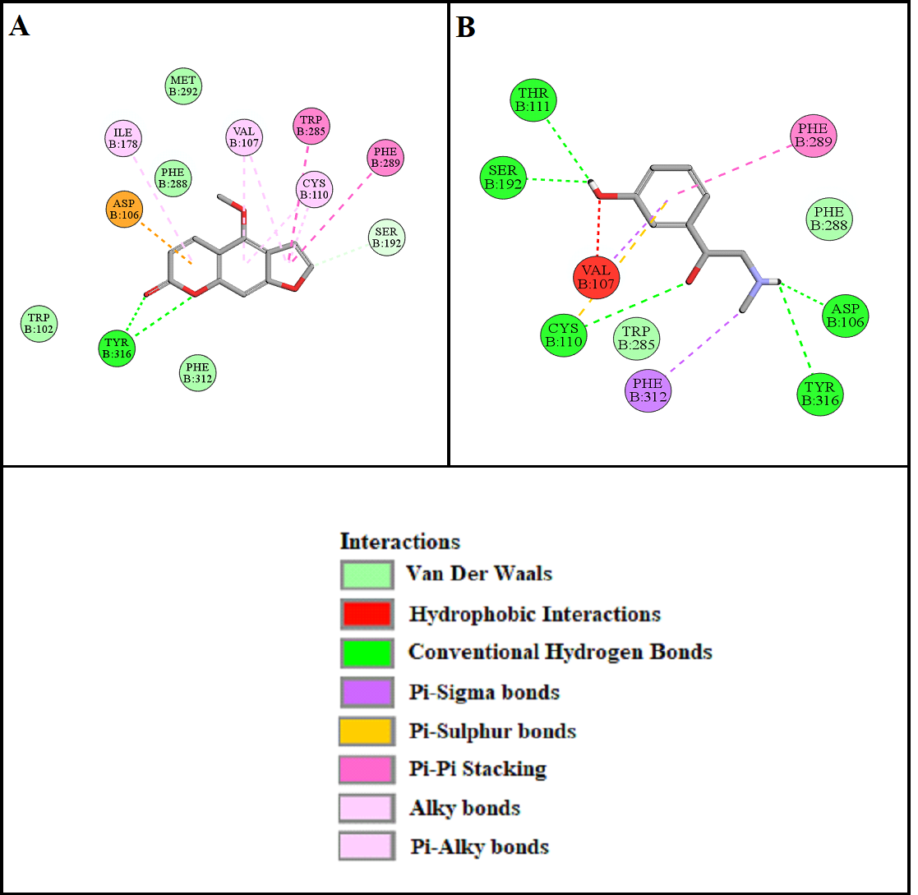

**Supplementary Figure S1: A** and **B** and represents 2D interactions of bergapten and phenylephrine with alpha adrenergic receptor (α1) respectively, drawn through Biovia Discovery Studio Visualizer 2016.

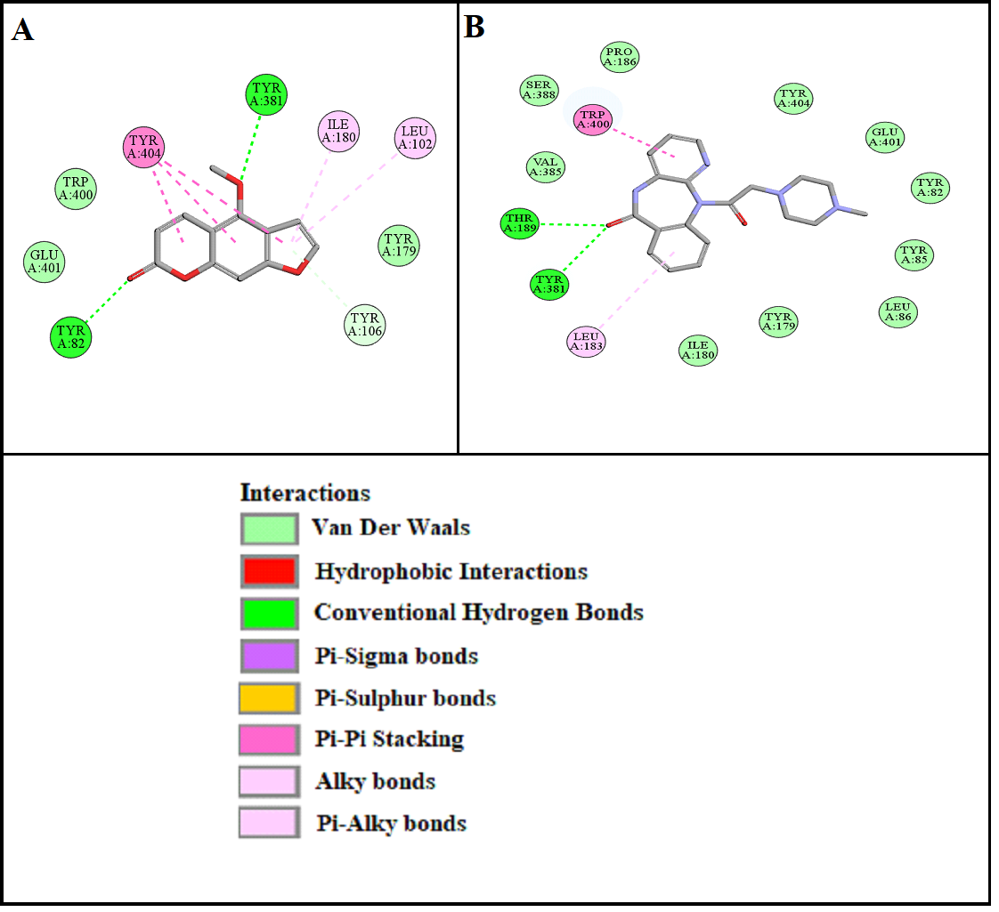

**Supplementary Figure S2: A** and **B** represents interactions of bergapten and pirenzepine with muscarinic M1 receptor (M1) respectively, drawn through Biovia Discovery Studio Visualizer 2016.

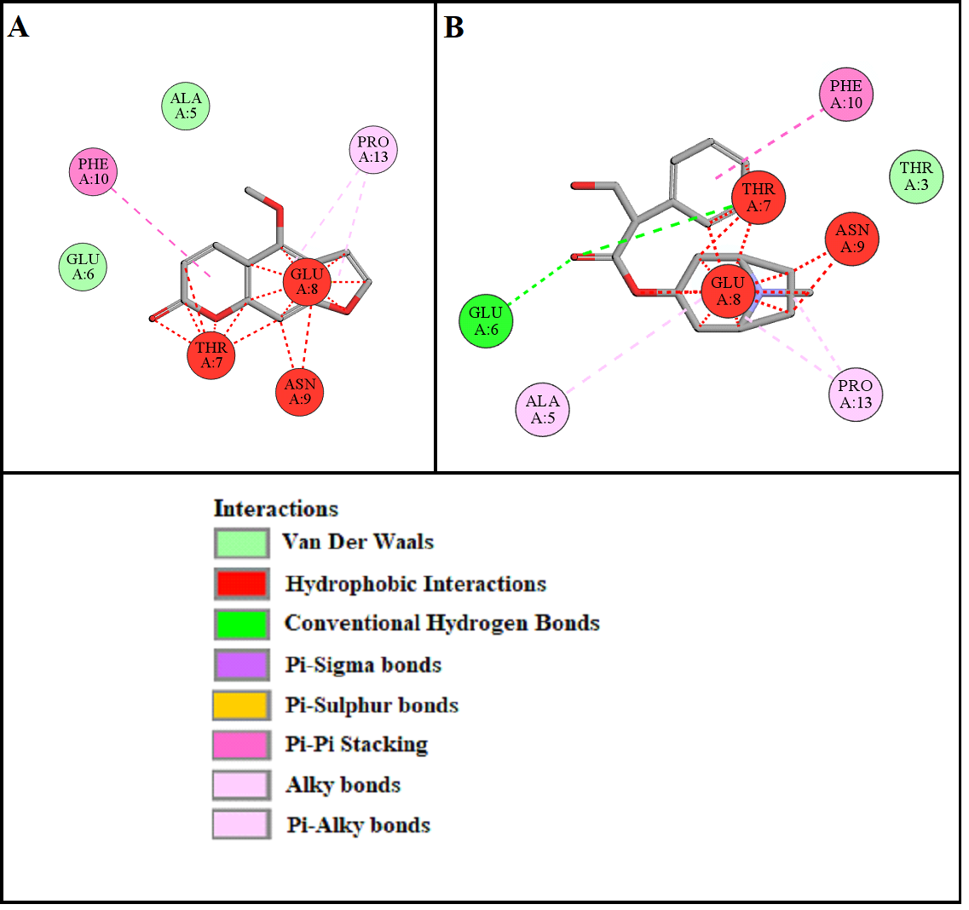

**Supplementary Figure S3: A** and **B** represents 2D interactions of bergapten and atropine with muscarinic receptor (M3) respectively, drawn through Biovia Discovery Studio Visualizer 2016.

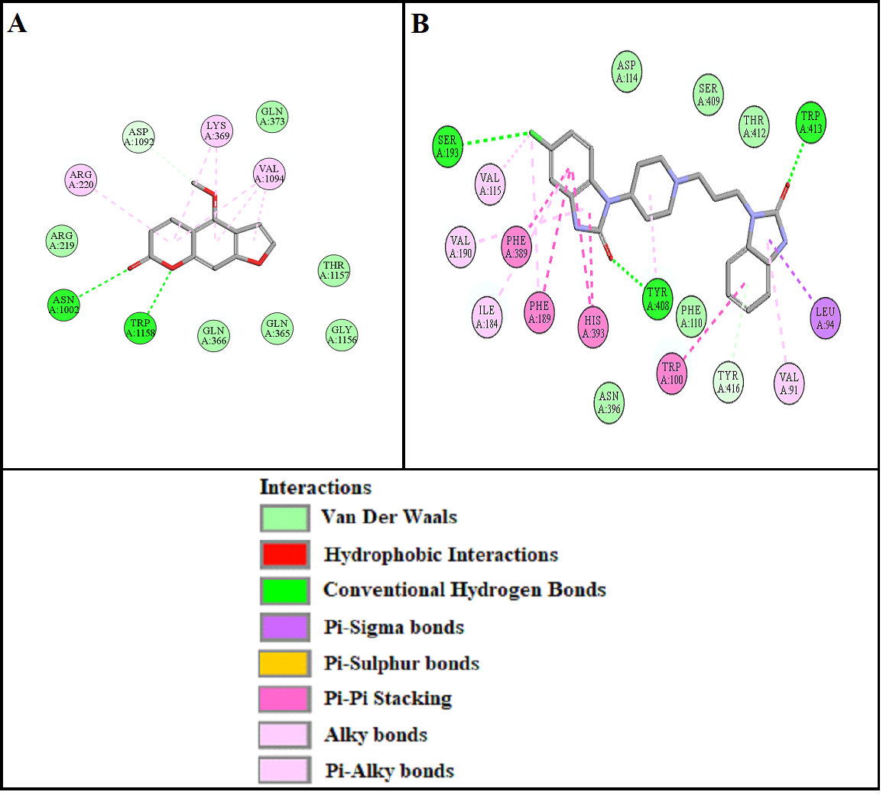

**Supplementary Figure S4. A** and **B** represents 2D interactions of bergapten and domperidone with dopaminergic receptor (D2) respectively, drawn through Biovia Discovery Studio Visualizer 2016.

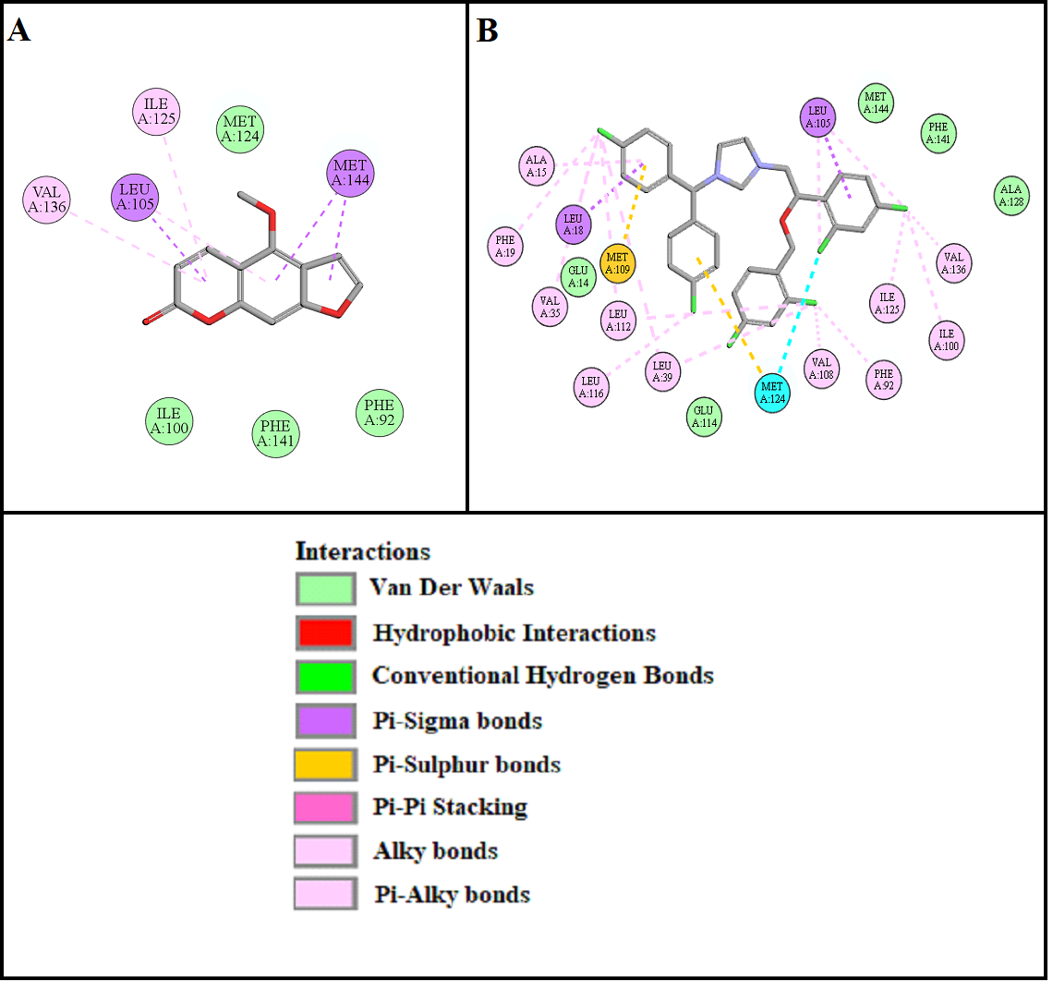

**Supplementary Figure S5: A** and **B** represents 2D interactions of bergapten and calmidazolium with calmodulin respectively, drawn through Biovia Discovery Studio Visualizer 2016.

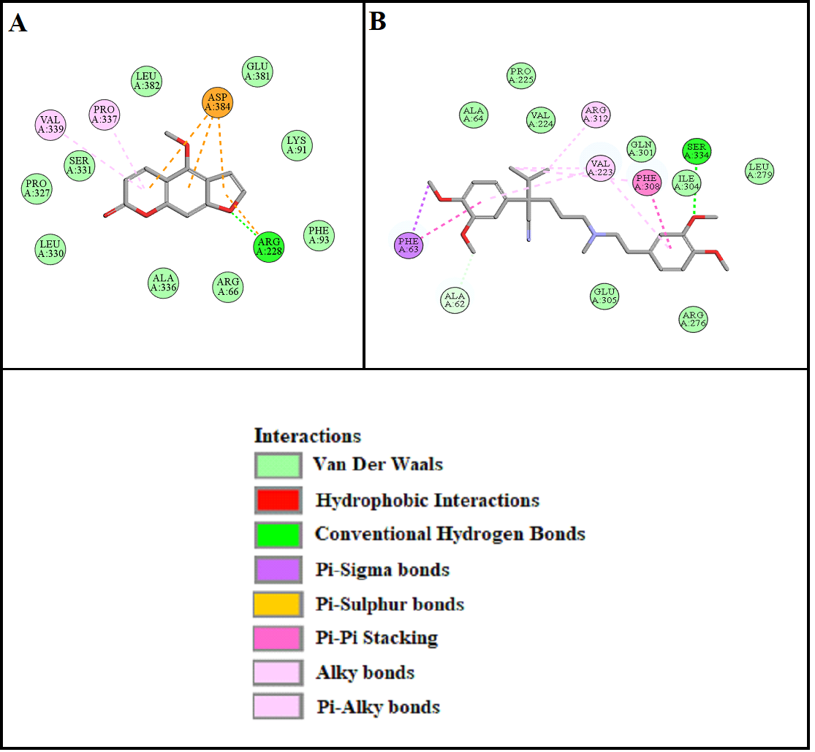

**Supplementary Figure S6. A** and **B** represents **2D** interactions of bergapten and verapamil with voltage gated L-Type calcium channel respectively, drawn through Biovia Discovery Studio Visualizer 2016.

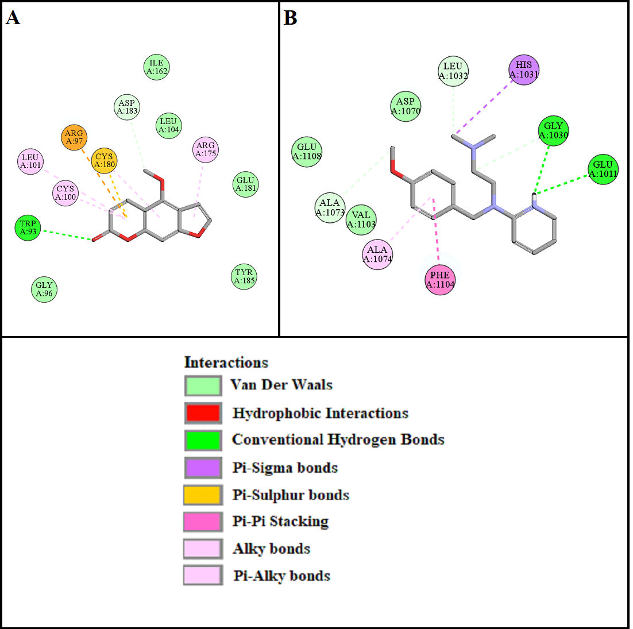

**Supplementary Figure S7. A** and **B** demonstrate **2D** interactions of bergapten and pyrilamine with histaminergic receptor (H1) respectively, drawn through Biovia Discovery Studio Visualizer 2016.

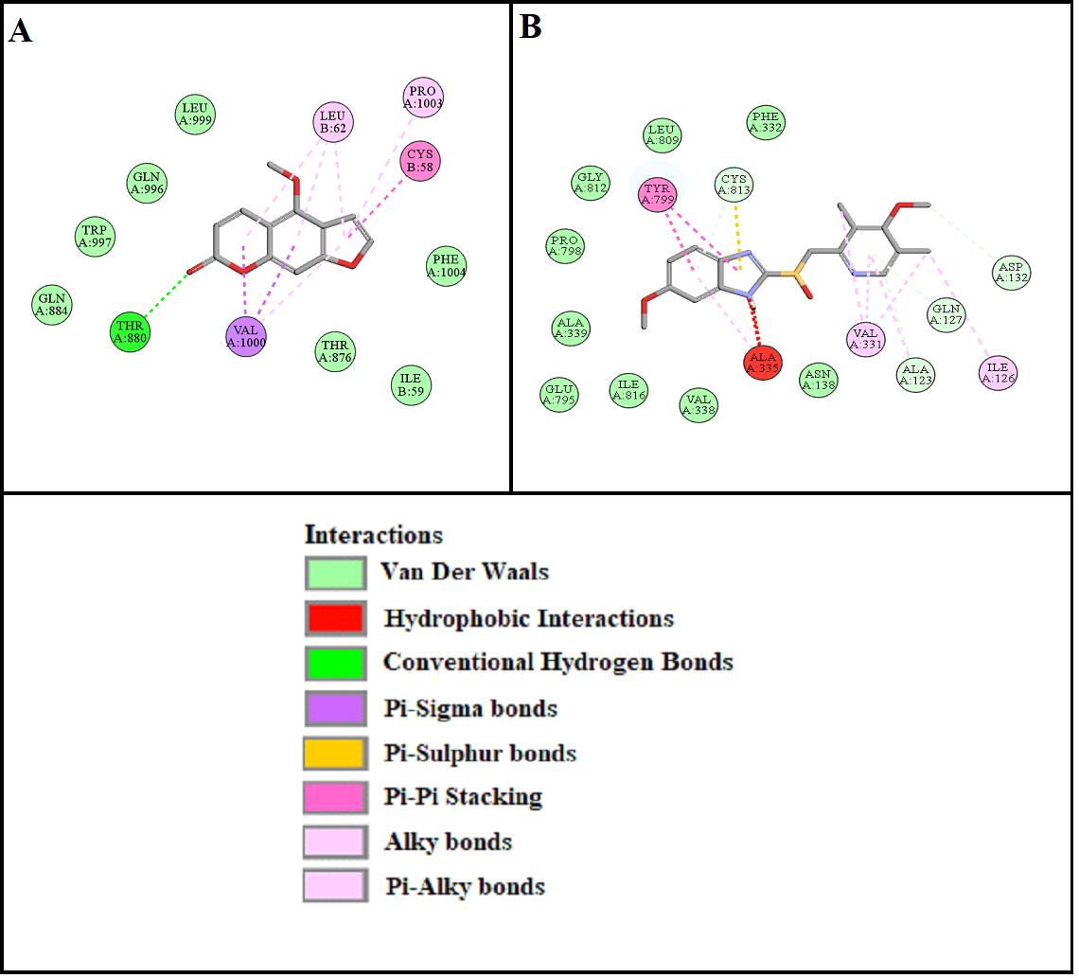

**Supplementary Figure S8. A** and **B** demonstrate **2D** interactions of bergapten and omeprazole with hydrogen potassium ATPase, also known as H+/K+ ATPase receptor respectively, drawn through Biovia Discovery Studio Visualizer 2016.

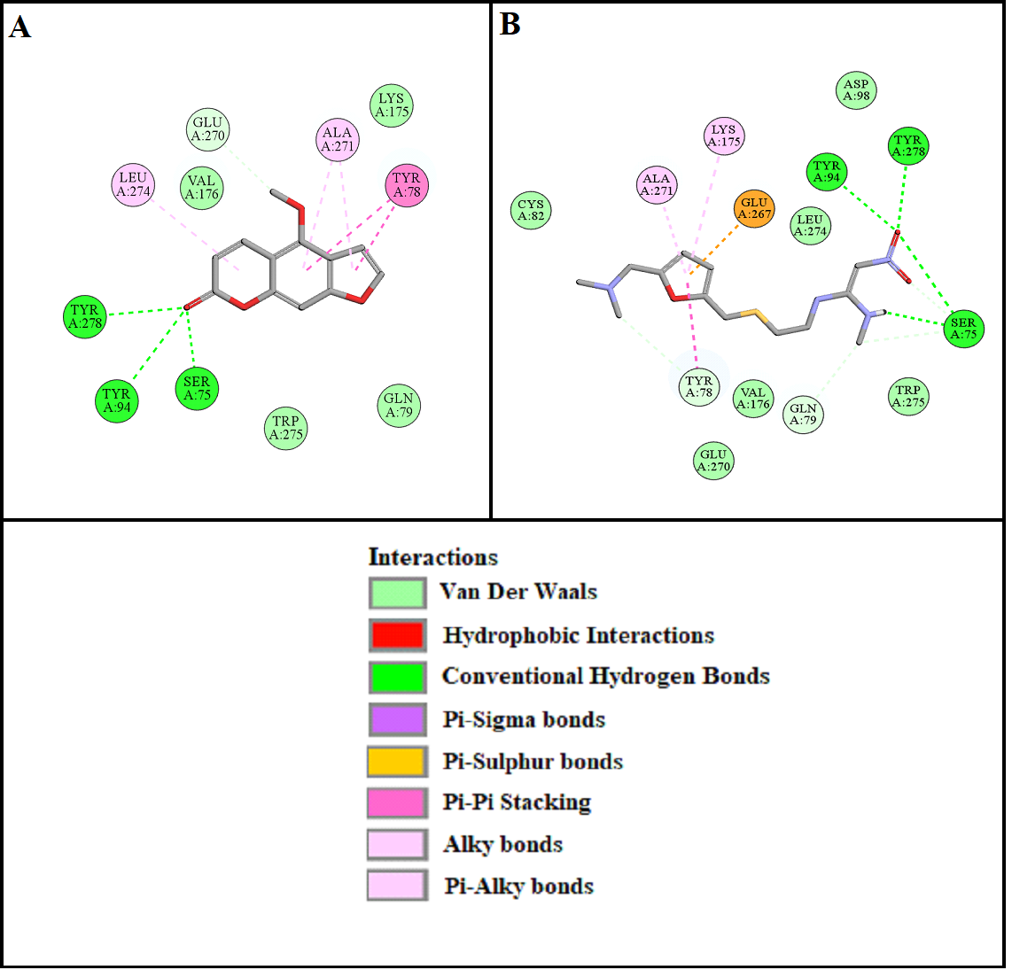

**Supplementary Figure S9. A** and **B** demonstrate **2D** interactions of bergapten and ranitidine with histaminergic receptor (H2) respectively, drawn through Biovia Discovery Studio Visualizer 2016.

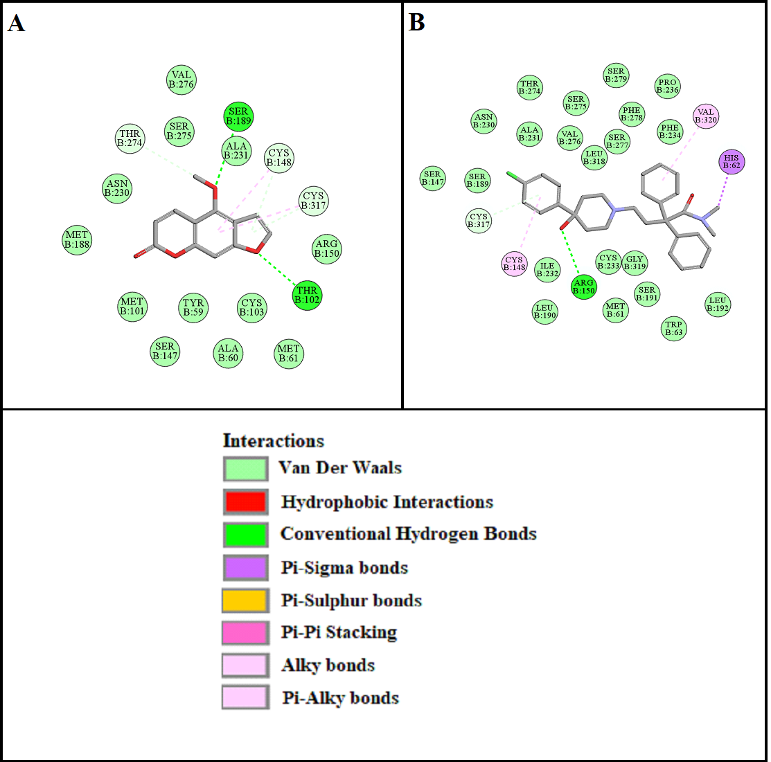

**Supplementary Figure S10. A** and **B** demonstrate **2D** interactions of bergapten and loperamide with mu-opioid receptor (μ) respectively, drawn through Biovia Discovery Studio Visualizer 2016.

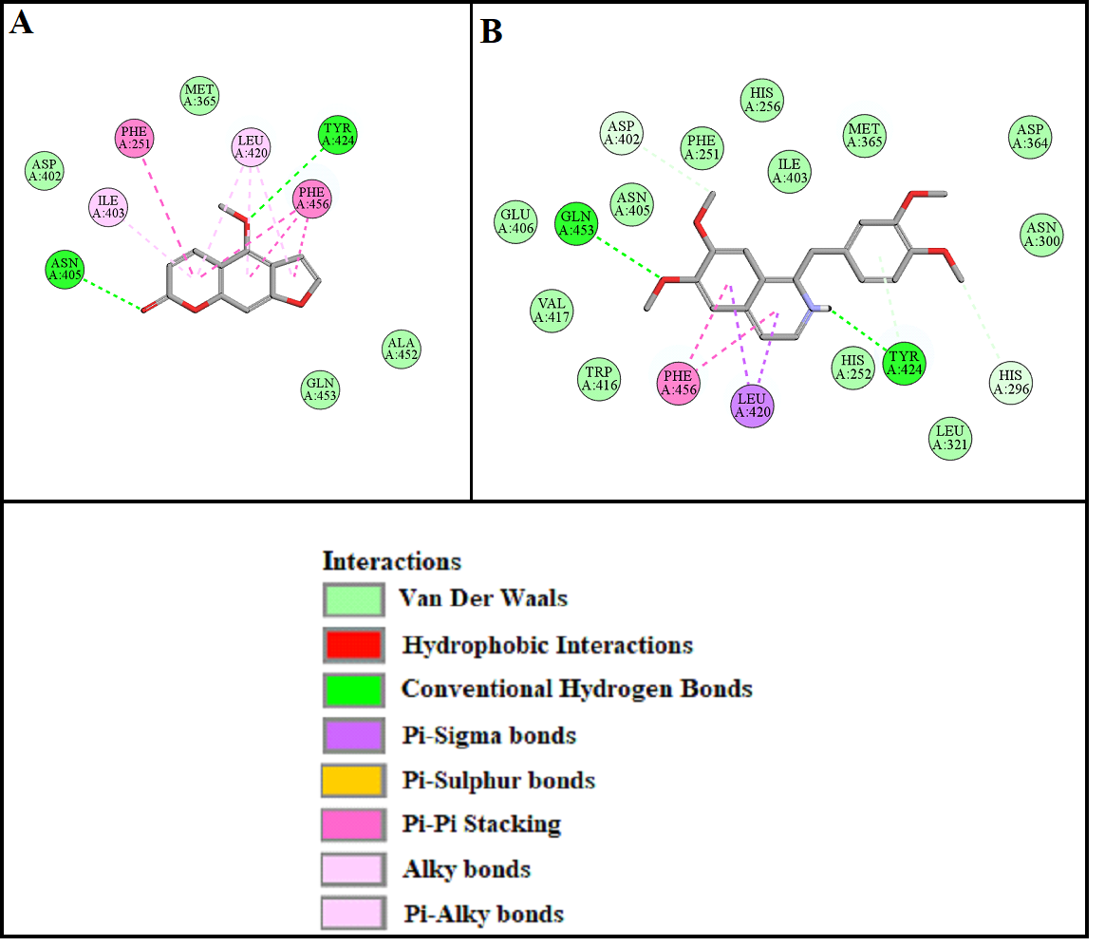

**Supplementary Figure S11. A** and **B** demonstrate **2D** interactions of bergapten and papaverine with phosphodiesterase enzyme respectively, drawn through Biovia Discovery Studio Visualizer 2016.