Supplementary Material for

Volatile trace metals deposited in ice as soluble volcanic aerosols during the 17.7.ka eruptions of Mt Takahe, West Antarctic Rift

Emily Mason¹, Marie Edmonds^{1*}, Joseph R. McConnell^{2,3}

¹Department of Earth Sciences, University of Cambridge, Downing Street, Cambridge, Cambridgeshire, CB2 3EQ, UK
²Division of Hydrologic Science, Desert Research Institute, 2215 Raggio Parkway, Reno, NV 89512, USA
³Sir Nicholas Shackleton Visiting Fellow, Clare Hall, University of Cambridge, Cambridge CB3 9AL, UK

Email: marie.edmonds@esc.cam.ac.uk

This PDF file includes:

Figures S1 to S5
Table S1
Legend for Dataset S1
SI References

Other supplementary materials for this manuscript include the following:

Dataset S1

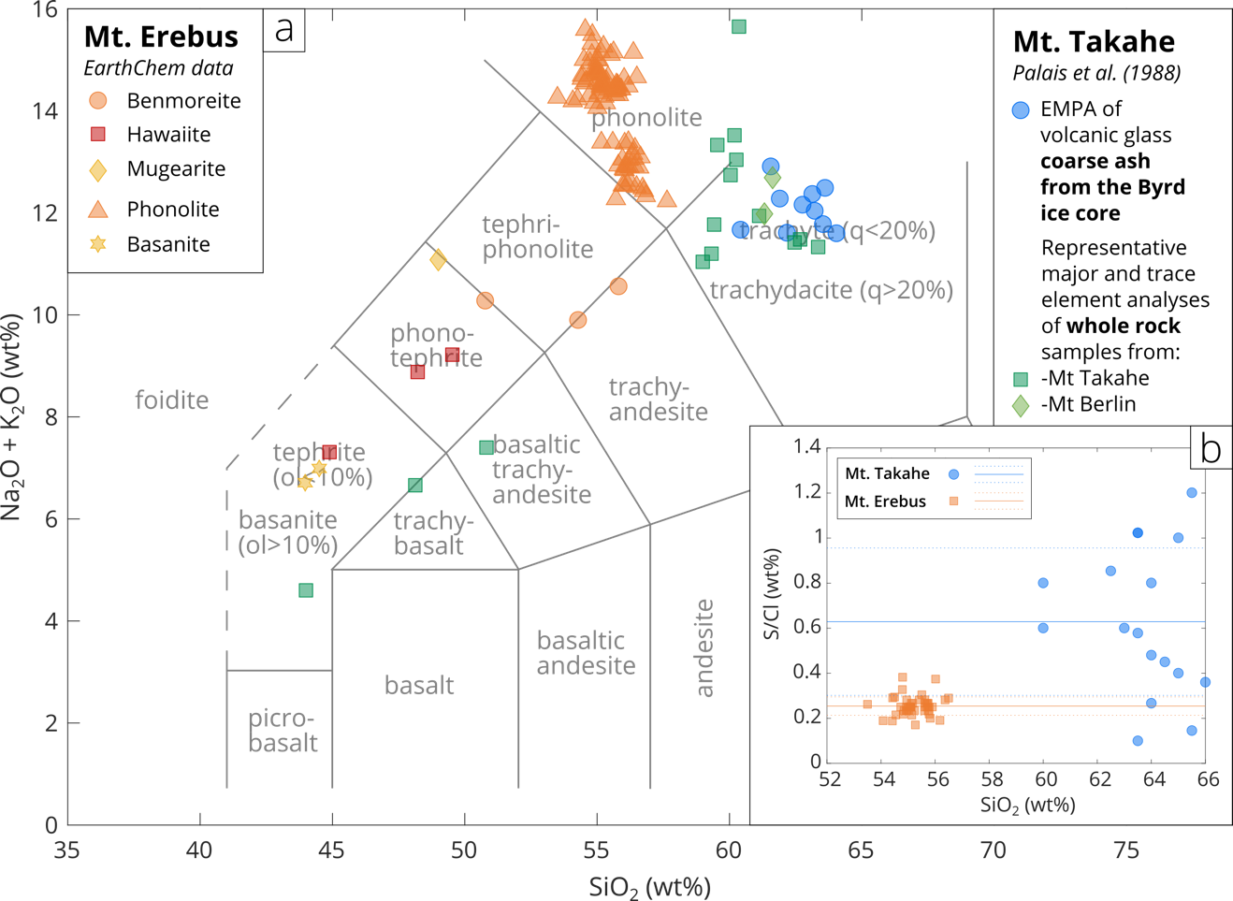
Fig. S1. Lava compositions for Mt. Takahe and Mt. Erebus.All data are from EarthChem and are given with sources in Dataset S1 (only data where the rock composition is known are used here). a: Total alkali (Na₂O + K₂O) versus silica (SiO₂) plot for Mt. Takahe and Mt. Erebus lava compositions. Semi-quantitative energy dispersive X-ray analyses are not shown. b: S/Cl mass ratios versus SiO₂ (wt%) in whole rock/glass analyses from Mt. Takahe (blue circles) and Mt. Erebus (orange squares). Solid and dashed lines represent the means and standard deviations of the datasets, respectively. Compositional data for Mt. Takahe are semi-quantitative, measured by energy dispersive X-ray analysis, and therefore their reliability is uncertain.

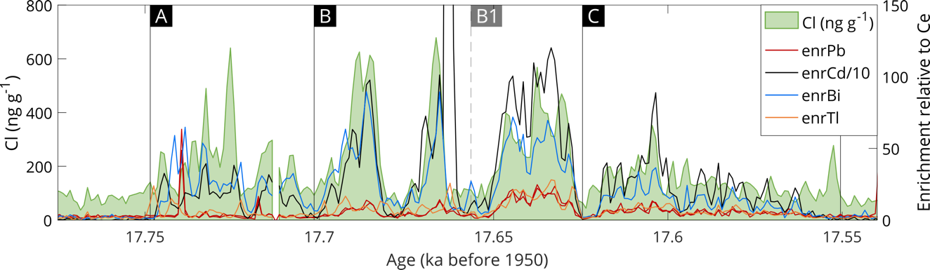Fig. S2. Volatile metal enrichments in the WD ice core relative to crustal sources. Enrichment factor calculation described in Materials and methods. Note the different y-axis scales and that enrCd values have been divided by 10. A large enrCd peak at the end of stage B is not shown fully to make the scale more readable – this peak reaches a maximum value of ~6500.

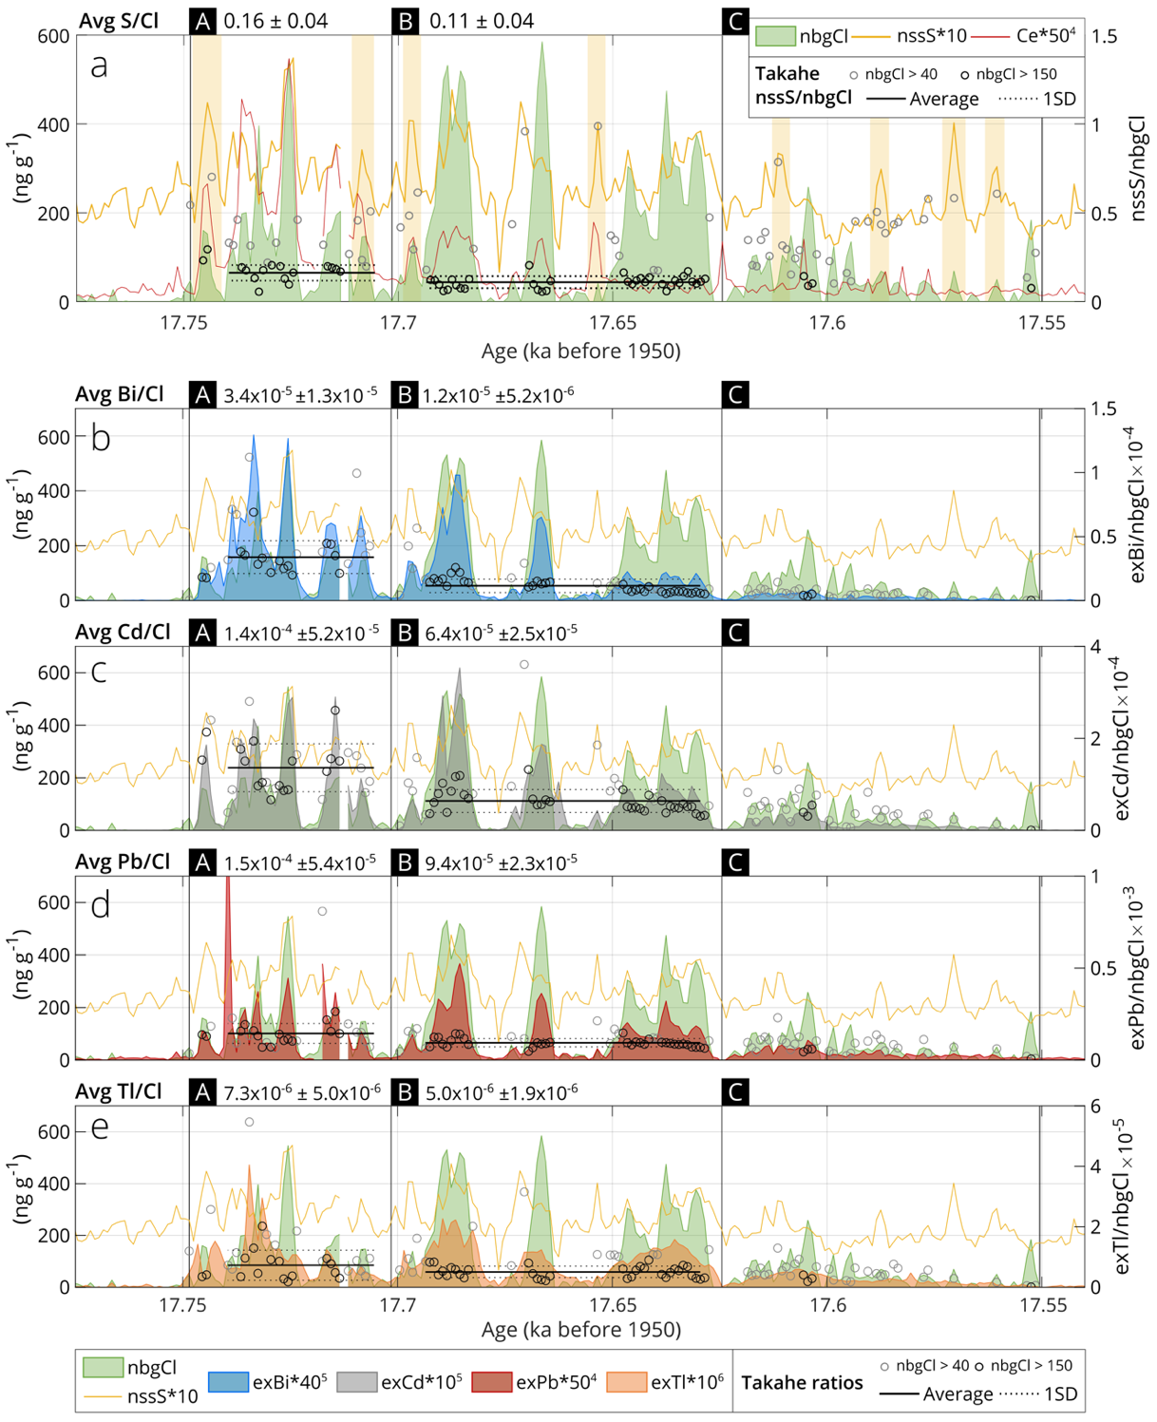
Fig. S3. Changes in sulphur (a), chlorine and volatile metal (b-e) concentrations in the WAIS Divide ice core during the 17.7 ka Mt. Takahe event. ‘nbgCl’ (non-background chlorine) is calculated by subtracting a consistent background Cl concentration of 94 ppm from measurements in ref.¹. ‘nssS’ = non-sea-salt sulphur. Here, the eruption sequence has been divided into 3 time periods (A-C) which show self-consistent chemical features, and will be referred to in subsequent figures. Yellow regions in a correspond to larger S peaks that are not associated with a large Cl peak. Average ratios and standard deviations (shown at the top of each figure) are calculated separately for different sections of the eruptions for nbgCl values >150 ng g⁻¹ only (black circles), and are not shown for stage C as there are too few data points >150 ng g⁻¹. To reduce the impact of 'edge effects' where slight offsets between Cl and trace metal concentrations lead to artificially high/low ratios, only individual ratios above for nbgCl >40 ng g⁻¹ (grey circles) are shown.
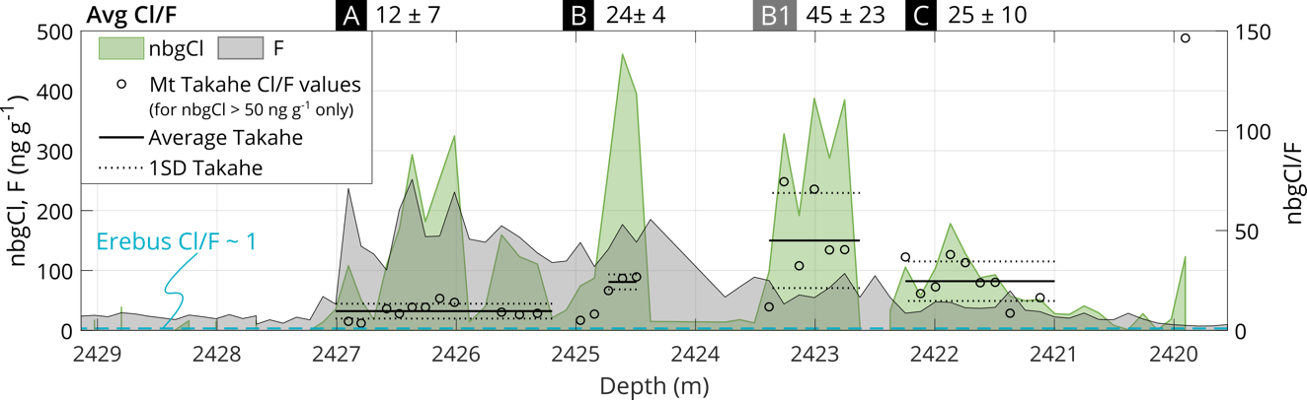
Fig. S4. Discrete measurements of Cl and F concentrations in the WAIS Divide ice core during the 17.7 ka Mt. Takahe event. Some detail of the shape of the Cl peaks is lost due to a lower frequency of measurements (per time/depth). Mean and standard deviation values are shown for different stages of the eruption at the top of the figure. Stages are positioned approximately by matching the shapes of Cl peaks from Fig S2a. Due to variability within stage B, two different ratios have been calculated.

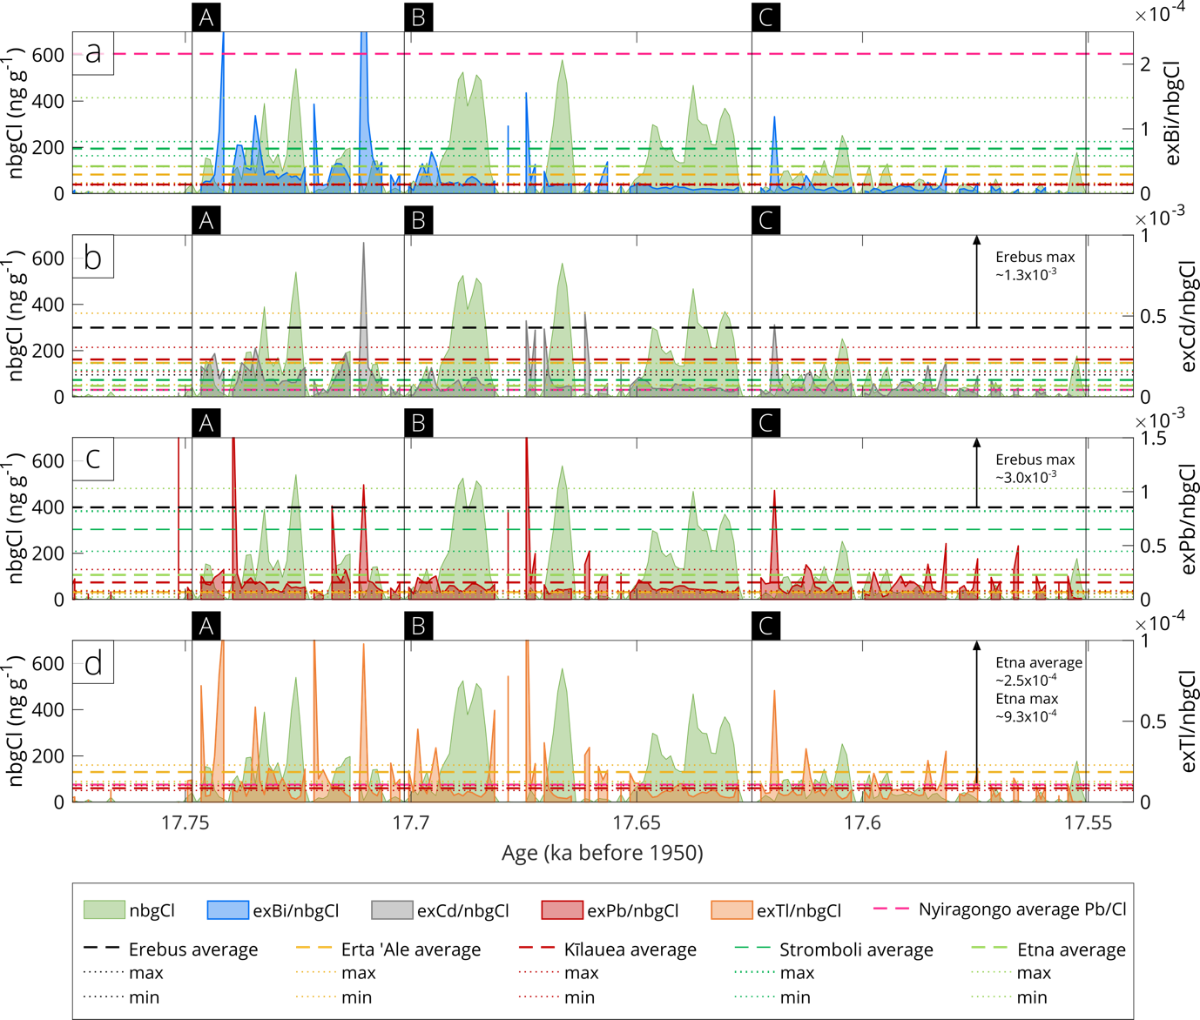
Fig. S5. Metal-to-Cl ratios (as in Figure 2) during the 192-y Mt. Takahe eruption sequence, compared to metal-to-Cl ratios from a selection of other basaltic (Erta ‘Ale, Kīlauea, Stromboli, Mt. Etna) and alkaline (Nyiragongo, Mt. Erebus) volcanoes.Data sources are: Mt. Etna², Stromboli³, Kīlauea⁴, Erta ‘Ale⁵, Mt. Erebus^{6,7} and Nyiragongo⁸. Note the different y-axis scales; when a ratio plots far from other values, its value is indicated next to an arrow.

Table S1. Input concentrations of gases for speciation models. Chemical species are ordered by abundance in the Mt. Takahe gas mixture. All Erta 'Ale data is from ref⁵.
 | Mt. Takahe model |  | Erta 'Ale model
Chemical species (gases) | Input concentration  (mol%, normalised to 100) | Data source | Input concentration  (mol%, normalised to 100)
H₂O | 47.7 | ¹² | 64.9
CO₂ | 43.9 | " | 21.4
CO | 3.3 | " | 0.3
H₂ | 1.6 | " | 0.7
HCl | 1.6 | Mt. Takahe S/Cl ratio | 0.5
SO₂ | 1.1 | ¹² | 11.3
H₂S | 0.6 | " | 0.6
HF | 0.3 | Mt. Takahe Cl/F ratio | 0.4
OCS | 1.0E-02 | ¹² | No data
S₂ | 3.1E-03 | " | No data
Cd | 9.3E-05 | Mt. Takahe Cd/Cl ratio | 3.1E-04
Pb | 5.4E-05 | Mt. Takahe Pb/Cl ratio | 5.1E-05
Bi | 1.2E-05 | Mt. Takahe Bi/Cl ratio | 1.8E-05
Tl | 2.7E-06 | Mt. Takahe Tl/Cl ratio | 1.1E-05
ΔFMQ | –1 | Redox couples¹³ | +0.2

Dataset S1 (separate file). Chemical compositional data from ice core record used in this study, tephra compositions, and chemical speciation modelling results.

SI References

1. McConnell, J. R. et al. Synchronous volcanic eruptions and abrupt climate change ∼17.7 ka plausibly linked by stratospheric ozone depletion. Proc. Natl. Acad. Sci. 114, 10035–10040 (2017).
2. Aiuppa, A., Dongarrà, G., Valenza, M., Federico, C. & Pecoraino, G. Degassing of Trace Volatile Metals During the 2001 Eruption of Etna. Volcanism Earths Atmosphere (2003) doi:10.1029/139GM03.
3. Allard, P. et al. Acid gas and metal emission rates during long‐lived basalt degassing at Stromboli Volcano. Geophys. Res. Lett. 27, 1207–1210 (2000).
4. Mason, E. et al. Volatile metal emissions from volcanic degassing and lava–seawater interactions at Kīlauea Volcano, Hawai’i. Commun. Earth Environ. 2, 1–16 (2021).
5. Zelenski, M. E. et al. Trace elements in the gas emissions from the Erta Ale volcano, Afar, Ethiopia. Chem. Geol. 357, 95–116 (2013).
6. Wardell, L. J., Kyle, P. R. & Counce, D. Volcanic emissions of metals and halogens from White Island (New Zealand) and Erebus volcano (Antarctica) determined with chemical traps. J. Volcanol. Geotherm. Res. 177, 734–742 (2008).
7. Zreda‐Gostynska, G., Kyle, P. R., Finnegan, D. & Prestbo, K. M. Volcanic gas emissions from Mount Erebus and their impact on the Antarctic environment. J. Geophys. Res. Solid Earth 102, 15039–15055 (1997).
8. Calabrese, S. et al. Passive degassing at Nyiragongo (D.R. Congo) and Etna (Italy) volcanoes. Ann. Geophys. 57, (2015).
9. Ilyinskaya, E. et al. Rapid metal pollutant deposition from the volcanic plume of Kīlauea, Hawai’i. Commun. Earth Environ. 2, 1–15 (2021).
10. Mandon, C. L., Christenson, B. W., Schipper, C. I., Seward, T. M. & Garaebiti, E. Metal transport in volcanic plumes: A case study at White Island and Yasur volcanoes. J. Volcanol. Geotherm. Res. 369, 155–171 (2019).
11. Kyle, P. R., Meeker, K. & Finnegan, D. Emission rates of sulfur dioxide, trace gases and metals from Mount Erebus, Antarctica. Geophys. Res. Lett. 17, 2125–2128 (1990).
12. Moussallam, Y. et al. Hydrogen emissions from Erebus volcano, Antarctica. Bull. Volcanol. 74, 2109–2120 (2012).
13. Moussallam, Y., Oppenheimer, C. & Scaillet, B. On the relationship between oxidation state and temperature of volcanic gas emissions. Earth Planet. Sci. Lett. 520, 260–267 (2019).

